IBM/Coursera Data Science Certificate - Capstone Project

Karen McEwen

April 2020

**Co-working spaces in Northeastern Ohio**

**Introduction**

This project began in early March, 2020, prior to any of the restrictions put in place due to the COVID-19 virus. The project intended to look at places where self-employed freelancers and entrepreneurs could work, if they were unable to work at home. Data was collected on dedicated Coworking places, as well as coffeeshops, cafes, tea rooms, and public libraries. Since then, in Ohio, all these places have been closed to limit the spread of coronavirus. In order to complete the project, I will assume that there will come a time in the future when all of these businesses are open again.

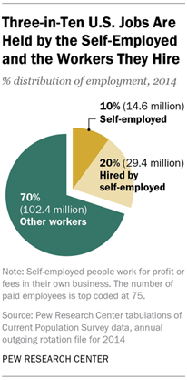

**Introduction to the Business Problem**

According to the U.S. Bureau of Labor and Statistics (BLS) approximately 15 million people are self-employed in the United States (as of 2014). This includes workers from construction and building trades, to real estate agents, accountants, hairdressers and service workers, as well as consultants, computer programmers, and freelance data scientists! According to the IRS, the actual number may be much higher - in 2016, there were 25.5 million nonfarm sole proprietorships, based on Schedule C tax filings. And the Pew Center reports that 3 in ten jobs in the U.S. are held by the self-employed and the people they hire.

So where do all of these self-employed people work? According to the Federal Reserve Banks Office of Advocacy, over 60% of small businesses with only one owner/employee are home-based, while only 23% of small businesses with at least one non-owner employee are. Those who are self-employed can take advantage of tax breaks allowed under the IRS rules and work from a home office, whether that be a dedicated room, or a corner of the kitchen table. Those who are self-employed in various service industries, beauticians or dentists, may need to have special equipment and spaces that cannot be accommodated in the home. Electricians and plumbers and those in the building trades may require garage space, or may work out of their specially equipped trucks. Tax preparers or accountants may need spaces to keep confidential information secure. In this project, I am going to focus on those who are consultants, such as those in the tech fields, who basically need just a computer and an internet connection to do their work. Most of these people work from home. However, many people prefer to have other options, whether that be to get away from household distractions, to meet clients in a more professional atmosphere, or just to be around other similarly self-employed people. The problem is that the opportunities for entrepreneurs and self-employed persons may be limited depending on geographic location and financial considerations.

A number of companies are beginning to address this growing segment of the population. The drama surrounding the company WeWork during its attempt to become publicly traded in 2019, has brought this issues into the news recently. As a self-employed potential entrepreneur, I have encountered first-hand the limitations of working space. While I am lucky now to have space in my home for a dedicated office, that has not always been the case. In addition, I sometimes miss the opportunities for interactions with colleagues and to be away from the temptations of non-work activities that are ever-present when working from home. However, in my geographic region, it can be difficult to find the right type of space where one can accomplish work. In theory, all that is required is a computer and an internet hookup. But not all places have reliable wi-fi, there may not be access to electrical outlets, and the cost of working and eating all day at a coffeeshop can be prohibitive over time. So there are coffeeshops, cafes and tea rooms, which will allow you to work there but may be noisy. Fortunately the region is particularly blessed by an outstanding public library system, which is part of every community. There are also a growing number of businesses which cater particularly to the computer IT professional and are branded as co-working spaces.

The purpose of this project is to examine options for the types and locations of working spaces available to self-employed and entrepreneurs, particularly in the fields of technology, in the Northeastern Ohio region of the United States.

## **Location - Northeastern Ohio (Cuyahoga County)**

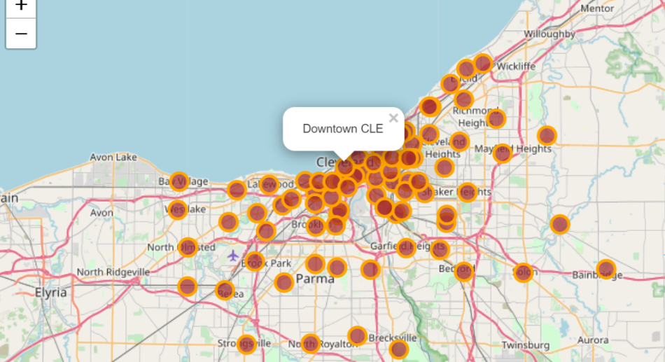**Map 1: Cuyahoga County Zip Code Locations**

I will be looking at the area where I live, which is Northeastern Ohio in the United States of America. Specifically, I will look at Cuyahoga County, which is home to the city of Cleveland and its associated suburbs. Below is a map of the area with the locations of the county zip codes and Cleveland city neighborhoods marked. Approximately 1.25 million people live in the county.

## **Stakeholders**

There are two stakeholders considered.

1) The self-employed individual or entrepreneur. Where is the best space to work if you can't or don't want to work at home?

2) The property owner or developer who may want to open up a co-working space. Where in the Northeast Ohio region would be a good location for such an endeavor?

In November, 2017, Fresh Books entrepreneurial statistics in conjunction with Research Now, conducted an online survey of over 2700 individuals who work full time, either as employees, entrepreneurs, or self-employed individuals. From that, they estimated that, in 2017, of the approximately 15 million Americans are full-time self-employed, with that number expected to rise to 27 million in the 2020s. They estimate that approximately 20% of these are in the construction trades, 10% each in retail, real estate, and consulting.

Therefore, there are approximately 40% of up to 27 million people who will need to find workspace for themselves. 10% of those people are consultants who are those considered here. That is about 1.1 million people who will need to find a place to do their work full-time. 1.38% of those will be in Northeastern Ohio, which is over 15,000 people. (Note that this does not take into account the millions of Americans who filed for unemployment in March and April 2020 due to coronavirus business closures.)

## **Assumptions**

The project assumes an aspiring self-employed technical consultant who is unable or unwilling to work from home and seeks to find a place to work on a daily, transient basis. It is assumed that the self-employed freelance or entrepreneur does not require any specialty equipment beyond an outlet, wi-fi, and coffee! Said Neil Weakland who started Canton Workspace:

About a year and a half ago I was in the job market looking for a new job and I couldn’t do that from my house because I have small children. So I went looking for a place outside my house where I could sit down and look for work and things like that, and I found that there really wasn’t a good place to do that in Canton. There are coffee shops, there are libraries, but at all of those places you can’t leave your belongings and leave and come back, and phone calls aren’t really a good for that situation either. So I went looking for a coworking space and found out that Canton didn’t have one. (Source: jumpstartinc.org)

There are basically four workspace options available:

1) Coffee Shops, Cafes, and Tea Rooms

2) Public Libraries

3) Dedicated Co-Working Spaces

4) Commercial Office Space

I will not be looking at commercial office spaces, because it is a prohibitively expensive option for most self-employed professionals. Also, traditional office spaces are generally handled through private real estate or corporate entities that handle many different locations.

## **Data**

Geographical data for Cuyahoga county was accessed by zip codes in publicly available data. During the study, it was discovered that several of the zip codes in the city of Cleveland did not have associated latitude and longitudes and that this was disseminated throughout all of the free resources available. Most likely, those particular codes were for individual businesses. In lieu of some areas of Cleveland inadvertently being missed, neighborhood data for the 26 neighborhoods of the City of Cleveland was gathered from Cleveland Live. The approximate latitude and longitude for that data was estimated by looking at a map of each neighborhood and determining the center.

The primary data for cafes, coffee houses, and tea rooms was gathered through the Foursquare geographical data API.

Library data was gathered from the Ohio Library Service and the Ohio Public Library Information Network (OPLIN). When using Foursquare, the libraries in the regions were not being collected correctly, perhaps because they were closed due to COVID. Cafes and coffeehouses and tea rooms were still open for carryout business.

Data for Coworking spaces came from searches on the internet and Google, as well as personal experience and visits and word-of-mouth followed up with phone calls. I requested access to the API for a website called Co-working, but did not receive access. The data that was collected included the name and location, whether the venue offered day passes, and the cost for the day pass. Note that Foursquare has a category that is labelled ‘Coworking Space’, but upon close inspection, it was determined that of 26 venues that were called up, 22 were not appropriate for use in this study. They were either commercial space, without access for individuals on a daily basis, or they were specialty firms such as law, advertising, or creative endeavors. Therefore, that category of Foursquare data was not used in this project. There were a total of 22 coworking spaces in Cuyahoga County on March 1, 2020.

## **Map 2: Cuyahoga County Areas with Coworking Spaces Included**

## **Methodology**

## Data was analyzed using Python programming language through a Jupyter notebook either on IBM AI Cognitive Class Labs. Many times during the month of March, the servers there were unavailable as schools and businesses shut down and students and workers began working from home. At that time, I switched to downloading Anaconda on my personal computer.

## Geographical data was uploaded into the Jupyter notebook and basic maps were made using Folium. A Foursquare account allowed for searches of Cafes, Coffee shops, and tea rooms. Library data and Coworking Space data were uploaded and combined with the results of these searches.

## The first part of the program looked specifically at the Downtown Cleveland neighborhood because it had the most venues. A distance of 1000m from the center was used as the search radius for Foursquare. Several other distances were tried, from 500m to 5000m, and 1000m was chosen as allowing enough distance to find venues within the center of each neighborhood, but not too much overlap.

## Once the individual neighborhood was considered, the program looked at each of the neighborhoods and zip codes in Cuyahoga County. That data was analyzed using both basic data analytic techniques, data visualization, and through K-Means clustering technique.

## **Map 3: Downtown Cleveland and Coworking Venues**

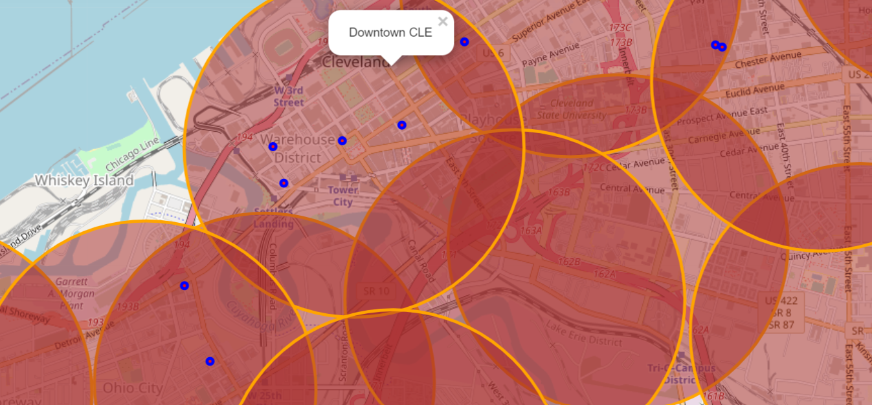

As you can see, there was some overlap in the areas due to the desire to get as many of the venues as possible into the search, particularly in the more widely spaced areas of Cuyahoga County, as seen in Map 2.

## **Results**

## The study looked at 79 separate neighborhoods and zip code areas in Cuyahoga County.

## There were 22 coworking spaces in the county, represented by 11 unique municipalities, with Cleveland being the primary location. Costs for day passes ranged from $10-$50, with a mean of $22.86.

## There are 65 public libraries in Cuyahoga County. They are free and open to the public. Each branch provides computers, wi-fi, and meeting rooms for public use.

## Downtown Cleveland was the area with the most venues, and with the largest number of coworking spaces (5). There were also 33 cafes, coffee shops, and tea rooms located in the area. Three libraries were located within the Downtown Cleveland area. The total number of venues that a self-employed freelancer could use in the area was 41.

## The top 10 areas for all venues is listed below in Table 1. On the next page is a stacked horizontal bar chart that shows the neighborhoods and what venues were available in each (Graph 1).

**Table 1: Top 10 Areas in Cuyahoga County for Coworking-type Venues**

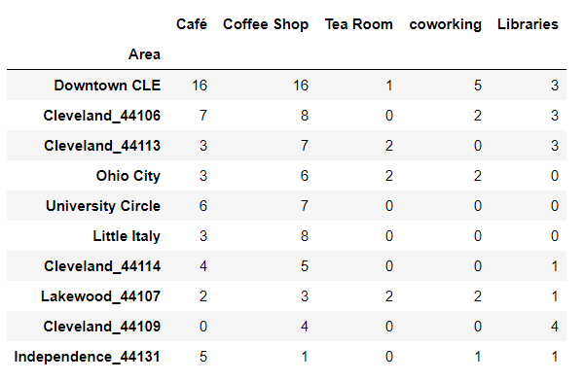

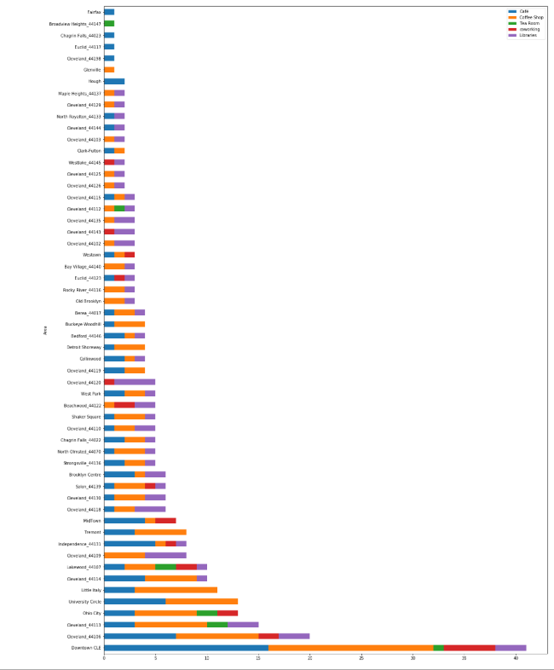

**Graph 1: Bar Chart of Venues in Cuyahoga County by Area**

## **Results: KMeans Clustering**

## KMeans Clustering was performed on all of the areas. Kmeans is an unsupervised machine learning method. It groups data based on similarity. Basically, it looks at the variables and determines how closely related the two are by comparing them to a chosen number of centers (centroid) and how close an individual set of data is to a particular centroid of a cluster. Data within a cluster is more similar to other data within the cluster than it is to data outside of the cluster. The initial number of centroids for this study was 7. Data was standardized by dividing the number of each venue by the total number of venues in an area. The Sci-kit Learn module Kmeans was used to perform the calculations. Below is the resulting map of clusters (Map 4).

## **Map 4: KMeans Clusters for Cuyahoga County, Ohio**

## KMeans Clustering

## Cluster 0: There are 5 areas in this cluster. All of them have Cafes only.

## Cluster 1: There are 18 areas in this cluster. There is a mix of venues.

## Cluster 2: 14 areas of mixed venues, all of which have a library, but no coworking spaces.

## Cluster 3: 8 areas with mixed venues, but all contain both coffee shops and a library.

## Cluster 4: Consists of only 1 area. Contains only a Tea Room.

## Cluster 5: Consists of 4 areas, all of which have both libraries and coworking spaces but no cafes.

## Cluster 6: 5 areas containing only cafes and coffee houses.

## **Discussion**

This study began as I was working with a group of entrepreneurs who were looking for places to work outside of their homes that were not too expensive and were flexible with respect to how often the space was needed. Two weeks later, restrictions began to be put in place in Ohio due to coronavirus . This made this study a more difficult challenge due to limitations on computer server time, as well as the closure of most, if not all, of the venues in the study. The decision was made to complete the study as if all of these venues would, in fact, reopen at the time that self-employed freelancers and entrepreneurs are looking to leave the house and work someplace else. Given the circumstances, there may, in fact, be a larger market in the future for dedicated coworking spaces as some businesses are also learning that many of their employees may be able to work adequately from home.

It would be interesting to run the KMeans analysis again, and combine all the coffeehouses, tea rooms, and cafes into a single retail category and compare with libraries and coworking spaces.

It would also be interesting to get cost data for a day spent working at a coffeehouse or café and compare that to the coworking spaces that are available to day users.

Foursquare geographical data is really good at looking at places that are near to other places. However, using Foursquare and searching based on latitude and longitude may not have been the best way to look for data. I think using the zip codes through another format may have gotten better results because of the larger areas involved. Cleveland and Cuyahoga County are not really walkable places. There is public transportation, but it is not accessible everywhere in the county. Most people drive to where they want to be, and so looking for the closest café to a particular location is not necessarily the way a freelancer is going to choose a place to work. Parking, by contrast, is a major concern. Libraries are known to have good parking facilities, in general, while many retail facilities do not. Some of the coworking spaces have dedicated parking, while others do not. That is something that was not considered in this study.

For the person interested in starting a dedicated coworking space, it seems that there is the possibility that one of the areas in cluster 6 might be a place to start, as they already have some cafes and coffeehouses but no coworking spaces or libraries to use. Obviously, many other factors (such as cost) which were beyond the scope of this study would have to be considered.

**Conclusion**

In Cuyahoga County, Ohio, during ordinary times, there are a wealth of places for the self-employed and entrepreneur to work on a daily basis in the Downtown Cleveland area. Ohio City and University Circle also have an abundance of workspace. However, most other places around the County suffer from a lack of coworking locations, or even coffee shops or libraries where one could work. If one were to want to create a coworking space, one place to start would be the areas in cluster number 6.