Kartine’s Restaurant

Kitchen & Bar

Karen O’Callaghan x18138926

Christine Shine X20211651

Contents

**No table of contents entries found.**

# Executive Summary:

The team consists of Karen O’Callaghan and Christine Shine, both students of the HDCYB_SEPOL course. Prior to the initial meeting on the 20th November, both team members had a few ideas around a booking system, whether for travel, hotel or restaurant and it was at this meeting that Kartine’s became the concept for the domain.

Starting a business in the middle of a pandemic is inspirational, especially now that the latest cultural trends are for fresh organic products using traditional farming methods and with least impact on the environment. Katrine’s is one of the new age restaurants bringing together irish cuisine, with the produce from local farmers.

The Covid Pandemic has brought about trying times for all businesses and with more and more customers embracing being online, it makes sense that they don’t have to ring to make a booking but can easily book a table for any occasion in line with Covid regulations. The system will allow the restaurant to confirm bookings and track customers.

Having an online presence introduces the restaurant to not just those in the locality of the restaurant but also to those far and wide, who maybe visiting the city. The system may be an influential decision making tool for the restaurant.

The functionality that we’re trying to showcase, is to show how information can be displayed and interacted with by the consumer. It’s to make the domain look presentable and navigation around the site to be easy to use.

Project Plans

* + How did your team split the project work?
    - Show work packages with milestones and deliverables
  + How was your site designed?
  + evidence of testing

# Wireframes:

* Show wireframes for each web page and reference at least one design pattern per wireframe

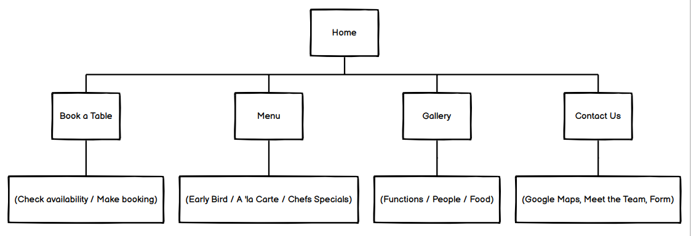

Figure : Site Map

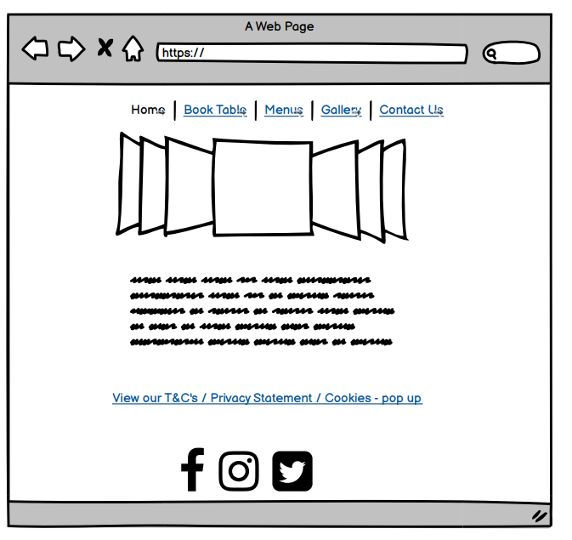

Figure : index.html

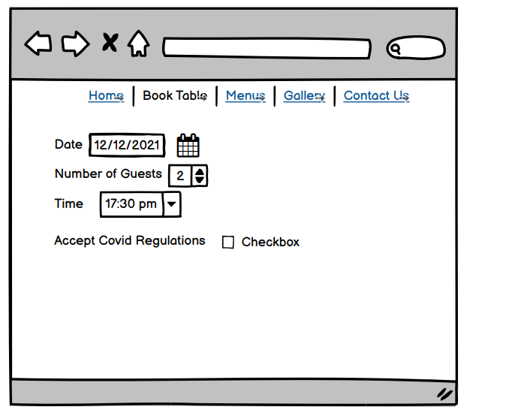

Figure :reservation.html

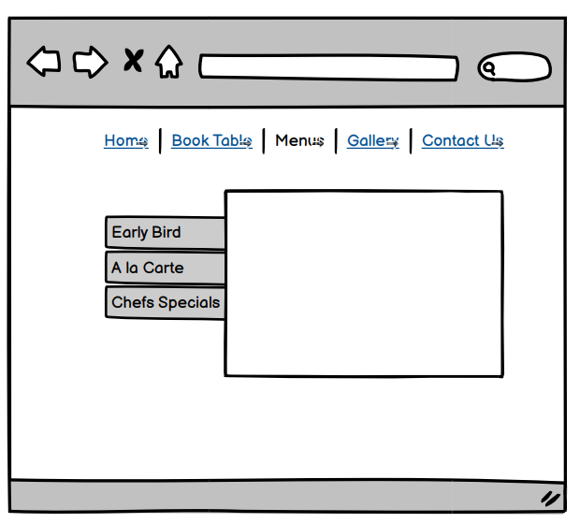

Figure : menus.html

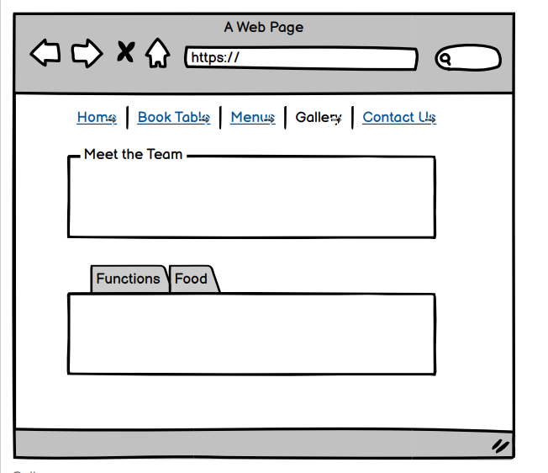

Figure : gallery.html

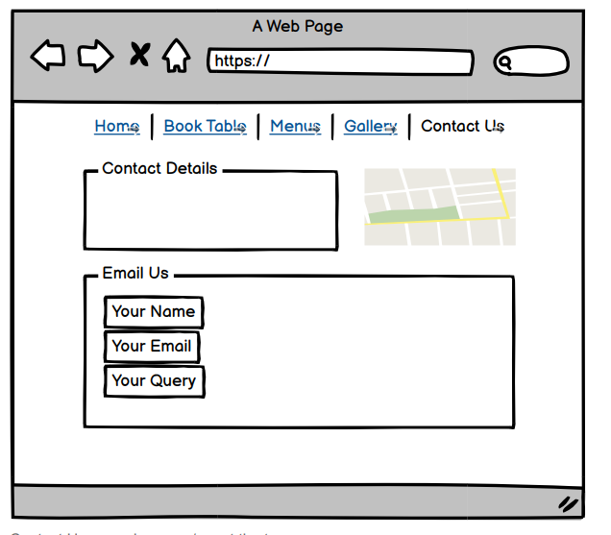

Figure : contactus.html