# Entity Framework Core grouping

|  |
| --- |
| Note this should had been in part 4 of the repository branch but got messed up and went to part 3. Way too difficult to remedy so it’s here. |

Grouping is one of the most powerful capabilities of LINQ. The following examples show how to group data in various ways:

* By a single property
* By a compound key (multiple properties)
* By the first letter of a string property
* By a computed numeric range
* By Boolean predicate or other expression.

Let’s look at a simple SQL SELECT/GROUP-BY

In our north wind database, orders table, customers want to know who has the most orders. The following query can be used.

|  |
| --- |
| SELECT  EmployeeID,  COUNT(EmployeeID) AS Counter  FROM  NorthWind2020.dbo.Orders  GROUP BY  EmployeeID  ORDER BY  Counter DESC; |

Results (note the last row with a NULL)

|  |
| --- |
| 4,156  3,127  1,123  8,104  2,96  7,72  6,67  9,43  5,42  NULL,0 |

Let’s get rid of the NULL record(s).

|  |
| --- |
| SELECT  EmployeeID,  COUNT(EmployeeID) AS Counter  FROM  dbo.Orders  WHERE  EmployeeID **is not null**  GROUP BY  EmployeeID  ORDER BY  Counter DESC; |

To return the employee identifier and count of orders using a data provider.

* Karen will supply
  + Add NuGet package [System.Data.SqlClient](https://www.nuget.org/packages/System.Data.SqlClient/4.8.2?_src=template)
  + NorthWindCoreUnitTest.Classes.SqlOperations in GitHub
  + A unit test class with a test method
  + Walkthrough second and third bullet

Now let’s do the same with EF Core.

* Karen will provide OrderOperations class code

First step, get a list of employee in a method separate from performing a group-by which means this method is reusable for other operations.

In the database table, there is one record without an employee identifier which should never happen but we know there is a chance so Karen setup for failure if a developer does not assert for null.

OrderOperations class

1. Create an instance for a list of Employees
2. Query Orders
3. Where employee id is not null
4. Perform the query asynchronously

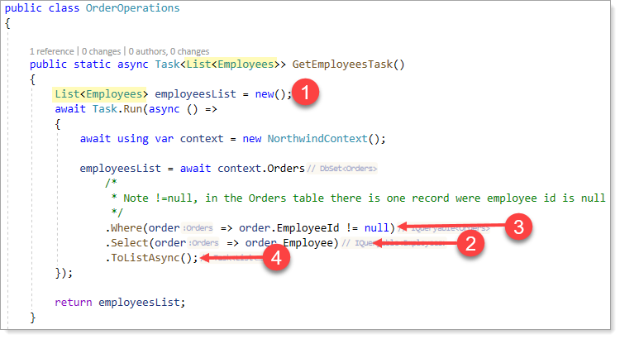

Next, the following method accepts a list of employees obtained from GetEmployeesTask method above

1. Group by employee identifier
2. Perform a descending order on count which returns the count of elements in a sequence
3. Ask for the first employee using FirstOrDefault. Note with FirstOrDefault a check can be done for null while a sister extension First if there are no elements in a sequence will throw a runtime exception.
4. Return a IGrouping<int, Employees> where int is the count of orders for the employee with the most orders

Time to write unit test

1. Create a new class in the root of the project NorthWindCoreUnitTest named
2. Change the class signature to public partial class OrderTests : TestBase hint: needs a using statement, look at the other test classes.
3. Add the following attribute [TestClass] hint: needs a using statement, look at the other test classes.
4. Add the following test method (Karen will walk through the code) and supply SqlOperations code.

[TestMethod]

[TestTraits(Trait.GroupingEntityFramework)]

public async Task GroupByEmployeeIdentifierGetHighCountInOrders()

{

    List<Employees> employeeList = await OrderOperations.GetEmployeesTask();

    IGrouping<int, Employees> employee = OrderOperations.EmployeeMostOrders(employeeList);

    Assert.IsTrue(employee != default);

    Debug.WriteLine($"Order count: {employee.Count()} employee id: {employee.Key}");

    SqlOperations.Server = ".\\SQLEXPRESS";

    SqlOperations.Database = "NorthWind2020";

    //    |   |

    //    V   V    <- Discards

    var ( _ , _ , dictionary ) = SqlOperations.EmployeeMostOrders();

    Assert.AreEqual(employee.Count(), dictionary.FirstOrDefault().Value);

}

# By a single property

For this exercise we will work with Contacts and ContactType models grouping on ContactTypeIdentifier

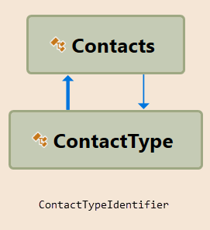

As with several former code samples we don’t want all properties in Contacts and ContactType as there are navigation properties that we don’t care for.

ContactItem class will slim down to only the properties required.

public class ContactItem

{

    public int ContactId { get; set; }

    public string FirstName { get; set; }

    public string LastName { get; set; }

    public string FullName => $"{FirstName} {LastName}";

    public int? ContactTypeIdentifier { get; set; }

    public string ContactTitle { get; set; }

    public override string ToString() => $"{ContactTitle} {FirstName} {LastName}";

    public static Expression<Func<Contacts, ContactItem>> Projection

    {

        get

        {

            return (contacts) => new ContactItem()

            {

                ContactId = contacts.ContactId,

                FirstName = contacts.FirstName,

                LastName = contacts.LastName,

                ContactTypeIdentifier = contacts.ContactTypeIdentifier,

                ContactTitle = contacts.ContactTypeIdentifierNavigation.ContactTitle

            };

        }

    }

}

To read contacts and contact types we will create a class named ContactOperations. Using ContactItems above read data.

public static async Task<List<ContactItem>> GetContactsWithProjection()

{

    List<ContactItem> contactList = new();

    await Task.Run(async () =>

    {

        await using var context = new NorthwindContext();

        contactList =  await context.Contacts.Select(ContactItem.Projection).ToListAsync();

    });

    return contactList;

}

Using the method above, group by contact type identifier and order by contact title.

public static async Task<List<IGrouping<int?, ContactItem>>> ContactsGroupedByTitleAsync()

{

    List<ContactItem> contactList = new();

    await Task.Run(async () =>

    {

        contactList = await GetContactsWithProjection();

    });

    return contactList

        .GroupBy(contactItem => contactItem.ContactTypeIdentifier)

        .Select(grouped => grouped)

        .OrderBy(contactItem => contactItem.FirstOrDefault().ContactTitle)

        .ToList();

}

What about a secondary order by on contact last name? This can be done in the caller to this method, in this case a test method.

Did I break a cardinal rule? Yes by using a single character for a variable. Many times a developer will use a single character and think “I will rename it later” but later never comes.

[TestMethod]

[TestTraits(Trait.GroupingEntityFramework)]

public async Task GroupByContactType()

{

    var test = await ContactOperations.ContactsGroupedByTitleAsync();

    foreach (var contactsGrouped in test)

    {

        Debug.WriteLine($"{contactsGrouped.FirstOrDefault().ContactTitle} - {contactsGrouped.Count()}");

        foreach (var contactItem in contactsGrouped.OrderBy(x => x.LastName))

        {

            Debug.WriteLine($"\t{contactItem.FullName}");

        }

    }

}

Let’s fix it with

foreach (var contactItem in contactsGrouped.OrderBy(item => item.LastName))

{

    Debug.WriteLine($"\t{contactItem.FullName}");

}

Changing from x to item is really not describing the lambda variable yet now it’s easier to figure out the type by hovering of the variable item.

C:\Users\paynek\AppData\Local\Temp\SNAGHTMLc342fa0.PNG