For part of Visual Studio training I looked at some of the OOP in Cold Fusion 2021.

Not surprised most code samples are not tag based but script based.

Took a look at Interfaces as in C# Interfaces are used often.

Question, how would the following be done in C#?

<https://helpx.adobe.com/coldfusion/developing-applications/building-blocks-of-coldfusion-applications/object-oriented-programming-coldfusion.html>

In the page above they mention Abstract components and methods which C# does and goes deeper but let’s keep it simple.

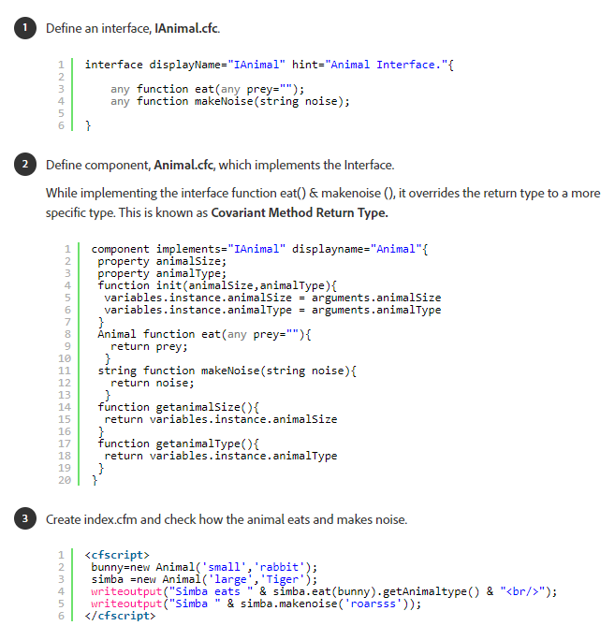

cid:image003.png@01D74030.CB5D0D80C# code (which is not as loose as the cold fusion code above but can be yet that defeats what C# is about.

Size would be an enumeration

public enum Size {

    Small,

    Medium,

    Large

}

Interface

interface IAnimal

{

    /// <summary>

    /// Animal name

    /// </summary>

    public string Name { get; set; }

    /// <summary>

    /// Size of animal

    /// </summary>

    public Size Size { get; set; }

    public string Eats { get; set; }

    /// <summary>

    /// Sound of animal

    /// </summary>

    /// <returns></returns>

    string MakeNoise();

}

Implement Interface for several animal types

public class Dog : IAnimal

{

    public string Name { get; set; }

    public Size Size { get; set; }

    public string Eats { get; set; }

    public string MakeNoise() => "Bark";

}

public class Cat : IAnimal

{

    public string Name { get; set; }

    public Size Size { get; set; }

    public string Eats { get; set; }

    public string MakeNoise() => "Meow";

}

public class Rabbit : IAnimal

{

    public string Name { get; set; }

    public Size Size { get; set; }

    public string Eats { get; set; }

    public string MakeNoise() => "growl";

}

public class Tiger : IAnimal

{

    public string Name { get; set; }

    public Size Size { get; set; }

    public string Eats { get; set; }

    public string MakeNoise() => "Roar";

}

Create a list of animals then iterate each one and show details

class Program

{

    static void Main(string[] args)

    {

        Console.WriteLine("Cold Fusion 2021 to C#: Interfaces");

        Console.WriteLine(new string('-',45));

        List<IAnimal> animals = new()

        {

            new Cat()

            {

                Name = "Fluffy",

                Size = Size.Small,

                Eats = "Mice"

            },

            new Dog()

            {

                Name = "Doggie",

                Size = Size.Medium,

                Eats = "Dinner scraps"

            },

            new Tiger()

            {

                Name = "Tigger",

                Size = Size.Large,

                Eats = "wild pigs"

            },

            new Rabbit()

            {

                Name = "Thumper.",

                Size = Size.Small,

                Eats = "grass"

            }

        };

        foreach (var animal in animals)

        {

            Console.WriteLine($"{animal.GetType().Clean(),8} says {MakeNoise(animal),6} and eats {animal.Eats,15} size: {animal.Size}");

        }

        Console.ReadLine();

    }

    static string MakeNoise(IAnimal animal) => animal switch

    {

        Cat => animal.MakeNoise(),

        Dog => animal.MakeNoise(),

        Tiger => animal.MakeNoise(),

        Rabbit => animal.MakeNoise(),

        _ => ""

    };

}

