Hi Josh,

In regards to registration, have those who want to attend send me an email. For software listed below I can pass their names to you. I will keep a record for those who will attend and send those who will attend an email for times and dates once they have been finalized.

The section below “Visual Studio Installation” is for whomever will perform Visual Studio install so you need not look at that section

# Data access requirements

* When needed, I will provide the attendees a script which will create needed databases and data on their laptops so no need for special permissions to our dev databases.

# Required software

* Three versions of the .NET Framework, .NET 5, .NET 3.1, .NET 4.8 from [this site](https://dotnet.microsoft.com/download).
* Create **C:\OED\Dotnetland\VS2019**
* GitHub Desktop <https://desktop.github.com/> - **added 4/10/2021**
* For each student, Microsoft Visual Studio (Community edition for those outside of the web teams). See “Visual Studio Installation” which list what components need to be installed by the service desk as the standard install is insufficient.
  + **Important**: The licence for Visual Studio 2019 can only be used for personal and training, not for creating applications so we are good.
* After VS2019 is install
  + Some may need this, service desk needs to see if it’s installed [GitHub Extension](https://marketplace.visualstudio.com/items?itemName=GitHub.GitHubExtensionforVisualStudio) for Visual Studio which installs inside of Visual Studio and is free. They can consult with me.
  + [Markdown editor](https://marketplace.visualstudio.com/items?itemName=MadsKristensen.MarkdownEditor) which installs inside of Visual Studio and is free.
  + [EF Core Power tools](https://marketplace.visualstudio.com/items?itemName=ErikEJ.EFCorePowerTools).
  + Project templates S:\APPLICATIONS\WebTeam\DotNetTraining\ProjectTemplates  
    C:\Users\**paynek**\Documents\Visual Studio 2019\Templates\ProjectTemplates
* Microsoft Visual Studio code [download](https://code.visualstudio.com/download).
  + [~~C# extension~~](https://marketplace.visualstudio.com/items?itemName=ms-dotnettools.csharp) ~~for Visual Studio code free by Microsoft~~.
* SSMS (SQL-Server Management Studio), version 18 (I believe the engineers have this on the network) and is free
* Each class particpent, needs to be able to uncompress .zip files. This can be done right from Windows. When the service desk performs software installs they need to verify that the user can uncompress .zip files **Added 4/13/2021**

# Visual Studio installation

The following was taken from Visual Studio 2017 installation so the screen may be slightly different in VS2019.

Both VS2017 and VS2019 use the same installer.

There should be a screen which has



Click on Individual components.

The following pages/screenshots (Visual Studio installer) show which components should be installed. If they are not found it’s most likely because they were taken from a higher edition.

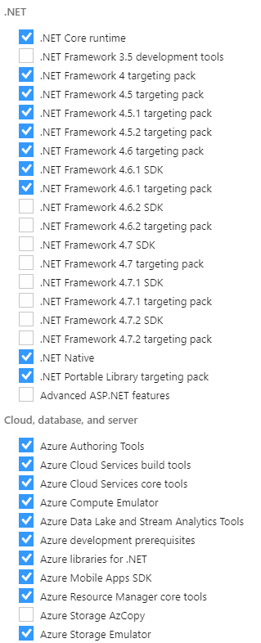

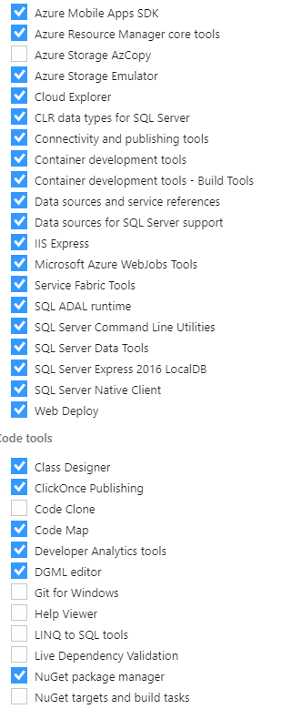

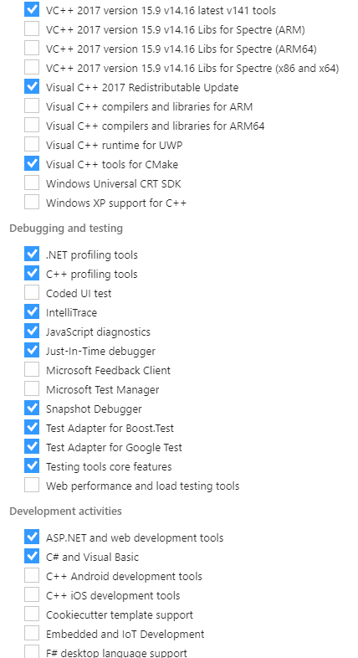

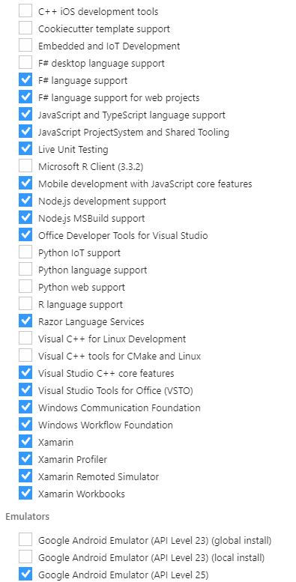

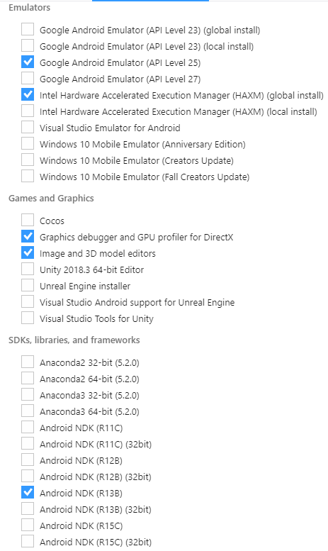

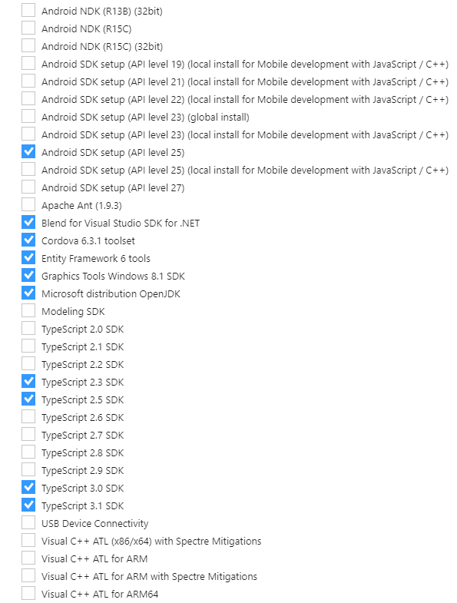

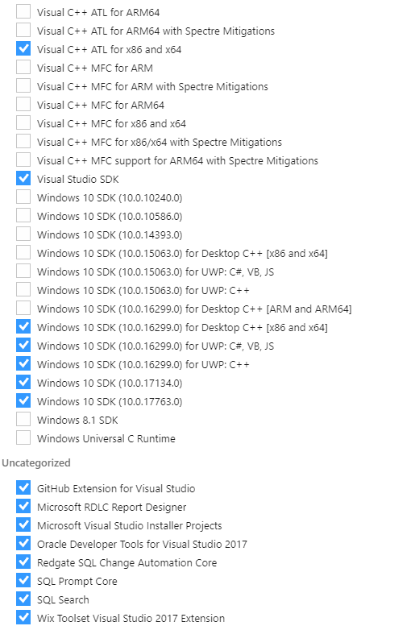

Issues

Over the past two weeks keep running into security issues. As of this morning the issues have gotten to the point that all installations must be cancelled.

* Failed to gaining access to a web site <https://karenpayneoregon.github.io/> which Jeff from security provided a fix which will not work from students
* Worked with Charlotte to gain access to our GitHub repositories yesterday, failed with what looks like permission issues. This is needed also for teaching.
* This morning while adjusting installation instructions for service desk to install various software hit yet another road block, using Git Desktop utility which is needed for teaching.

As known, I’ve been spend the better part of two months on preparing for Visual Studio training. As of this morning I’ve hit too many issues to continue.

What is needed to move forward?

Estimate 2 hours for first person

Select a developer to install all software along with

* Test in Visual Studio
  + Markdown editor
  + EF Power tools
  + Validate NuGet package install/uninstall
  + Creating a simple project
    - Validate build process
* Test GitHub
  + Login with a OED account with Visual Studio
  + Clone a repository using Git Desktop
* SSMS
  + Creating a database, tables and indexes
  + SELECT, DELETE, UPDATE, INSERT
  + Interacting with EF Core in Visual Studio
* ZIP files, ensure un-compressing is possible
* Ensure PowerShell works
* VS Code
  + Validate Git integration