Spent time today working with setting up IIS. The following are the steps taken but even though I can browse to the site there is some fine tuning needed which I will need assistance with when we get to configuring \\wtoedwebl17. So with that when there is time the information below should get us going.

* Had to install Current .NET Core Hosting Bundle installer (this [link](https://dotnet.microsoft.com/permalink/dotnetcore-current-windows-runtime-bundle-installer) will auto download the setup)
* Connect as (did this last week) specific user, this needs to be different of course for the server  
  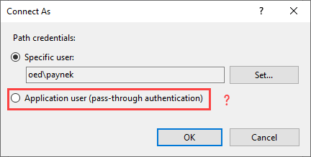
* Fire up SSMS as admin, traverse to Security, select NT AUTHORITY\SYSTEM, check sysadmin  
  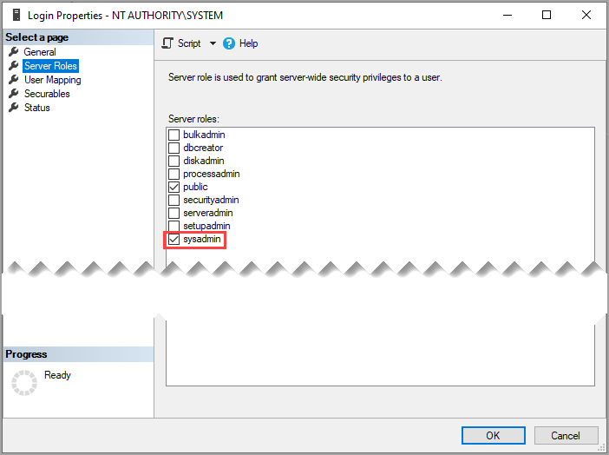
* Back in IIS browse and site comes up  
  cid:image004.png@01D8D40F.4D9E2F40