Visual Studio suggested settings

The following settings are suggestions only unless otherwise indicated that specific settings are mandatory.

To access setting from Visual Studio menu

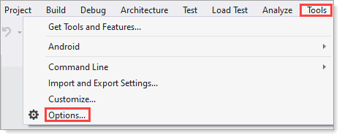

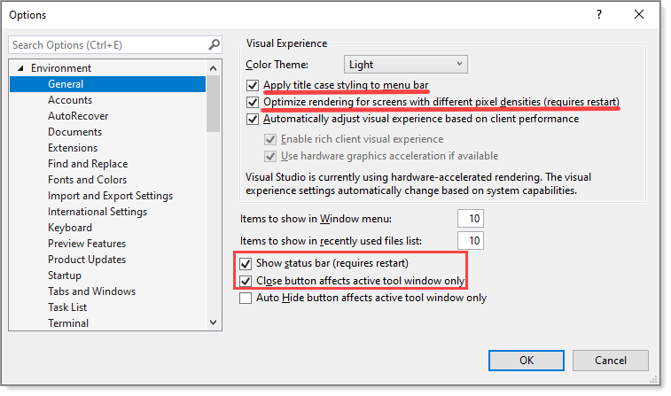

First two check boxes will recognize changes to files changed outside of Visual Studio, best to keep this checked as it’s the same behavior as VS-Code.

Last check box can be a life-safer when a global change can turn into intentional consequences which may go unnoticed and cause issues whiel coding and/or building a project.

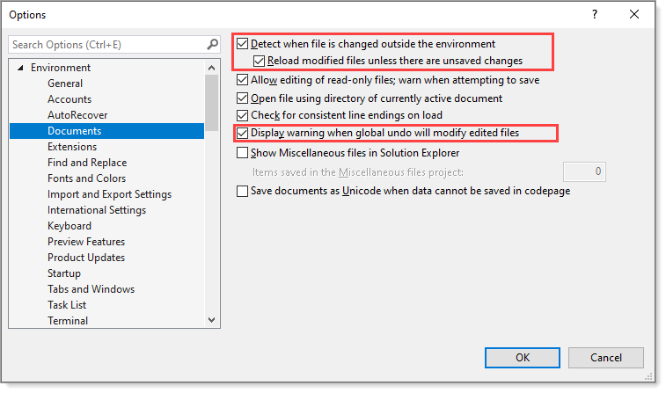

For keyboard mapping, start off with (Default) or Visual Studio code. Karen got use to Visual Basic 6, no need for anyone here to use Visual Basic 6.

Resharper (Visual Studio), this is either

* Their key mapping or a cross between a current mapping e.g. (Default) and Resharper
* Karen uses the cross between which means chaos at first as Resharper plays havoc several times before settling down

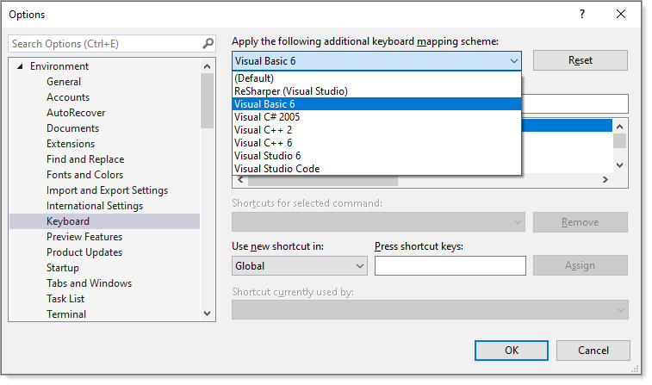

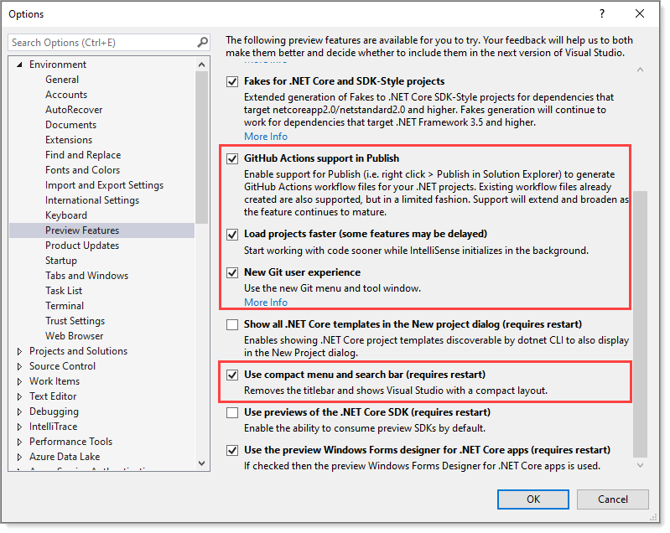

For startup, suggest starting with an empty environment unless working on the same project day after day.

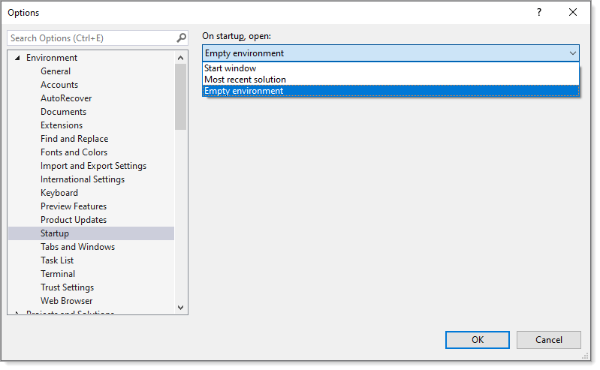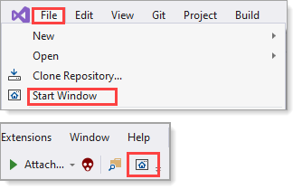

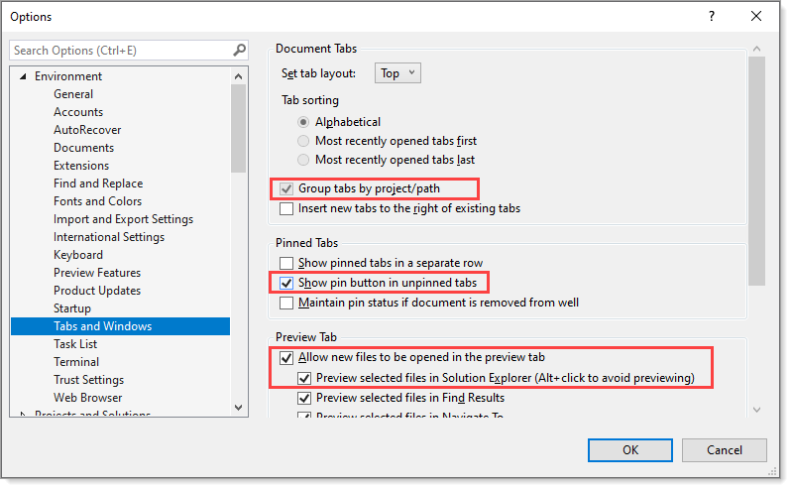

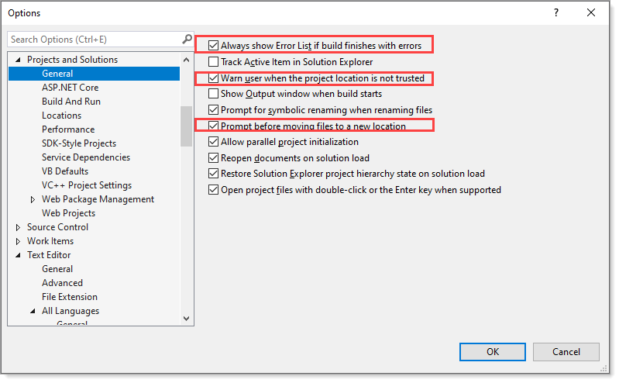

This is not cut and dry

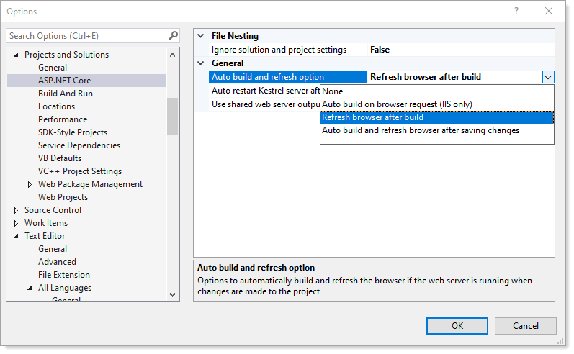

Mandatory settings

Each developer will store their projects under C:\OED\Dotnetload\2019 for constancy along with ensuring local NuGet package paths are the same. VB.NET setting are mandatory (ask Karen for clarification).

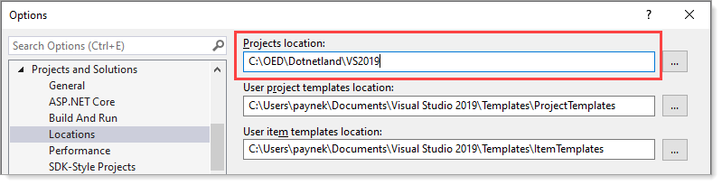

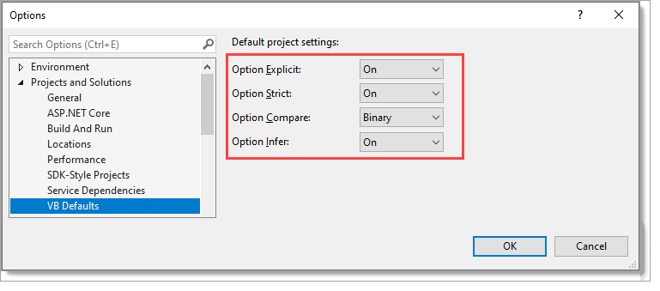

All languages

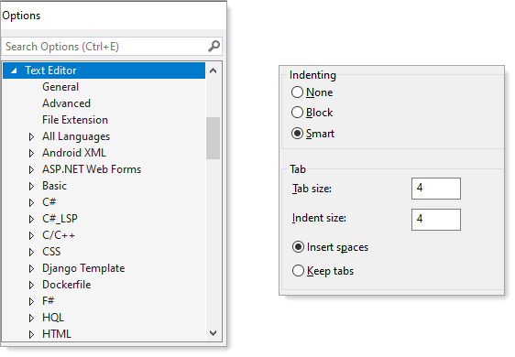

|  |
| --- |
| **End mandatory** |

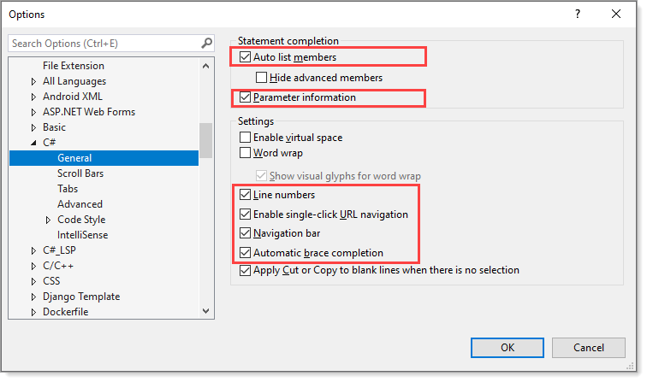

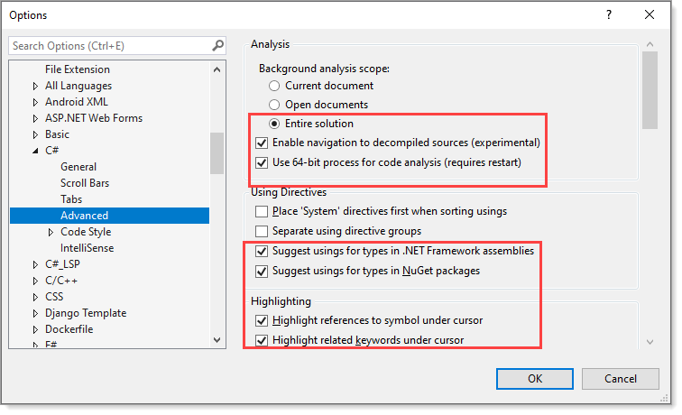

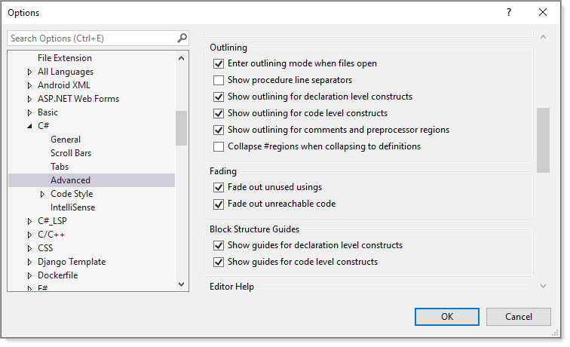

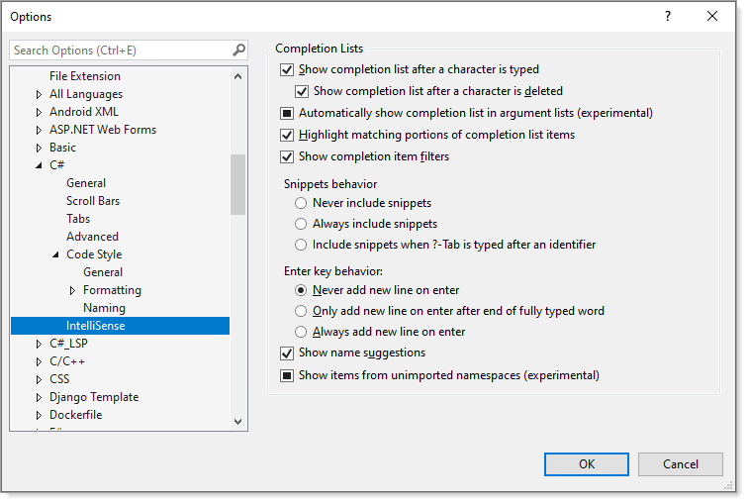

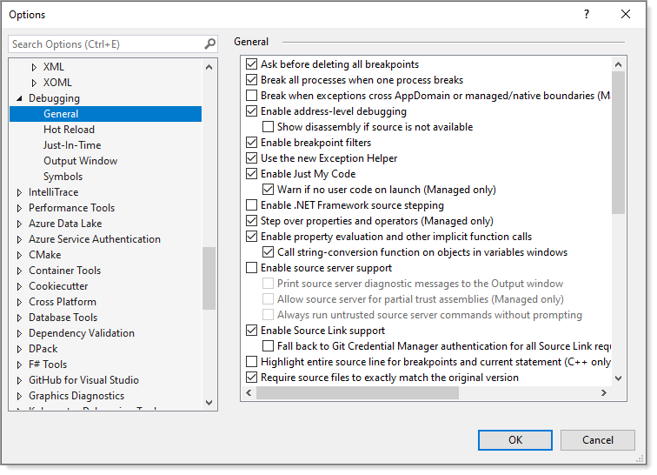

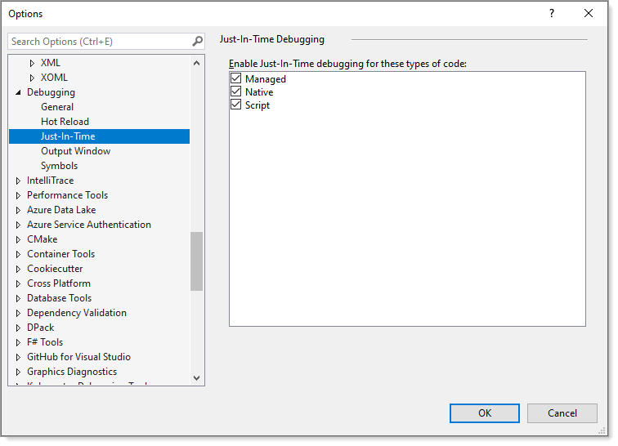

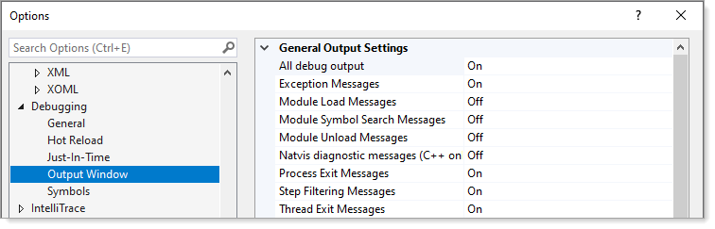

# Requires

A discussion but for now do not enable.

And note this is an invaluable way to diagnose runtime issues and determine issues at development time.

