**Internet and Web Programming(DA-2)**

**Name: Karen Pinto Slot: B2**

**Reg No: 18BCE0596 Faculty: Lydia Jane**

**GitHub Link:** <https://github.com/karenpinto1602/Online-Auction-System>

Docs includes only the output:

**Tables of the Database:**

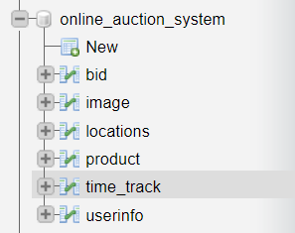

**Sign Up: Every User is given an ID that is automatically generated**

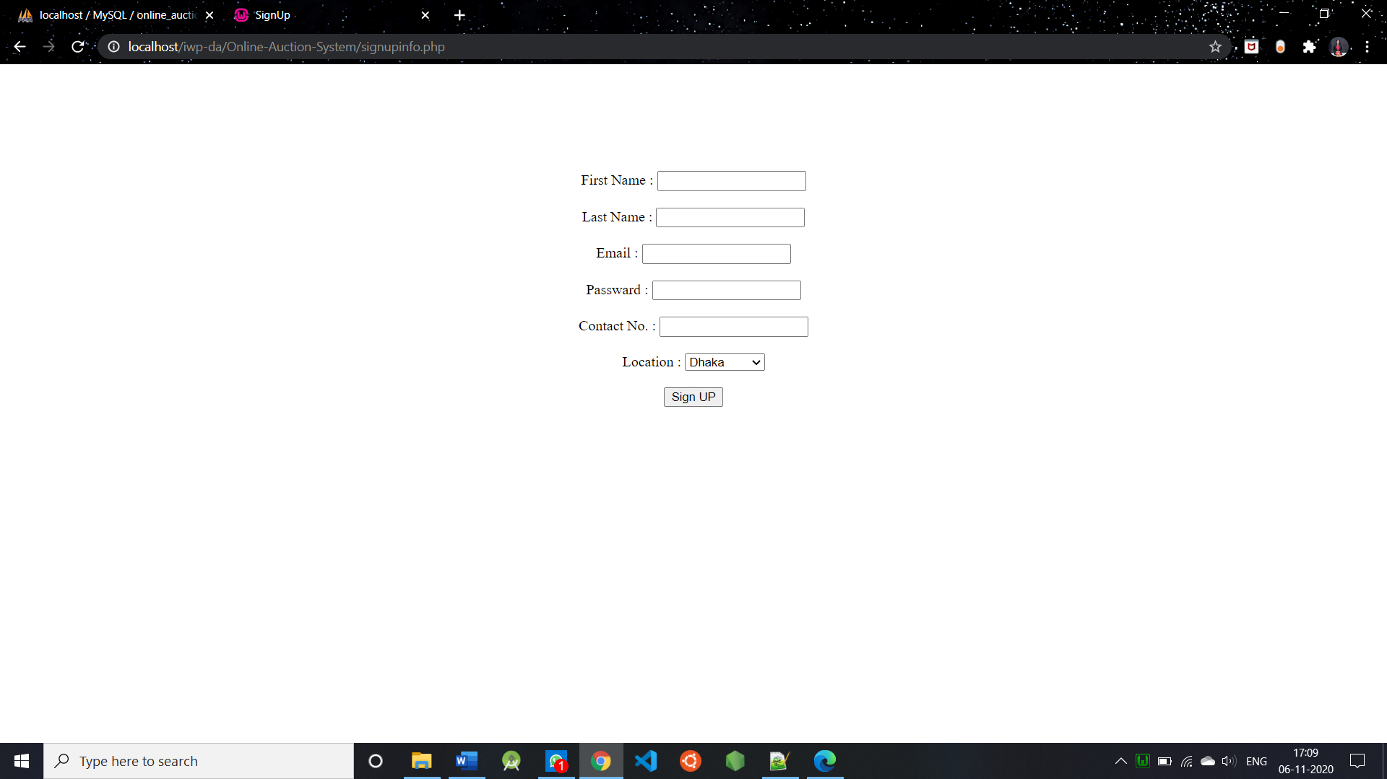

**Login: Password Authentication Done**

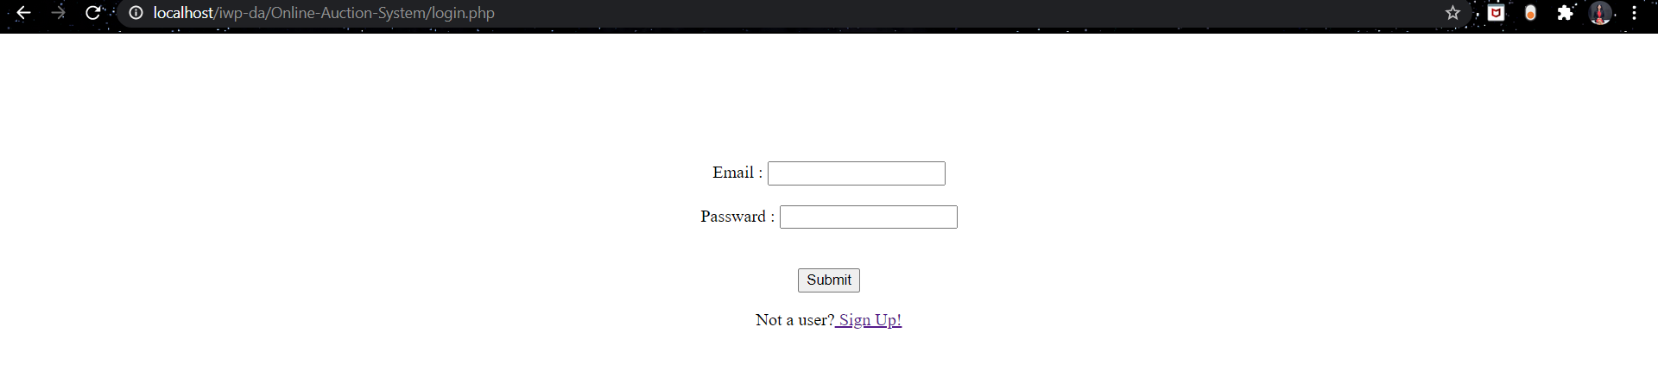

**Dashboard:**

* Includes Ongoing and Yet to be bided items
* On the right, there is an Add to Item Button To add any item that is within the item category (Electronics, Vehicle, Property and Garments)
* On Clicking on Details Button, we will be able to bid and see the item description in detail.
* We can also type/search for a particular item.
* We can also Checkout the items from only “Ongoing/Finished/Yet to Bid” items

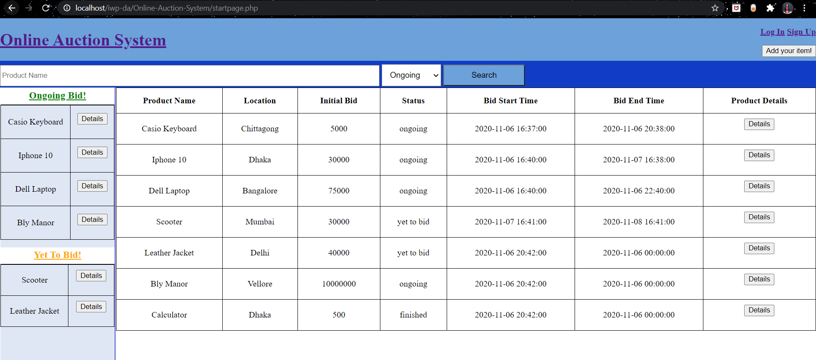

**To checkout Ongoing or Finished or Yet to Bid Items Separately.**

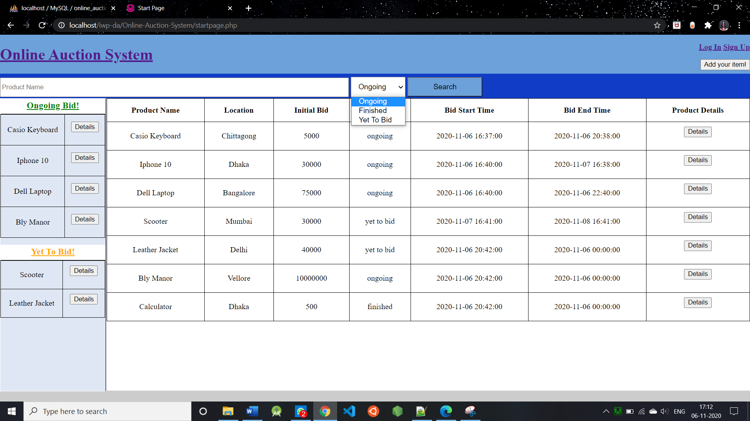

**Add Items to be bided**

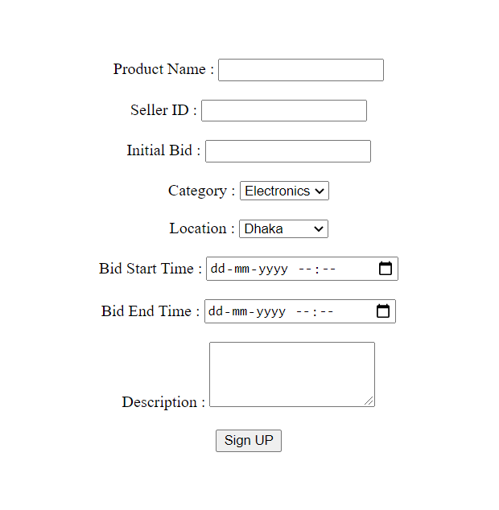

**An Ongoing *Item: Casio Keyboard* that is undergoing bidding.**

**User has not yet bided – You can see the status on the Right**

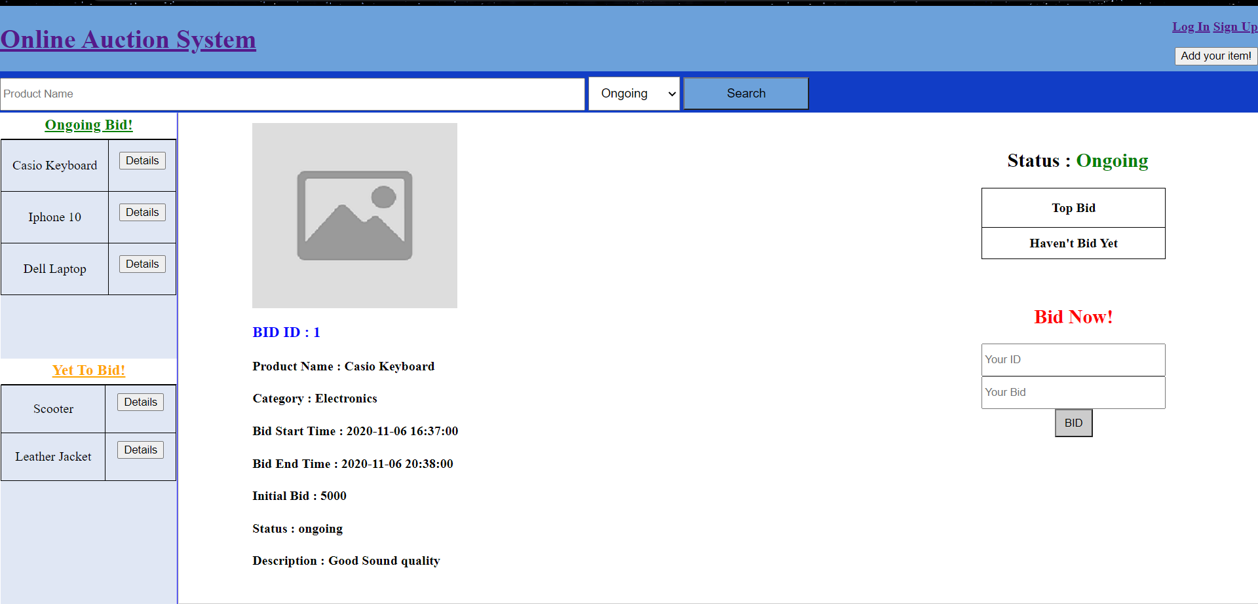

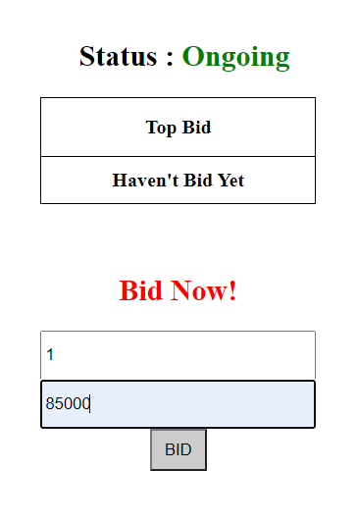

**Bidding Value Updated to a higher value**

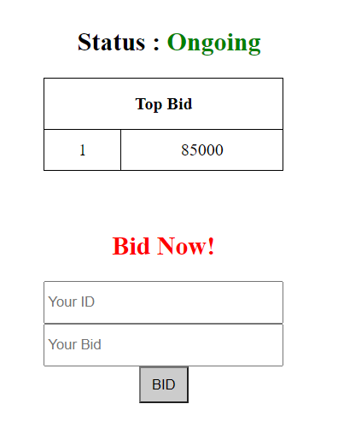

**If a value lower than the previous bidding is entered – it displays the following message**

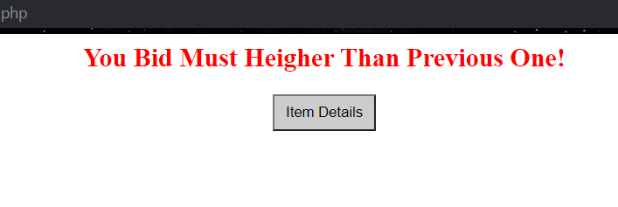

**Items that have completed bidding**

1. **Here, no bidding took place**

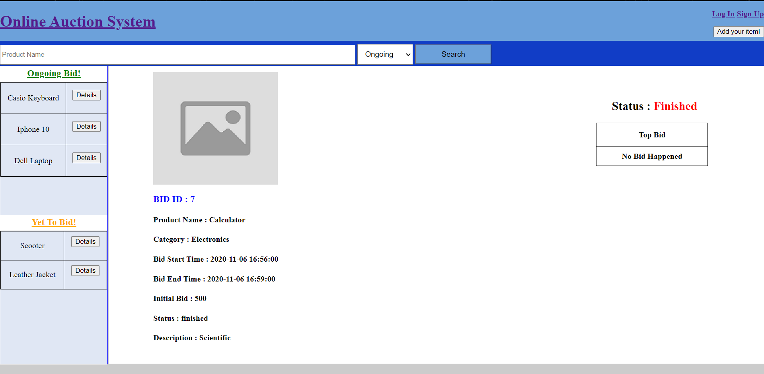

1. **Here, the highest bidder with Sell_ID 2 won**

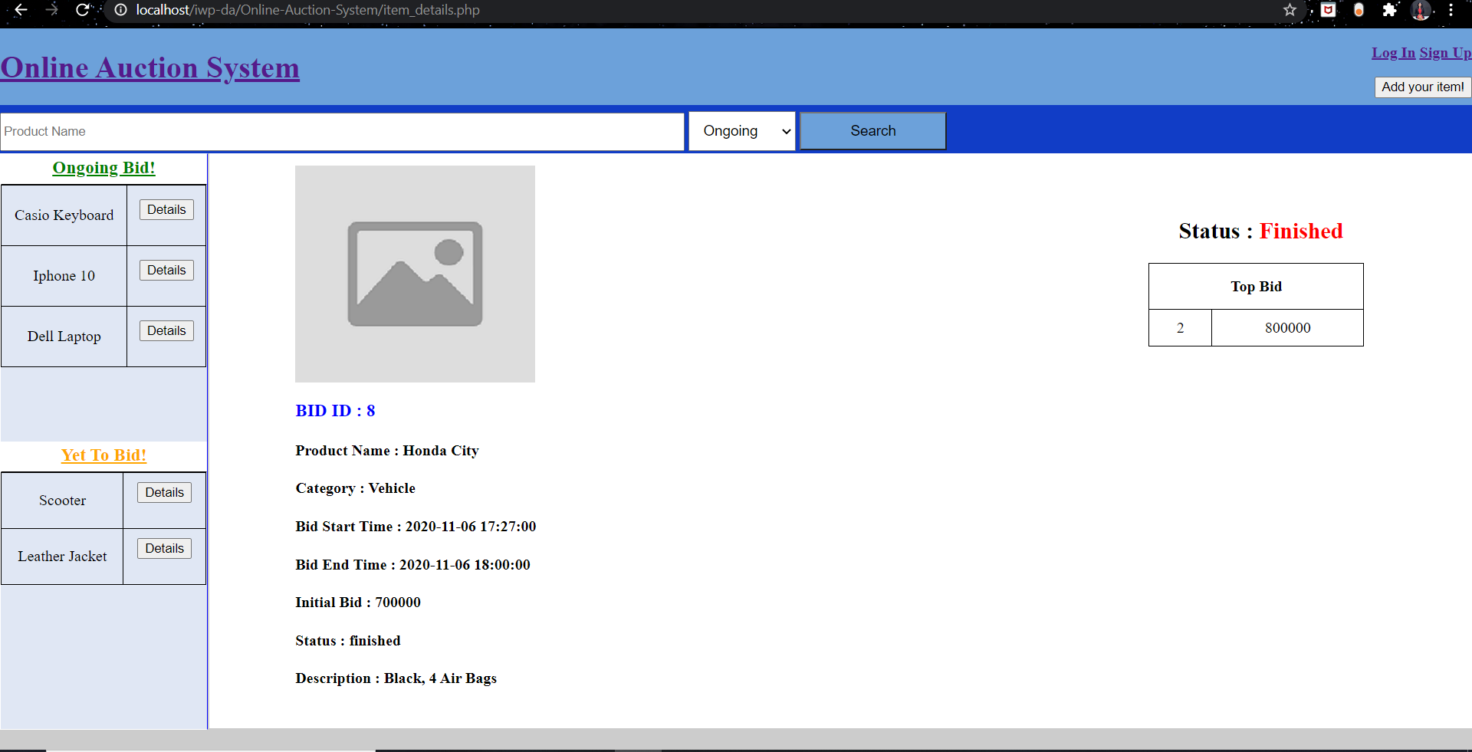

**Items that yet to bid: (This is based on the time entered during the Add to Products Sign Up)**

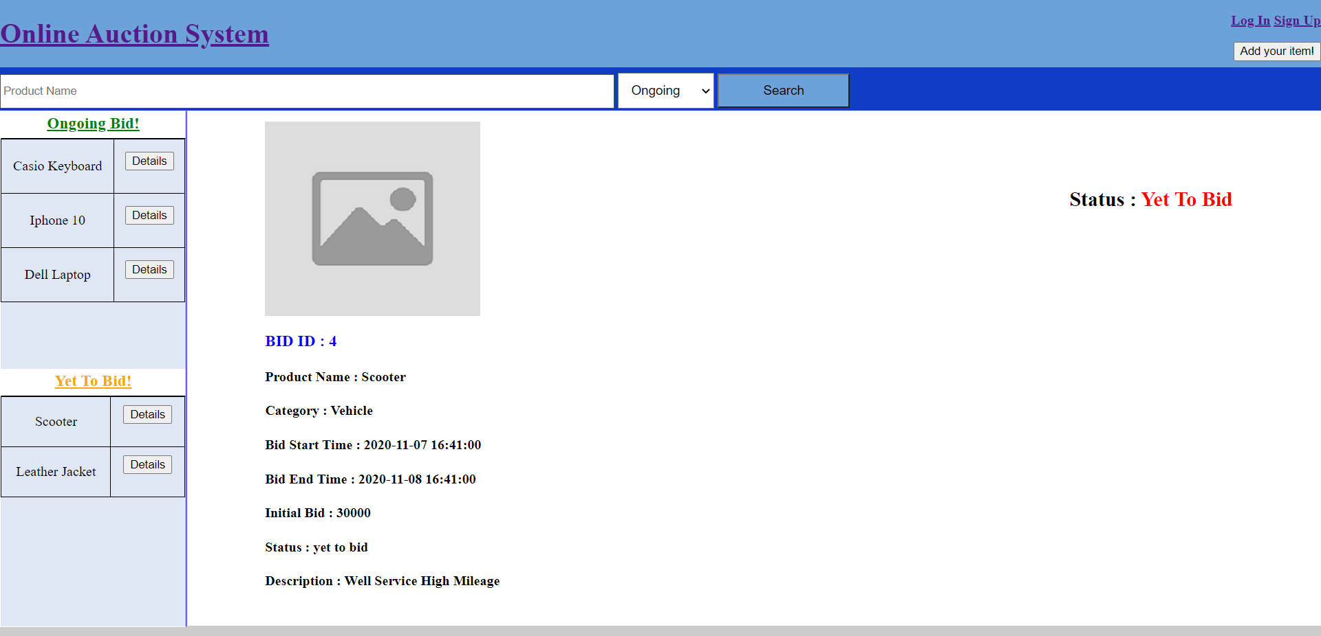

**I have given a standard image to all the items.**

**Tables:**

**Userinfo:**

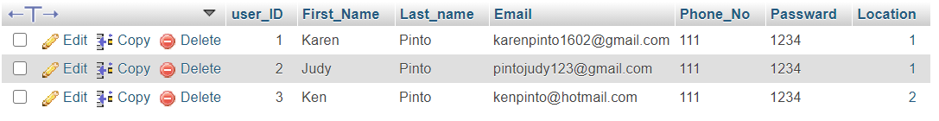

**Locations:**

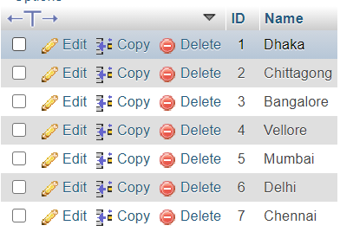

**Product:**

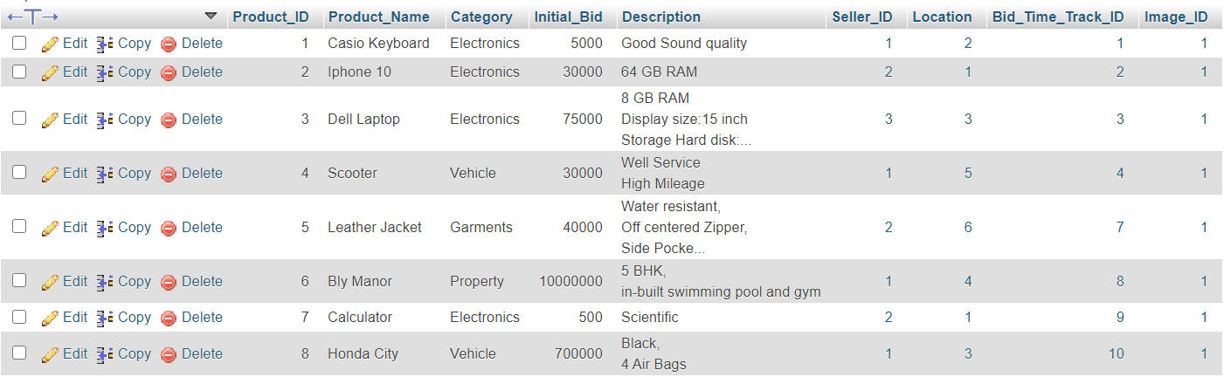

**Bid:**

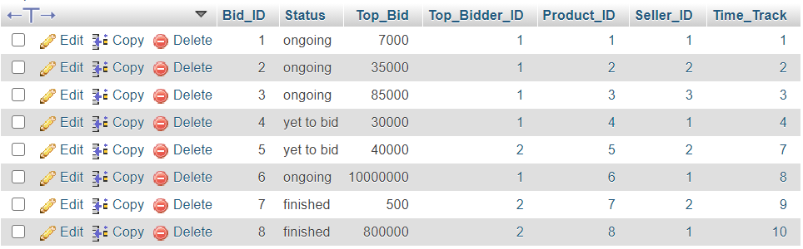

**Time_track**

