HRS Data Summary for Cognitive Prediction Project
Survey years 2016 to 2022 | Preliminary dataset output
This summary describes the sample prepared for our project on whether chronic disease burden improves prediction of cognitive performance in older adults. The current analysis dataset contains 13,053 adults aged 65 or older, with one eligible observation per participant. It also reports the main missing-data patterns and the sample's distribution across selected survey years. These are data preparation results; model performance has not yet been estimated.

Data sources and measures
We combined the RAND HRS Longitudinal File 2022 with the HRS CogImp 2022 cognition data for survey years 2016, 2018, 2020, and 2022. The outcome is the derived 0 to 27 cognition score. The four cognition components were also extracted to inspect the availability of the score.
The main predictor, Chronic Disease Burden, is the sum of seven conditions coded 0 for absent and 1 for present: hypertension, diabetes, cancer, chronic lung disease, heart disease, stroke, and arthritis. Its possible range is 0 to 7. Other variables selected for modeling are age, sex, race or ethnicity, education, marital status, smoking, and BMI. Proxy respondent and interview mode were collected for data-quality review; they are not planned model predictors.

How the analysis sample was formed
The initial extraction produced a four-year scaffold: each of 45,234 RAND participants had a row for every survey year. A scaffold row does not necessarily mean that an interview was completed in that year. The table follows the saved notebook outputs through age selection, quality checks, BMI review, and the choice of one year per person.
Selection stage | Records | Decision
Four-year extraction scaffold | 180,936 | 45,234 participants represented in each of four years
Age 65 or older | 36,991 | 32,646 rows below age 65 and 111,299 with missing age removed
Required features and self-response | 32,349 | 4,642 unique rows with a missing or invalid required value, or proxy response, removed
BMI and height or weight review | 32,329 | 20 additional records excluded under the project review rules
Latest eligible year per participant | 13,053 | 19,276 earlier-year records removed; one row per person
After the age filter, the data represented 14,380 distinct participants. After required-feature and proxy screening, 13,061 distinct participants remained. The final 13,053 records represent 13,053 distinct people. When a person had more than one eligible year, the latest year was kept.

Missing data and quality checks
The missing-data counts below use the 36,991 age-eligible participant-year records as their denominator. They describe the data before the complete-case screen. A person can have more than one missing feature, so the rows in this table cannot be added to obtain the number excluded.
Feature | Missing | Share of age-eligible rows
Cognition score and each of four components | 2,320 | 6.3%
Smoking | 1,746 | 4.7%
BMI | 484 | 1.3%
Education | 133 | 0.4%
Marital status | 65 | 0.2%
Race or ethnicity | 44 | 0.1%
Age, sex, seven disease indicators, disease count, and proxy status | 0 | 0.0%
The quality screen also flagged 2,300 proxy-response records. We retained self-respondents and removed proxy responses because the cognitive outcome is intended to reflect the participant's own test performance. Proxy flags overlapped with missing-feature flags; the total number removed at this stage was 4,642 unique records. Interview mode was kept for review rather than used to exclude participants or predict cognition. Its missing values in 2016 were expected in this extraction.
BMI was checked against height and weight for records with unusually low or high values. The project review rules treated heights outside 1.00 to 2.70 m, weights outside 20 to 350 kg, BMI outside 11 to 75, nonpositive source measurements, or a recalculation difference above 10% as reasons for exclusion. These are project plausibility thresholds, not official HRS validity codes. The saved output reports 20 exclusions at this step.

Final sample distribution
The selected survey year is the latest year in which each participant passed the eligibility and quality checks.
Selected year | Participants | Share of final sample
2016 | 1,578 | 12.1%
2018 | 1,486 | 11.4%
2020 | 3,218 | 24.7%
2022 | 6,771 | 51.9%
Total | 13,053 | 100.0%
The 2022 group is the largest because the selection rule favors later eligible observations. This distribution should not be read as a change in the HRS population over time. The displayed percentages are rounded and may sum to 100.1%.

Exploratory analysis of demographic composition
We examined the age, sex, race or ethnicity, and education distributions after cleaning and selecting one observation per participant. The denominator for each percentage is the final sample of 13,053 people.
Age averaged 76.31 years (SD 8.07); the median was 75 years and the interquartile range was 69 to 82. Education averaged 12.79 years (SD 3.26); the median was 12 years and the interquartile range was 12 to 16.
Characteristic | Distribution in the final sample
Age groups | 65–74: 6,135 (47.0%); 75–84: 4,582 (35.1%); 85+: 2,336 (17.9%)
Sex | Male: 5,387 (41.3%); Female: 7,666 (58.7%)
Race or ethnicity | Hispanic: 1,876 (14.4%); Non-Hispanic White: 8,186 (62.7%); Non-Hispanic Black: 2,616 (20.0%); Non-Hispanic Other: 375 (2.9%)
Education groups | 0–11 years: 2,612 (20.0%); 12 years: 3,966 (30.4%); 13–15 years: 3,154 (24.2%); 16–17 years: 3,321 (25.4%)
Figure 1. Distributions of age, sex, race or ethnicity, and years of education.
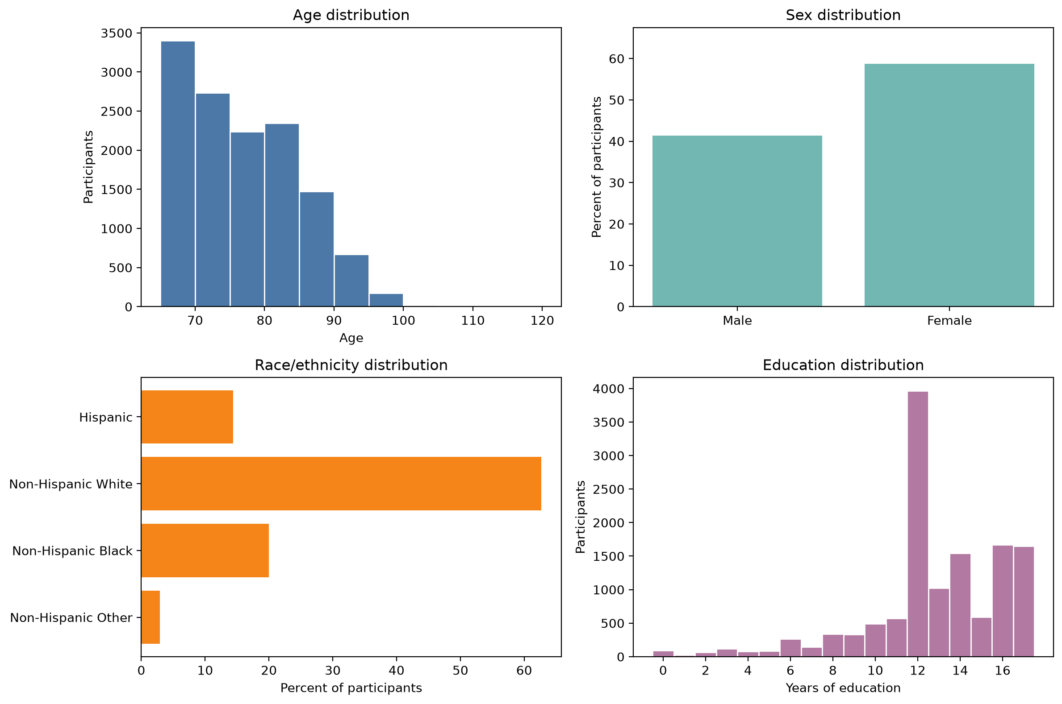
The sex split is moderately uneven (41.3% male and 58.7% female), but both groups are well represented. Participants aged 85 or older account for 17.9% of the sample. Non-Hispanic White participants form the largest race or ethnicity group (62.7%); Non-Hispanic Other is the smallest (375 participants, 2.9%). The latter group's separate test results, if reported, may be less stable. Education is spread across the four descriptive groups, with 12 years the largest category (30.4%).
These distributions do not require automatic resampling. The project predicts a continuous cognition score, so there are no outcome classes that must have equal counts. Overall predictive performance may reflect the larger demographic groups more strongly. We should report the sample composition and later check whether the training and test sets have similar distributions.

Planned predictive analysis
Model 1 will use age, sex, race or ethnicity, education, marital status, smoking, and BMI. Model 2 will use the same variables plus Chronic Disease Burden. Both models will predict the 0 to 27 cognition score. Comparing their performance on held-out data will show whether the disease count adds useful predictive information beyond the other selected features.
The saved split notebook reports 9,137 training participants and 3,916 test participants, corresponding to a 70/30 split. Because the final dataset has one row per participant, a person cannot appear in both sets. No accuracy, error, or other model-performance result is available yet.
Source of counts: saved aggregate outputs from Extract data.ipynb, data cleaning.ipynb, and data split.ipynb, plus the demographic EDA summary files and figure.

