Orbis Platform Monthly Business Review February 2026

Platform & Delivery metrics
Metric | Dec'25 | Jan ‘26 | Feb ‘26 | Target for H1 2026
Tooling for Map Editing & Feedback at scale
Platform contribution to manual operator Efficiency per task type (top 5) | N/A | 0% | 0% | 10%
Operator readiness on day 1⁽¹⁾ | 25% | N/A | 16% | 90%
Traceability of Map feedback to product version ⁽³⁾ | 65% | - | - | >75%
Orbis ACI Yield for RM | 85%  (79/93) | 91%  (413/454) | 93.6%  (779/832) | 90%
Orbis ACI Yield for LM⁽²⁾ | TBD | TBD | TBD | 80%
Map Releases*
% On-time delivery of Orbis Sectioned (OS) | 100% | 100% | 100% | 95%
% On-time delivery of LM map | N/A | 100% | 100% | 95%
E2E lead time of LM map | 15,57 | 12,9 | 13,68 | 7 days
Avg. production issues per Lane Model release | N/A | 0 | 0,66 | <1/release
New cost metric to be defined via “Cost per Unit“ | -- | -- | -- | ETA:April 2026
Average platform cost per hosted layer  - VS only | $564 | $551 | $510 | $345
Lead time of Platform for RM (incremental) ** |  |  |  | Target?
Lead time of Platform for LM (batch) |  |  |  | Target?
Vandalism Prevention
Prevented bad edit metric | 64.7% | 60.3% | 62,6% | > =60%
Quarantine Average Lead Time | 28.3h | 30.1h | 26.2h | < 24h

* see definitions: metrics
** we have to redefine those metrics and targets. Update will come with the next MBR
(1) Reference RMLANES_Quality conducted on WK06, quality threshold assumed at 90%.
(2) Orbis ACI Yield for LM, we are yet to configure the metric to begin tracking, will be working on it to be able to populate the data in next review
(3) We have found issues in the data (view that we are using) that will cause incorrect stats on a changelet being in product. Also there does appear to be a very large number of Changelets that are VS approved but are queuing up for product in ToDo Status which needs looking into. As of now the data is not reliable for “Traceability of map feedback in product”

Executive Summary
Orbis Platform has transitioned to a weekly delivery cadence for the Lane Model map, which comes with additional KTLO on the Platform side (2x–4.5x increase), as well as increased cloud costs. To improve this and the map lead time, a dedicated workstream is focused on establishing a stable, repeatable, and scalable weekly NDS release flow. In parallel, we have continued strengthening Lane Model scalability across platform components like DiSCOS and Binding to ensure we can absorb future growth in data volume without becoming a bottleneck. A recent example is the increase in CoW processing capacity for ADAS HD Basemap, where we expanded throughput from 30,000 to 100,000 daily H3 tiles, which makes the writing-to-DiSCOS step roughly 3x faster.
In the OSM vandalism protection field, we made operational progress: analytics dashboards covering predicate distribution, release patterns, system freshness, and premature-release tracking are now live. Current ML precision remains at approximately 35%, with 33% of ML leads already resolved by the OSM community and editors reviewing approximately 55% of leads on average; MLP 2.0 investments in model versioning, retraining, and drift detection, combined with labeling-quality work alongside editors, target measurable precision gains in Q2.
In Feedback and Resolution, we are addressing a risk from Operations seeking a structural solution that enables them to manage violations at scale to boost quality for Toyota and JLR. This includes exposing an effective categorization system for violations and false positives to support efficient triage and customer reporting. Additionally, we have initiated work on a proposal to unify both internal and external feedback intake and handling processes for Lane Model. The first step involves integrating internal feedback from Cancun into OrbIT, which is in progress, facilitating efficient storage and aggregation so the ADAS and Guidance engineering teams can prioritize resolution accordingly.
Customer demand focuses on freshness and transparency. Toyota is pushing toward daily updates; Tesla targets a 15-minute update cycle; Hyundai needs stable IDs to evaluate an Orbis migration; and BYOD/GEM onboarding for Stellantis, Ford, and Unipol is in planning. The highway-only product decision window remains open through end of April - Volvo does not require a dedicated product today and CARIAD's quality and safety requirements are still being assessed - allowing the Fermi team to complete the batch component before an informed go/no-go.
Over the next 30 days, the primary focus is concluding the P0 discoveries on self-contained incremental conflation and ingress validation for snapshots and changelets. By end of Q1 we will have a validated architectural path to continuous, reset-free production and a 7-day LM map lead time. In addition, we will launch our first version of the Operations Training Environment to support the scale of Operations in 2026.

Discovery Initiatives
In H1 2026, our discovery work focuses on understanding what must change in the production platform to make it stable, scalable, and ready for incremental operation. Much of the effort targets core systems - LM map, LR, RM map, and CoW - where architectural and operational limits still slow production or force resets. The goal is to understand these bottlenecks well enough to define a path toward continuous, lower latency map updates.
The work on validation, data structures, and internal interfaces shows where today’s design creates friction and what boundaries and abstractions a modernized platform will need.
We are also analyzing how customer feedback moves through the system. By reviewing TTApp, Orbit, CSAT, and analysis tooling together, we aim to see where feedback gets lost or delayed and what would make the loop more reliable and responsive.
Cost and operational effort remain important. Findings around validation, modularity, and storage efficiency help reveal where simplification could reduce reprocessing and run cost without affecting quality.
And, we are assessing what it takes to support a broader ecosystem, including BYOD and GEM in self-hosted setups, to understand how far our tools and data models can extend beyond the current platform.
Overall, these discoveries provide the technical foundation needed to justify investments and decide how the platform should evolve — and what must be fixed first.
Here is a selection of initiatives that we see as P0 and P1, and where we expect learnings in Q1.

1. Self‑contained Incremental Conflation
Priority: P0 | Quarter: Q1
This initiative explores how conflation — combining multiple inputs into a unified map representation — can be executed incrementally, without requiring full resets. It seeks to identify blockers, define minimal architectural adaptations, and enable a continuous, reset‑free production cycle.
2. Validation for Snapshots & Changelets Entering Orbis Platform
Priority: P0 | Quarter: Q1
This discovery investigates how Orbis should validate snapshots and changelets before ingestion. It aims to define validation rules and pipelines that ensure correctness, reduce reprocessing, and provide the reliability foundation needed for incrementality and Platform 2.0.
3. Truly Incremental Production — Continuously Running Product Line
Priority: P1 | Quarter: Q1
This initiative explores what is required to operate the entire production chain (LM → RM → Binding → Orbis) continuously, without resets. The goal is to identify systemic blockers and define the architectural direction for continuous production in Platform 2.0.
4. 3S: Optimizing LR Processing (incl. incremental LR formatter)
Priority: P1 | Quarter: Q1/Q2
This discovery focuses on understanding bottlenecks in Linear Referencing (LR) and determining how to transform LR into an incremental, scalable component. At the end of February we started an investigation into how we to do incremental context fetching to drive. There are multiple angles we want to build small POCs of to 1. Pick the right technical solution 2. Identify the amount of work needed to use it for LR Formatting.

Hotly Debated Topic(s)
No HDTs this month.

Risks
Risk1: Violation Store readiness and CC downstream integration
OPS CC Downstream Violation resolution (aka Quality boosting) is at increasing risk as the scope of violations expands beyond lanes to additional routing features (speeds, one-ways, control access, lanes, etc.) that come with Toyota & JLR commitments. In the current operating model, OPS can start resolving violations only after the product is complete, which leaves very limited time to resolve issues before customer delivery, and this is not feasible at the current and expected volumes. While upstream detection of violations would materially reduce this risk, upstream adoption of CC rules across value streams is currently weak and has known feature gaps (for example, teams needing a “bound state of multiple layers” to perform CC rules upstream). As a result, downstream OPS continues to absorb violations across value streams exceeding available resources.
In parallel, the downstream execution model is becoming less controllable because clustering improves throughput by bundling multiple violations into a single task, but clusters mix severities (critical, warnings, false positives) and the system effectively treats all tasks as equal. Severity information exists in RMS (Rules Management System), but it is not available in the CC run outputs used operationally, and outside of Toyota there is no consistent, maintained “master rule list” with severity tagging. This creates a prioritization risk (OPS cannot reliably focus capacity on the highest customer impact items) and a reporting/traceability risk, especially for Toyota where detailed quality reporting requires breakdowns such as warning vs critical and fixed vs remaining. Violation Store is expected to mitigate a significant part of this by preserving violation history and enabling stamping false positives.
Risk Recommendation: Treat this as a delivery and customer-commitment risk (Toyota in particular) and prioritize (1) CC downstream → Violation Store ingestion /w ability to stamp false-positives (CM-14514 Owner: Platform FnR), (2) utilize Severity list maintained by CC team and use that as an input for severity-based prioritization and clustering (3) find an owner for exposure of severity metadata (via RMS or CC Rules) to enable severity-based prioritization and clustering, and (4) a structured plan to increase upstream CC adoption where feasible to reduce downstream load and reduce late-stage firefighting.
Risk 2. Unifying Customer Feedback for LM Product
Lane Model feedback Reporting is fragmented across multiple channels for internal and external reporting. They are making use of IM JIRA for issue tracking and resolution management. However, the current Incident Management (IM) framework is not fully aligned with the maturity level of LM Map. LM Map is still at a very early stage of maturity. As a result, most identified issues are structural and foundational in nature, requiring significant time and cross-functional collaboration to resolve. Unlike mature processes where IM is primarily used to validate detection controls and strengthen preventive measures LM Map often requires prevention mechanisms to be designed and built from scratch. In several cases, even detection mechanisms are not yet fully established (e.g., Control Checks are largely available only for the Basemap today). ADAS team is seeking one unified way of receiving all possible feedback so that Lane Model issues can trigger the right actions and guide downstream processes effectively.
F&R has created a proposal to extend the unified E2E feedback workflow created for road model feedback to lane model feedback with customized flow that is suitable for handling the volume, processes for triage, resolution and reporting for ADAS team.
The solution design proposal is to extend the OrbIT echo system (Map Feedback API, Issue Store, Task Manager, Map Feedback Hub) and also introduce new components like Violation Store and Triage to handle the structured intake, classification, prioritization and routing of Lane Model feedback in a scalable and transparent manner.

We are integrating Cancun Lane Model feedback into Issue Store to position OrbIT as the first-class ecosystem enabling Lane Model feedback within a unified flow. This integration defines how Lane Model feedback is ingested, stored, queried, and routed end to end, establishing a standardized and scalable framework.

Deep Dives

Voice of the customer: feedback from customers, what customers are asking for
Toyota: Strong focus on map freshness, looking even at daily updates; starting with monthly updates but limited by AISIN’s quarterly cycles. Next major metrics meeting in May.
Omron & Aisin: Embedded devices: update size/frequency impacts cost. Need transparency to balance cost vs freshness.
Volkswagen: Porsche has no strict limits on data consumption for freshness. Internally they just state data needs. While Audi and CARIAD value detailed freshness discussions and data consumption optimization.
CARIAD (Release notes & Quality insights): Cariad requests more developer‑focused S‑map release notes that clearly outline the delivered map content (feature and country scope) and provide deeper insights into the compiled map—such as specification alignment, compilation report details, and their impact on delivered quality. They also expect quality metrics and measurements to cover not only the source data (uncompiled map) but the compiled map itself. They are also evaluating three BYOD layers. Aligning feasibility.
Tesla: Wants a 15-minute update cycle via fleet/social-media detection. Needs Orbis OGP docs and CA sample map.
Hyundai Motor Group: Evaluating move to Orbis, needs stable IDs for that. Priorities: Lane Guidance, Routing, Traffic, 3D visuals. HAE: Wants daily changelets; system supports weekly.
Volvo: Highways-only map delayed to Nov 2026. Evaluating AllRoads vs highways-only.
Mercedes: Interested in highways-only; still evaluating.
Honda / NAV RFQ: Workshop done; uses quarterly NDS.Live. Needs quality assurance before streaming.
Tesla & Stellantis: BYOD + GEM onboarding plan coming.
Ford: Struggles merging HERE with others. Exploring BYOD or GERS + GEM.
Unipol: Interested in self-hosted GEM. Provided H2 availability and early access.
MS2: Reviewing GEM; working on AADT integration. New Mexico dataset ready.
LTA Singapore: Defining next GEM steps. We will provide evaluation plan.
Arity: Extending PBF with LR offsets. Helps connect NextBillion to OGP.
Microsoft: Low feedback; moving reporting to NAM. Working on data-retention policy.
Streetnames Team: Wants auto-resolution of violations. Feasibility being assessed.
OPS: ~1,000 hours/month lost due to delays. Investigating OrbIT involvement.
Incidental Feedback: Right problems identified. Need stronger Value Stream collaboration

Value Stream perspective
The Geopol and Area team are noticing a considerable delay with read operations on large data amounts. This doesn’t seem to be caused by the State Reader itself, but an unidentified element around the State Reader. It slows their requests between 2x and 7x. On another topic, they really believe that multi-tenancy would considerably lower their discos bill, due to the fact that their Geopol layer costs mainly come from the infrastructure.
Geopol, APT (Geocoding), and POIs teams are facing issues with the discos auto scaling states. The main complaint is about the inability of the state to automatically scale back from an increased or decreased scale. To fix this issue, they have to manually monitor and run queries to scale back to normal state.
POIs and APT (Geocoding) teams regret to not be (properly/enough?) informed about credential rotations. It happens too many times that the credentials are refreshed, but not communication is done to the VS, leading to failing requests and downtime.
We recently disabled consistency check in CoW for HD Basemap due to the throughput limitation they were facing: they need to be able to write 100.000 fresh H3 tiles per day, but CoW only allows 30.000. They also mentioned that onboarding with Orbis is complex. 120 new people joined the ADAS effort, and the poor onboarding guide/documentation results in more hand-handling from senior engineers than actual effective work.
Orbis Overture GeoParquet Format: Total coverage of Orbis OGP Linear Reference (LR) handling increased to 93% with more coverage for relation handling scenarios. The Sectioning Service for Orbis OGP was also extended to keep ID stability on sectioned elements for consecutive runs and offers ID traceability. Furthermore, we introduced feedback for invalid LRs encountered during runs.
Sectioning Service: Internal launch target to decrease feedback loop when onboarding VS layers with LR and enable building custom sectioned maps in both Orbis and Overture ecosystems (go/nogo). During February we onboarded 2 more VS teams for data validation for a total of 23 validation runs spanning across Directions, Routing, Visualization and Addressing. We have collected feedback and it aligns with 2 action points with regards to smoother configuration which we will tackle in March (jira). Furthermore, we have built an extension to allow Orbis PBF to be produced from an Orbis OSNAP input which helps Directions to start building custom sectioned maps as input to produce RATS/online routing tiles (info).
Deliver Lane Model (LM) products with BYOD content in a timely manner
We are now delivering the LM map to CARIAD weekly, though the process is mostly manual and takes 18 days to complete (from the moment we start the release, to the moment we release it). To improve this, a dedicated work stream aims to create a stable and scalable weekly LM Map release in NDS and cut lead time from change ingestion to delivery down to 7 days.

Highway-only product
There has been an HDT on whether to continue, pause, or stop development of the highway‑only map product. Why this was initiated as an HDT:
- Volvo does not currently require a dedicated highway‑only product and can filter non‑highway data by themselves.
- Other OEMs (Cariad, Mercedes) have no confirmed requirements.
- Infrastructure and maintenance costs remain high.
- Continuing development therefore risks investing in a product with no confirmed demand.
Recent update: The delivery team indicated that Cariad may have specific quality and safety requirements related to a highway‑only map. To avoid stopping prematurely before these constraints are understood, the decision was made to continue development till the end of April. This allows the Fermi team to complete the batch component, establish the technical foundation for the product, and then make an informed decision on whether to continue further investment or stop.

Accelerate scaling of the map making factory
Improve Task Resolution Efficiency
Our goal (O2KR1) is to reduce the task resolution time on top tasks types (see Appendix-C) by improving operator efficiency without compromising quality, with focus on accelerating LM map editing. The acceleration of the Training Environment has shifted priorities, pushing out following features to Q2: Workflow Templates, Geolocking v1.1 and OrbIT self-service capabilities. Team is working only (1) Geolocking Dynamic Task improvement for LM production and (2) Performance of Task Manager to ensure our application is ready more traffic. Improvement results to be seen in weeks.
For Vertex Top 10 Improvements for Ops Efficiency - To date, we have completed and released 5 out of 10 top Ops priorities (and #6 with an ETA of Feb 17) as captured in the H1 2026 Vertex Orbis OPS Top 10 Improvements document – achieving our Q1 Milestone.

Improve Operator readiness on day 1
We are creating a Training environment to train & onboard new operators efficiently, for supporting OPS to scale up editing on the RM and LM map. MVP scope has been agreed with a delivery schedule for in March. In MVP, training environment will be compatible with RM Lanes related of training packages and we’ll deploy more features to enable more training type in next phases. We have a dependency on QGIC team to enable training packages for HD Leg editing / leg reposition steps.

Ops Enablement
We aim to enable efficient, high-quality manual production of new and complex map features in Vertex Orbis by adding purpose-built editing capabilities beyond basic tag editing. Right of Way (Cariad) editing and a new widget to enable RM Lane-level Tolls Editing (JLR) were delivered. Priority has shifted to enabling editing capabilities for Medians & Barriers to satisfy Cariad requirements. Work is also underways to improve UX when adding a new Yield/Stop line (Cariad).

Mitigating Large OEM Data Growth Risk Through Binding Discovery
We previously flagged the unknown size of data in the large OEM as a risk and it is now addressed by prioritizing a focused discovery initiative. The goal of this discovery initiative is to validate whether the current batch Binding architecture can support expected OEM‑driven data growth, or whether a 7–10× re‑architecture is required. We aim to conclude this discovery by end of March to decide next steps. Please see more details here.

OSM Ingestion and Vandalism Detection and Protection
We initiated two complementary discoveries to strengthen the end-to-end handling of ML detected suspicious edits: enhancing quarantine to hold ML detected edits until resolution, and improving ML lead resolution and fix detection capabilities. Together, these efforts aim to reduce premature data releases, improve vandalism handling, and close critical ML feedback loops. The quarantine discovery focuses on improving lock management and release control by rethinking how locks are constructed and how data exits quarantine, including exploring a graph-based representation of edits to enable more granular decisions and selectively release the least potentially harmful changes when full blocking is not feasible. In parallel, we finalized work initiated in Q4’25 on the analytics platform, which now provides automated KPI dashboards and operational insights (e.g., predicate behavior, release patterns, system freshness, geomap views, and premature releases), significantly strengthening data driven decision making across both discoveries. From a delivery perspective, progress was initially impacted by the departure of the ML engineer responsible for the model, with knowledge handover completed in January. In February, we invested in MLP 2.0, enabling model versioning, retraining, drift detection, and deeper visibility into model behavior, while continuing close collaboration with editors to improve labeling quality. Since January, four editors have been actively resolving ML leads directly in OSM; current precision is ~35% (investigation ongoing), ~33% of leads are already fixed by the community, and ~55% of leads are reviewed on average. Finally, we initiated a discovery focused on deeper engagement with the OSM community, including discussions with Jake Low, the sole maintainer of OSMCha, to explore surfacing ML leads through widely adopted community tools to improve adoption, scalability, and alignment with existing workflows.

Appendix A: Cloud costs

Financial summary including Cloud Cost Spend vs Budget (January-26)
Teams |  |  |  |  | YTD Cost (in USD)
 | January 2026 Actuals | MoM (%) | January-26  Budget | Var (%) | YTD Actuals | YTD Budget | Var (%) | 2026 Budget | %Spend
ODS | 74,998 | n/a | 103,420 | -27.5% | 74,998 | 103,420 | -27.5% | 1,273,040 | 5.9%
OPC | 59,833 | n/a | 97,882 | -38.9% | 59,833 | 97,882 | -38.9% | 1,648,590 | 3.6%
F&R | 62,301 | n/a | 80,098 | -22.2% | 62,301 | 80,098 | -22.2% | 919,440 | 6.8%
Total | 197,133 | n/a | 281,400 | -29.9% | 197,133 | 281,400 | -29.9% | 3,841,070 | 5.1%

Teams |  |  |  |  | YTD Cost (in USD)
 | January 2026 Actuals | MoM (%) | January-26  Budget | Var (%) | YTD Actuals | YTD Budget | Var (%) | 2026 Budget | %Spend
Maps Operations | 50,727 | n/a | 49,896 | 1.7% | 50,727 | 49,896 | 1.7% | 622,278 | 8.2%
Total | 50,727 | n/a | 49,896 | 1.7% | 50,727 | 49,896 | 1.7% | 622,278 | 8.2%

Highlights
Strong Cost Control: All teams are under budget for January:
- ODS: 27% under budget
  - no AdHoc/NexVentura complementary layers reconfigurations
  - not started the full featured Lane Model expected this year
- OPC: 38% under budget
  - Review development subscriptions to address underutilization of our development budget
  - The full OEM products, already budgeted, are not yet being fully produced, causing this under use.
    - Costs should rise as production begins.
  - One team, representing 40% of the budget, is transitioning to ARM machines, reducing batch product running costs by about 30%.
- F&R: 22% under budget
  - F&R is under budget but will begin increasing costs as we add additional applications/environments
- For Maps Operations it's slightly over budget as this is due to cariad automation ADP is running now.
Total Spend: Overall cloud spend for January is 29% under budget.

Appendix B – Platform Objectives and Key Results

November OKRs Update

2025 H2 Maps Platform
2026 H1 Maps Platform

Appendix C – Top Task Types

TOP | Work Type | Editing Tool | Nov’25 (Total OPS hours)
 | Overall HD Basemap
 | Leg Editing | QGIS | 36.6k
 | Leg Positioning | QGIS | 6.2k
 | Gap filling | QGIS | 7.6k
 | Defect Fixing | QGIS
 | Mass QC | MassQc
 | RM Lanes | Vertex | 8.6k
 | Oneways* | Vertex | ~3k
 | RM Basemap* | Vertex | ~2.1k
 | Sign Posts* | Vertex | ~1.8k
 | Traffic Signs* | Vertex | ~1.4k
 | Turn Restrictions* | Vertex | ~3.3k
 | HD Lane Restrictions | Vertex | ~1.4k

Appendix E – Map Defect IM Report

Link to platform IM dashboard

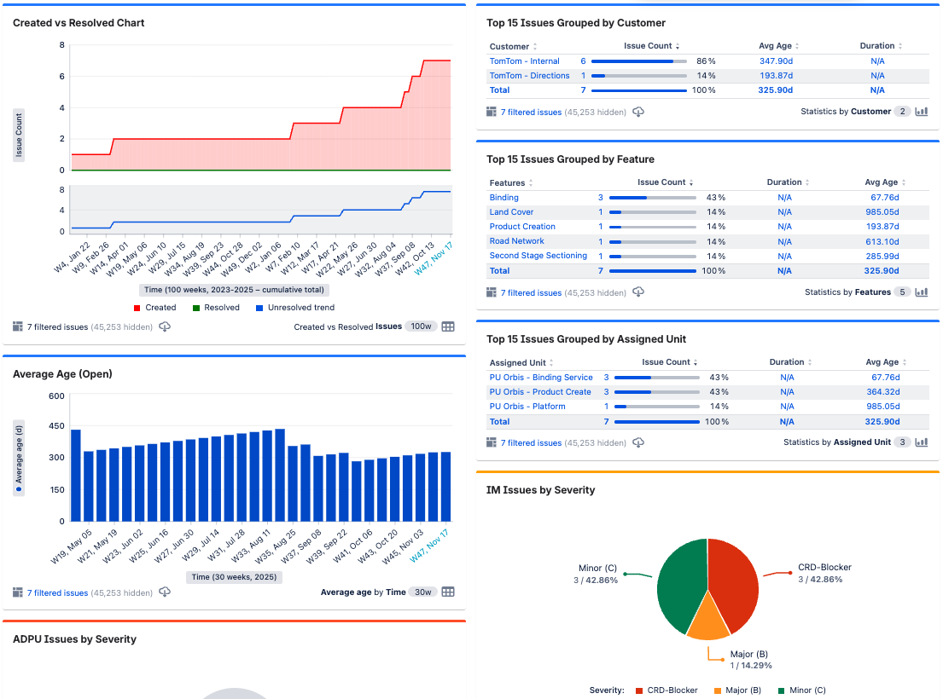

Open CRD Blockers breaching SLA:
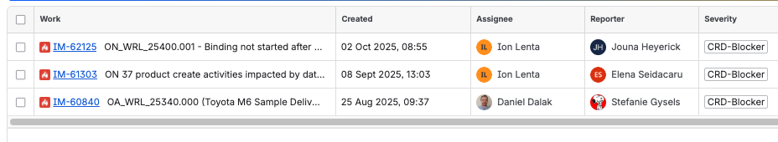
While we don’t have a large backlog of tickets to address, we do have a few that remain open that require clean up (+300 days open, under review). The 3 CRD blockers with more than 15 days open have ongoing resolution plans and should be closed by the end of November.

OLD METRICS
Metric | September'25 | October’25 | November ‘25 | Target for H2 2025
Products
% On-time accepted ON and OS releases | ON: 75%  OS: 100% | ON: 80%  OS: 100% | ON: 50% ⁽¹⁾  OS: 100% | 95%
Orbis Sectioned release lead time between Binding and Go/No-go  - Lead time in days of first-time right releases  - Lead time in days when we need re-runs (and number of reruns) | a. 2,73  b. NA | a. 2,65  b. 7,3 ⁽²⁾ | a. 2,67  b. 3,7 | a. 3  b. 5
M 3.0: Avg. production issues per release | 1,26 | 0,54 | 0,50 | <1/release
Average platform cost per released Orbis Sectioned product | $ 6405 | $ 7313 | $ 6441 | $7500
Average platform cost per hosted layer | $505 | $595 | $539 ⁽⁷⁾ | $460
Lead time – Binding & IPI (p50 & p95) | 3h40m p50  24h10 p95 | 3h47 p50  14h18 p95 | 1h20m p50  12h08m p95 ⁽⁶⁾ | <30min p50  <4h for p95
New feature Time to Market from first request (in days) | 20,96 | 20,96 | 20,92⁽²⁾ | 14
Feedback Resolution
Conversion rate: feedback-to-map-change | 74%  (427/579) | 89%  (658/741) | 92%  (783/849) | Informative
Percentage of ACI closed within 48h (E2E) | 87.7% | 61% | 68% | 100%
Changelet rejection rate | 2.4% | 3.68% | 3.16% | <5% ⁽³⁾
OrbIT assisted hands-on-keyboard Hours (SD | HD) | 45%| 92% | 41%|90% | 42%| 80% | >75%
Unified Incidental Feedback Reporting at TT | 1/4 | 1/4 | 1/4 | 4
`MTTR - Mean Time to Repair till external product | 11.3 | 12.58 | 12 | 16 days
Traceability to product (customer feedback that can be traced back to a specific version of the product) | 51% | 51% | 45% ⁸⁾ | 95%
Vandalism Detection
Prevented bad edit metric | 54.4% | 41,1% | 61.9%⁽⁴⁾ | > =50%
Quarantine Average Lead Time | 31,7h | 29,4h | 30.1h⁽⁵⁾ | < 24h

- Week 45 was rejected due to Eurotunnel issue (https://tomtom.atlassian.net/browse/IM-63069) and week 48 was again rejected due to another Eurotunnel Issue (https://tomtom.atlassian.net/browse/IM-64121). Both rejections were by NDS.
- Further major lead time reduction can only be realized when we have implemented lead time reduction for OS. Which would lead to 17,5 days. No further actions are defined yet to further reduce to 14 days.
- Changelet rejection rate target has been updated from <1% to <5% to align it with MSO recommendations and Value Stream targets. In parallel, starting January 15th, daily alerts for layers breaching the rejection rate target will be launched. We expect the combination of per layer and aggregated metrics is enough to detect issues on time.
- The metrics will still fluctuate (as it’s a lagging metric and both a) nr of quality leads as well as their b) lag is out of our control. To improve it, we rolled out Machine Learning Predicate (MLP). We also fixed an issue with metric calculation (some squashed edits – subsequent add and then delete – were wrongly calculated).
- This metric (by its definition) is slightly fluctuating as we have no control over who, what, when commits to OSM. Depending on the editor’s tenure, MLP score, we keep the data longer in the quarantine. To further improve it, we are investing in auditing capabilities and discovery initiatives. Improvements are planned for 2026.
- Target is probably too ambitious and would not be met even with perfect processing, but factors like reset windows and the additional config changes this month also negatively affect this metric.
- The CoreTech team implemented an optimization of the DiScOS Map State Reader component, which resulted in a 9% reduction in average layer cost.
- Number of fixes in read-only layers, that we cannot trace, was higher

