Lab 4 Notes

- Regression plot using seaborn (one line)
  - import seaborn as sns
  - sns.regplot(x=’someColName,y=’anotherColName’,data=somedata)

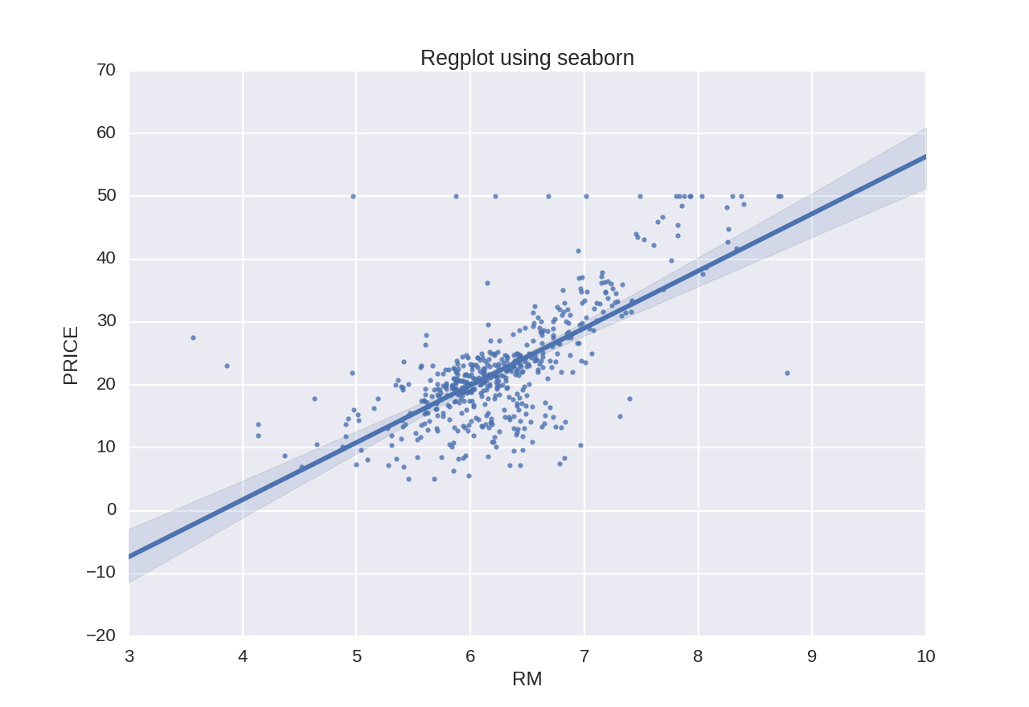

- Regression parameters
  - Using ols
    - from statsmodels.formulas.api import ols
    - m=ols(‘YColName ~ XColName1 + XColName2 + … + XColNamen’, data=somedata).fit()
    - Get info:
      - Fitted values: m.fittedvalues
      - m.summary()
      - m.params

  - Using LinearRegression()
    - from sklearn.linear_model import LinearRegression
    - lm=LinearRegression()
    - lm.fit(2Darray of X values, Y values)
      - each row corresponds to an observation
      - each column corresponds to a feature
    - Get info:
      - Any predicted values: lm.predict(array of any X values)
      - lm.coef_
      - lm.intercept_

- Train/Test Split
  - Xtrain, Xtest, Ytrain, Ytest = sklearn.cross_validation.train_test_split(X, Y, test_size=0.33, random_state=5)

