Homework 2 Problem 2

Overview

This exercise runs simulations of polls assuming a binomial distribution.

Useful commands:

- Probability plot
  - import scipy.stats
  - scipy.stats.probplot( normalized_data, dist=’normal’,plot=plt)

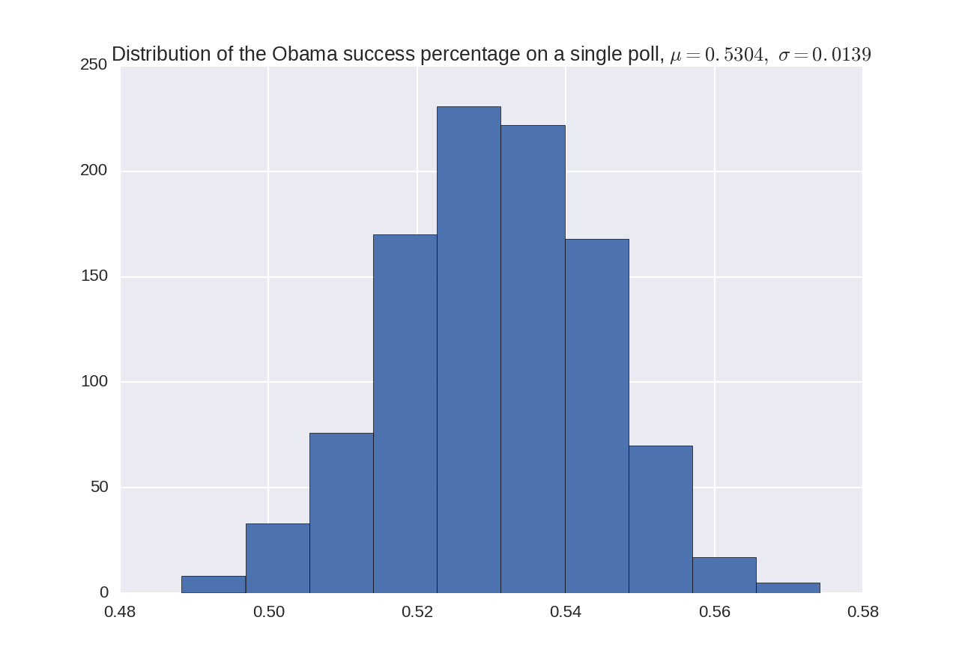
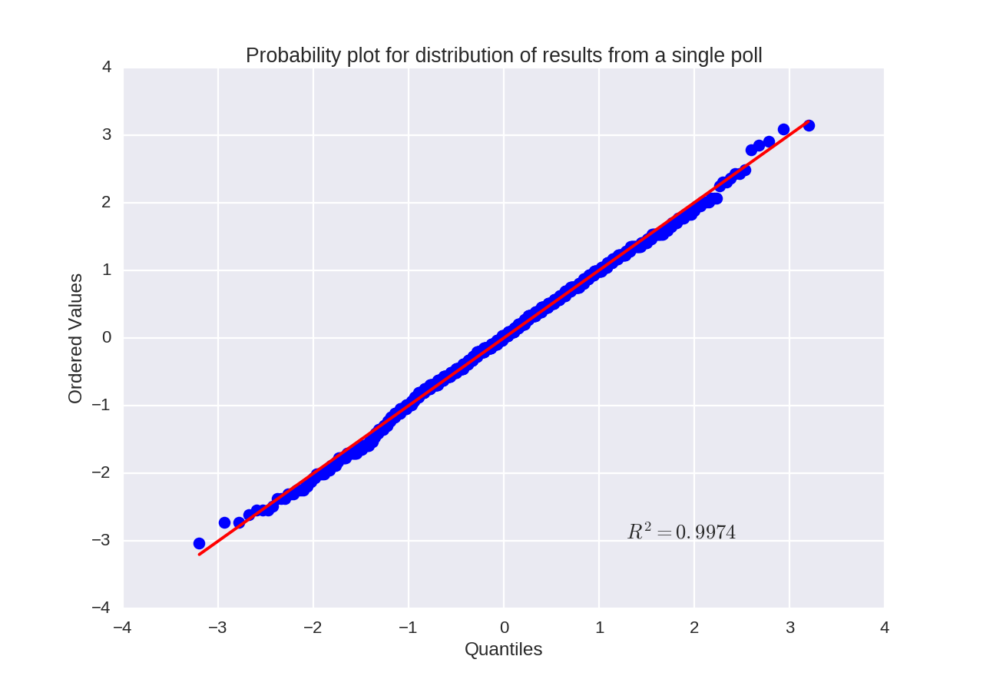

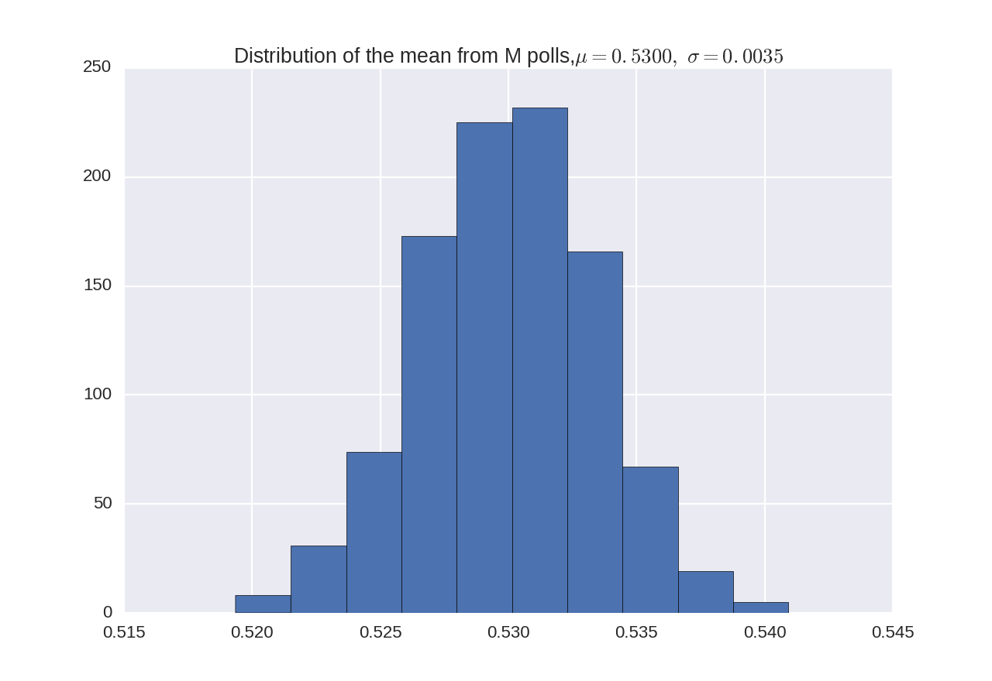
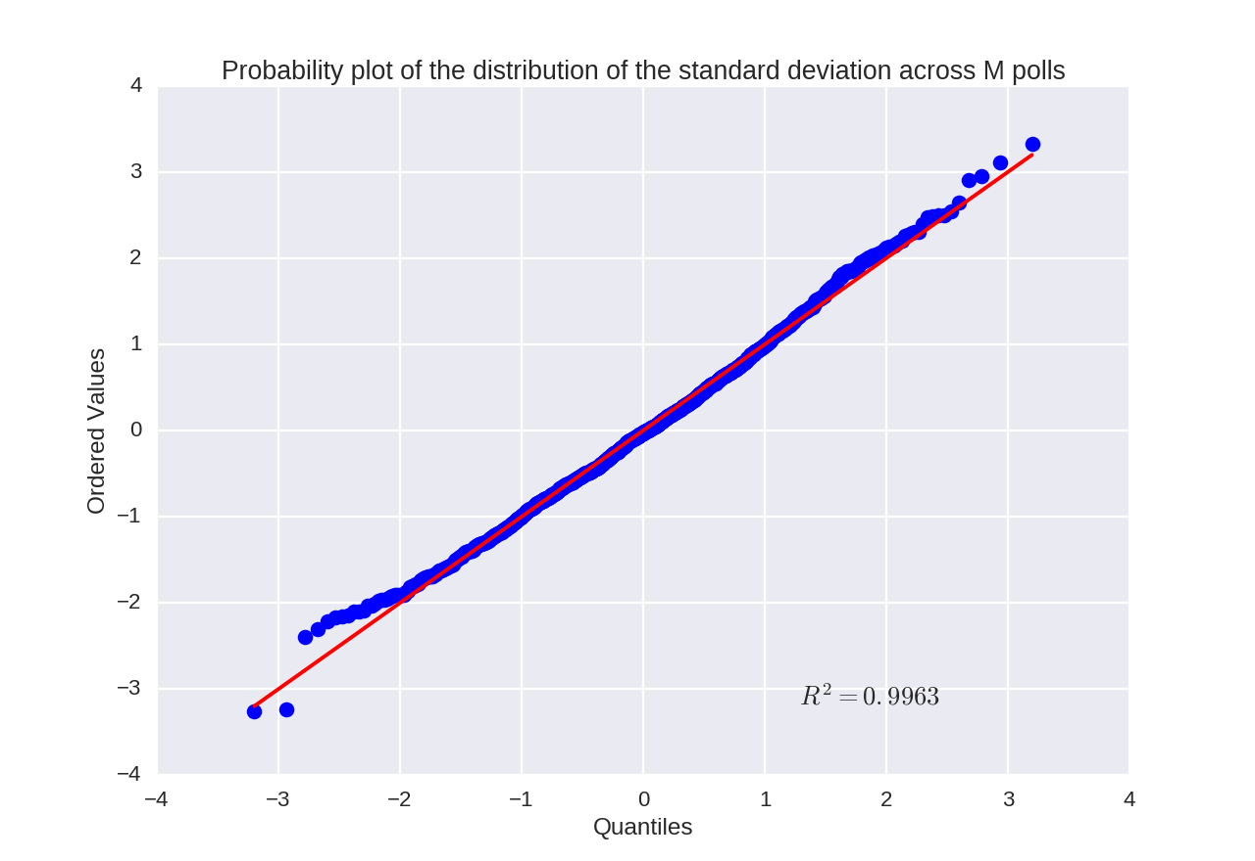

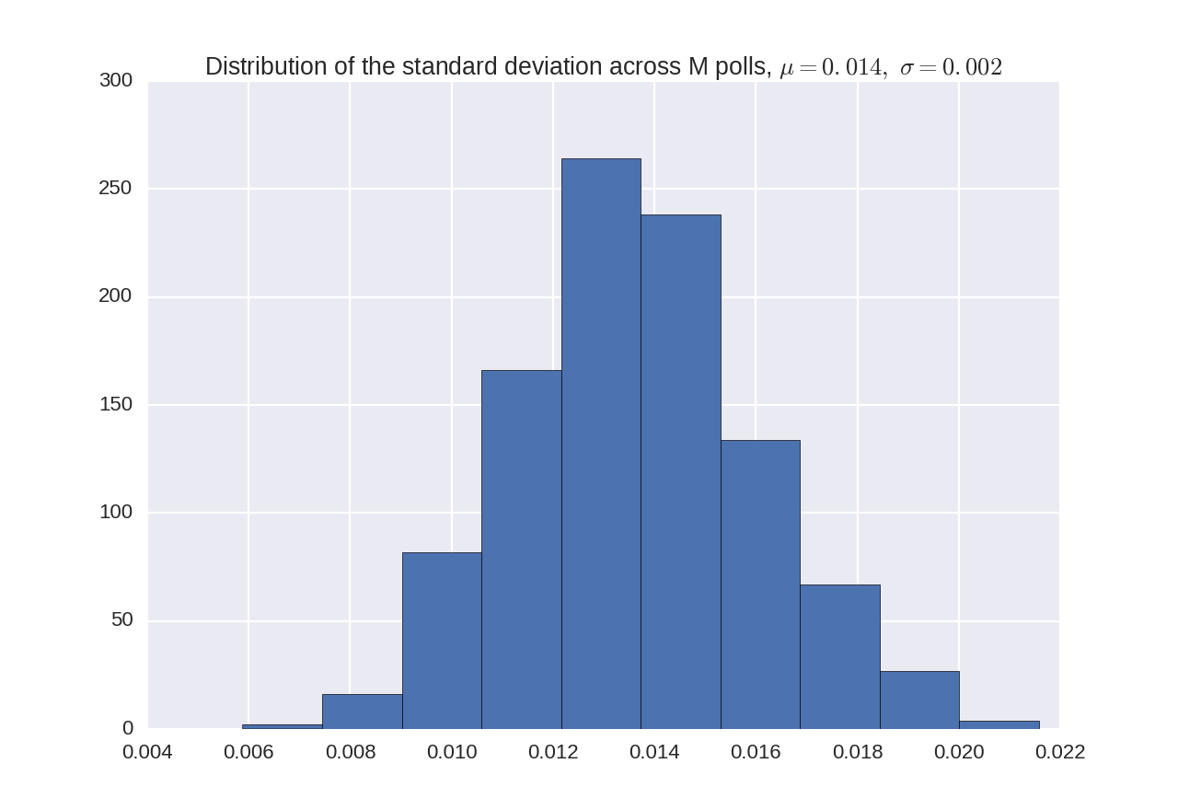

The actual standard deviation across M polls taken before the election was 0.01055, which is less than the standard deviation would be if the distribution was completely random binomial.

