Additional MS/TP Baud Rates

Problem:
The baud rates listed in clause 9.2.3 of 135-2004 are limited with regard to common best practices.

Background:
The baud rates 57600 and 115200 are supported in PCs and commonly used UARTs. Some UART/microprocessor combinations that can support 57600 baud have trouble keeping up with, or are incapable of supporting, 76800. In this case, the best interoperable baud rate they can offer is 38400.

It has been determined through observation of MS/TP networks that 9600 baud does not provide adequate network throughput and that higher baud rates (specifically 38400) are in common use. Based on these observations, 9600 should not be the default MS/TP baud rate nor should the baud rates 19200 and 38400 be optional.

The technical literature regarding EIA-485 best practices (see AN-1057 from National Semiconductor) shows that the 115200 baud rate exceeds the maximum recommended length of wiring (4000 ft.) specified in clause 9.2.1 of 135-2004.

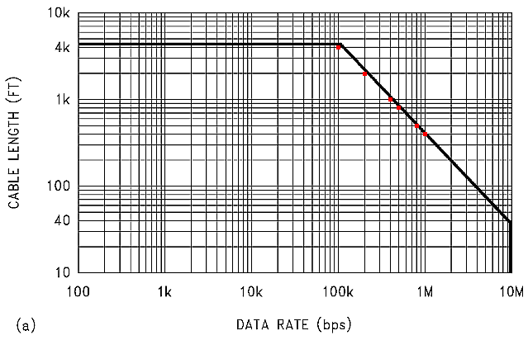

The formula is:
Length in m = 1200 / ( 1 + ( Baud-rate / 250 ) ² ) ^{0.5}

The following table shows the calculated cable length in feet (row 2) based on the above graph and the Scilab formulas in STK-013-2. This table is base on the 1,000,000 baud rate, where row 1 is the baud rate divisor, row 2 is the cable length in ft and row 3 is the actual baud rate.

This table shows that the maximum cable length for 115200 baud is 3472.22 feet. However, in order to provide for a margin of error, the specified MS/TP segment size shall be 3280 feet or 1000 meters.

The 115200 baud data rate is common in UARTs and PCs, and can work with MS/TP given consideration of less network length; available CPU bandwidth and UART design (e.g. FIFO based instead of double buffered).

Solution Summary:

Expand the standard baud rates to allow the optional use of 57600 and 115200; add length restriction language for 115200; change the required baud rates to 9600, 19200 AND 38400; and, make 38400 the standard baud rate.

Solution Detail:

[Change 9.2.1 Medium, page 74]

9.2.1 Medium

An MS/TP EIA-485 network shall use shielded, twisted-pair cable with characteristic impedance between 100 and 130 ohms. Distributed capacitance between conductors shall be less than 100 pF per meter (30 pF per foot). Distributed capacitance between conductors and shield shall be less that 200 pF per meter (60 pF per foot). Foil or braided shields are acceptable. The maximum recommended length of an MS/TP segment shall be 1200 meters (4000 feet) with AWG 18 (0.82 mm² conductor area) cable, except when the baud rate 115200 is used, in which case the maximum recommended length of an MS/TP segment shall be 1000 meters (3280 feet) with AWG 18 (0.82 mm² conductor area) cable. The use of greater distances and/or different wire gauges shall comply with the electrical specifications of EIA-485.

[Change 9.2.3 Timing, page 76]

9.2.3 Timing
Octets shall be transmitted using non-return to zero (NRZ) encoding with one start bit, eight data bits, no parity, and one stop bit. The start bit shall have a value of zero, while the stop bit shall have a value of one. The data bits shall be transmitted with the least significant bit first. This is illustrated in Figure 9-2.

Although asynchronous framing is used, there shall be no more than T_{frame_gap} of idle line (logical ones or stop bits) between any two octets of a frame.

The standard baud rate shall be 9600 38400, plus or minus 1%. The additional baud rates 9600 and 19200 shall also be supported. Any or all of the additional baud rates 19200, 38400, 57600, 76800, and 115200 may be supported at the vendor's option, but the 9600, 19200, and 38400 baud shall always be selectable.

