Problems:
When reviewing MS/TP in Clause 9, I noticed that the baud rates specified in 9.2.3 are rather limited, and the fastest one doesn't work well on PC based UARTs (76800 baud). Since PC based control is becoming more prevalent in industry these days, it seems appropriate to permit fast speeds for PC compatible UARTs.

I propose to expand the allowable baud rates (9600, 19200, 38400, 76800) to include 57600 baud and 115200 baud.

After perusing the technical literature regarding RS-485 best practices (see AN-1057 from National Semiconductor), it seems that the proposed 115200 baud rate exceeds the maximum recommended length of the wire at a distance of 4000 feet, which is specified in the BACnet standard. Linear interpolation from the graph in Figure 4a of AN-1057:
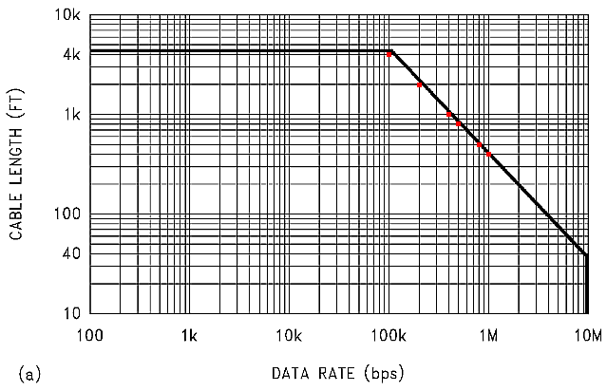
-->// Scilab 3.0
-->// data from the graph
-->// The data is linear, but the graph is logarithmic
-->t = [0.1 0.2 0.4 0.5 0.8 1.0];
-->y = [4000 2000 1000 800 500 400];
-->xyd = [t;y];
-->yi=exp(interpln(log(xyd),log(t)));
-->err = (y-yi)'
err =
1.0D-12 *
! 0.4547474 !
! 0.2273737 !
! 0.2273737 !
! 0.1136868 !
! 0.1705303 !
! 0.1136868 !
-->tt = [0.1 0.1152 0.2 0.2304 0.4 0.4608 0.5 0.8 1.0];
-->yi=exp(interpln(log(xyd),log(tt)));
-->xyi = [tt ; yi]'
xyi =
! 0.1 4000. !
! 0.1152 3472.2222 !
! 0.2 2000. !
! 0.2304 1736.1111 !
! 0.4 1000. !
! 0.4608 868.05556 !
! 0.5 800. !
! 0.8 500. !
! 1. 400. !

I propose to reduce the maximum recommended length to 3280 feet (1000 meters) at 115200 baud. Other PC based UART baud rates are possible at reduced maximum recommended lengths including 230400 baud (1736 feet) and 460800 baud (868 feet), but the MS/TP state machine functionality has not been verified at those rates.

References:
ANSI/ASHRAE Standard 135-2004, “BACnet®, A Data Communication Protocol for Building Automation and Control Networks”

Document Conventions
Italics are used to indicate changes or additions to the standard. Strike-through is used to indicate deletion from the standard.

Changes To Standard 135

[change 9.2.1 Medium, page 75]

9.2.1 Medium
An MS/TP EIA-485 network shall use shielded, twisted-pair cable with characteristic impedance between 100 and 130 ohms. Distributed capacitance between conductors shall be less than 100 pF per meter (30 pF per foot). Distributed capacitance between conductors and shield shall be less that 200 pF per meter (60 pF per foot). Foil or braided shields are acceptable. The maximum recommended length of an MS/TP segment is 1200 meters (4000 feet) with AWG 18 (0.82 mm² conductor area) cable at baud rates less than 100000; at 115200 baud the maximum recommended length of an MS/TP segment is 1000 meters (3280 feet). The use of greater distances and/or different wire gauges shall comply with the electrical specifications of EIA-485.

[change 9.2.3 Timing, page 76]

9.2.3 Timing
Octets shall be transmitted using non-return to zero (NRZ) encoding with one start bit, eight data bits, no parity, and one stop bit. The start bit shall have a value of zero, while the stop bit shall have a value of one. The data bits shall be transmitted with the least significant bit first. This is illustrated in Figure 9-2.

Although asynchronous framing is used, there shall be no more than T_{frame_gap} of idle line (logical ones or stop bits) between any two octets of a frame.

The standard baud rate shall be 9600, plus or minus 1%. Any or all of the additional baud rates 19200, 38400, 57600, 76800, and 115200 may be supported at the vendor's option, but the 9600 baud shall be selectable.

