**KRINIKA DATABASE MANAGEMENT SYSTEM**

Student Name

Institutional Affiliation

Project Supervisor

**Introduction**

Managing in the Modern World An organization's information systems cannot function without the input and diverse processes required to achieve specific goals in management. To establish, construct, maintain, and control access to a database, you need a database management system. Users of a successful information system have access to up-to-date, accurate data that is useful for making decisions. decisions, both routine and long-term, in running the business and charting its course. Accurate decisions can only be made with access to relevant information and data in a timely manner. In order to get knowledge, one must first process data, which is done through information management with the use of information technology. On the other hand, Krinika is a wholesale database management system used to oversee things like healthcare equipment, supplier and customer activity, and more. A number of different payment options are available to customers for the purchase of hospital equipment. During the development of this system, the following tools were used in order to make the final project deliverable complete:

* PHP
* MySQL
* Bootstrap

**List of queries**

**1. Insert into brands table**

INSERT INTO `brands` (`brand_id`, `brand_name`, `brand_active`, `brand_status`, `companyid`) VALUES

(1, 'test', 2, 1, 5437265),

(2, 'HHCS', 1, 1, 5437265);

**2. Insert into buyers table**

INSERT INTO `buyers` (`buyer_id`, `buyer_name`, `buyer_address`, `productname`) VALUES

(1, 'Aaron', 2328, 'Clinical Centrifuge'),

(2, 'mark', 2328, 'ventilators'),

(4, 'John', 2057, 'oscilators'),

(5, 'james', 55, 'Generator'),

(6, 'daniel', 4532, 'Infusion pumps'),

(7, 'BB maak', 5242, 'LASIK '),

(8, 'jacob', 5423, 'Medical lasers'),

(9, 'suleiman', 5568, 'Consult 120 Urine Analyzer'),

(10, 'prijate', 6465, 'Urine Reagent Strips 10 Parameter'),

(11, 'Violet', 5241, 'Consult Liquid Urine Control'),

(12, 'Green', 73, 'Plastic urine containers, sterile or unsterile'),

(13, 'Purple', 845, 'Conical centrifuge tube, 15 ml'),

(14, 'brown', 532, 'Microscope slides and 1 coverslip'),

(15, 'PINK', 65, 'Clinical Centrifuge'),

(16, 'purples', 543, 'gaga'),

(17, 'NITE', 436, 'Cent'),

(18, 'ronny', 6, 'Yoga ma'),

(19, 'Don', 641, 'Slide strainers'),

(20, 'Esther', 7434, 'Differential counters'),

(21, 'Nate', 72373, 'Electrolyte analyzers');

**3. Insert into categories table**

INSERT INTO `categories` (`categories_id`, `categories_name`, `categories_active`, `categories_status`, `companyid`) VALUES

(1, 'test1', 1, 2, 5437265),

(2, 'test1', 1, 1, 5437265),

(3, 'Hospital machines', 1, 1, 5437265);

**4. Insert into orders table**

INSERT INTO `orders` (`order_id`, `order_date`, `client_name`, `client_contact`, `sub_total`, `vat`, `total_amount`, `discount`, `grand_total`, `paid`, `due`, `payment_type`, `payment_status`, `payment_place`, `gstn`, `order_status`, `user_id`, `address`) VALUES

(1, '2020-05-01', 'rrr', '12345', '366.00', '65.88', '431.88', '0', '431.88', '122', '309.88', 2, 1, 1, '65.88', 2, 1, 5437265),

(61, '2022-11-11', 'lg', '33245', '6344.00', '1141.92', '7485.92', '252', '7233.92', '2525', '4708.92', 2, 1, 1, '1141.92', 1, 1, 5437265),

(62, '2022-11-25', 'jane', '563453', '11200.00', '2016.00', '13216.00', '2542', '10674.00', '432', '10242.00', 1, 1, 1, '2016.00', 1, 1, 5437265),

(63, '2022-11-09', 'jgfj', '43212', '3785.00', '681.30', '4466.30', '20', '4446.30', '101', '4345.30', 2, 1, 1, '681.30', 1, 1, 5437265),

(64, '2022-11-26', 'kira', '5424', '242.00', '43.56', '285.56', '24', '261.56', '4124', '-3862.44', 1, 1, 1, '43.56', 1, 1, 5437265),

(65, '2022-11-09', 'job', '543', '4958.00', '892.44', '5850.44', '24', '5826.44', '5432', '394.44', 2, 1, 1, '892.44', 1, 1, 5437265),

(66, '2022-11-17', 'jhfj', '5345', '600.00', '108.00', '708.00', '24', '684.00', '424', '260.00', 1, 1, 1, '108.00', 1, 1, 5437265),

(67, '2022-11-24', 'jane', '534', '25.00', '4.50', '29.50', '0', '29.50', '0', '29.50', 2, 3, 1, '4.50', 1, 1, 5437265);

**5. Insert into users table**

INSERT INTO `users` (`user_id`, `username`, `password`, `email`, `companyid`) VALUES

(1, 'b@gmail.com', '214', 'b@gmail.com', 5437265),

(2, 'admin', '1234', 'brianmwe425@gmail.com', 5437265),

(3, 'Mike', '1234', 'm@gmail.com', 5437265),

(4, 'hdhd', '1234', 'hfdhd@gmail.com', 5437265),

(5, 'fafaf', '1234', 'faf@gmail.com', 5437265),

(6, 'hioh', '1234', 'jn@gmail.com', 5437265);

**6. Insert into order_item table**

INSERT INTO `order_item` (`order_item_id`, `order_id`, `product_id`, `quantity`, `rate`, `total`, `order_item_status`, `companyid`) VALUES

(13, 1, 1, '1', '122', '122.00', 2, 0),

(14, 1, 1, '1', '122', '122.00', 2, 0),

(15, 1, 1, '1', '122', '122.00', 2, 0),

(16, 2, 1, '1', '122', '122.00', 1, 0),

(17, 2, 1, '1', '122', '122.00', 1, 0),

(18, 2, 1, '1', '122', '122.00', 1, 0),

(19, 3, 1, '1', '', '', 1, 0),

(20, 4, 1, '1', '', '', 1, 0),

(21, 5, 1, '5', '', '0.00', 1, 0),

(22, 6, 1, '5', '', '0.00', 1, 0),

(23, 7, 1, '2', '', '0.00', 1, 0),

(24, 8, 1, '1', '122', '122.00', 1, 0),

(25, 9, 1, '8', '122', '976.00', 1, 0),

(26, 10, 1, '30', '122', '3660.00', 1, 0),

(27, 11, 1, '20', '122', '2440.00', 1, 0);

**7. Insert into product table**

INSERT INTO `product` (`product_id`, `product_name`, `product_image`, `brand_id`, `categories_id`, `quantity`, `rate`, `active`, `status`, `companyid`) VALUES

(1, 'test', '../assests/images/stock/16494709285ec3834885aef.jpg', 1, 2, '77', '122', 1, 1, 5437265),

(2, 'Ventilators', '../assests/images/stock/1197853275637ca72b3f534.jpg', 2, 3, '15', '320', 1, 1, 5437265),

(3, 'Cardiopulmonary bypass device', '../assests/images/stock/645109529637d06a1d8869.jpg', 2, 3, '500', '1000', 1, 1, 5437265),

(4, 'Dialysis machine', '../assests/images/stock/2146868497637d06c4a5a2f.PNG', 2, 3, '525', '5425', 1, 1, 5437265),

(5, 'Infusion pumps', '../assests/images/stock/423489205637d06e10d6d5.PNG', 2, 3, '25', '522742', 1, 1, 5437265),

(6, 'LASIK surgical machine', '../assests/images/stock/1821450330637d06fb305d2.jpg', 2, 3, '523', '2452', 1, 1, 5437265),

(7, 'Medical lasers', '../assests/images/stock/666573390637d0712736f5.PNG', 2, 2, '0110', '010', 1, 1, 5437265),

(8, 'Consult 120 Urine Analyzer', '../assests/images/stock/1993732651637d0737bb703.PNG', 2, 2, '65325', '522', 2, 1, 5437265),

(9, 'Urine Reagent Strips 10 Parameter', '../assests/images/stock/1010910236637d07577bfbd.jpg', 2, 3, '528', '525', 1, 1, 5437265),

(10, 'Consult Liquid Urine Control', '../assests/images/stock/103609926637d077d169b1.jpg', 2, 3, '565', '525', 1, 1, 5437265),

(11, 'Plastic urine containers, sterile or unsterile', '../assests/images/stock/26673131637d07949854f.jpg', 2, 3, '510', '25', 1, 1, 5437265),

(12, 'Conical centrifuge tube, 15 ml', '../assests/images/stock/1460722874637d07b9a9abc.jpg', 2, 3, '856', '272', 1, 1, 5437265),

(13, 'Microscope slides and 1 coverslip', '../assests/images/stock/1225456683637d07cef1239.jpg', 2, 3, '5325', '2542', 1, 1, 5437265),

(14, 'Clinical Centrifuge', '../assests/images/stock/2093517130637d07e63ef3c.jpg', 2, 2, '852', '27', 1, 1, 5437265),

(15, 'Flow cytometers', '../assests/images/stock/544922278637d08018dbf1.jpg', 2, 2, '534', '3543', 1, 1, 5437265),

(16, 'Blood gas analyzers', '../assests/images/stock/2122664233637d081513608.jpg', 2, 2, '835', '35', 1, 1, 5437265),

(17, 'Electrolyte analyzers', '../assests/images/stock/1473824670637d083804243.jpg', 2, 3, '241', '54', 1, 1, 5437265),

(18, 'Differential counters', '../assests/images/stock/892866412637d0850bcd7e.jpg', 2, 3, '5323', '242', 1, 1, 5437265),

(19, 'Coagulation analyzers', '../assests/images/stock/296848999637d0866b6ead.jpg', 2, 3, '24', '2542', 1, 1, 5437265),

(20, 'Slide strainers', '../assests/images/stock/1274950678637d087b56854.jpg', 2, 3, '523', '242', 1, 1, 5437265),

(21, 'Magnetic resonance imaging (MRI)', '../assests/images/stock/522669475637d08908a466.jpg', 2, 2, '32423', '242', 1, 1, 5437265);

**Interfaces**

**Print screen of the interface (PHP) used to enter a new details of stock**

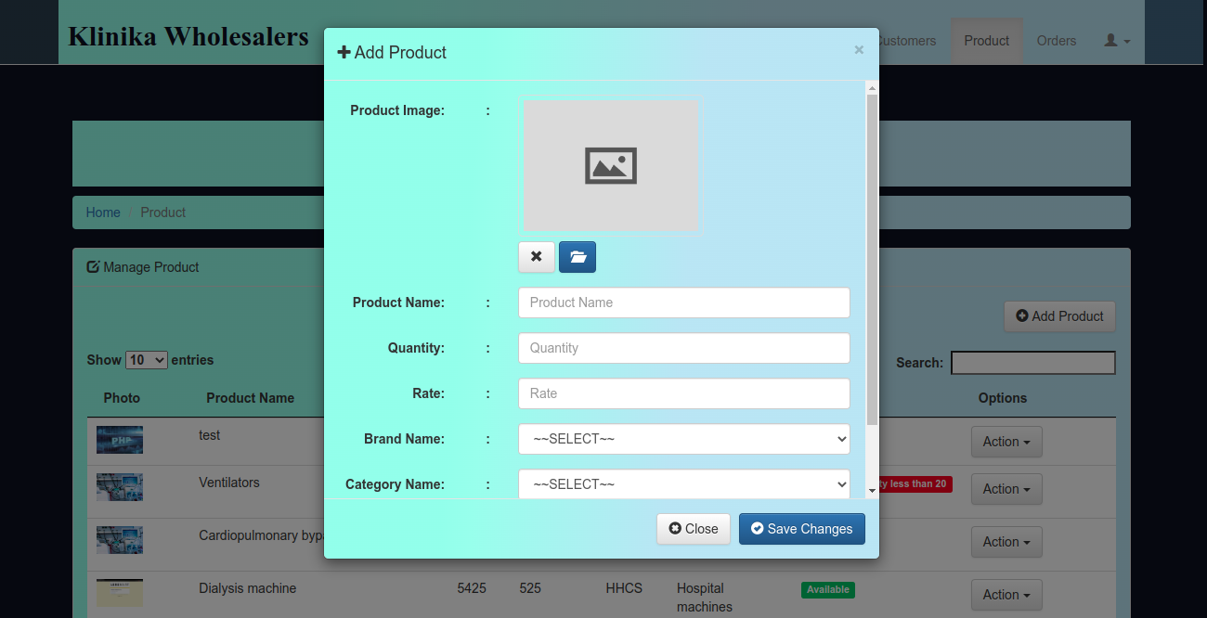

**Print screen of the interface (PHP) used to enter the details of buyers**

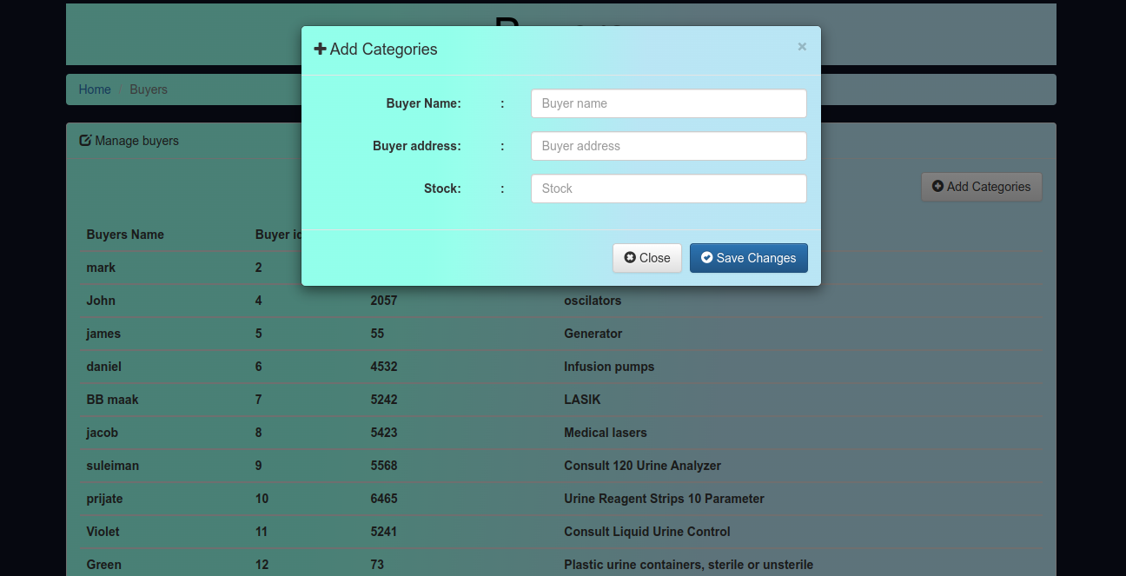

**Print screen of the interface (PHP) used to enter the details of customers**

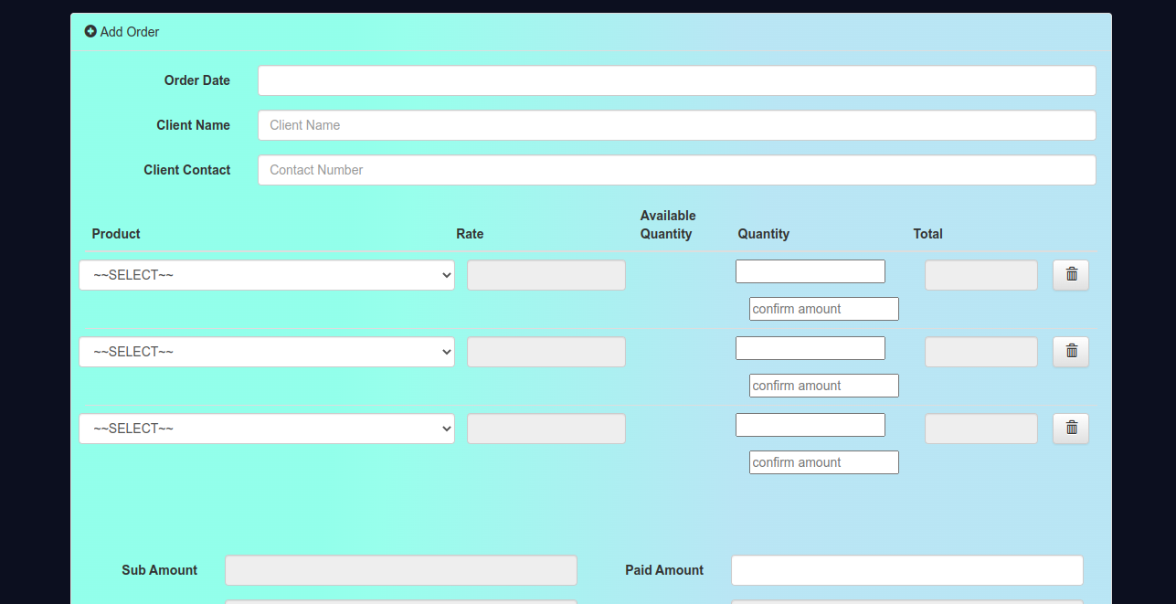

**Print screen of the table attributes Maintaining the details of stock**

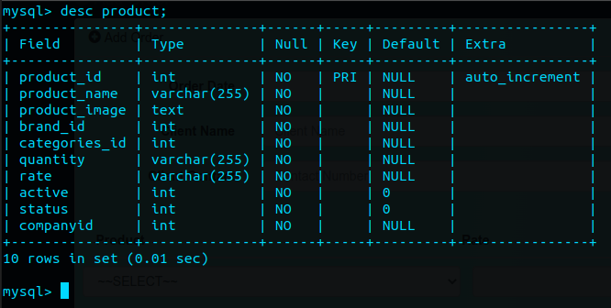

**Print screen of the table attributes Maintaining the details of buyers**

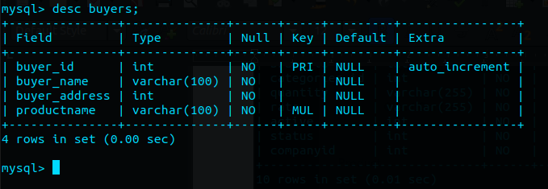

**Print screen of the table attributes Maintaining the details of customers**

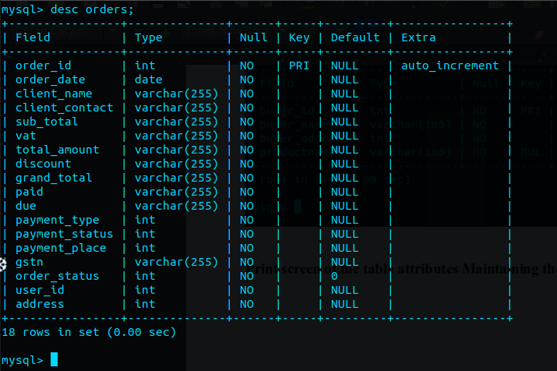

**Print screen of the table content Maintaining the details of stock**

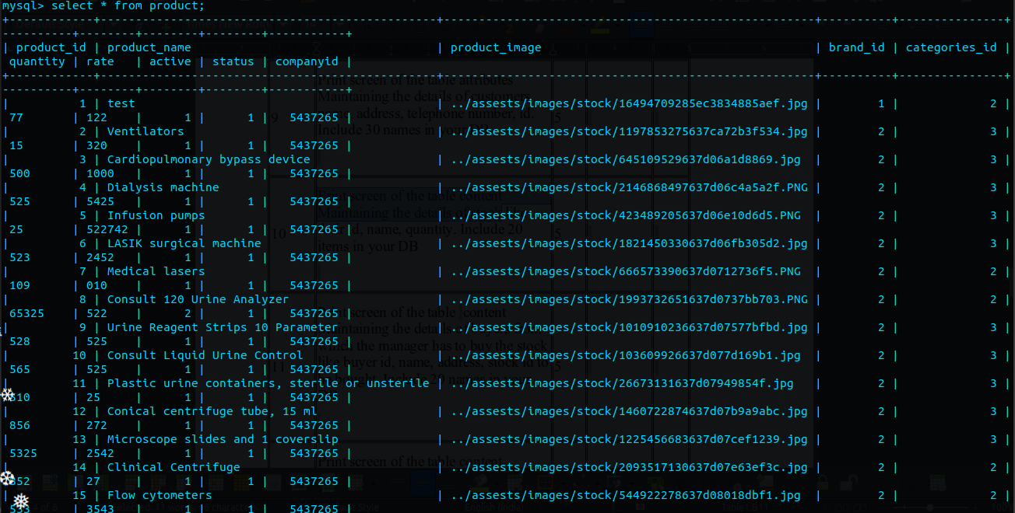

**Print screen of the table content Maintaining the details of buyers**

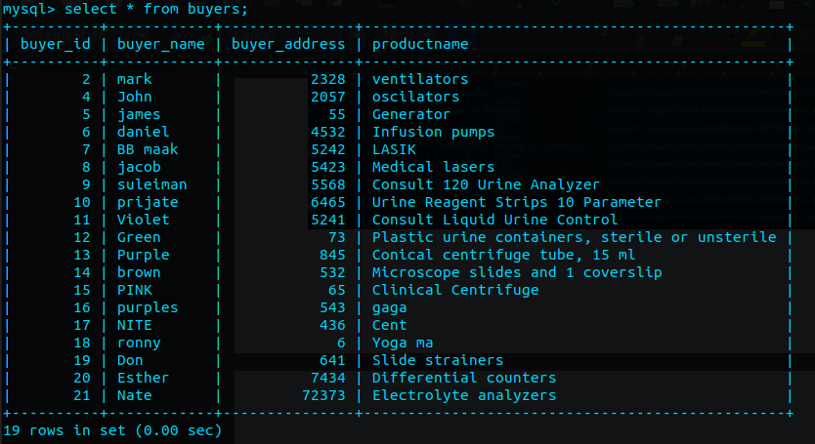

**Print screen of the table content Maintaining the details of customers**

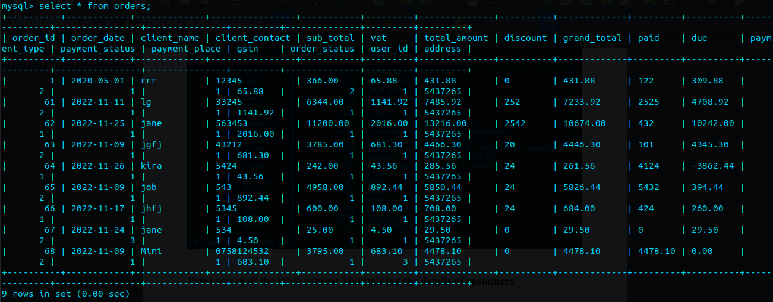

**Prints screen of a report (PHP) with the Defaulter’s list**

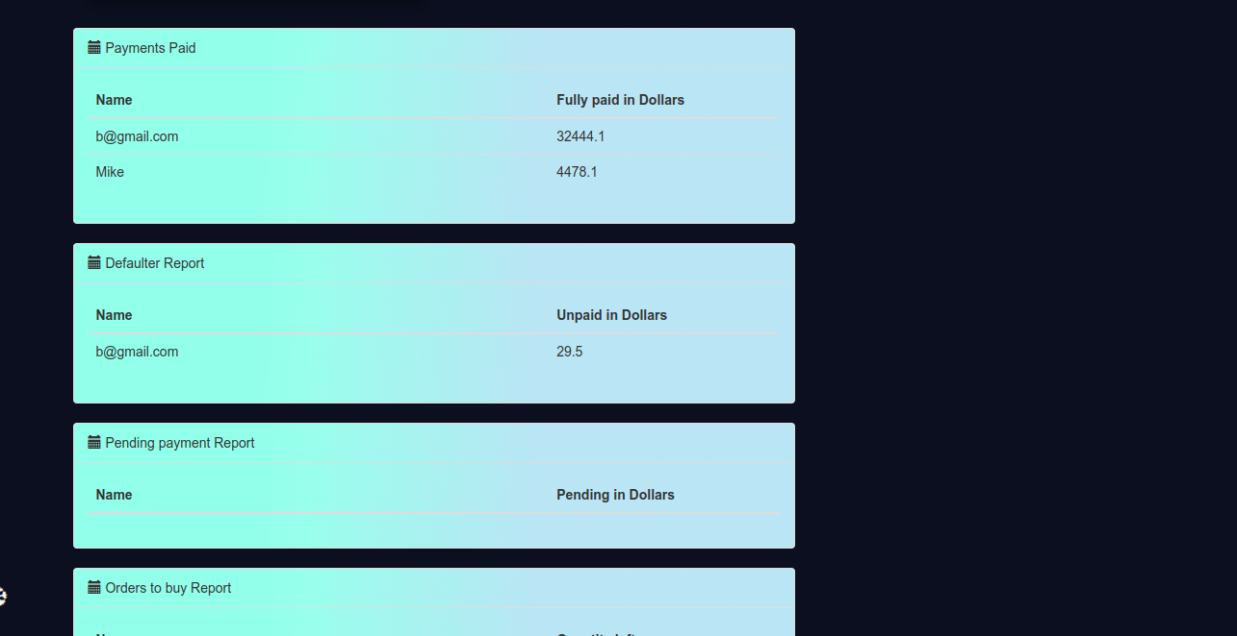

**Prints screen of a report (PHP) with the List of payments paid**

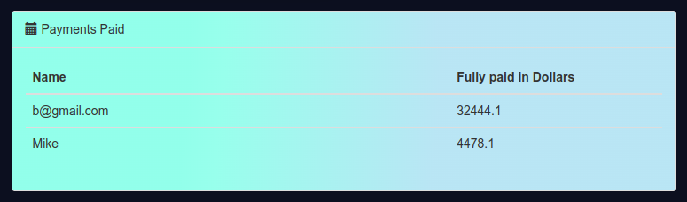**Print screen of a report (PHP) with the List of payments pending.**



**Prints screen of a report (PHP) with the List of the stock that is to buy if quantity goes less than a particular amount**

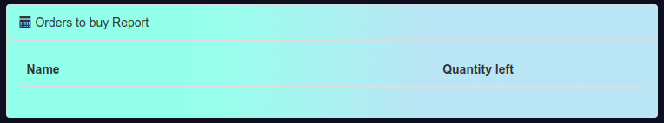

**Print screen of a report (PHP) with the Profit calculation for a month.**

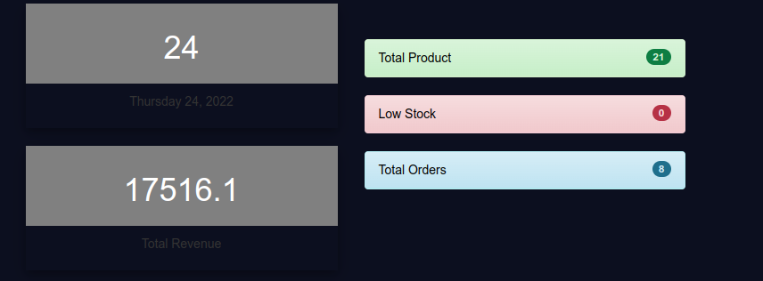

**Print screen of the Produced warning when an error occurs if the Quantity cannot be sold to a customer if the required amount is not present in stock and the date of delivery should be maintained up to which stock can be provided.**

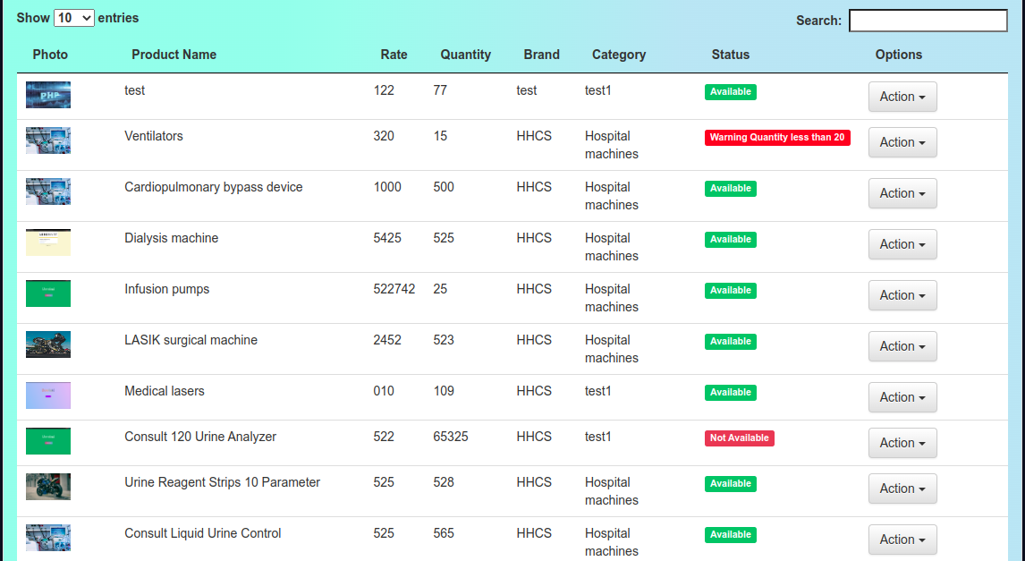

**Print screen of the Produced warning when a customer who have not paid their pending amount is requesting more items.**

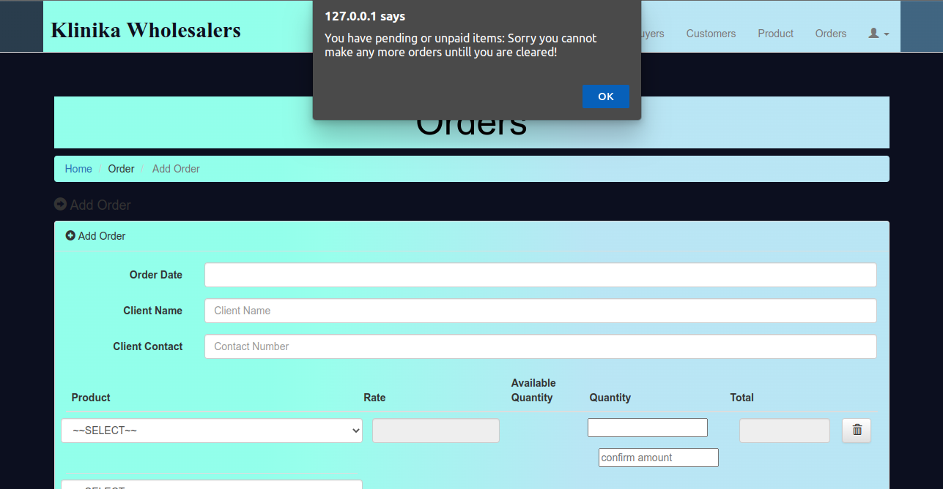

**Print screen of the Produced warning when the quantity of an item goes less than a particular amount.**



**Conclusion**

All in all, developing this web application was a fun experience. I learned how to design tables in the database and how to utilize PHP to retrieve data from a database. A database is a collection of related material that has been properly structured and is kept in a persistent format. DBMS's benefits include a decrease in data repetition, the upkeep of accuracy, consistency, and integrity, a strengthening of data security, an improvement in the effectiveness and efficiency with which data is used, as well as an increase in the efficiency of data users. One of the DBMS's limitations is that it necessitates both external disk and internal storage space for the DBMS to perform fast and efficiently, which necessitates specialized knowledge from its users in order to achieve the best possible database structure and data interactions. The demand for resources is typically extremely strong. Since so many people rely on the DBMS, its collapse will have far-reaching consequences. Reliable DBMS systems can be somewhat costly. The main issue was that I had to study a lot because some concepts were new to me. But the whole process of learning new concepts and practicing them was amazing. This project has really taught me a lot about software systems and database systems and how they can work together in order to build a complete solution to a day to day problem in the society, businesses or even large organization.

**Copy of Code**

**Code for login**

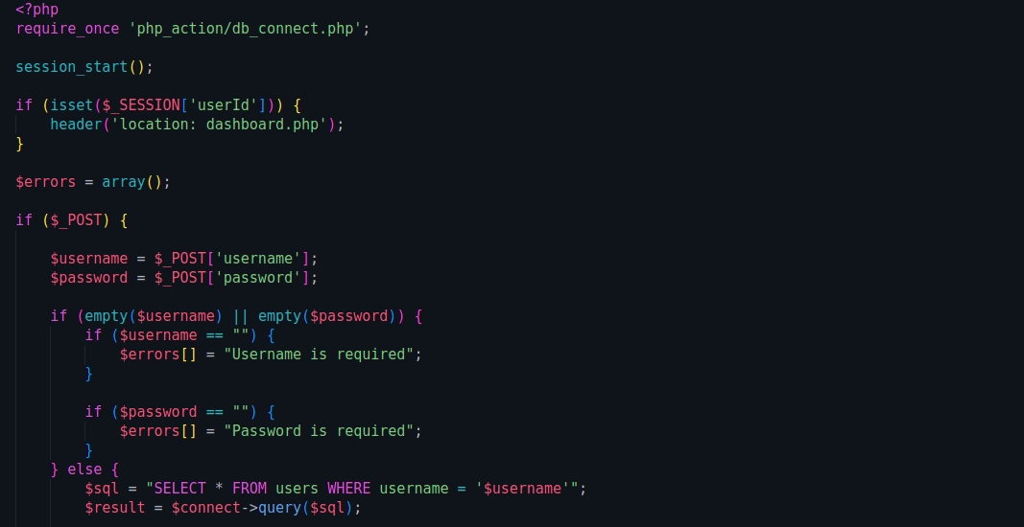

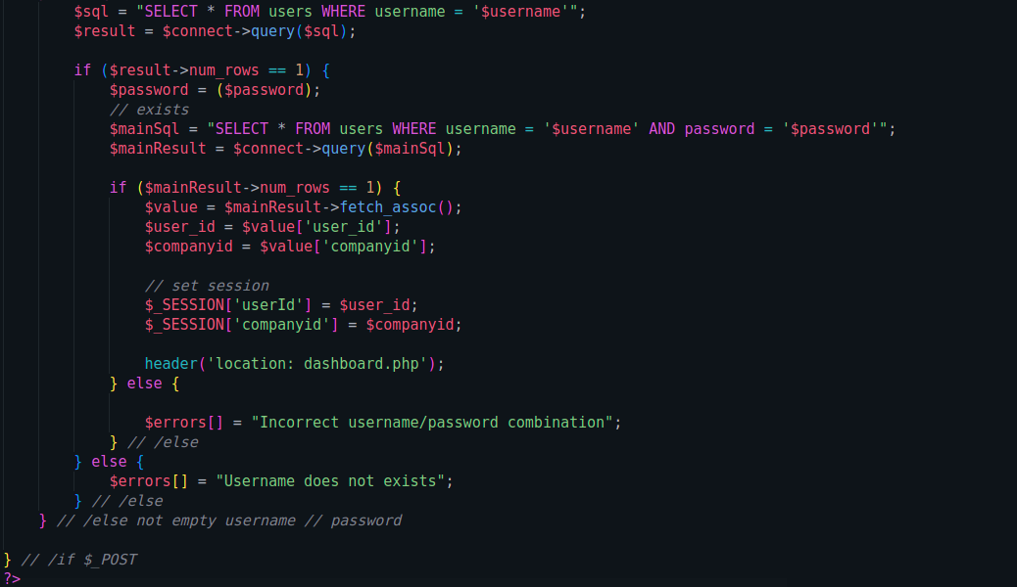

**Code for the dashboard**

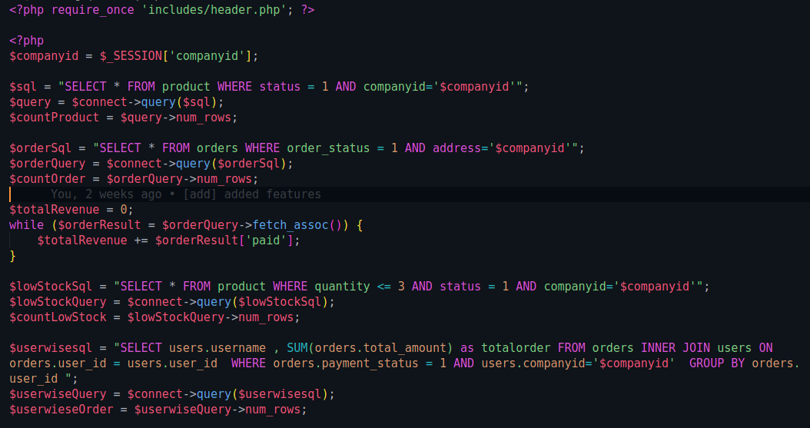

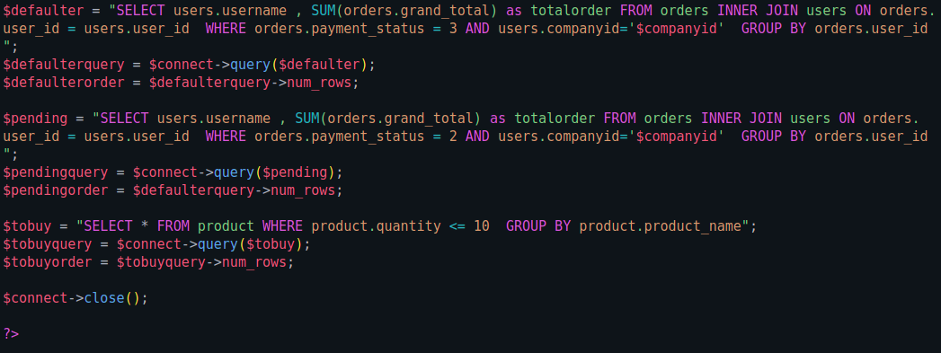

**Code for the registration**

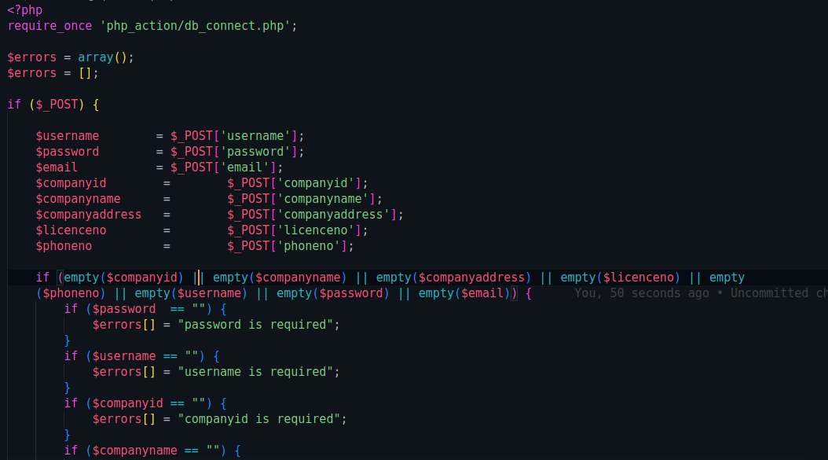

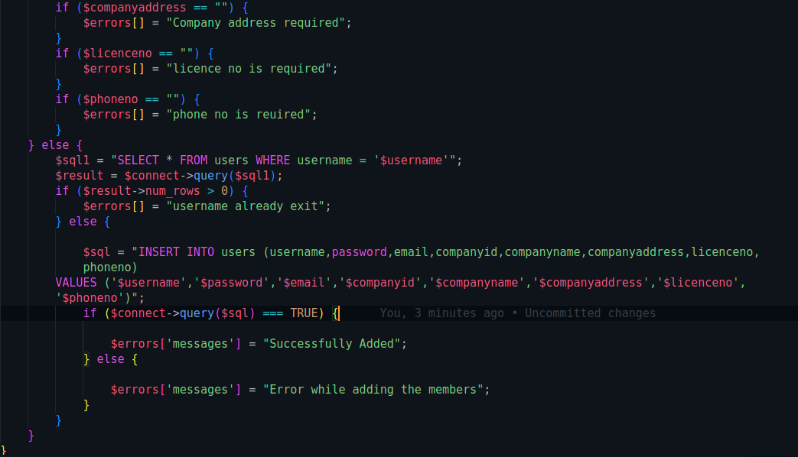

**Code the buyers’ logic**

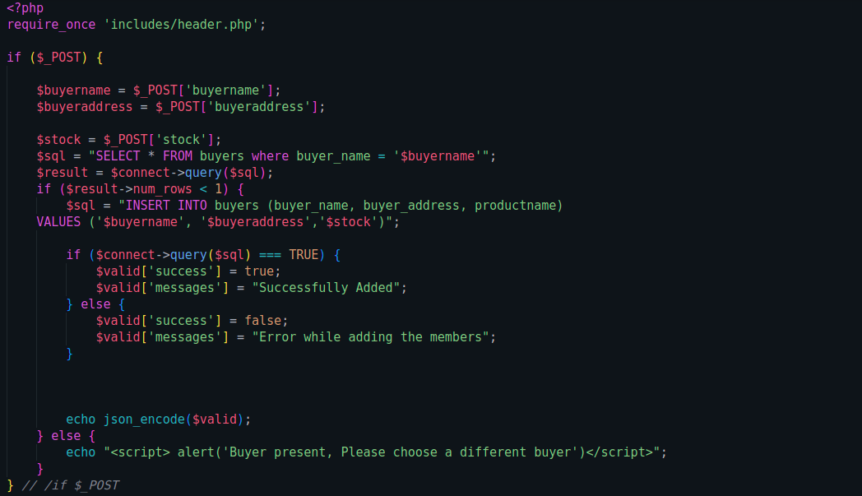

**Code logic to remove a user**

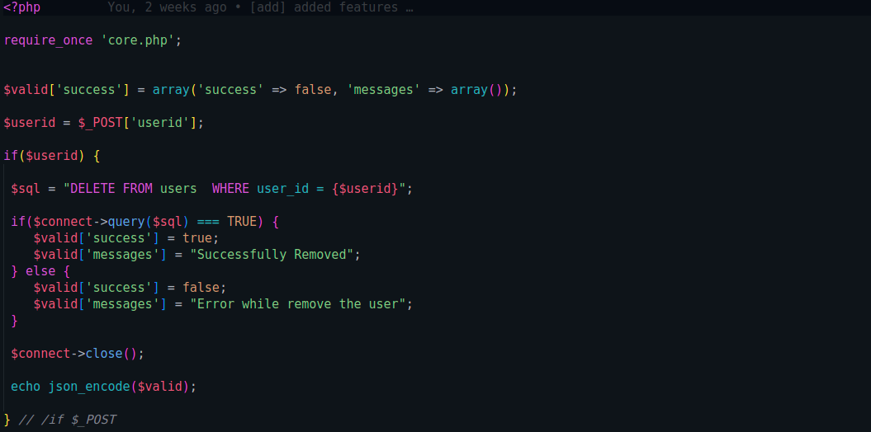

**More code samples**

