18

select count(distinct p.id) as count from PACIENTS p

inner join VACCINE_CARDS vc on p.ID = vc.PACIENT_ID and vc.ENABLED = 1

inner join VACCINATIONS v on vc.ID = v.VACCINE_CARD_ID and v.ENABLED = 1 and v.APPLY_COMPANY_ID = 139

inner join DPC.HST0408 d on v.DISEASE_ID = d.ID

inner join DPC.HST0407 t on v.TOUR_ID = t.ID

where t.CODE = 181 and d.CODE = 32 and p.ENABLED = 1

and MONTHS_BETWEEN(SYSDATE, p.DATE_OF_BIRTH) / 12 <18

and v.INJECT_AT >=('01.01.2019') and v.INJECT_AT <=to_date('12.05.2021')

05

select count(distinct p.id) from PACIENTS p

inner join VACCINE_CARDS vc on p.ID = vc.PACIENT_ID and vc.ENABLED = 1

inner join VACCINATIONS v on vc.ID = v.VACCINE_CARD_ID and v.ENABLED = 1 and v.APPLY_COMPANY_ID = 139

inner join DPC.HST0408 d on v.DISEASE_ID = d.ID

inner join DPC.HST0407 t on v.TOUR_ID = t.ID

where (t.CODE = 2 or t.CODE = 46 or t.CODE = 47 or t.CODE = 181 or t.CODE = 484) and d.CODE = 28

and p.ENABLED = 1

and v.INJECT_AT >=('01.01.2019') and v.INJECT_AT <=to_date('12.05.2021')

06

select count(distinct p.id) from PACIENTS p

inner join VACCINE_CARDS vc on p.ID = vc.PACIENT_ID and vc.ENABLED = 1

inner join VACCINATIONS v on vc.ID = v.VACCINE_CARD_ID and v.ENABLED = 1 and v.APPLY_COMPANY_ID = 139

inner join DPC.HST0408 d on v.DISEASE_ID = d.ID

inner join DPC.HST0407 t on v.TOUR_ID = t.ID

where (t.CODE = 2 or t.CODE = 46 or t.CODE = 47 or t.CODE = 181 or t.CODE = 484) and d.CODE = 28

and p.ENABLED = 1

and v.INJECT_AT >=('01.01.2019') and v.INJECT_AT <=to_date('12.05.2021')

and MONTHS_BETWEEN(SYSDATE, p.DATE_OF_BIRTH) / 12 <18

12

select count(distinct p.id) from PACIENTS p

inner join VACCINE_CARDS vc on p.ID = vc.PACIENT_ID and vc.ENABLED = 1

inner join VACCINATIONS v on vc.ID = v.VACCINE_CARD_ID and v.ENABLED = 1 and v.APPLY_COMPANY_ID = 139

inner join DPC.HST0408 d on v.DISEASE_ID = d.ID

inner join DPC.HST0407 t on v.TOUR_ID = t.ID

where (t.CODE = 2 or t.CODE = 46 or t.CODE = 47) and d.CODE = 27

and p.ENABLED = 1

and v.INJECT_AT >=('01.01.2019') and v.INJECT_AT <=to_date('12.05.2021')

and MONTHS_BETWEEN(SYSDATE, p.DATE_OF_BIRTH) / 12 <18

25

select count(distinct p.id) from PACIENTS p

inner join VACCINE_CARDS vc on p.ID = vc.PACIENT_ID and vc.ENABLED = 1

inner join VACCINATIONS v on vc.ID = v.VACCINE_CARD_ID and v.ENABLED = 1 and v.APPLY_COMPANY_ID = 139

inner join DPC.HST0408 d on v.DISEASE_ID = d.ID

inner join DPC.HST0407 t on v.TOUR_ID = t.ID

where (t.CODE = 123) and d.CODE = 26

and MONTHS_BETWEEN(SYSDATE, p.DATE_OF_BIRTH) < 1

and p.ENABLED = 1

and v.INJECT_AT >=('01.01.2019') and v.INJECT_AT <=to_date('12.05.2021')

44

select count(distinct p.id) from PACIENTS p

inner join VACCINE_CARDS vc on p.ID = vc.PACIENT_ID and vc.ENABLED = 1

inner join VACCINATIONS v on vc.ID = v.VACCINE_CARD_ID and v.ENABLED = 1 and v.APPLY_COMPANY_ID = 139

inner join DPC.HST0408 d on v.DISEASE_ID = d.ID

inner join DPC.HST0407 t on v.TOUR_ID = t.ID

where (t.CODE = 2 or t.CODE = 46 or t.CODE = 47 or t.CODE = 48) and d.CODE = 35

and p.ENABLED = 1

and v.INJECT_AT >=('01.01.2019') and v.INJECT_AT <=to_date('12.05.2021')

45

select count(distinct p.id) from PACIENTS p

inner join VACCINE_CARDS vc on p.ID = vc.PACIENT_ID and vc.ENABLED = 1

inner join VACCINATIONS v on vc.ID = v.VACCINE_CARD_ID and v.ENABLED = 1 and v.APPLY_COMPANY_ID = 139

inner join DPC.HST0408 d on v.DISEASE_ID = d.ID

inner join DPC.HST0407 t on v.TOUR_ID = t.ID

where (t.CODE = 2 or t.CODE = 46 or t.CODE = 47 or t.CODE = 48) and d.CODE = 35

and p.ENABLED = 1

and v.INJECT_AT >=('01.01.2019') and v.INJECT_AT <=to_date('12.05.2021')

and MONTHS_BETWEEN(SYSDATE, p.DATE_OF_BIRTH) / 12 <18

50

select count(distinct p.id) from PACIENTS p

inner join VACCINE_CARDS vc on p.ID = vc.PACIENT_ID and vc.ENABLED = 1

inner join VACCINATIONS v on vc.ID = v.VACCINE_CARD_ID and v.ENABLED = 1 and v.APPLY_COMPANY_ID = 139

inner join DPC.HST0408 d on v.DISEASE_ID = d.ID

inner join DPC.HST0407 t on v.TOUR_ID = t.ID

where (t.CODE = 2 or t.CODE = 181) and d.CODE = 40

and p.ENABLED = 1

and v.INJECT_AT >=('01.01.2019') and v.INJECT_AT <=to_date('12.05.2021')

54

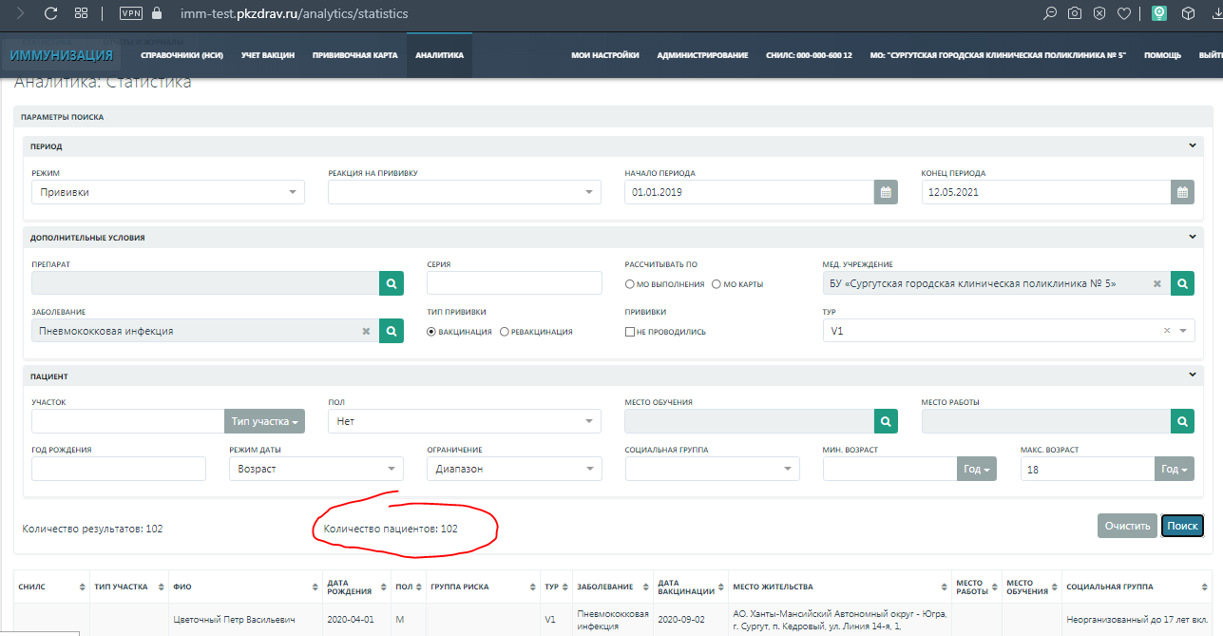

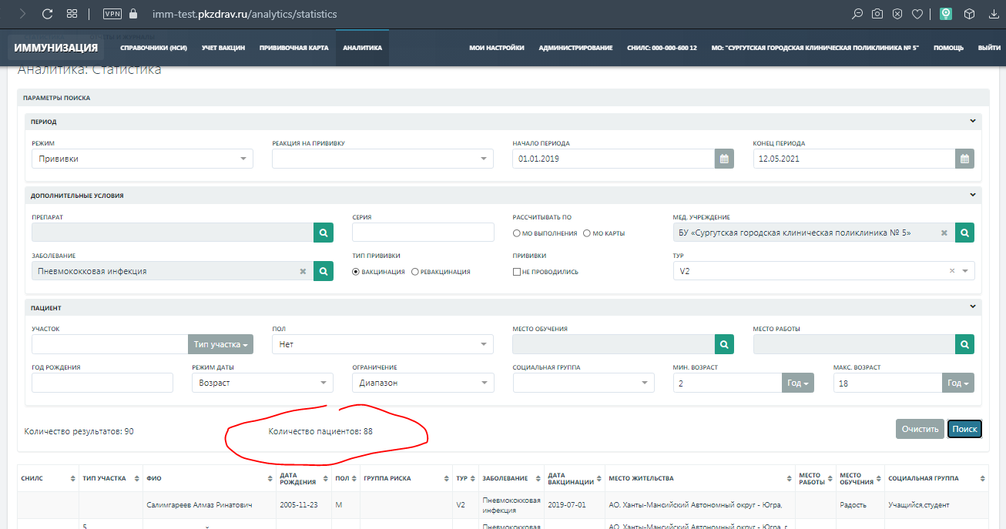

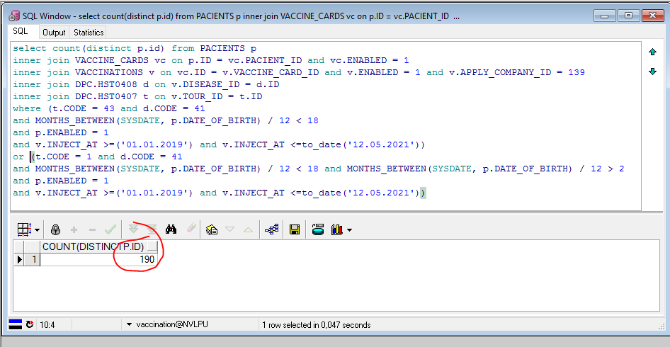

select count(distinct p.id) from PACIENTS p

inner join VACCINE_CARDS vc on p.ID = vc.PACIENT_ID and vc.ENABLED = 1

inner join VACCINATIONS v on vc.ID = v.VACCINE_CARD_ID and v.ENABLED = 1 and v.APPLY_COMPANY_ID = 139

inner join DPC.HST0408 d on v.DISEASE_ID = d.ID

inner join DPC.HST0407 t on v.TOUR_ID = t.ID

where (t.CODE = 43 and d.CODE = 41

and MONTHS_BETWEEN(SYSDATE, p.DATE_OF_BIRTH) / 12 < 18

and p.ENABLED = 1

and v.INJECT_AT >=('01.01.2019') and v.INJECT_AT <=to_date('12.05.2021'))

or (t.CODE = 1 and d.CODE = 41

and MONTHS_BETWEEN(SYSDATE, p.DATE_OF_BIRTH) / 12 < 18 and MONTHS_BETWEEN(SYSDATE, p.DATE_OF_BIRTH) / 12 > 2

and p.ENABLED = 1

and v.INJECT_AT >=('01.01.2019') and v.INJECT_AT <=to_date('12.05.2021'))