Setup / Configuration Approach

1. Database

- Create a table for dashboard in existing database

2. API

- Copy python files to wsc server
- Modify the config file with database details
- Trigger start script

3. WEB

- Copy the build folder to wsc server (httpd / jboss)
- Start web app (according to web server)

4. Agents

- Copy the shell script to below servers
a. wsc
b. ocs
c. fin
- Trigger start script

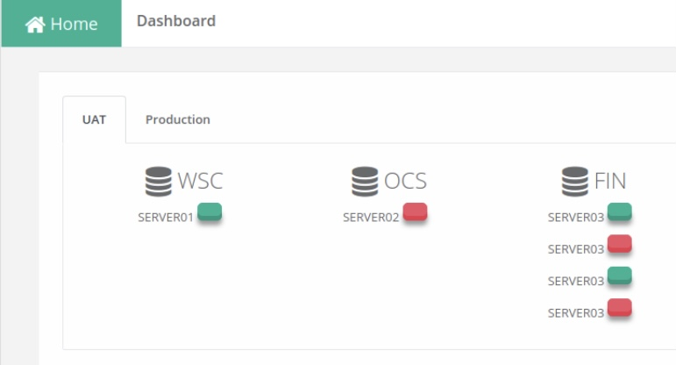
5. Open the Dashboard to monitor the services

