**Faculty of engineering - Shoubra**

**Benha University**

# Research Article / Research Project / Literature Review

in fulfillment of the requirements of

|  |  |
| --- | --- |
| **Department** | **Engineering Mathematics and Physics** |
| **Division** | **------------------** |
| **Academic Year** | **2019-2020 Preparatory** |
| **Course name** | **Computer** |
| **Course code** | **ECE001** |

## Title: -

**Programming Languages**

By:

|  |  |  |  |
| --- | --- | --- | --- |
|  | Name | Edu mail | B.N |
| 1 | كريم هاني حجاج رمضان | Karim195677@feng.bu.edu.eg | 609 |

**Approved by:**

|  |  |
| --- | --- |
| Examiners committee | Signature |
| Dr.Ahmed Bayoumi |  |
| Dr.Shady Elmashad |  |
| Dr. Abdelhamid Attaby |  |

**Githup link:**

**Githup pages:**

(Computer Programming Languages)

There is also a language for humans to communicate with each other, if for computers and smart computers, the programming language is another. This language also allows communication between programming engineers and specialists to communicate with computers. There is between this language, there is Python, what is that language and what is it used for and who use it and where to use it? Python is an advanced programming language that is interpreted, object-oriented and built on flexible and robust semantics who use it and where use it Professions and Industries Python developers, software engineers, back end developers, Python programmers Used by employers in information technology, engineering, professional services and design Major Organizations: Google, Pinterest, Instagram, YouTube, DropBox, NASA, ESRI Specializations and Industries: Web and Internet development (frameworks, micro-frameworks and advanced content management systems); scientific and numeric computing; desktop graphical user interfaces and what makes it important Python lets you work quickly to integrate systems as a scripting or glue language. It’s also suited for Rapid Application Develop The game Civilization 4 has all its inner logic, including AI, implemented in Python NASA uses Python in its Integrated Planning System as a standard scripting language Features Simple to learn and easily read Associated web frameworks for developing web-based applications Free interpreter and standard library available in source or binary on major platforms The second language is java, so what is that language and who are they using it Java is a general-purpose, object-oriented, high-level programming language with several features that make it ideal for web-based development Software engineers, Java developers Used by employers in communications, education, finance, health sciences, hospitality, retail and utilities

**screenshots**

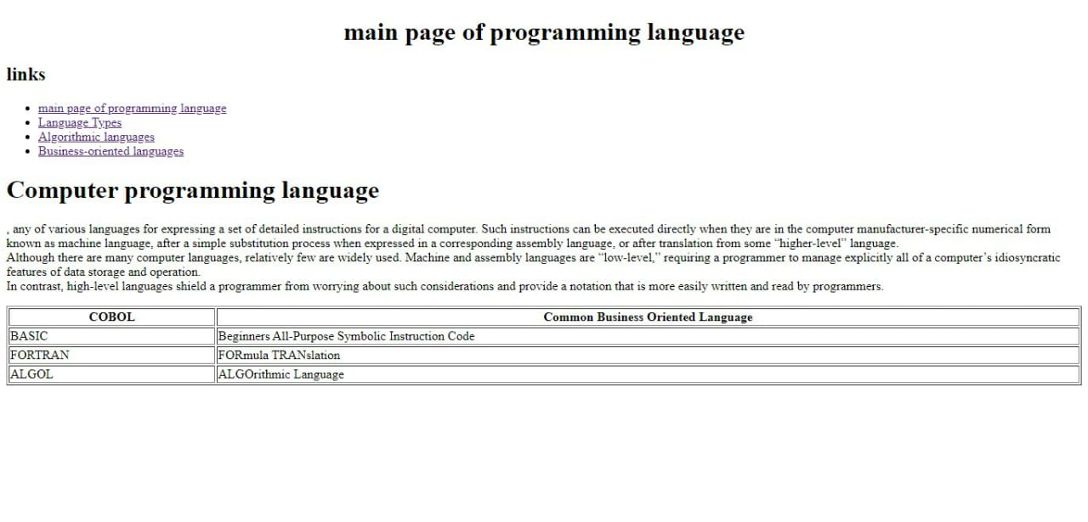

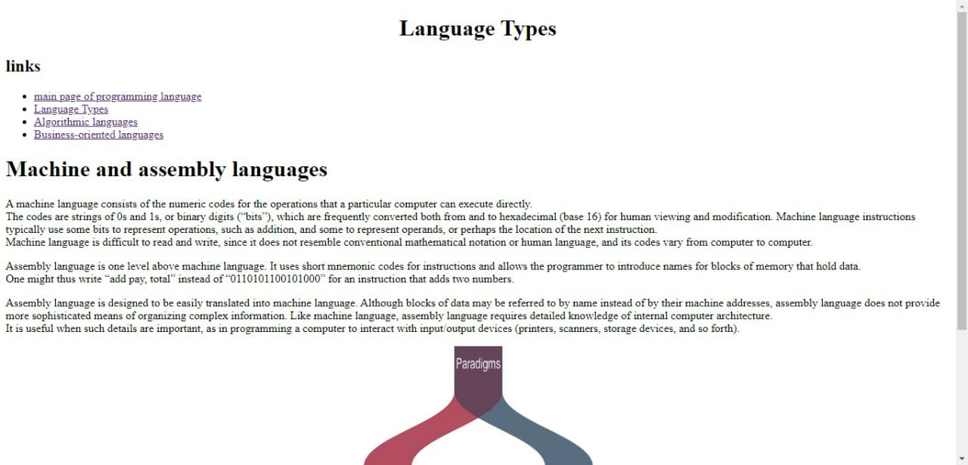

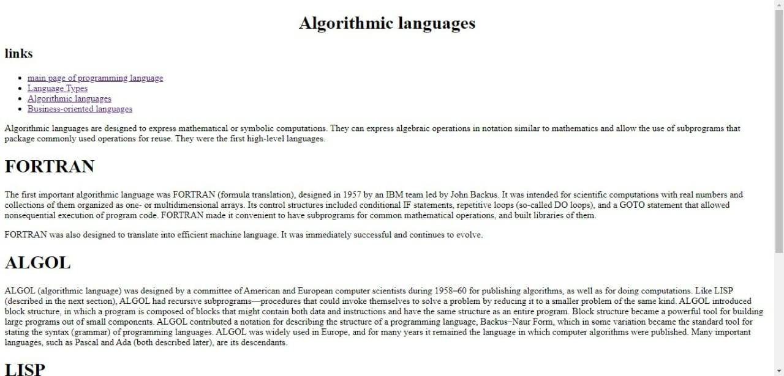

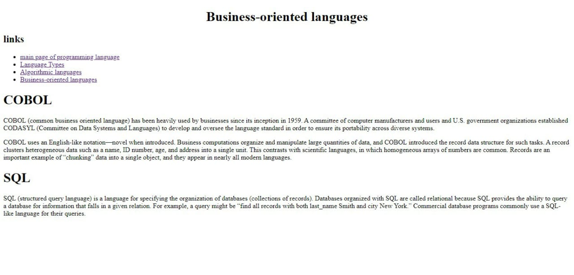

**Source code**

