Developing Python Apps

Part 1: Basics b

Kauko Kolehmainen

2020

Contents

Arrays 2

One dimensional array 2

2 dimensional array 3

Basic array algorithms 3

# Arrays

Normal variable can store only 1 value.  
Array can store several values of same data type.

In python we can use either arrays that have to be defined using array method or we can use lists.

With Python arrays we can use libraries as NumPy.

Now we use only concept array (though we here mean a python list).

## One dimensional array

Example: an array that can store 5 integers

|  |  |  |  |  |
| --- | --- | --- | --- | --- |
| 10 | 55 | 0 | 222 | 789 |

values = [10, 55, 0, 222, 789]

Every place of an array has an index. The first index is 0.

Print (values[0])

Gives 10.

Method **len()** gives the size of an array.

Let's print all values

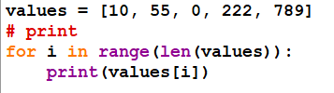

Result



## 2 dimensional array

Has rows and columns.

Example: Measures

|  |  |  |  |
| --- | --- | --- | --- |
| 1 | 2 | 3 | 4 |
| 122 | 132 | 99 | 96 |

measures = [[1,2,3,4],[122,132,99,96]]

Printing values

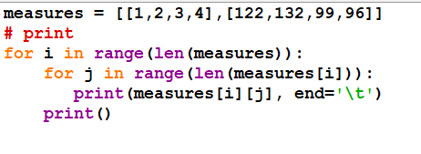

Result  


How to initialize a 2 dimensional array?

Example here

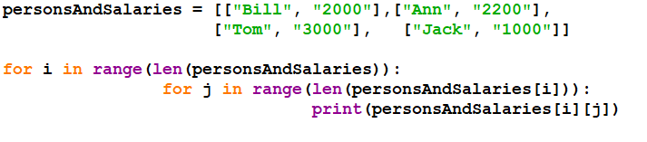

About string lists: in comparing you can use here common operators == and !=.

Here is an example

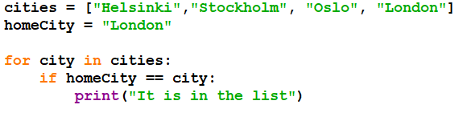

Result



## Basic array algorithms

Filling an array with random numbers   
Calculate the sum and the average.   
  
Searching for the minimun/maximum value   
Checking if a specific value is in the table   
Sorting an array   
------------------------------------------------------

Filling with random numbers

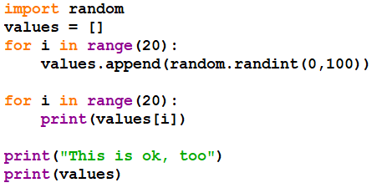

Result

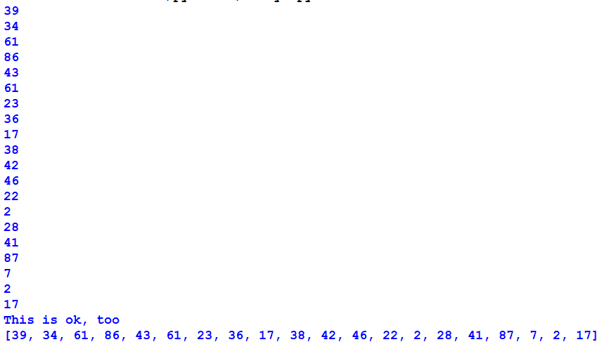

Minimun and maxmimun:  
Principle:  
Assign the first value of the table to some variable (e.g named min or max):  
Then we check if there are smaller or bigger values in the remaining part of the array  
If bigger or smaller value is found, it is assigned to min or max variable

Minimun:

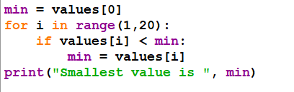

We get



Maximun: this is one of the assignments!

Searching for a specific value

Principle:  
Inside a loop we start comparing the value of array to the value we are searching for  
If values are same  
 add the position to some variable  
 break the loop (no use to go on…)

After loop we can test the variable: if it has some positive value,  
we can print that value was found  
else  
we print that it was not found

Code

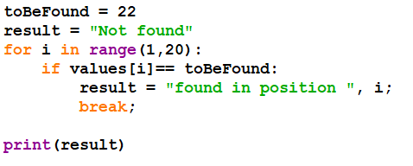

Result

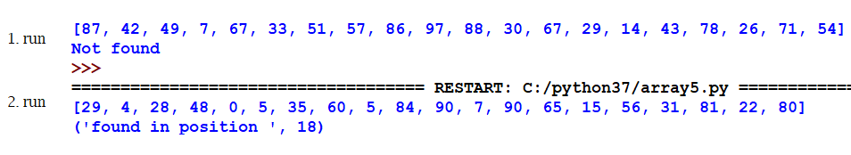

Sorting: We use here selection sort method (slow method, but good for demonstration)

Example table:

|  |  |  |  |  |  |
| --- | --- | --- | --- | --- | --- |
| 6 | 7 | 3 | 9 | 2 | 99 |

First we compare the first value to others value and swap values when needed:  
1. round:  
7 < 6? no  
3 < 6? yes, swap

|  |  |  |  |  |  |
| --- | --- | --- | --- | --- | --- |
| 3 | 7 | 6 | 9 | 2 | 99 |

9 < 3? no  
2 < 3? yes, swap

|  |  |  |  |  |  |
| --- | --- | --- | --- | --- | --- |
| 2 | 7 | 6 | 9 | 3 | 99 |

99 < 2? no  
  
Code

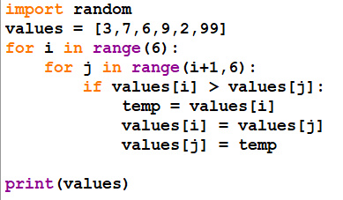

Result

