# Blockchain

1) Ganache workspace created

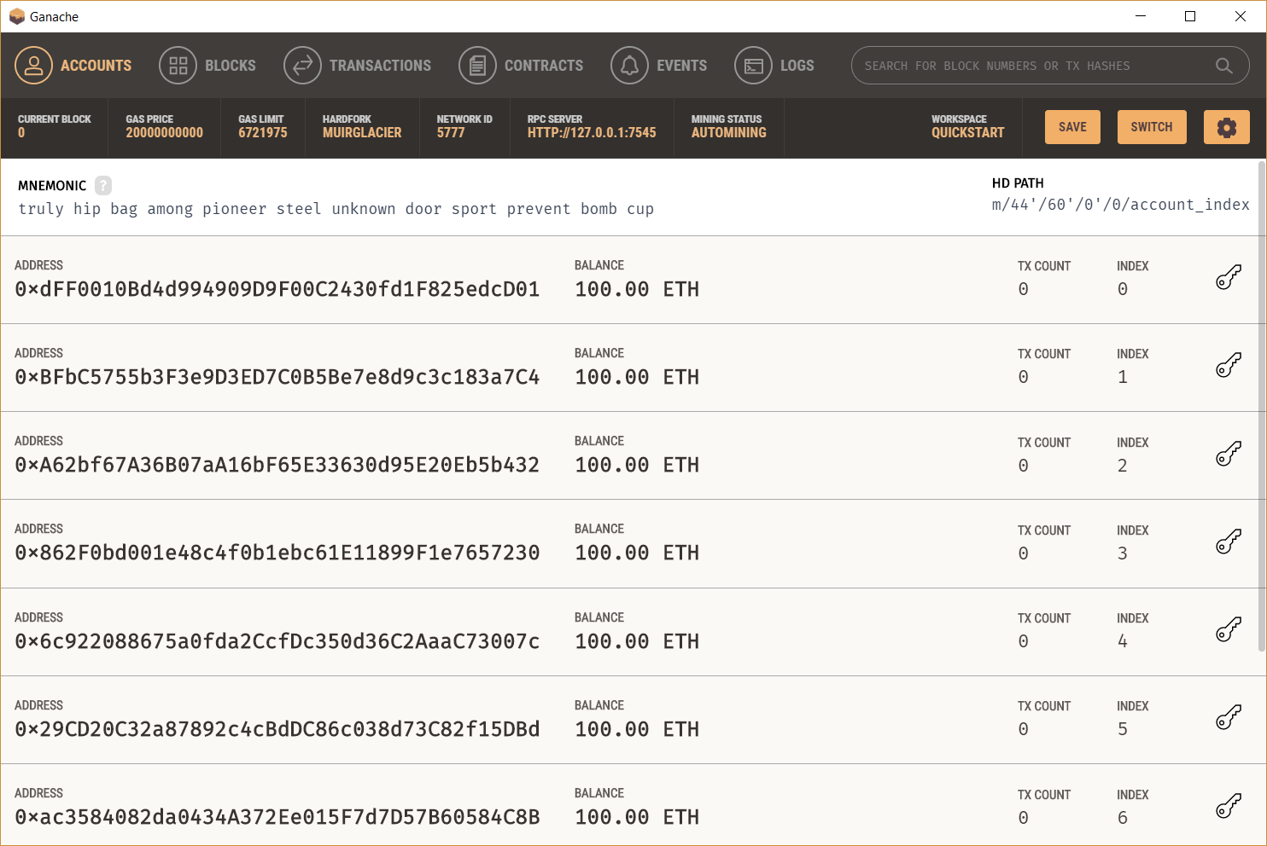

2) Access account with index 0 using its private key through my ether wallet

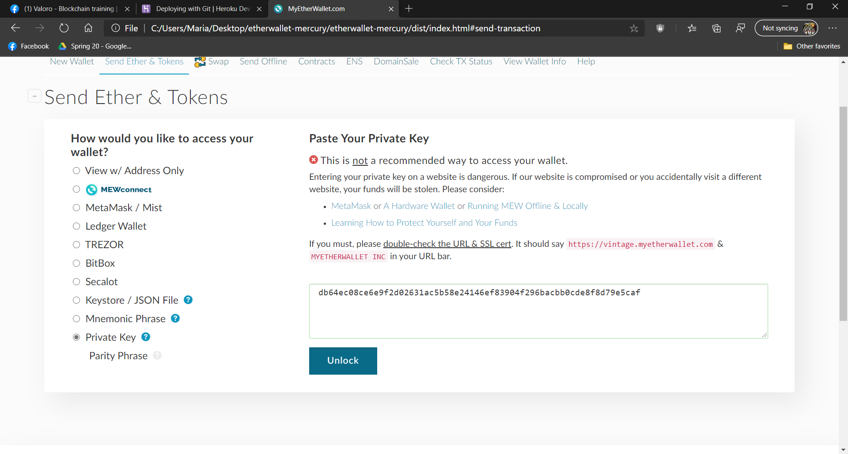

3) Sending 50 ether to account of index 1

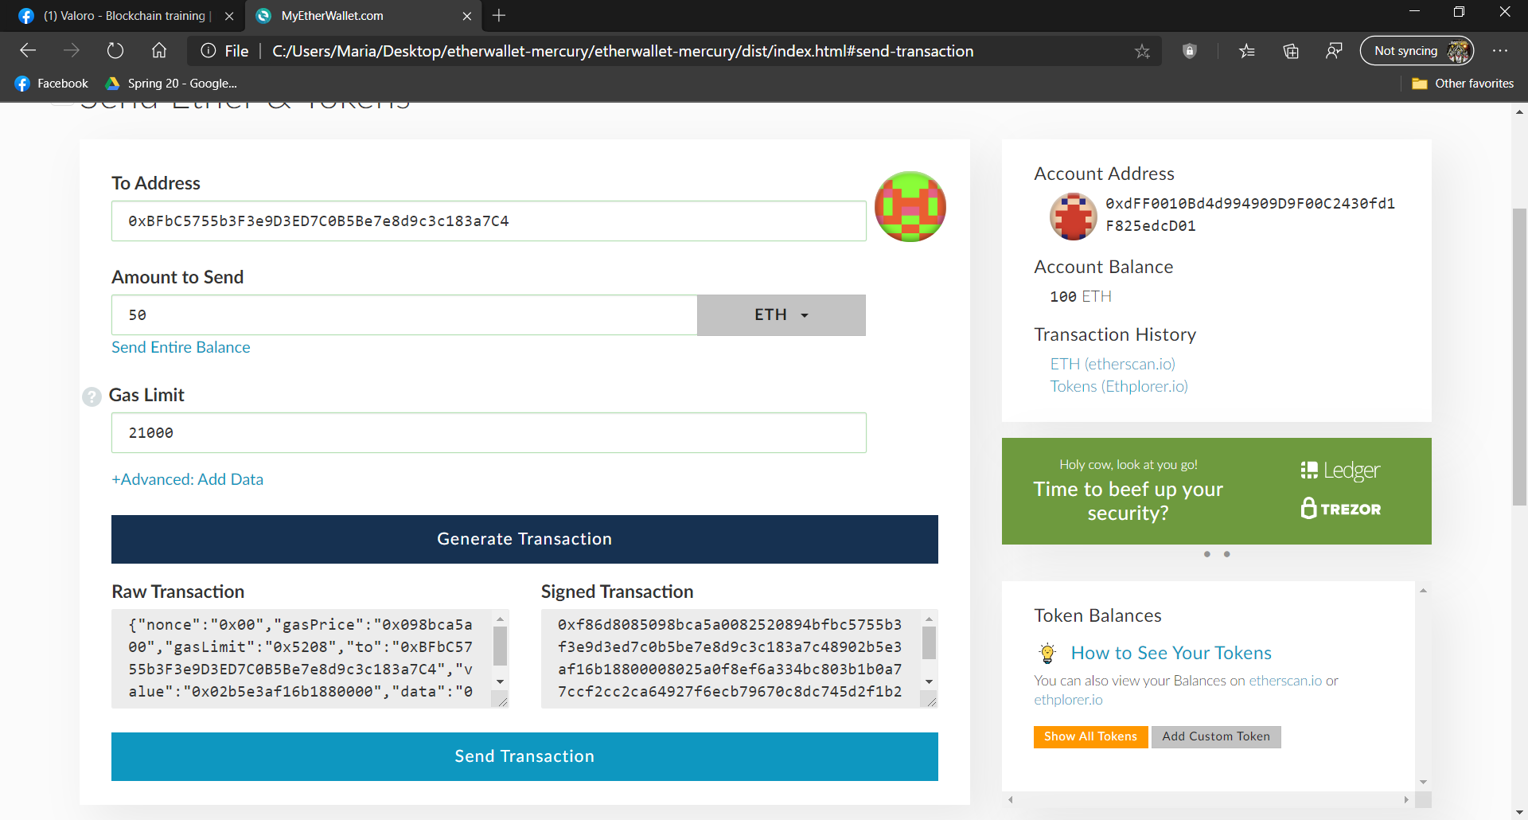

4) Balance transferred in ganache and a block is made

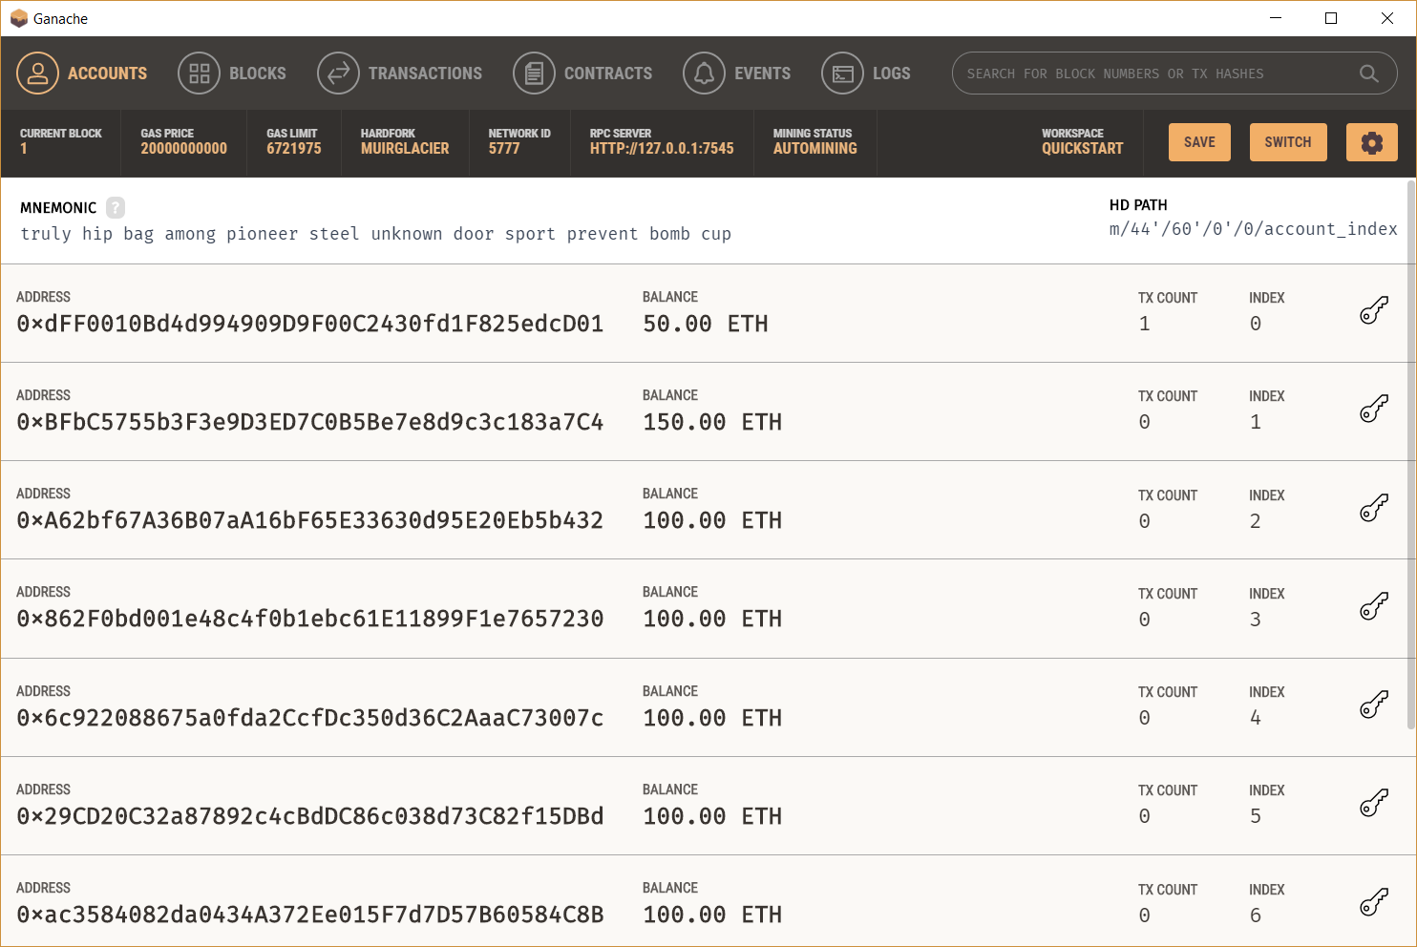

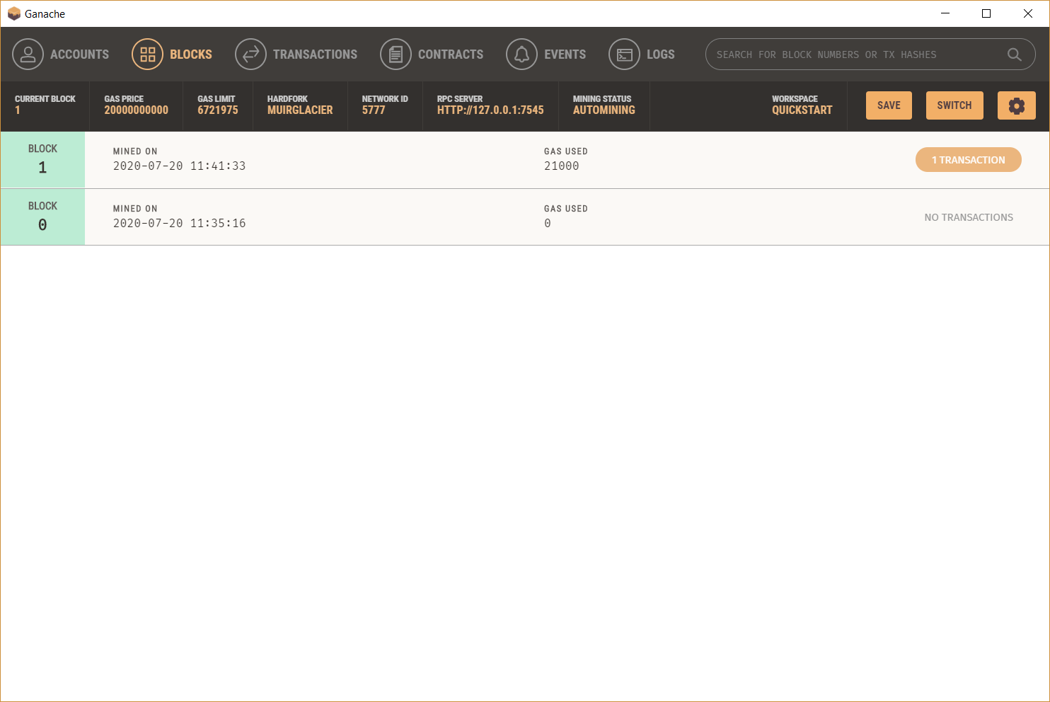

5) Using a smart contract (cryptokitties ales auction) (now 2 blocks are made)

