**Theory of Computing**

**Solution tutorial 1**

**Exercise 1** (*Sets*)

**1.** Is each of the following a well-defined set? Give brief reasons for each of your answers.

1. The collection of all alphanumeric characters.

Well-defined set. It does clearly describe the elements of the set. The set could be described as {x| x ϵ [a..z] or x ϵ [A..Z] or x ϵ [0..9] }

1. The collection of all tall people.

Not well-defined set. ‘Tall’ is not a well-defined property.

1. The collection of all integers *x* for which: 2*x* – 9 = 16.

Well-defined set but empty set. Because the solution will be a real number.

1. The collection of all real numbers *x* for which: 2*x* – 9 = 16.

Well-defined set that contains {x| x=(19+9)/2, x ϵ R}

1. The collection of all good tennis players.

Not well-defined set. ‘Good’ is not a well-defined property.

**2.** Prove the following identities:

$\left(A ∩ B\right)∪\left(A ∩ \overline{B }\right)=A$

$\left(A ∩ B\right)∪\left(A ∩ \overline{B }\right)$

$=A∩\left(B∪ \overline{B }\right)$

$$=\left(A ∩ U\right)=A$$

$\left(A ∩ B\right)∪\overline{\left(A ∪ \overline{B} \right)} = B$

$$\left(A ∩ B\right)∪\overline{\left(A ∪ \overline{B} \right)}$$

$$=\left(A ∩ B\right)∪(\overline{A} ∩\overset{̿}{B})$$

$$=B∩(A ∪\overline{A})$$

= $B∩U$

= B

1. A ∩ (A ∪ B) = A

A ∩ (A ∪ B)

= (A ∪ ø) ∩ (A ∪ B)

= A ∪ (ø ∩ B)

= A ∪ ø = A

**3.** Let U be the universe and *P*, *Q* and *R* three sets such that: **U** = {a, b, c, d, e, f, g, h}, *P* = {c, f}, *Q* = {a, c, d, e, f, h} and *R* = {c, d, h}

1. Draw a Venn diagram, showing these sets with all the elements entered into the appropriate regions.

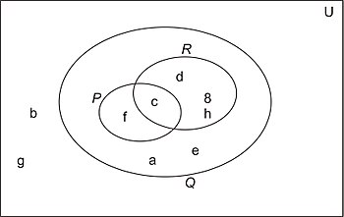

1. Which of the sets *P*, *Q* and *R* are proper subsets of others?

*P* ⊂ *Q*; *R* ⊂ *Q*

1. Are *P* and *R* disjoint sets?

No.

**Exercise 2** (*Graphs*)

1. Draw a picture of the graph with vertices {*v1*, *v2*, *v3, v4*} and edges {(*v1*, *v2*), (*v2*, *v3*), (*v3*, *v4*), (*v4*, *v1*), (*v1*, *v3*), (*v2*, *v4*)}.

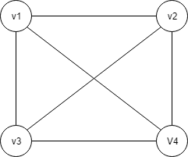

1. Enumerate all cycles in this graph.

{(*v1*, *v2), (v2, v4), (v4, v3), (v3, v1)*}

{(*v1*, *v2), (v2, v3), (v3, v1)*}

{(*v1*, *v4), (v4, v3), (v3, v1)*}

{(*v1*, *v2), (v2, v4), (v4, v1)*}

{(*v2*, *v3), (v3, v4), (v4, v2)*}

Let G = (V, E) be a simple undirected graph.

* 1. What is the maximum degree a node can have?

n - 1 (with n the number of vertices).

* 1. What is the maximum number of possible edges in this graph?

n(n-1)/2

**Exercise 3** (*Relations and Functions*)

Determine if the given relation is a function:

1. {(2, 4), (3, −7), (6, 10)}

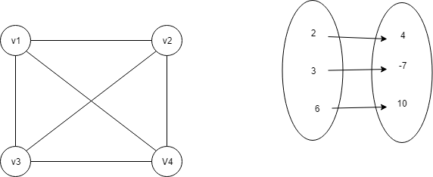

In this case, no matter which number you pick from the 1st set there is exactly one number in the second set which is associated to it. Therefore, this relation is a function.

1. {(−1,8), (4, −7), (−1, 6), (0, 0)}

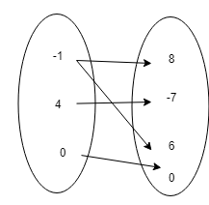

We have found a number (-1) from the 1st list that has two numbers in the 2nd list associated with it. Therefore, this relation is NOT a function.

1. {(2, 1), (9, 10), (−4, 10), (−8, 1)}

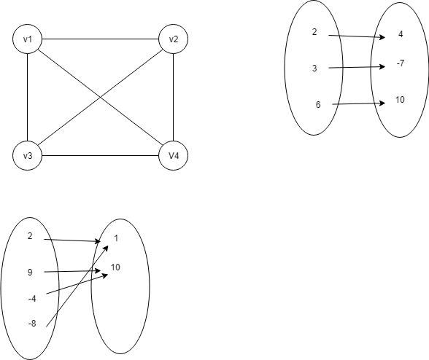

In this case, no matter which number you pick from the 1st list there is exactly one number in the second list which is associated to it. Therefore, this relation is a function.

**Exercise 4** (*Proof Techniques*)

1. Show that, $∀ n ϵ N$, we have:

$\sum_{i=0}^{n}{i^{2}}=\frac{n\left(n+1\right)\left(2n+1\right)}{6}$

Basis

For n=0, we have:

$$\sum_{i=0}^{0}{i^{2}}=0^{2}=0$$

And $\frac{n\left(n+1\right)\left(2n+1\right)}{6}=\frac{0(1)(2)}{6}=0$

So, the statement holds for n=0.

Induction assumption

Let us suppose that we have, for n ϵ N:

$$\sum_{i=0}^{n}{i^{2}}=\frac{n(n+1)(2n+1)}{6}$$

We want to prove now that:

$$\sum_{i=0}^{n+1}{i^{2}}=\frac{(n+1)(n+2)(2\left(n+1\right)+1)}{6}$$

$$\sum_{i=0}^{n+1}{i^{2}}=\sum_{i=0}^{n}{i^{2}}+{(n+1)}^{2}$$

$$=\frac{n(n+1)(2n+1)}{6}+{(n+1)}^{2}$$

$$=\frac{n\left(n+1\right)\left(2n+1\right)+6{(n+1)}^{2}}{6}$$

$$=\frac{\left(n+1\right)[n \left(2n+1\right)+6\left(n+1\right)]}{6}$$

$$=\frac{\left(n+1\right)[ {2n}^{2}+n+6n+6]}{6}$$

$$=\frac{\left(n+1\right)(n+2)(2n+3)}{6}$$

$$=\frac{(n+1)(n+2)(2\left(n+1\right)+1)}{6}$$

1. Prove that:

$$∀n ϵN, 2^{n+1}-1= \sum_{i=0}^{n}{2^{i}}$$

$∀ n ϵ N$ 2n+1 -1= $\sum_{i=0}^{n}{2^{i}}$

Basis

For n=0

20+1 -1 = = 20 =1

Induction assumption:

Let n ϵ N, we suppose that we have:

2n+1 -1= $\sum_{i=0}^{n}{2^{i}}$

We want to prove that:

2(n+1)+1 -1= $\sum_{i=0}^{n+1}{2^{i}}$

$\sum_{i=0}^{n+1}{2^{i}}$ = $\sum_{i=0}^{n}{2^{i}}$ +2(n+1)

= 2n+1 -1+2(n+1)

= 2n+2-1

=2(n+1)+1-1

1. Prove that for any a , if a2 is even, then a is even.

Let a2 be even. Suppose that a is odd, then there exists k $∈N$ such as: $a=2k+1$ with.

Then:

+ 1

Even number +1 : gives an odd number

Which gives: $a^{2} is an odd number$ which is a contradiction.

1. Prove that if a.b = n, then either a or b must be ≤ $\sqrt{n}$, where a, b, and n are non-negative real numbers.

$$a.b=n a≤\sqrt{n} or b≤\sqrt{n}$$

Suppose that: $a>\sqrt{n} and b>\sqrt{n}$

$a.b >\sqrt{n}. \sqrt{n}$

$a.b > n$ → Impossible (contradiction)