CMOS Ring Oscillator

Group Names:

1. مصطفى المهدى أحمد عطوة
2. فتحى محمد فتحى أمين
3. مصطفى ياسر عبد الحميد
4. الحسن السيد حسين على
5. عمر خالد عبد الرحمن عبد الحفيظ
6. أحمد محمود محمد سيد
7. كريم أسامة السيد عبد الرحمن

What is a CMOS Ring Oscillator?
A CMOS ring oscillator is a circuit composed of a series of CMOS inverters connected in a closed loop. Due to the propagation delay of each inverter, the circuit makes an oscillatory behavior.

Main Applications
CMOS ring oscillators are used in various applications, including:
- Clock generation: Used in integrated circuits for generating timing signals.
- On-chip testing: Helps measure process variations and transistor performance.
- Random number generation: Used in cryptographic applications due to its noise and variability properties.

Key Components
The CMOS ring oscillator primarily consists of the following components:
- Inverter stages: A series of CMOS inverters that form the oscillatory loop.
- Power supply (VDD, GND): Provides the necessary voltage levels for operation.
- Control circuitry : Used in voltage-controlled ring oscillators to control frequency.

Importance of Having an Odd Number of Stages
For oscillation to occur, the total phase shift around the loop must be 360°. Each CMOS inverter provides a 180° phase shift. If an even number of inverters were used, the total phase shift would be 0° (mod 360°), leading to a stable DC state instead of oscillation. An odd number of inverters ensures a phase shift of 180° + 180° (feedback delay) = 360°.

Derivation of the Sensitivity Equation
The oscillation frequency of a CMOS ring oscillator is given by:
f = 1/2Ntd
where:
- N is the number of inverter stages (odd number).
- td is the propagation delay of a single inverter.

The sensitivity Equation:
Sf = df/dx = -1/2N d(td)/dx 1/(td^2)

Circuit
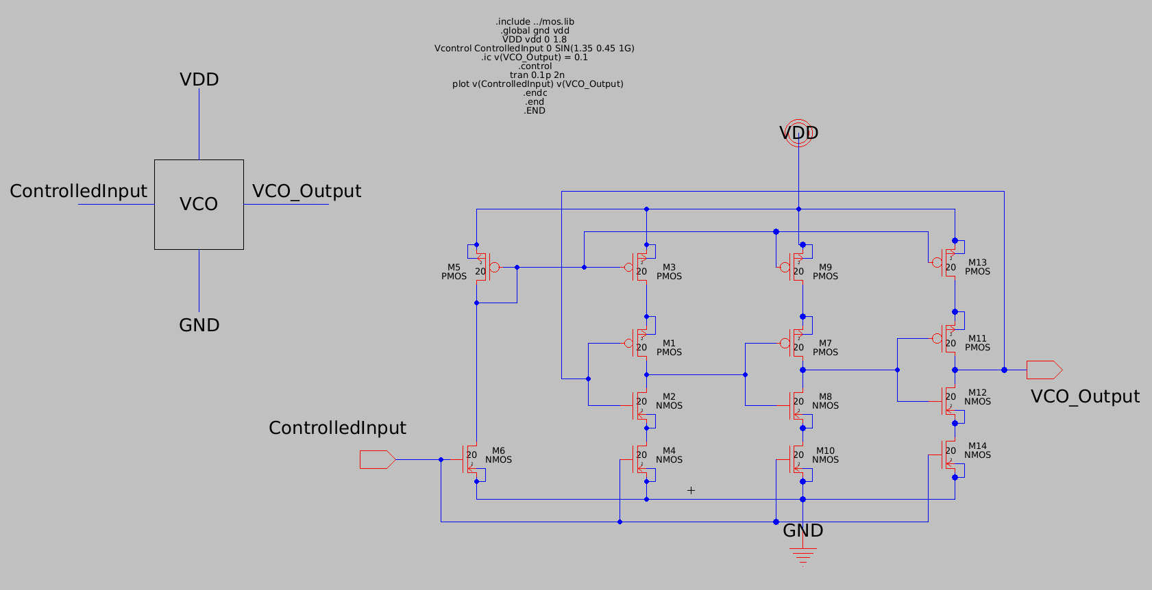

Simulation

SineWave Input:

