CMOS_NAND

Group Names:

1. مصطفى المهدى أحمد عطوة
2. فتحى محمد فتحى أمين
3. مصطفى ياسر عبد الحميد
4. الحسن السيد حسين على
5. عمر خالد عبد الرحمن عبد الحفيظ
6. أحمد محمود محمد سيد
7. كريم أسامة السيد عبد الرحمن

Impact of Feature Size Reduction

As semiconductor technology advances, transistor dimensions shrink, leading to several consequences:
- Reduced Gate Capacitance: Shorter channel lengths decrease gate capacitance, improving switching speed.
- Utilizing Area: Lead To Add more Transistors which led to more features.

Effect on Circuit Performance
- Speed Enhancement: Reduced capacitance enhances signal propagation and switching speeds.
- Power Consumption: Lower capacitance reduces dynamic power dissipation, but leakage currents may increase.

Circuit

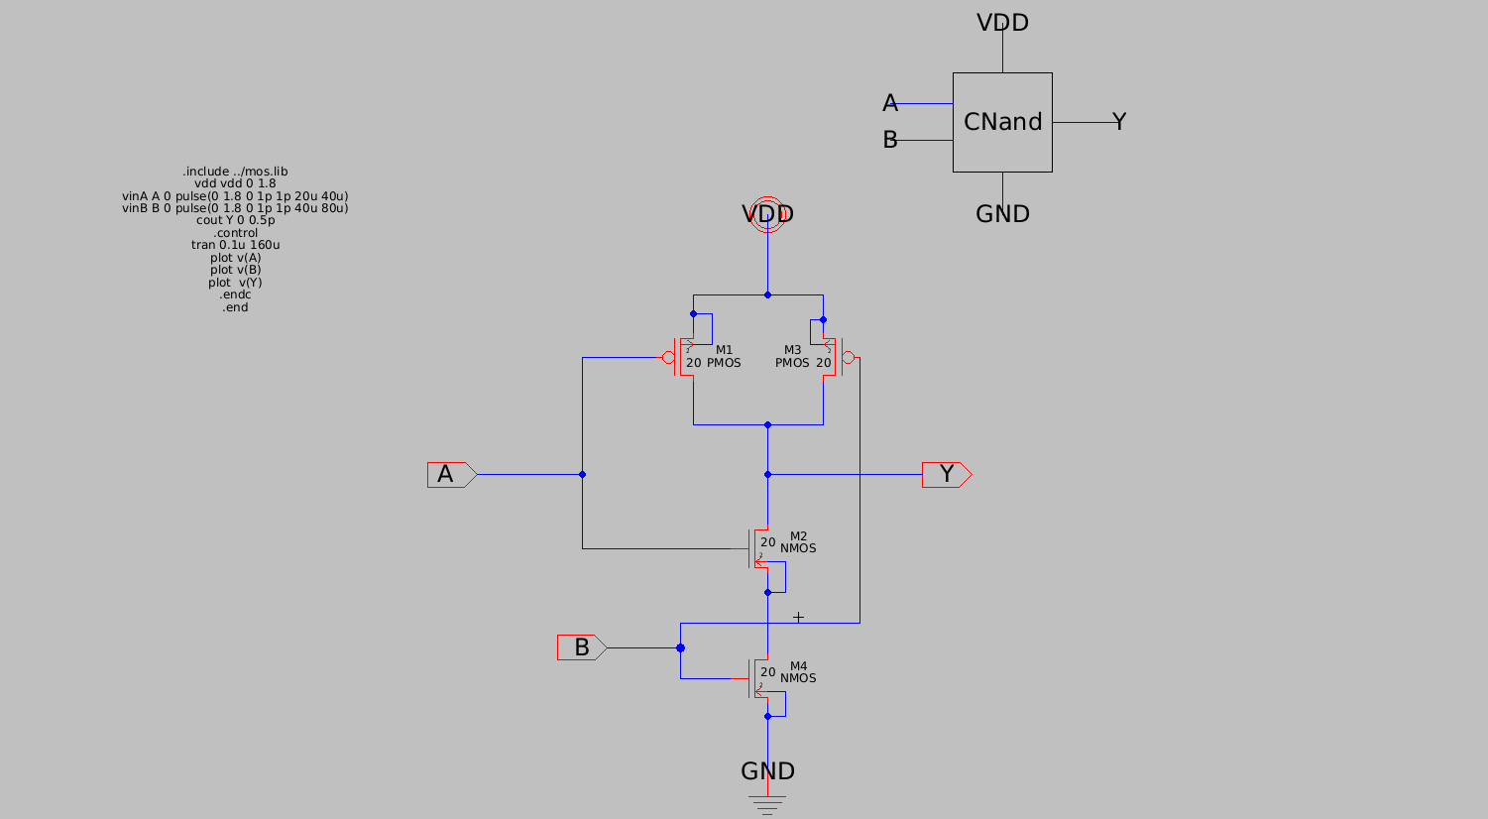

Layout
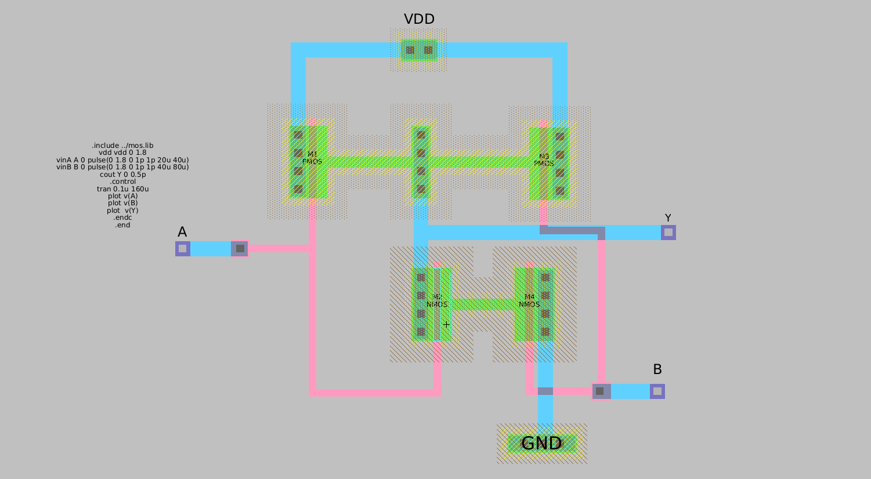

Simulation
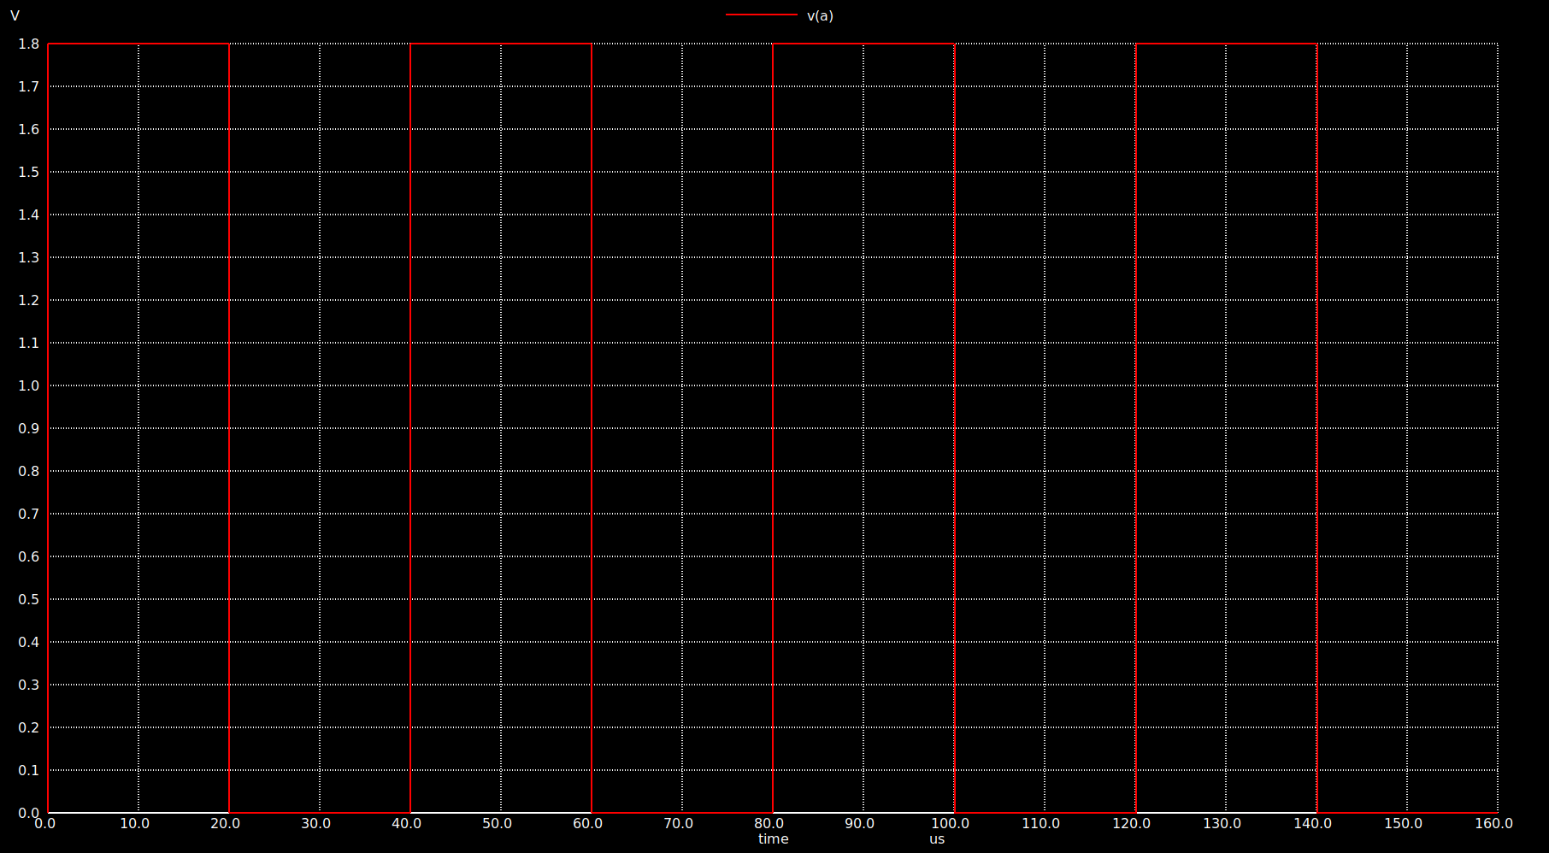
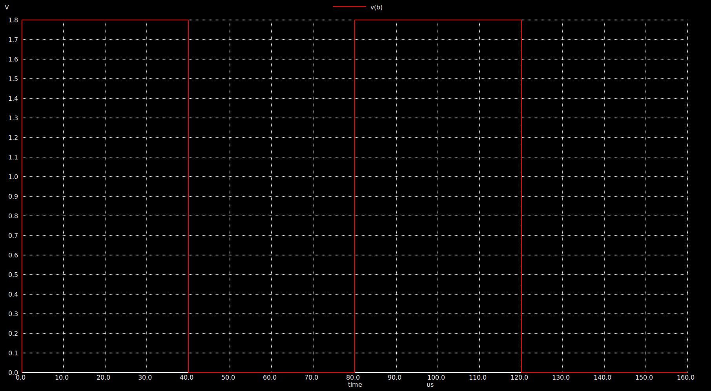
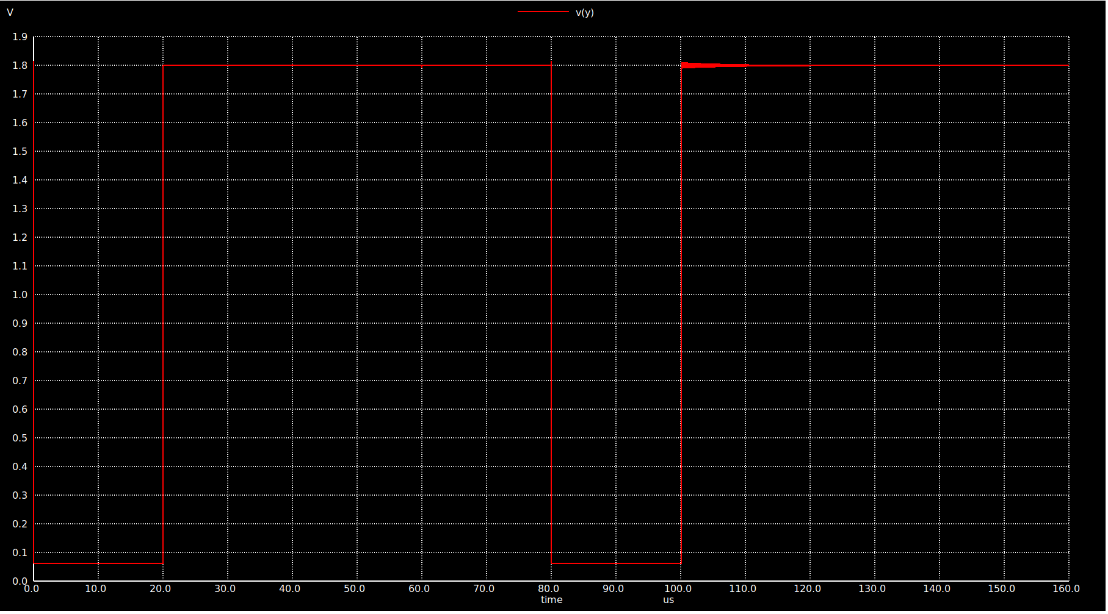

DRC And LVS

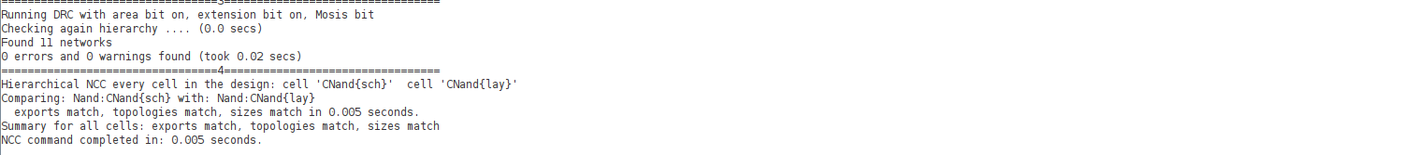

PEX : DUE TO Problems in Cadence we Used Another Program But it doesn’t support PEX just DRC And LVS.

