DSP Lab
Assignment

الاسم : كريم أسامة السيد عبد الرحمن
السكشن : 2

Q1:

When n = 4

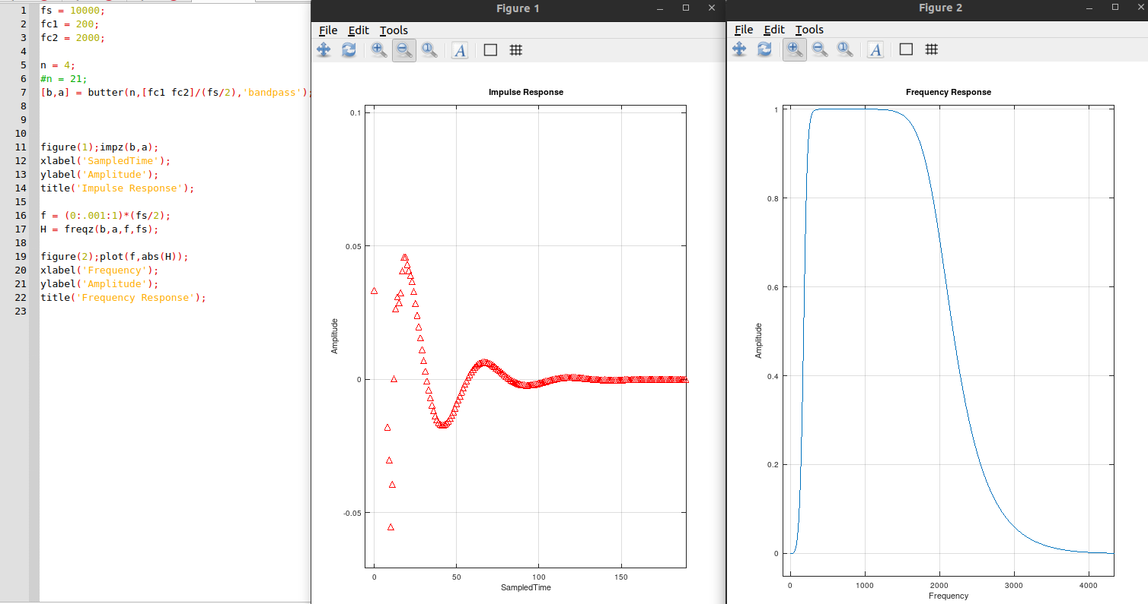

System is stable

When n = 21

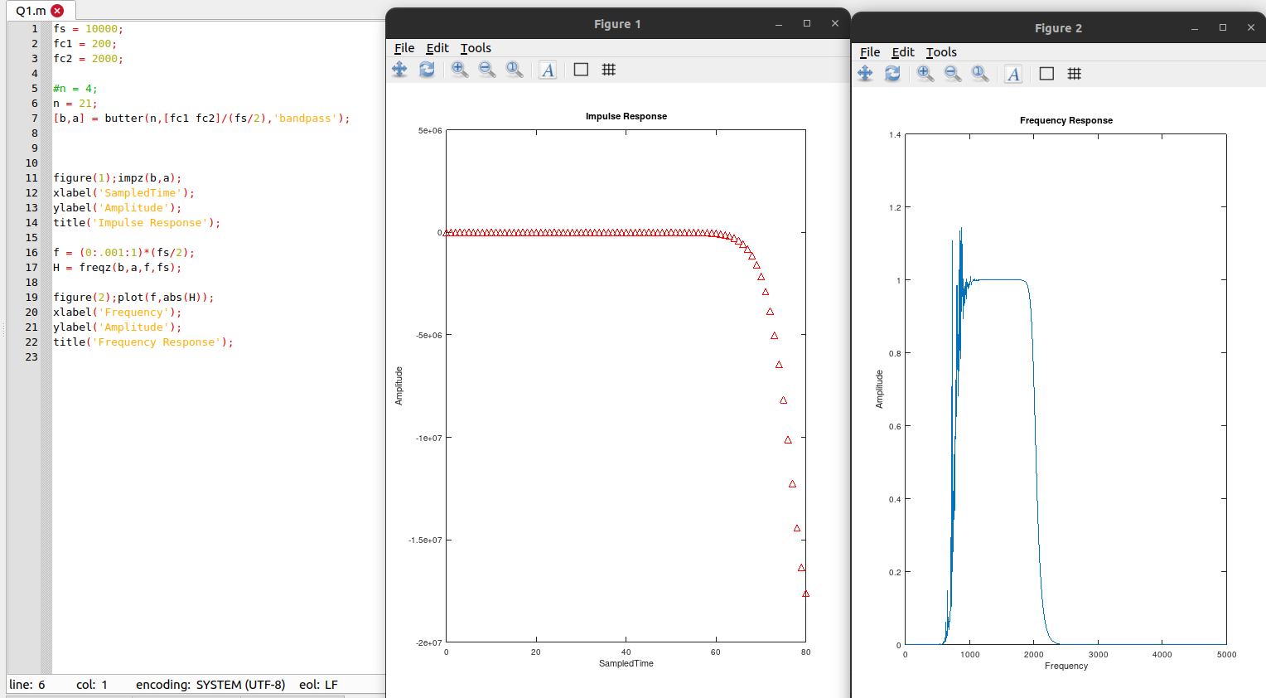

System is unstable

Q2:

1- Read the file into MATLAB, specify #samples and time of recording in sec.

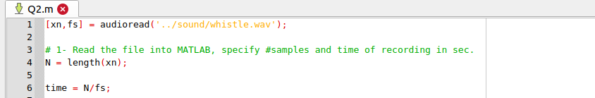
#samples = 41472
time = 1.7280 sec

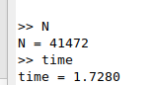

2- Plot the frequency spectrum of signal x, do you notice the peaks?

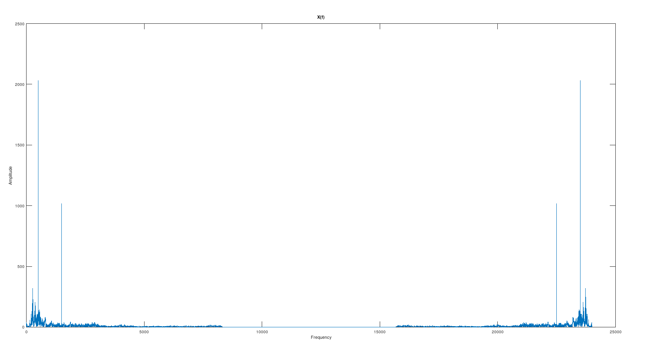
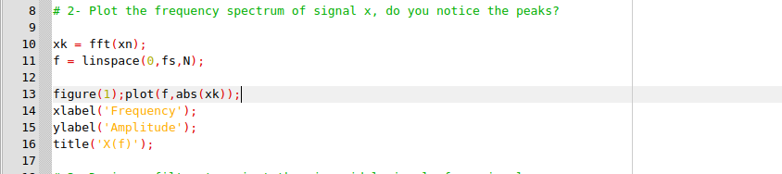

3- Design a filter to reject the sinusoidal signals from signal x.

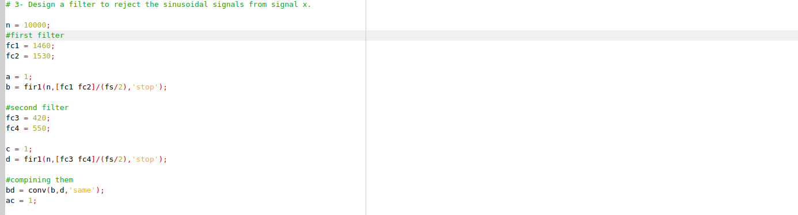

4- Plot frequency response, impulse response of the designed filter. Is the filter stable?

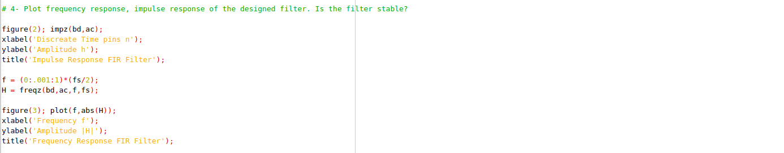

Impulse Response:

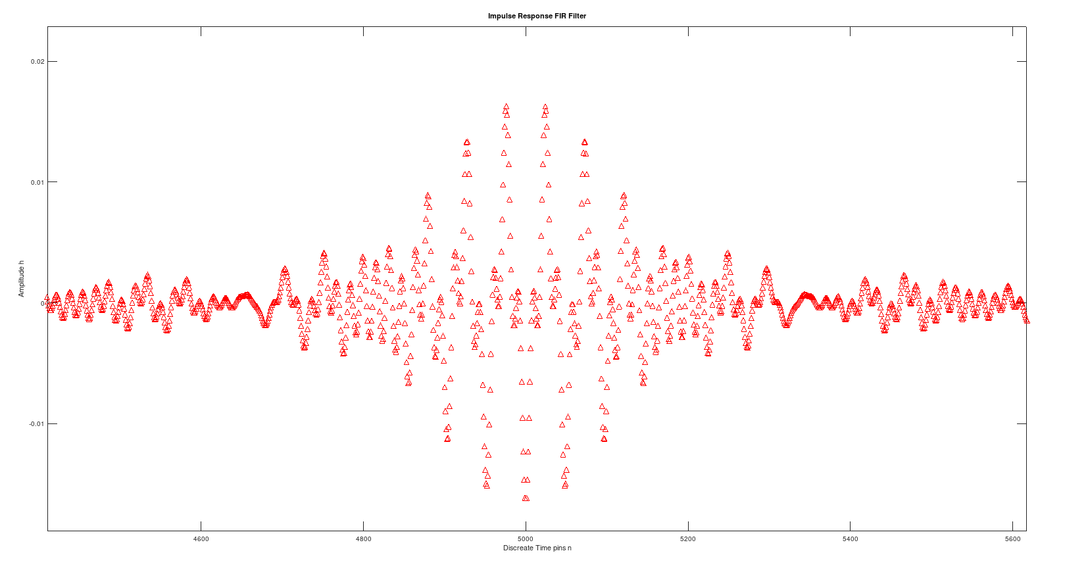

Frequency Response:

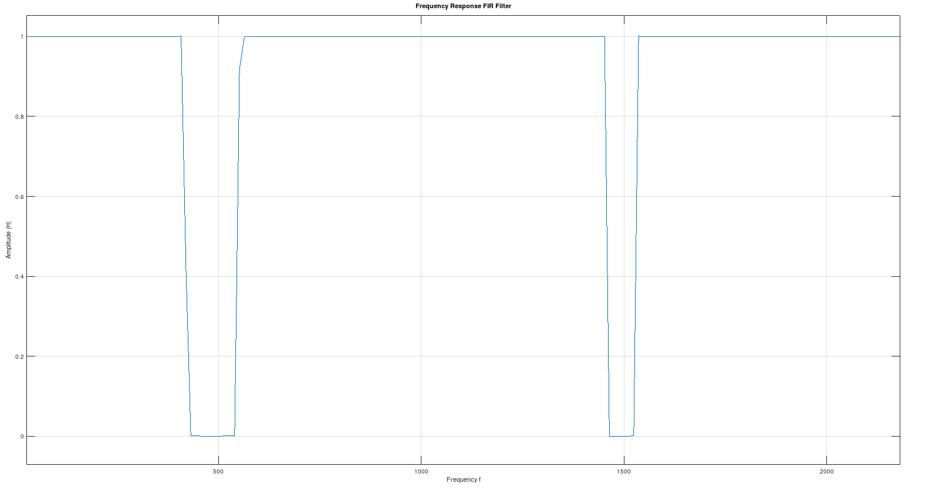

Yes Filter is Stable

5- Plot the frequency spectrum of signal y (the output of the filter).

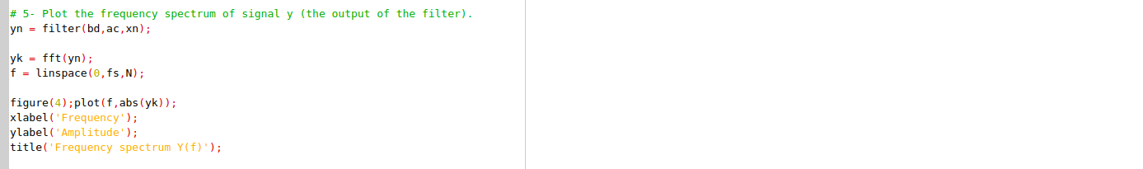

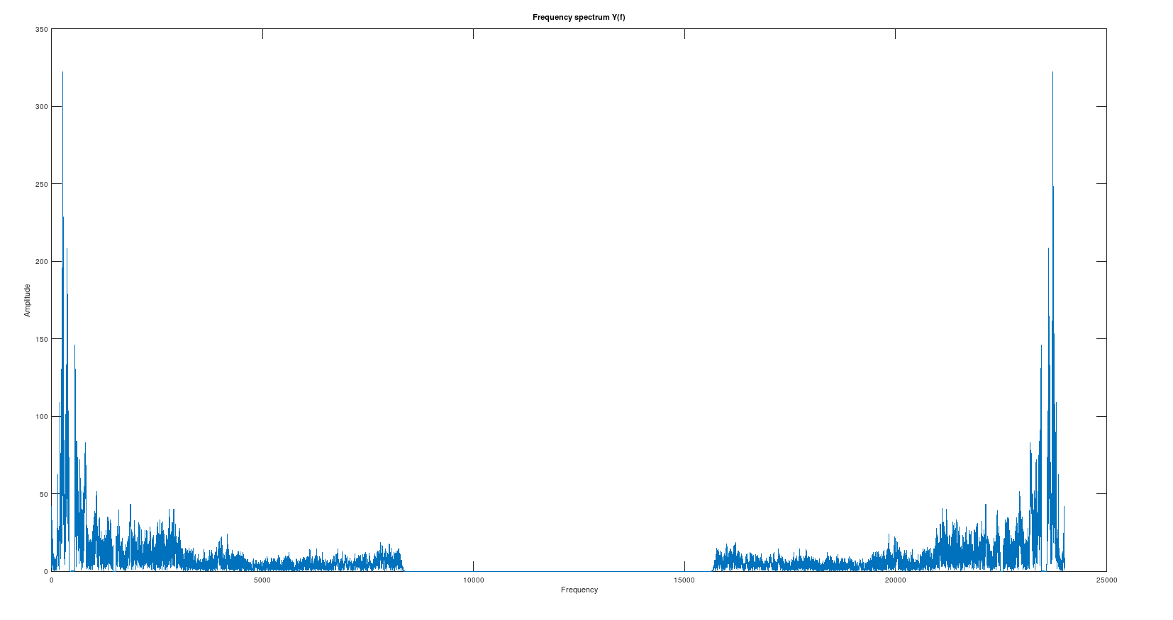

6- Play the output signal is the whistle still there?



No

7- Calculate the energy for the original signal and the filtered signal.

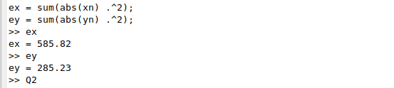

Q3: For each of the following filters plot frequency responses, impulse responses:

1- y[n] =1/8 * (x[n] + x[n − 1] + x[n − 2] + x[n − 3] + x[n − 4] +x[n − 5] + x[n − 6] + x[n − 7])

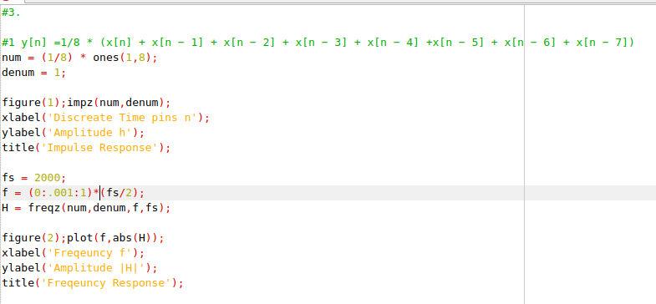

Impulse Response:

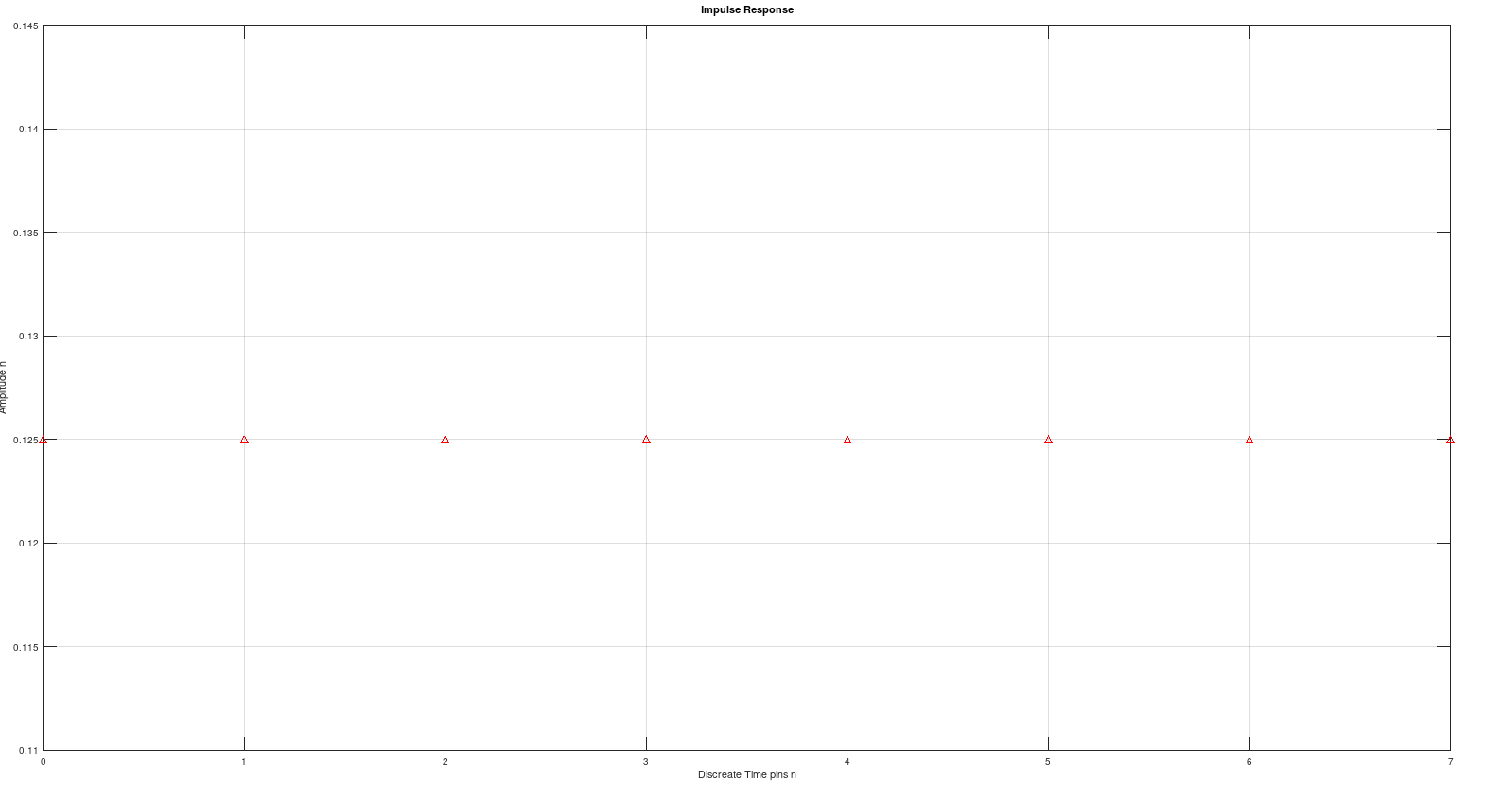
Freq Response:

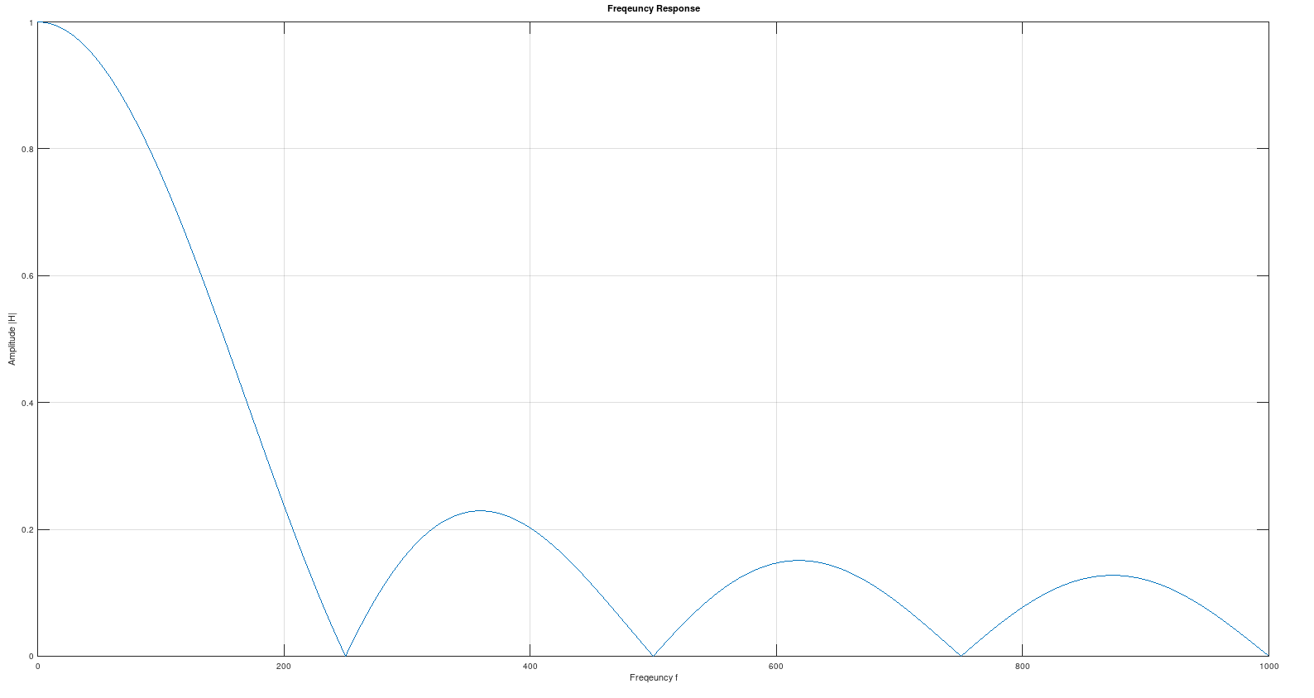

2- y[n] =1/8 * (x[n] − x[n − 8]) + y[n − 1]

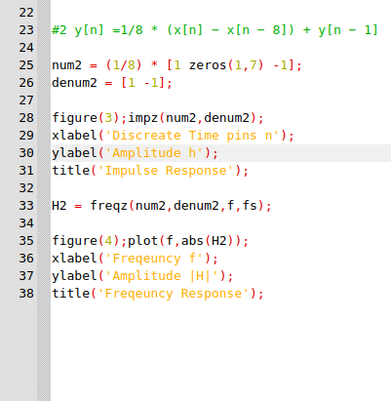

impulse Response

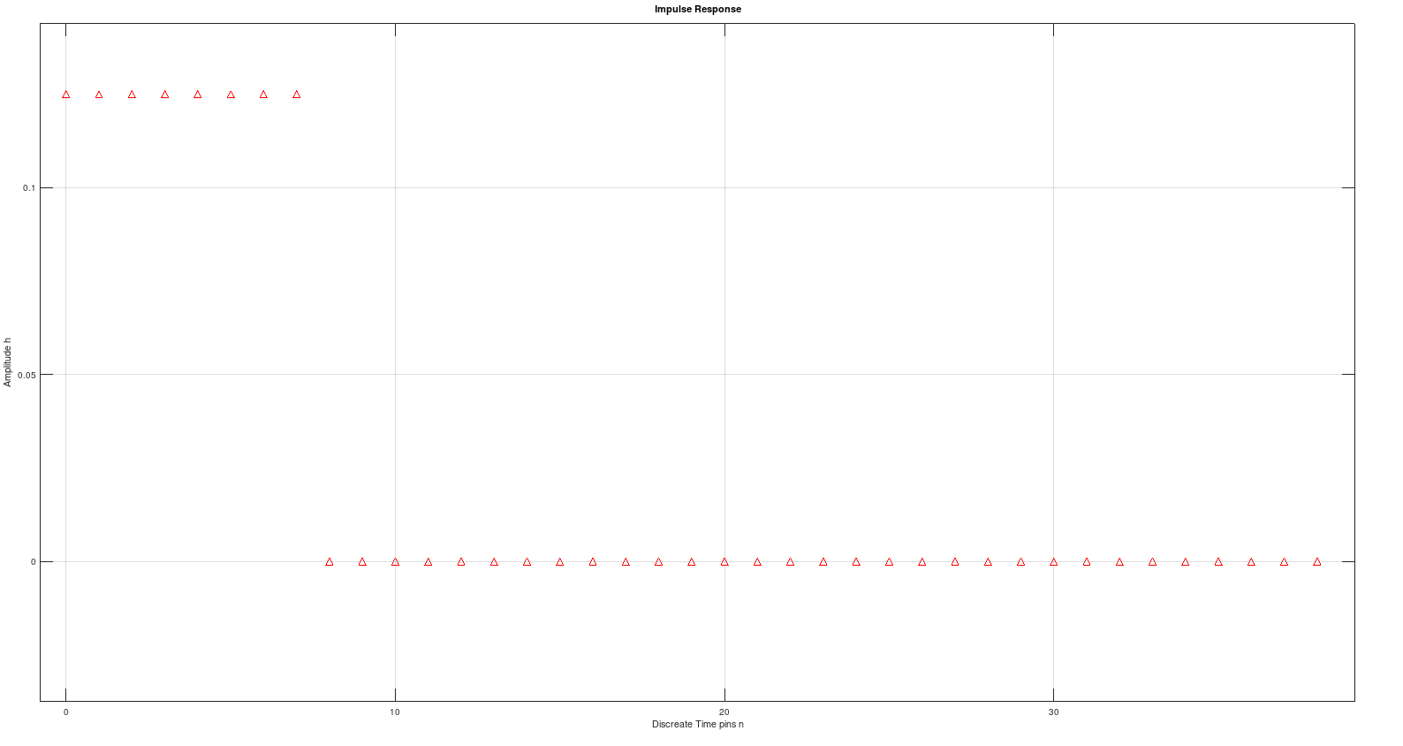

Freq Response:

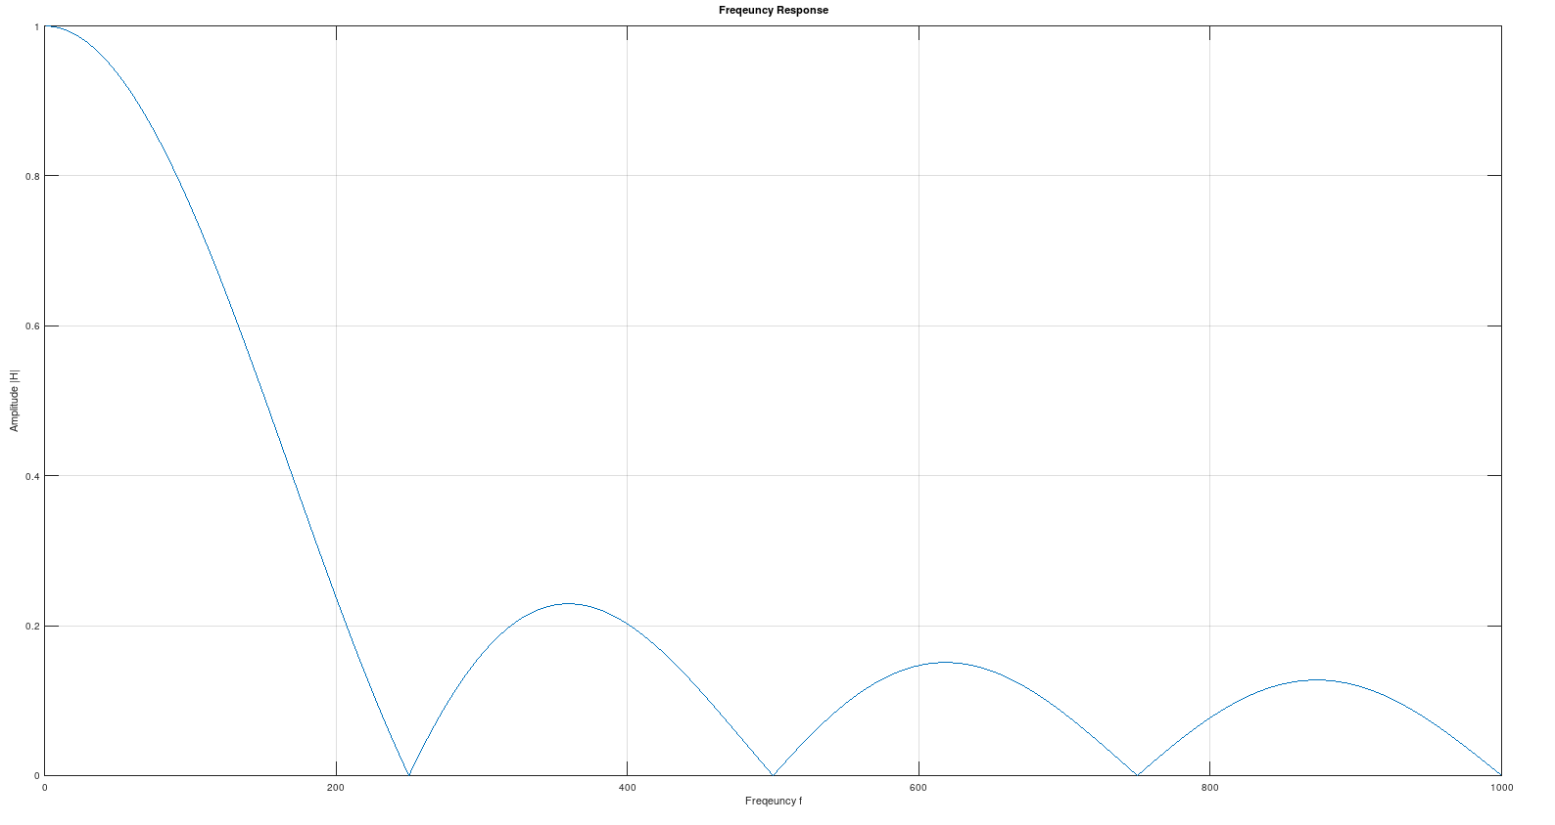

Comment
Both Filter Systems Have the Same Impulse and Frequency Response with CutOff Freq = 150 Hz

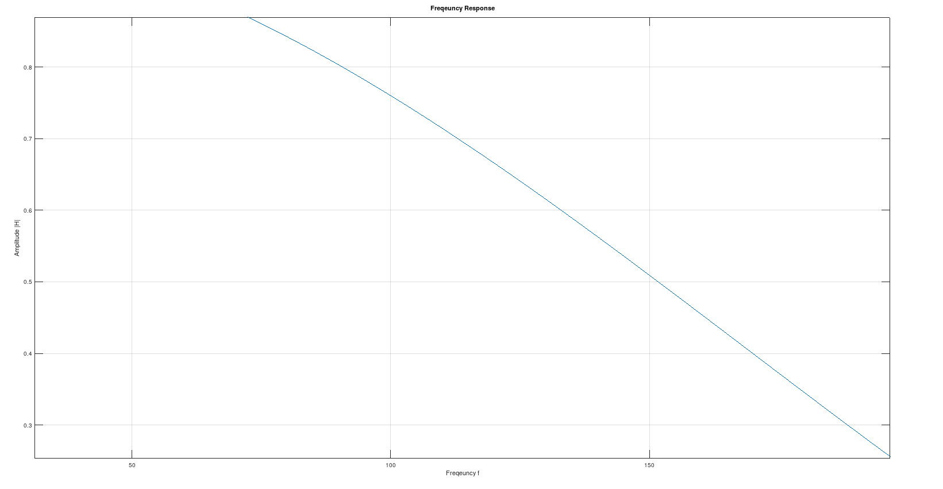

Q4: Filter File1.wav

it’s same code as Whistle Question but with
CutOff Frequencies [480 520] and [590 610]

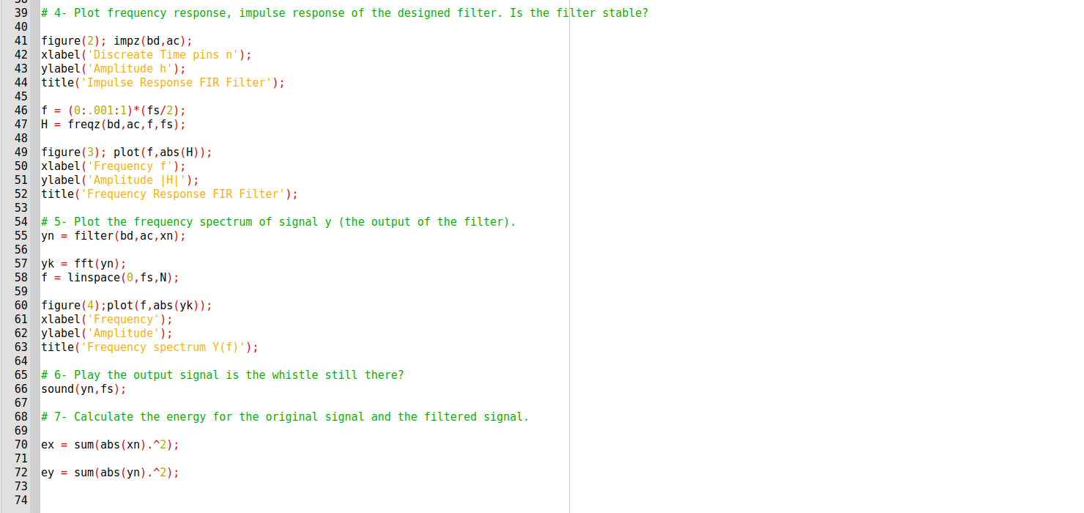
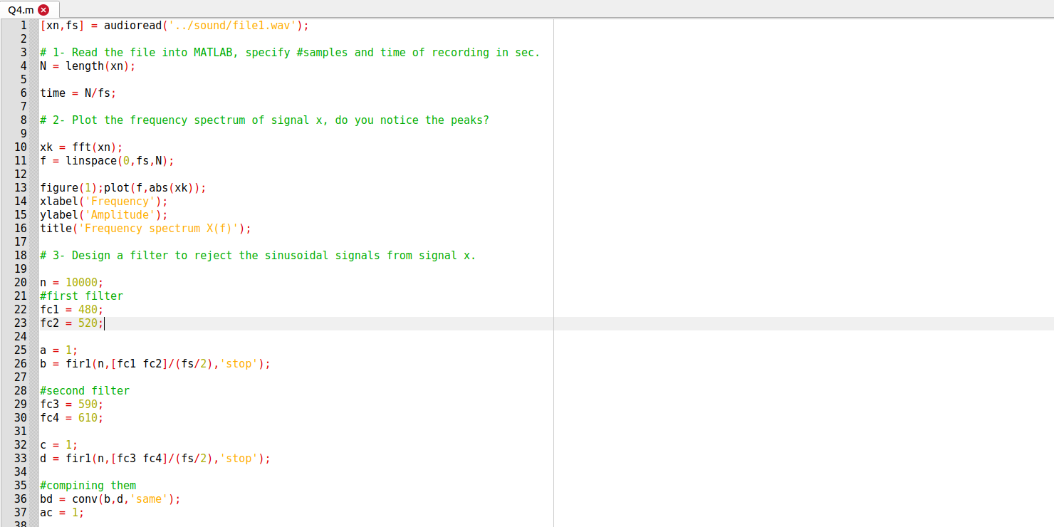

Plotting input Signal in freq domain:

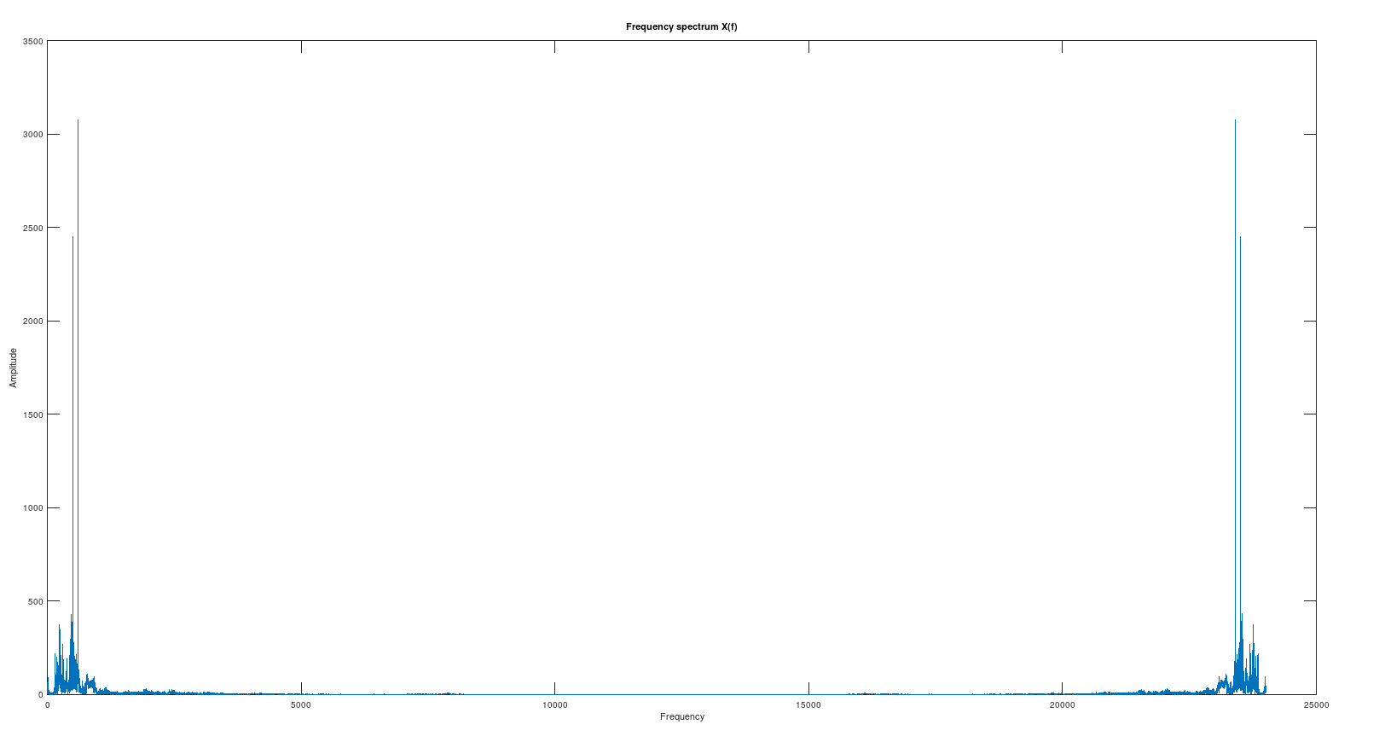
Impulse Response of Band Stop filter
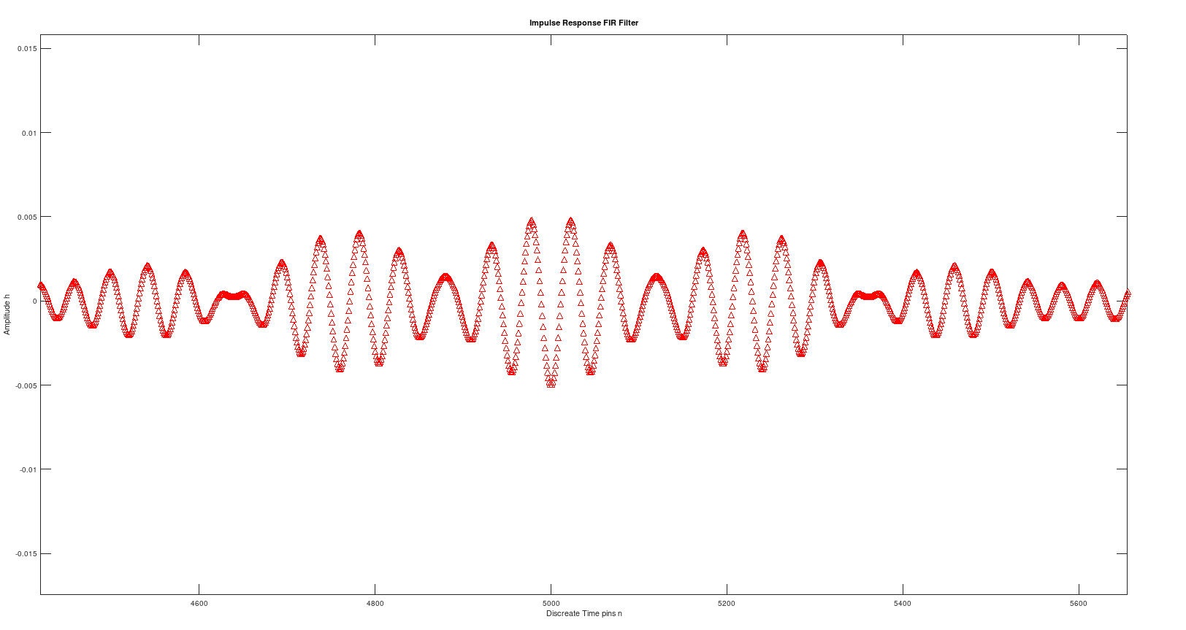
Freq Response
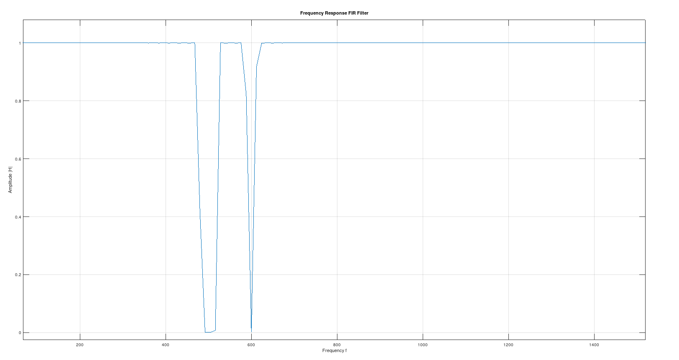
Output Signal
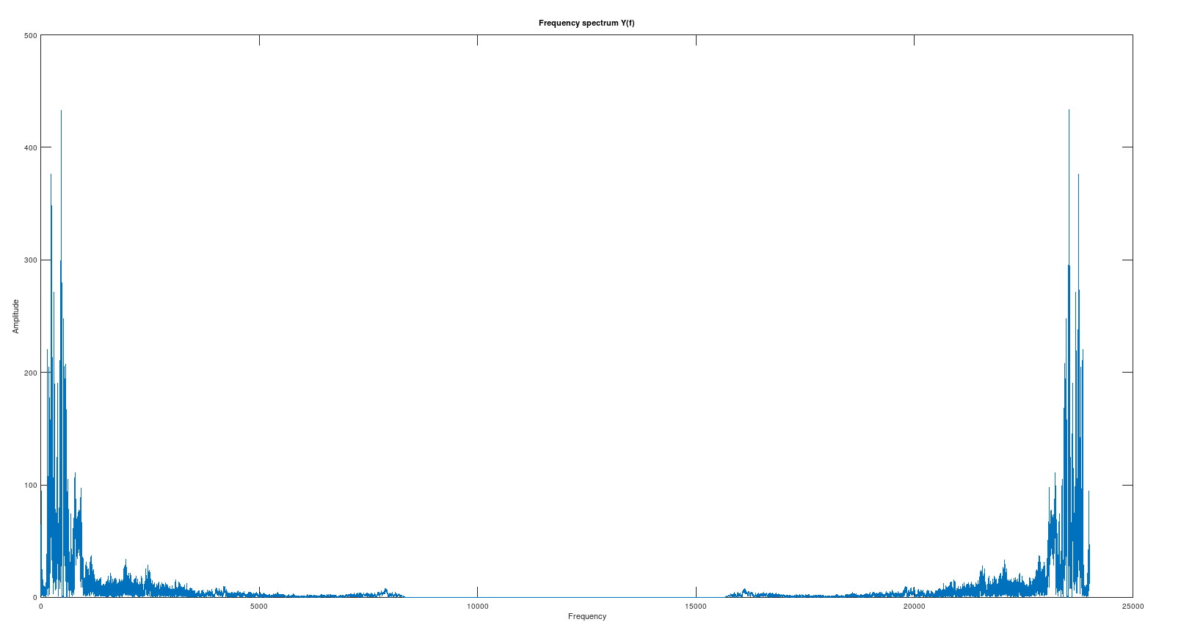
Noise has been Removed

Energies of Both:
