10th June 2020
UniLearn

HEROKU DOCUMENTATION

link : https://dashboard.heroku.com
1- to create new project click menu then select Dashboard

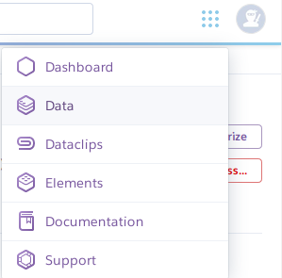

2- click on New to start new project then click on Create new app
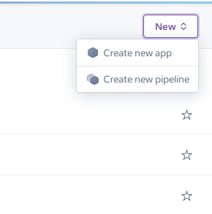

3- set your project name (must be unique), choose your region then click Create app
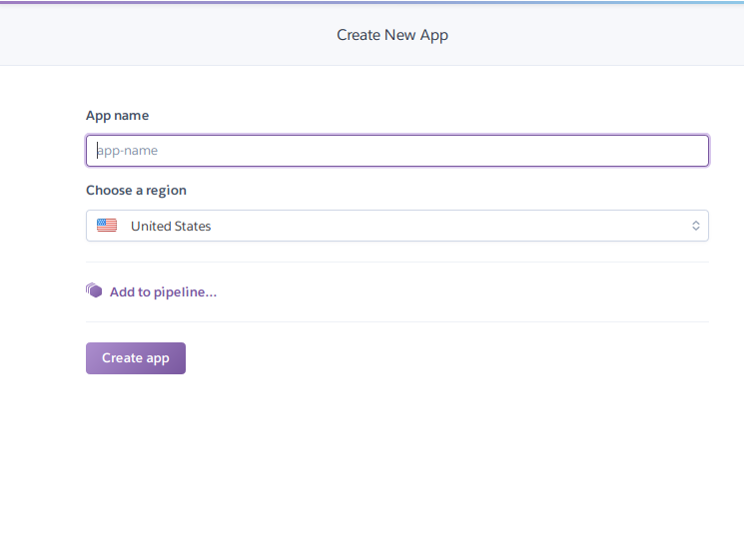

4- in Ur project:
- active Ur virtual environment (. ./Env/bin/activate)
- create new file in Ur project root path called requirements(touch requirements.txt)
- push all Ur installed apps on requirements file(pip freeze > requirements.txt)

5- login to heroku

6- Initialize a git repository in a new or existing directory
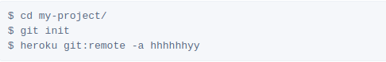

7- to stop collecting static:
- heroku config:set DISABLE_COLLECTSTATIC=1

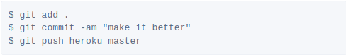
8- Commit your code to the repository and deploy it to Heroku using Git.

9- or existing repositories, simply add the heroku remote

NOTES :
- change <hhhhhhyy> with Ur project name

10- to migrate data on server
- heroku run python manage.py makemigrations && heroku run python manage.py migrate

