**Berita Acara**

Pada hari ini, Selasa tanggal 04 Bulan Agustus tahun 2021, yang bertanda tangan di bawah ini:

1. Nama : Alvin Winata  
   Jabatan : Software Engineering Head

Dalam hal ini bertindak untuk dan atas nama PT Solusi Pembayaran Elektronik (SPE).

Dengan ini menyatakan bahwa **telah menyetujui** aktfitas:

1. **Pengadaan Infrastruktur Production Project Wappin**

Demikian Berita Acara ini dibuat untuk dipergunakan sebagai mestinya.

# **Wappin Existing Database**

Wappin memiliki beberapa database di environment production (prod) yang nantinya akan dilakukan migrasi ke PolarDB.

Tabel 1. Wappin Existing Database

|  |  |  |
| --- | --- | --- |
| **IP Address** | **Database Name** | **Size** |
| 192.168.88.174 | Wappin_blog_db | 7.3 MB |
| 192.168.88.174 | Wappin_prod_db | 182 GB |
| 192.168.88.174 | Wappin_prod_log_db | 151 GB |

# **Utilization in 1 Month**

Berikut merupakan penggunaan CPU, Memory, dan Disk IO pada DB Wappin prod.

## CPU

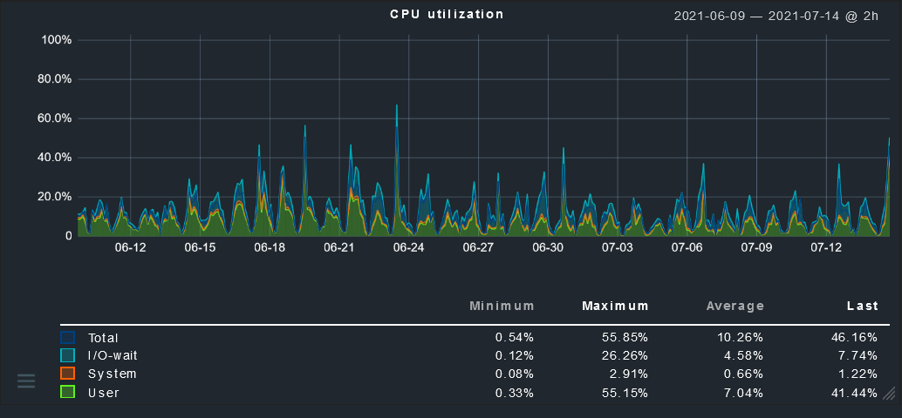

Gambar 1. CPU Utilization

Berdasarkan gambar di atas, rata-rata penggunaan CPU pada DB Wappin prod adalah 10.26% dari 16 core dan untuk maksimum penggunaannya adalah 55.85% pada tanggal 24 Juni 2021.

## Memory

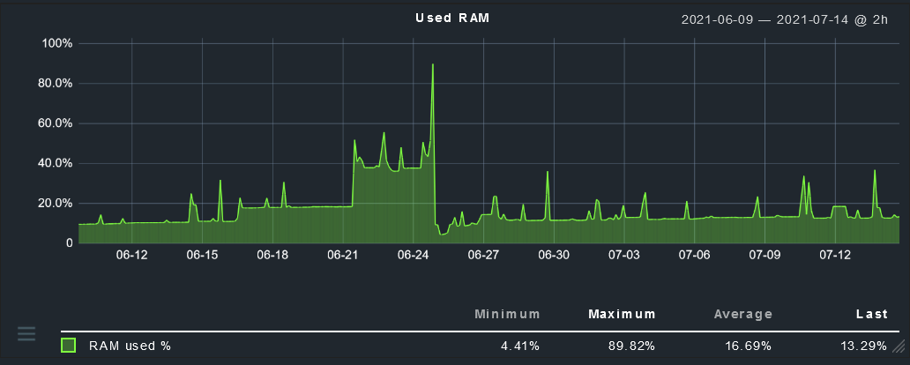

Gambar 2. Memory Utilization

Berdasarkan gambar di atas, rata-rata penggunaan memory pada DB Wappin prod adalah 16.69% dari 32 GB RAM dan untuk maksimum penggunaannya adalah 89.82%.

## Disk IO

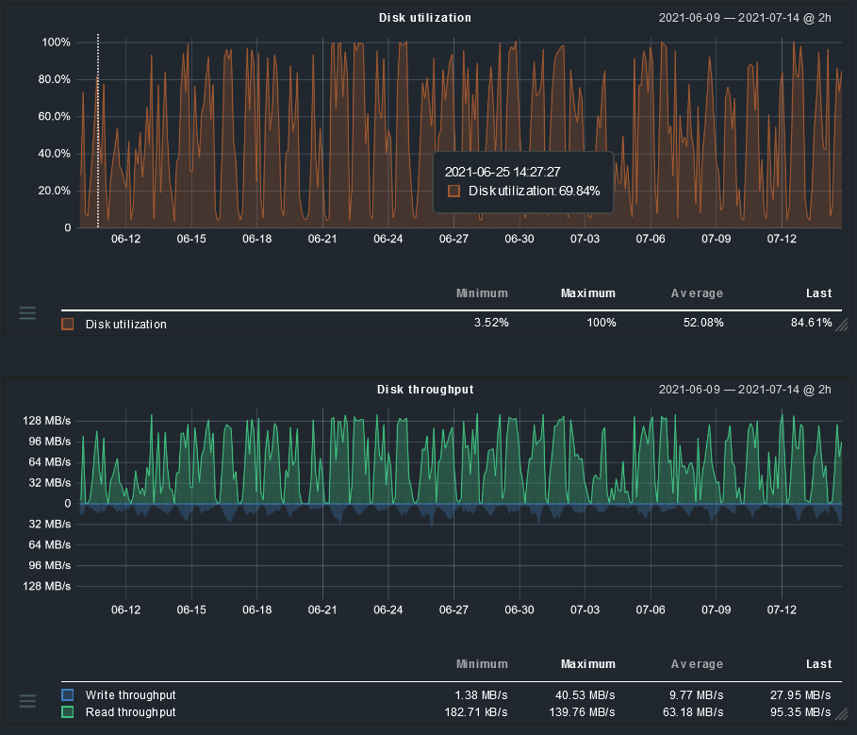

Gambar 3. Disk IO Utilization

Berdasarkan gambar di atas, rata-rata Disk utilization-nya adalah 52.08% dan pernah mencapai peak (maksimum) 100%.

# **Architecture**

Berikut merupakan gambar arsitektur PolarDB dan penjelasannya secara singkat.

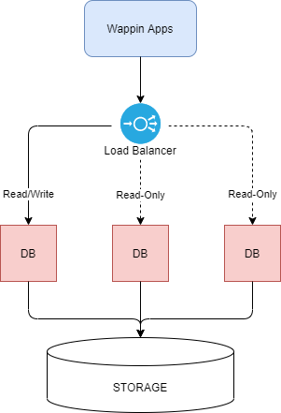

Gambar 4. Wappin Apps PolarDB Architecture

Pada gambar di atas terdapat sebuah cluster yang terdiri dari tiga node database, dimana salah satunya menjadi master (Read/Write) dan kedua lainnya untuk Read-Only. Terdapat juga sebuah load balancer yang berfungsi untuk menerima dan mendistribusikan data ke database.

# **Action Plan**

Perencanaan berikut ini digunakan untuk melakukan migrasi db Wappin ke PolarDB dan bagaimana cara untuk upgrade atau downgrade.

## **Migration to PolarDB**

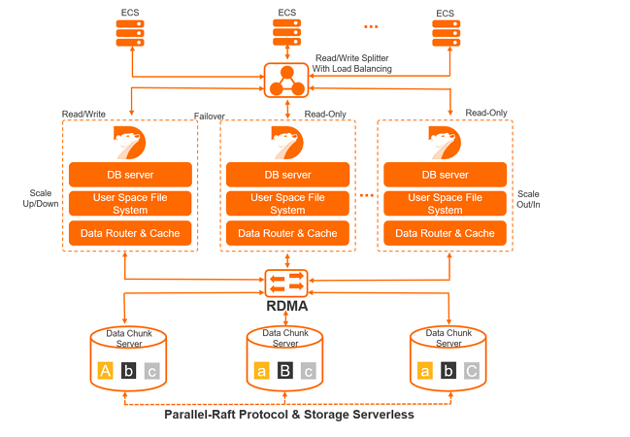

Gambar 5. PolarDB Architecture

Gambar di atas merupakan gambaran arsitektur PolarDB. Untuk melakukan migrasi ke PolarDB, berikut merupakan Langkah-langkah yang akan dilakukan.

## Migration step before production

Tabel 2. Migration Step Pre-Production

|  |  |  |  |  |
| --- | --- | --- | --- | --- |
| **Step** | **Action** | **Note** | **Estimated Time** | **PIC** |
| 1 | Create MySQL PolarDB | * 4 Core 16 RAM * MySQL 5.7 * 3 Node * 1 TB Storage Plan * Split Write/Read | 15 mins | Alvi |
| 2 | Config MySQL PolarDB | * Whitelist IP * Create user DB * Config parameter MySQL | 15 mins | Alvi/Alvin |
| 3 | Stop Service | * Stop Wappin Apps * Stop Wappin Chat * Stop Wappin CMS * Stop Wappin Blog * Stop Wappin SWC * Stop Wappin API | 10 mins | Alvi |
| 4 | Migrasi DB UAT to PolarDB | * wappin_blog_db * wappin_prod_db * wappin_prod_log_db | 60 mins | Alvi/Alvin |
| 5 | Change pointing config Apps with domain test | * Wappin Apps * Wappin Chat * Wappin CMS * Wappin Blog * Wappin API * Wappin Admin | 30 mins | Alvi |
| 6 | Test connection from VM Apps to RDS PolarDB | * Create connection DB PHP file for testing | 10 mins | Alvin |
| 7 | Start Service | * Start Wappin Apps * Start Wappin Chat * Start Wappin CMS * Start Wappin Blog * Start Wappin SWC * Start Wappin API | 10 mins | Alvi |
| 8 | QA Testing | * Testing whole flow process based on Sprint 8 tasks | 2 weeks | Tim QA |
| 9 | Stress Testing |  | 3 hours | Tim QA |

## Migration step production

Tabel 3. Migration Step Production

|  |  |  |  |  |
| --- | --- | --- | --- | --- |
| **Step** | **Action** | **Note** | **Estimated Time** | **PIC** |
| 1 | Clear existing DB UAT on PolarDB | * wappin_blog_db * wappin_prod_db * wappin_prod_log_db | 30 mins | Alvi/Alvin |
| 2 | Config MySQL PolarDB | * Whitelist IP * Create user DB * Config parameter MySQL | 10 mins | Alvi/Alvin |
| 3 | Stop Service | * Stop Wappin Apps * Stop Wappin Chat * Stop Wappin CMS * Stop Wappin Blog * Stop Wappin SWC * Stop Wappin API | 10 mins | Alvi |
| 4 | Migrasi DB Prod to PolarDB | * wappin_blog_db * wappin_prod_db * wappin_prod_log_db | 120 mins | Alvi/Alvin |
| 5 | Change pointing config Apps with domain prod | * Wappin Apps * Wappin Chat * Wappin CMS * Wappin Blog * Wappin API * Wappin Admin | 30 mins | Alvi |
| 6 | Test connection from VM Apps to RDS PolarDB | * Create connection DB PHP file for testing | 10 mins | Alvin |
| 7 | Start Service | * Start Wappin Apps * Start Wappin Chat * Start Wappin CMS * Start Wappin Blog * Start Wappin SWC * Start Wappin API | 10 mins | Alvi |
| 8 | QA Testing |  |  | Tim QA |

## **Upgrade/Downgrade**

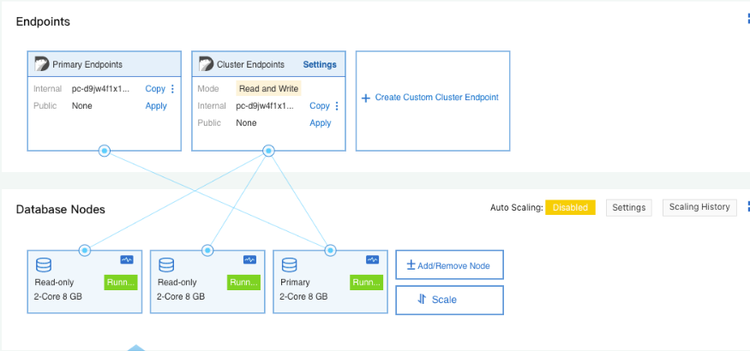

Gambar 6. PolarDB Console

1. Log on to the PolarDB console.
2. In the upper-left corner of the console, select the region where the cluster is deployed.
3. Go to the Change Configurations page. You can use the following methods to change the specifications:
4. Find the cluster and click Change Configurations in the Actions column.

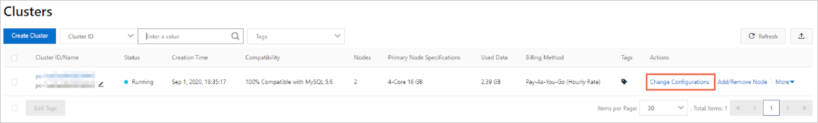

Gambar 7. Change Configuration Method One

1. Find the cluster, click the cluster ID, and then click Change Configurations in the Database Nodes section.

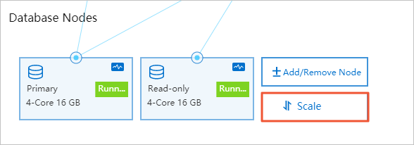

Gambar 8. Change Configuration Method Two

1. In the dialog box that appears, select Upgrade or Downgrade, and click OK.

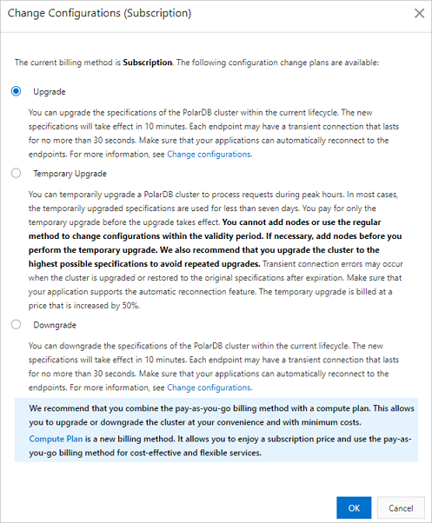

Gambar 9. Configuration for Upgrade or Downgrade

1. Select specifications.
2. Read the service agreement, select the check box, click Buy Now, and then pay for the order.

## **Add a Read-Only Node**

1. Log on to the PolarDB console.
2. In the upper-left corner of the console, select the region where the cluster is deployed.
3. You can use the following methods to go to the Add/Remove Node dialog box.
4. Find the cluster and click Add/Remove Node in the Actions column.

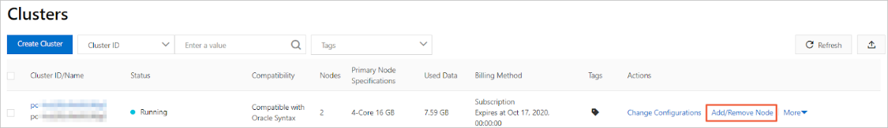

Gambar 10. Add/Remove Node Method One

1. Find the cluster, click the cluster ID, and then click Add/Remove Node on the Overview page.

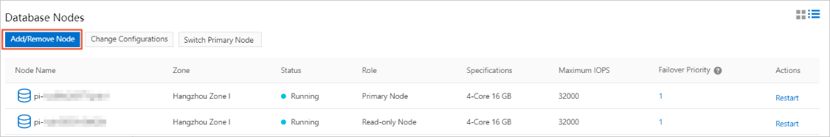

Gambar 11. Add/Remove Node Method Two

1. Select Add Node and click OK.

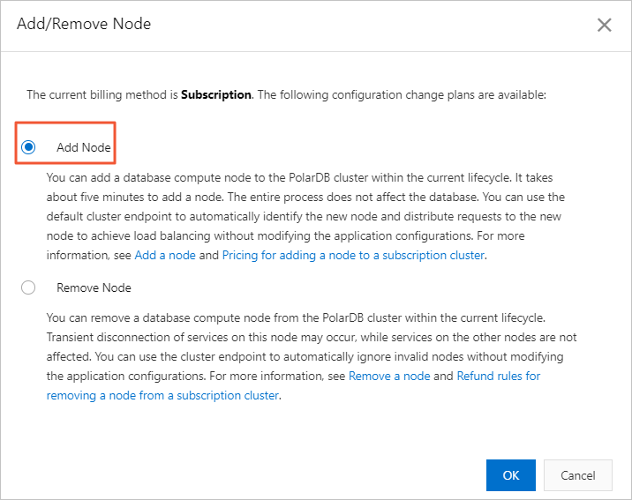

Gambar 12. Add Node

1. Click the Add a read-only node icon to add a read-only node. Read and agree to the service agreement by selecting the check box, and clikc Buy Now to complete the payment.

## **Remove a Read-Only Node**

1. Log on to the PolarDB console.
2. In the upper-left corner of the console, select the region where the cluster is deployed.
3. You can use the following methods to go to the Add/Remove Node dialog box.
4. Find the cluster and click Add/Remove Node in the Actions column.
5. Find the cluster, click the cluster ID, and then click Add/Remove Node on the Overview page.
6. Select Remove Node and click OK.
7. Click the minus sign (-) icon next to the node that you want to remove. In the dialog box that appears, click OK.

## **Perform a Switchover**

Manual switchover

1. Log on to the PolarDB console.
2. In the upper-left corner of the console, select the region where the cluster resides.
3. Find the cluster, and then click the cluster ID.
4. In the upper-right corner of the Database Nodes section on the Overview page, click the switch icon to switch the display mode.
5. Click Switch Primary Node.

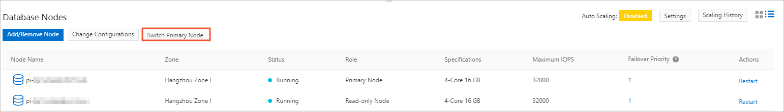

Gambar 13. Switch Primary Node

1. In the dialog box that appears, select a new primary node from the New Primary Node drop-down list and click OK.

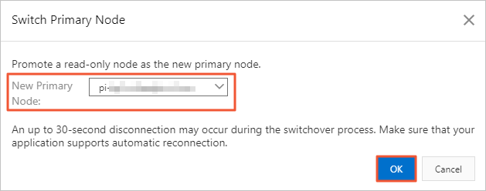

Gambar 14. New Primary Node

## **Create a Database Account**

1. Account types
   1. Privileged account (like a root)
   2. Standard account (custom user)
2. Create an account
3. Log on to the PolarDB console.
4. In the upper-left corner of the page, select a region.
5. On the cluster page, find the cluster and click the cluster ID.
6. In the left-side navigation page, choose Settings and Management > Accounts.
7. On the page that appears, click Create Account.
8. In the Create Account panel, set the parameters.
9. Click create.

## **Back-up Data**

* 1. Data Back-up
* Level-1 backups: 3-14 days (Enabled by default)
* Level-2 backups: 30-7.300 days
  1. Pricing

Tabel 4. Pricing Backup Data

|  |  |  |  |
| --- | --- | --- | --- |
| Region | Level-1 Backup | Level-2 Backup | Log Backup |
| Mainland China | USD 0.000464/GB/hour | USD 0.0000325/GB/hour | USD 0.0000325/GB/hour |
| Hong Kong (China) and regions outside China | USD 0.000650/GB/hour | USD 0.0000455/GB/hour | USD 0.0000455/GB/hour |

# **Pricing**

Berikut merupakan daftar spesifikasi dan harga server:

Tabel 5. Pricing PolarDB Wappin

|  |  |
| --- | --- |
| Spesifikasi | Harga |
| 1. PolarDB DB App Wappin 2. Spesifikasi hardware  * CPU : 4 Core * Memory : 16 GB * Disk : 1 TB * Node : 3 * Dedicated  1. Spesifikasi software  * OS Centos 7.x * MySQL 5.7 | 1. PolarDB DB App Wappin: USD 813 |
| Total: | USD 813 per bulan |

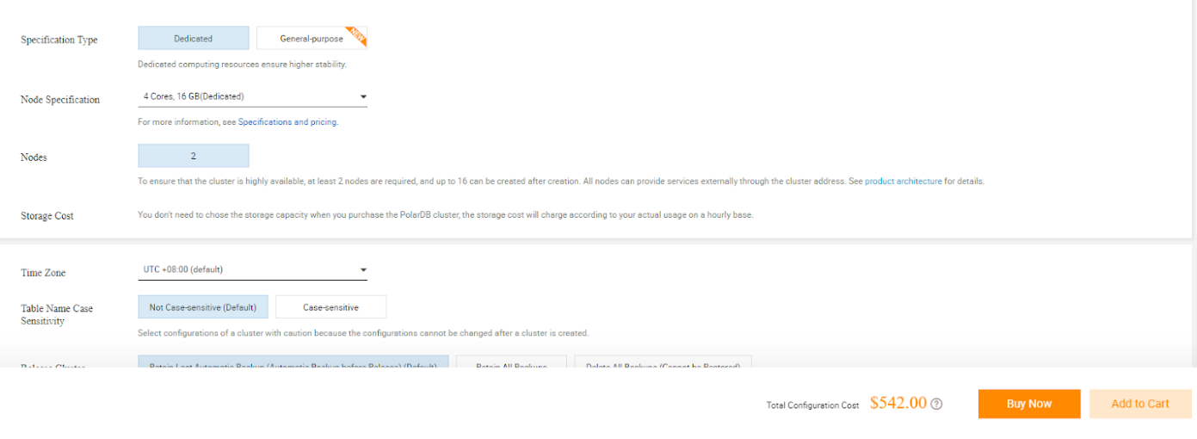

Gambar 15. Rincian Pricing PolarDB Wappin

Harga pada gambar merupakan harga untuk 2 node, sehingga jika membutuhkan 3 node maka ditambah setengah dari harga tersebut.

Document Disetujui Oleh:

|  |  |  |
| --- | --- | --- |
| Requestor | IT Compliance | Head IT Ops |
| Alvin Winata | **Fitri Amelia** | **Warisman Yudhi Syam** |

|  |  |  |
| --- | --- | --- |
| Head IT Infrastruktur | IT Manager | ProDev Manager |
| Puji Raharjo | **Arvid Theodorus** | **Rio Agustra Anjany** |

|  |
| --- |
| Direktur |
| Rico L. Simarmata |