**IELTS Task 1 Map Sample**

You should spend about 20 minutes on this task*.*

***The map below shows the development of the village of Ryemouth between 1995 and present.***

***Summarize the information by selecting and reporting the main features and make comparisons where relevant.***

Write at least 150 words.

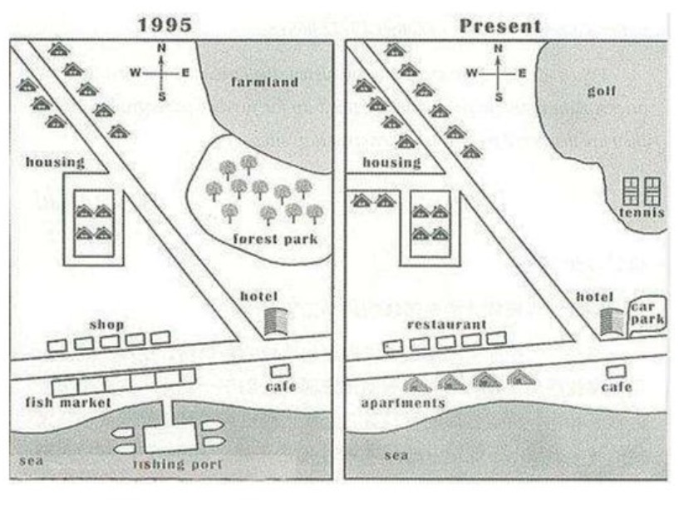

The map depicts the expansion of Reymouth village from 1995 until now.

From the figures, it can be inferred that there are so many rearrangements in Reymouth village such as get rid of fishing port and replacing forest park into tennis courts.

On the north side of village, there are extra housing on the left side of the map now. Moreover, it added a new way to adding more two houses there. Meanwhile on the right section, they replaced the farmland which exist in 1995 became gold area now. It also happened in the forest park which substituted with the tennis court.

The south side of village is also had a few differences. The first one is the shops end up being the restaurants. In the opposite of that, the fish market changed with a several apartments. The third difference, the hotel added a car park in the next of the building. And the last is they currently cleared up the fishing port in the sea.