

School of

Computing, Queen’s University,

Canada

CISC839 - Data Analytics

CISC839 Project-10: Recommender Systems using KuaiRec fully-observed dataset

*Authors:*

Zeyad Mohamed **[1]**

Kariman Mousaa **[2]**

Emails:

[zeyad.mohamed@queensu.ca](mailto:zeyad.mohamed@queensu.ca)

[21kkmm@queensu.ca](mailto:21kkmm@queensu.ca)

*Supervisors:*

**Yuan Tian,**

**Mohammad Sadegh**

May/2022

**Contents**

1. Introduction 1
   1. Background 1
   2. Objectives 1
2. Dataset 2
   1. Dataset description 2
   2. Files’ structure 2
   3. Big matrix and small matrix comparison 2
   4. Descriptions of the features in big_matrix.csv and small_matrix.csv 3
   5. Descriptions of the features in social_network.csv 3
   6. Descriptions of the features in item_feat.csv 3
3. Basic Data Exploration 4
   1. Have a look on each file data 4
      1. big_matrix.csv 4
      2. small_matrix.csv 4
      3. social_network.csv and item_feat.csv 5
   2. Every dataset statistics 7
      1. big_matrix.csv statistics 7
      2. small_matrix.csv statistics 7
      3. social_network.csv and item_feat.csv statistics 7
      4. some EDA about big_matrix.csv and small_matrix.csv 8
      5. some EDA about social_network.csv 10
      6. some EDA about item_feat.csv 10
4. Data Analysis Pipeline 12
   1. Plans and Methodology 12
   2. potential challenges in deploying this analysis in production 13
5. Team workload 14
   1. Zeyad’s Work 14
   2. Kariman’s Work 14
6. References 14

# Introduction

## Background

**A Recommender system (RS)** is an intelligent computer-based technique that predicts on the basis of users’ adoption and usage and helps them to pick items from a vast pool of online stuffs. Most internet users surely have happened upon an RS in some way. For instance, Facebook recommends us, prospective friends, YouTube recommends us the videos in accord, Glassdoor recommends us matching jobs.

**Recommender system (RS)** has emerged as a major research interest that aims to help users to find items online by providing suggestions that closely match their interests, and it’s a subset of information filtering system. Typically, recommendation systems are designed and assessed using past user-item records. However.

## Objectives

the majority of offline recommendation datasets are quite sparse and have a variety of biases. This impedes the assessment of policy recommendations Existing initiatives try to enhance data quality by gathering user preferences on randomly selected items, but one of the most problems in designing the recommendation systems is how should we evaluate the model accurately, and although that there are good methods but it’s time and money-consuming and entails the risk of failure, also static recommendation systems have limitations regarding to capturing precious real-time user preferences, so our objectives here is to provide recommendations based on recorded information on the users’ preferences with this fully observed dataset and evaluate our results accurately, also we want to demonstrate the efficacy and advantage of KuaiRec dataset.

for videos recommendation systems in general we have three important questions.

1. **What’s the watch_ratio of video for each pair of user and video?**

Answering to this question will help a lot of foundations like advertisement agents while the answer will tell them where they should put their advertisements and will help the content creator.

1. **Does the user like the video or dislike it?**

Like the previous question Answering this question will help advertisement agents because the answer will tell them what’s the most likes videos and where they should put their advertisement, also it will help the recommendation system engine to recommend videos to users like they pressed like button on them based on another features like tags.

1. **Are the shorter videos {less than 2 minutes} are more favorite than (more than) longer videos for the users?**

Answering these questions will help the app founder to determine what’s the best video duration that users like, and how each user will stay in the app, also they will recommend these videos to more people, and it’ll appear at the top of the page to the users, also it will help content creators to choose the best video duration to attract more users to their videos.

# Dataset

## Dataset description

Dataset which used in this project based on [3] is obtained from the Kuaishou App, a well-known short- video platform with a lot of subscribers. Users may view a range of short-form videos from different categories such as dance, entertainment, and fitness/sports on this site. The videos are ordered by suggesting streaming, our dataset here is the first dataset generated from real-world recommendation logs with all users’ preferences on items known and also it’s not highly sparse dataset, this data is a fully-observed dataset with millions of users’ interaction, the data collected here by the users themselves, every single user watch a video and left a feedback which means that we haven’t almost no missing values here, based on [3] analysis, this dataset is dubbed as the small matrix for convenience, can be used for evaluation the trained model. And for the training purpose, they further collect a larger dataset, represented as big matrix, which contains additional interactions for the users and items in the small matrix, and based on one [3] analysis they found that user-item interactions in the small matrix are excluded from big matrix to separate the training and evaluation data, since the evaluation process in the recommendation system design is very important, also they collect side information of users and items each data in a separate file. for the user side, they collected the social relationship among these users. On the item side, we list each item’s tags, i.e., a set of categories such as {Gaming, Sports}.

## Files’ structure

* KuaiRec
  + Data
    - Big_matrix.csv
    - Small_matrix.csv
    - Social_network.csv
    - Item_feat.csv

## Big matrix and small matrix comparison

#Users #Items #Observations #Attributes of items #Users who have friends Density small matrix 1,411 3,327

big matrix 7,176 10,729

4,676,570

12,530,806

31

31

146

472

99.6%

13.47%

Table 1: The statistics of the small matrix and big matrix in KuaiRec

## Descriptions of the features in big_matrix.csv and small_matrix.csv

|  |  |  |  |
| --- | --- | --- | --- |
| Feature | Description | Type | Example |
| user_id | The ID of the user | int64 | 5204 |
| video_id | The ID of the viewed video | int64 | 3650 |
| play_duration | Time of video viewing of this interaction (millisecond). | int64 | 13838 |
| video_duration | Time of this video (millisecond) | int64 | 10867 |
| time | Human-readable date for this interaction | str | “2020-07-05 00:08:23.438” |
| date | Date of this interaction | int64 | 20200705 |
| timestamp | Unix timestamp | float64 | 1593878903.438 |
| watch_ratio | video watching ratio (play_duration/video_duration) | float64 | 1.273397 |

Table 2: big_matrix.csv and small_matrix.csv features description

Data quality assurance: There aren't missing values in the **big_matrix.csv** dataset but it has **965819** consistent duplicated values, and for **small_matrix.csv** dataset, there are missing values in three features in this dataset but fortunately, there are no duplicated values in this dataset.

|  |  |  |
| --- | --- | --- |
|  | Total missing | Missing % |
| user_id | 0 | 0.0 |
| video_id | 0 | 0.0 |
| play_duration | 0 | 0.0 |
| video_duration | 0 | 0.0 |
| time | 0 | 0.0 |
| date | 0 | 0.0 |
| timestamp | 0 | 0.0 |
| watch_ratio | 0 | 0.0 |

Table 3: big_matrix.csv missing value analysis using pandas package

|  |  |  |
| --- | --- | --- |
|  | Total missing | Missing % |
| time | 181922 | 3.89157 |
| date | 181922 | 3.89157 |
| timestamp | 181922 | 3.89157 |
| user_id | 0 | 0.0 |
| video_id | 0 | 0.0 |
| play_duration | 0 | 0.0 |
| video_duration | 0 | 0.0 |
| watch_ratio | 0 | 0.0 |

Table 4: small_matrix.csv missing value analysis using pandas package

## Descriptions of the features in social_network.csv

Feature Description Type Example user_id The ID of the user int64 5204

friend_list the list of ID of the friends of this user. list [4202,7126]

Table 5: social_network.csv features description

You may want to note that there’s a common feature between social_network.csv and the two main datasets which is user_id feature and we can join between these two datasets using this key to recommend the video to users’ friends also. Note: There isn’t neither missing values nor consistent duplicated values in social_network.csv dataset

Data quality assurance: There are neither missing values nor consistent duplicated values in social_network.csv dataset

|  |  |  |
| --- | --- | --- |
|  | Total missing | Missing % |
| user_id | 0 | 0.0 |
| friend_list | 0 | 0.0 |

Table 6: social_network.csv missing value analysis using pandas package

## Descriptions of the features in item_feat.csv

Feature Description Type Example video_id The ID of the video int64 1

feat the list of tags of this video list [27,9]

Table 7: item_feat.csv features description

You may want to note that there’s a common feature between item_categories.csv and the two main datasets which is video_id feature and we can join between these two datasets using this key to get insights about the categories that’s user likes. Note: There isn’t neither missing values nor consistent duplicated values in item_feat.csv dataset

**Data quality assurance**: There are neither missing values nor consistent duplicated values in item_feat.csv dataset.

|  |  |  |
| --- | --- | --- |
|  | Total missing | Missing % |
| video_id | 0 | 0.0 |
| feat | 0 | 0.0 |

Table 8: item_feat.csv missing value analysis using pandas package

Outliers and noises analysis for all datasets: all numeric features in all datasets have outliers but there are not

any dataset has noise datapoint and the outliers here we shouldn’t drop them because there are have

informative values like (play_duration) feature, so, we want to deal with them carefully.

# Basic Data Exploration

## Have a look on each file data

### big_matrix.csv

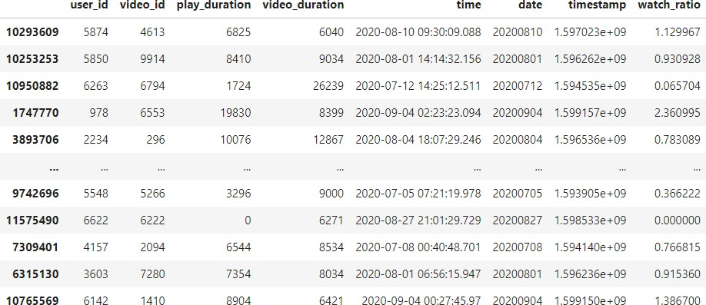

Figure 1: some random samples from big_matrix.csv

### small_matrix.csv

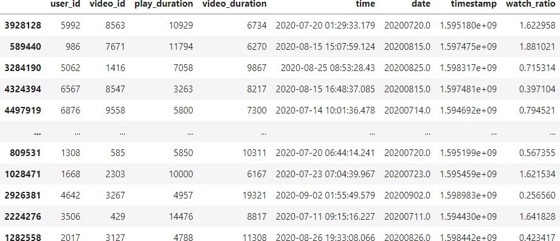

Figure 2: some random samples from small_matrix.csv

### social_network.csv and item_feat.csv

### 

Figure 3: some random samples from social_network.csv

And item_feat.csv

## Every dataset statistics

### big_matrix.csv statistics

|  |  |  |  |  |  |  |  |
| --- | --- | --- | --- | --- | --- | --- | --- |
|  | user_id | video_id | play_duration | video_duration | date | timestamp | watch_ratio |
| count | 12530810 | 12530810 | 12530810 | 12530810 | 12530810 | 12530810 | 12530810 |
| mean | 3574.377 | 5058.597 | 9027.027 | 1462.157 | 20200800 | 1596799000 | 0.9445059 |
| std | 2067.008 | 3090.082e | 15473.43 | 19834.74 | 50.80192 | 1514698 | 1.674601 |
| min | 0.0 | 0.0 | 0.0 | 140.0 | 20200700 | 1592872000 | 0 |
| 25% | 1788.0 | 2388.0 | 4218.000 | 7434.0 | 2.0200800 | 1596339000.0 | 0.3148246 |
| 50% | 3578.0 | 4823.0 | 7277.0 | 9636.0 | 2.0200810 | 1596669000 | 0.7234710 |
| 75% | 5343.750 | 7601.0 | 1035.0 | 1217.900 | 20200830 | 1.598502000 | 1.177644 |
| max | 7175.0 | 10728.0 | 999639.0 | 315072.0 | 20200900 | 1599694000 | 573.4571 |

Table 8: big_matrix.csv statistics

### small_matrix.csv statistics

|  |  |  |  |  |  |  |  |
| --- | --- | --- | --- | --- | --- | --- | --- |
|  | user_id | video_id | play_duration | video_duration | date | timestamp | watch_ratio |
| count | 4676570 | 4676570 | 4676570 | 4676570 | 4494578 | 4494578 | 4676570 |
| mean | 3631.649 | 4975.787 | 8612.637 | 14486.45e | 20200770 | 1596241000 | 0.9070695 |
| std | 2043.873 | 3064.837 | 12236.61 | 20467.11 | 48.95180 | 1254444 | 1362324e |
| min | 14.0 | 103.0000 | 0.0 | 3067.000 | 20200700 | 1593801000 | 0.0 |
| 25% | 1834.0 | 2370.0 | 5811.000 | 7523.0 | 20200720 | 1595210000 | 0.4675769 |
| 50% | 3687.0 | 4693.0 | 7549.0 | 9600.0 | 20200800 | 1596224000 | 0.7691666e |
| 75% | 5421.0 | 7475.0 | 9880.0 | 11934.0 | 20200810 | 1597121000 | 1.120590 |
| max | 7162.000 | 10596.00 | 7988155 | 315072.0 | 20200900 | 1599321000 | 571.5214 |

Table 9: small_matrix.csv statistics

### social_network.csv and item_feat.csv statistics

Note: in this dataset statistics we don’t care about the mean and the median since these statistics doesn’t important and suitable for information like ID, and there are friend list and feat feature and because it’s a list datatype, so I considered the length of each list and I construct another feature called friend_list_len for social_network.csv dataset and feat_len for item_feat.csv.

|  |  |  |
| --- | --- | --- |
|  | user_id | friend_list_len |
| count | 472.0 | 472.0 |
| min | 18.0 | 1.0 |
| 25% | 1648.0 | 1.0 |
| 50% | 3268.0 | 1.0 |
| 75% | 5233.5 | 2.0 |
| max | 7174.0 | 5.0 |

Table 10: social_network.csv statistics

|  |  |  |
| --- | --- | --- |
|  | video_id | friend_list_len |
| count | 10729.0 | 10729.0 |
| min | 0.0 | 1.0 |
| 25% | 2682.0 | 1.0 |
| 50% | 5364.0 | 1.0 |
| 75% | 8046.0 | 1.0 |
| max | 10728.0 | 4.0 |

Table 11: item_feat.csv statistics

### some EDA about big_matrix.csv and small_matrix.csv

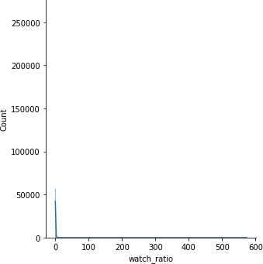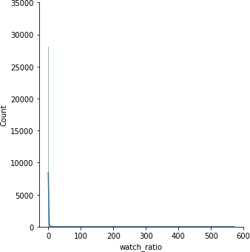

Figure 4: watch ratio data distribution in big_matrix.csv {left} and small_matrix.csv {right}

* + - 1. **Distribution of watch_ratio in big matrix and in the small_matrix.csv** Although that we can’t determine the actual distribution from this figure, but we notice that the frequency starts to decrease from value 6 so we will decrease the range and make it from 1 to 6 to have a better overview.

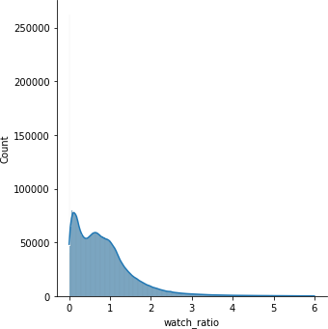 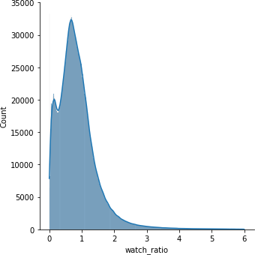

Figure 5: Ranged watch ratio data distribution in big_matrix.csv {left} and small_matrix.csv {right}

Now we noticed that the count of watch ratio decreased starting from 5 and they aren’t normally distributed.

* + - 1. **Distribution of video_duration in big matrix and in the small_matrix.csv** Same as the watch_ratio feature, we can’t determine the actual distribution from this figure, but we notice that the frequency starts to decrease from value 50000 so we will decrease the range and make it from 0 to 50000 to have a better overview.

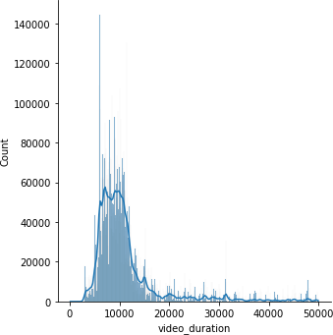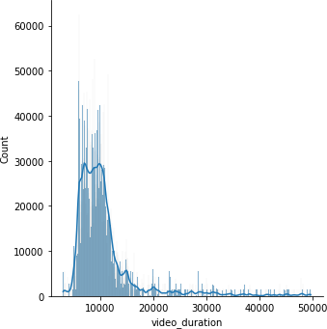

Figure 6: Ranged watch ratio data distribution in big_matrix.csv {left} and small_matrix.csv {right}

Now we noticed that the count of watch ratio decreased starting from 0 to 20000 is normally distributed.

### some EDA about social_network.csv

In this dataset we care about how many friends does each user have?

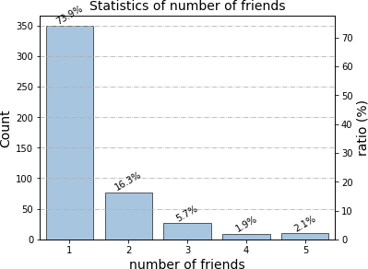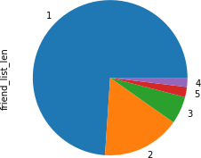

Figure 7: frequency of number of friends in each user

from above plots we see that the most users have only one {73.9% of the users} friend in this platform and there’s not user have more than 5 friends.

### some EDA about item_feat.csv

In this dataset we care about how many tags each video has because that may help us if the increasing in the number of tags make users happy or not, so we get the count of the tags in each video and we got the frequency of this counts to see which is the most frequent.

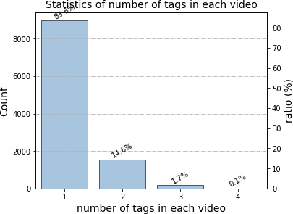 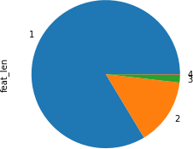

Figure 8: frequency of number of tags in each video

from above result we see that the videos that have only one tags is the most frequent videos.

And now we want to see what’s the most frequent tag, the which appears in most of the videos.

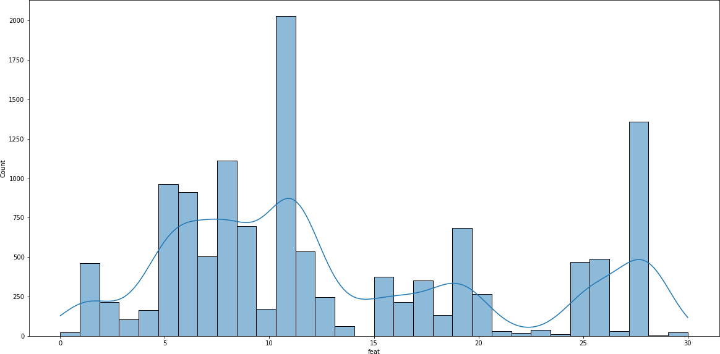

Figure 9: most frequented tags

from the above plot we see that the most frequent tag is the tag 11 and it’s appeared more than 2000 times.

# Data Analysis Pipeline

## Plans and Methodology

* The future Methodology
  + 1. **Data pre-processing and checking the quality for the data**
    2. **Data pre-processing and checking the quality for the data**

based on the basic data exploration there are some data quality issues either in the distributions or the format of the data, In this step I’ll check for duplicated values and outliers but not missing values since they are fully observed datasets, I can drop consistent duplicated values since there isn’t a same user can watch a same video at a same time, but the outliers here based on the distribution of the data and the box plot are very informative about the recommendation systems and data collection process, so in this case resisting the temptation to remove outliers inappropriately can be difficult, second this second is to handle the format of the data like the date feature or the friend_list feature because it’s string data not list data.

* + 1. **Do data exploration and analysis**

We will do some data exploratory like pie and histograms and the distribution of each feature data.

* + 1. **Do some feature engineering methods**

We’ll drop time feature in **big_matrix** and **small_matrix** datasets because we see that the time feature represented in the date feature but time has the time and the date of watching the video so we considered the time as redundant information, also we’ll change the format of the date feature and we will transform it one-hot-encoded data, and in the social_network dataset feature I will create a feature that holds the number of friends that’s each user has, and in the **item_feat.csv** I’ll create a feature that holds the number of tags in each video, I think the **play_duration** feature is the most important feature since the increasing in its value means that the user is enjoying this video and I can recommend him video from the same category, and I think that the number of observations in my datasets are enough but we don’t have that much of feature, we could have more features like number of likes on this video or number of comments that would help us a lot and would improve the performance, also we will check if the user watch the same video in different times (duplicated values in **user_id** and **video_id**) then we will aggregate the **play_duration** time of these duplicated records and then we will drop these duplicated records.

* + 1. **Start building and training the model**

on jupyter notebook and using python 3 programming language with some libraries like {numpy- matplotlib-pandas-seaborn-pyspark-recommenders}, we will apply one of those deep learning recommender algorithms either Alternating Least Squares (ALS) or eXtreme Deep Factorization Machines (xDeepFM), they are considering two of best filtering systems techniques.

* + 1. **start evaluating our model**

since they are many techniques to evaluate our performance, we’ll choose among these offline metrics, based on [1],[2]

* + - * **A/B testing:**
      * **Non-accuracy-based metrics:**

These do not compare predictions against ground truth but instead evaluate the following properties of the recommendations

**∗ Novelty:**

measures of how novel recommendation items are by calculating their recommendation frequency among users.

**∗ Diversity:**

measures of how different items in a set are with respect to each other

**∗ Serendipity:**

measures of how surprising recommendations are to a specific user by comparing them to the items that the user has already interacted with

**∗ Coverage:**

measures related to the distribution of items recommended by the system.

**∗ Ranking Metrics:**

These are used to evaluate how relevant recommendations are for users.

* Precision:

this measures the proportion of recommended items that are relevant

* **Recall:**

this measures the proportion of relevant items that are recommended

* **Normalized Discounted Cumulative Gain (NDCG):**

evaluates how well the predicted items for a user are ranked based on relevance

So, we didn’t determine which metrics should we select except for A/B testing since our data isn’t highly sparse an **A/B testing** should be one of the suitable metrics.

## potential challenges in deploying this analysis in production

* + 1. **Cold start:**

This issue arises when new users or new items are added to the system; a new item cannot be recommended to users when it is introduced to the recommendation system without any likes or reviews, making it difficult to predict the choice or interest of users, resulting in less accurate recommendations.

A newly published video, for example, cannot be suggested to the user until it has received some ratings. A new user or item added-based challenge is tough to manage since obtaining a comparable user without knowing past interest or preferences is impossible.

* + 1. **Sparsity:**

It occurs frequently when most users do not provide likes or reviews for the things they watch, causing the rating model to become highly sparse, perhaps leading to data sparsity issues. This reduces the chances of discovering a group of users with comparable ratings or interests.

* + 1. **Scalability:**

The scalability of algorithms with real-world datasets under the recommendation system is a major challenge. A large amount of changing data is created by user-item interactions in the form of ratings and reviews, and hence scalability is a major worry for these datasets. Recommendation systems inefficiently interpret findings from huge datasets; certain advanced large-scaled algorithms are necessary to address this issue.

# Team workload

## Zeyad’s Work

Zeyad will be responsible for EDA, and design and train and evaluate the recommendation system model and select the best model.

## Kariman’s Work

Kariman will be responsible for answering to the questions, feature engineering, do the hypotheses tests and preprocessing the data.

Note: both of us will be responsible for writing the final report.

# References

1. [A. Argyriou, M. González-Fierro, and L. Zhang, "Microsoft Recommenders: Best Practices for](https://dl.acm.org/doi/abs/10.1145/3366424.3382692) [Production-Ready Recommendation Systems", WWW 2020: International World Wide Web](https://dl.acm.org/doi/abs/10.1145/3366424.3382692) [Conference Taipei, 2020.](https://dl.acm.org/doi/abs/10.1145/3366424.3382692)
2. [S. Graham, J.K. Min, T. Wu, "Microsoft recommenders: tools to accelerate developing rec-](https://dl.acm.org/doi/10.1145/3298689.3346967) [ommender systems", RecSys ’19: Proceedings of the 13th ACM Conference on Recommender](https://dl.acm.org/doi/10.1145/3298689.3346967) [Systems, 2019.](https://dl.acm.org/doi/10.1145/3298689.3346967)
3. [KuaiRec: A Fully-observed Dataset for Recommender Systems](https://arxiv.org/abs/2202.10842)
4. [Recommender Systems: An Overview, Research Trends, and Future Directions.](https://www.researchgate.net/publication/339172772_Recommender_Systems_An_Overview_Research_Trends_and_Future_Directions)
5. [2014-Logistic Matrix Factorization for Implicit Feedback Data-NIPS-WS](https://www.shorturl.at/glrxD)