Canada Post Rate Calculator

# The Application:

A command line application that calculates postage rates for a parcel based on inputs from the user regarding the parcel’s: weight, height, length, width, Type of postage (Regular, Xpress, or Priority), and the destination postal code. The postage rate is not calculated based on real values.

# How To Run:

1. On the command line, navigate to the directory where the runnable jar file is.
2. Ensure that the jar file is in the same directory as the csv file.
3. Run: java -jar AssignmentB.jar

# Assumptions:

* The origin postal code will always start with an H (the parcel is sent from Montreal).
* Postal code inputs will be limited to those within Canada.
* Destination postal codes starting with H represent Montreal, G or J to represent the remainder of Quebec. Other letters represent the rest of Canada.
* The user inputs are in the form of Strings obtained from the console.

# How Rates are Calculated:

* The CSV file provided contains 6 sets of sub-rates, for each of the input parameters.
* The final rate is calculated as the sum of 1 sub rate from each of the set.
* The sub rates are selected from each set based on the user input and the range it falls into (with respect to the type of attribute).
* The ranges for each attribute are specified in the CSV file and are parsed in the code.

# Test 1: getDimensionSubRateTest

## Purpose:

* Test the ability to parse rates from sub tables associated with weight, height, length and width.

## Inputs and Expected Output:

* The value (0.1Kg) of the attribute being tested.
* Values for the columns with the ranges, and their respective rates.
* The output is the rate (0.3$) associated with the range of the attribute.

## C:\Users\karim\AppData\Local\Microsoft\Windows\INetCache\Content.Word\Test_1_Fail.pngFailing Screenshot:

## C:\Users\karim\AppData\Local\Microsoft\Windows\INetCache\Content.Word\Test_1.2_Pass.pngC:\Users\karim\AppData\Local\Microsoft\Windows\INetCache\Content.Word\Test_1.1_Pass(helper).pngPassing Screenshot:

# Test 2: typeRate

## Purpose:

* Test the ability to parse the sub rates associated with the type of postage.

## Inputs and Expected Output:

* The type of postage (Xpress).
* The output is the respective rate (0.5$) associated with the postage type.

## C:\Users\karim\AppData\Local\Microsoft\Windows\INetCache\Content.Word\Test_2_Fail.pngFailing Screenshot:

## C:\Users\karim\AppData\Local\Microsoft\Windows\INetCache\Content.Word\Test_2_Pass.pngPassing Screenshot:

# Test 3: toPostalCodeRate

## Purpose:

* Test the ability to parse the sub rates associated with the destination postal code of the parcel.

## Inputs and Expected Output:

* The destination postal code (A1A 1A1).
* The output is the rate (0.7$) associated with the input postal code.

## C:\Users\karim\AppData\Local\Microsoft\Windows\INetCache\Content.Word\Test_3_Fail.pngFailing Screenshot:

## C:\Users\karim\AppData\Local\Microsoft\Windows\INetCache\Content.Word\Test_3_Pass.pngPassing Screenshot:

# Test 4: baseFullRateTest

## Purpose:

* Test the ability to get the full rate of a parcel based on the sub rate of all it’s attributes.

## Inputs and Expected Output:

* ***weight*** (0.1 Kg), ***height*** (49 cm), ***width*** (49 cm), ***length*** (49 cm), and the ***destination postal code*** (H3Z 1J9) within Montreal, and ***type of postage*** (Regular).
* The output is the proper parcel rate (2.4$).

## C:\Users\karim\AppData\Local\Microsoft\Windows\INetCache\Content.Word\Test_4_Fail.pngC:\Users\karim\AppData\Local\Microsoft\Windows\INetCache\Content.Word\Test_3_Pass.pngFailing Screenshot:C:\Users\karim\AppData\Local\Microsoft\Windows\INetCache\Content.Word\Test_4_Pass.png

## Passing Screenshot:

# Test 5: fullRateWeightChange

## Purpose:

* Test the ability to get the full rate of a parcel with the ***weight*** varied.

## Inputs and Expected Output:

* ***weight (0.26 Kg),*** ***height*** (49 cm), ***width*** (49 cm), ***length*** (49 cm), and ***destination postal code*** (H3Z 1J9), and ***type of postage*** (Regular).
* The output is the proper parcel rate (2.6$).

## Failing Screenshot:

This test does not fail, since the previous logic gives the desired output.

## C:\Users\karim\AppData\Local\Microsoft\Windows\INetCache\Content.Word\Test_5_Pass.pngPassing Screenshot:

# Test 6: fullRateHeightChange

## Purpose:

* Test the ability to get the full rate of a parcel with the ***height*** varied.

## Inputs and Expected Output:

* ***weight*** ***(0.26 Kg),*** ***height (99 cm),*** ***width*** (49 cm), ***length*** (49 cm), and the ***destination postal code*** (H3Z 1J9), and ***type of postage*** (Regular).
* The output is the proper parcel rate (2.8$).

## Failing Screenshot:

This test does not fail, since the previous logic gives the desired output.

## C:\Users\karim\AppData\Local\Microsoft\Windows\INetCache\Content.Word\Test_6_Pass.pngPassing Screenshot:

# Test 7: fullRateLengthChange

## Purpose:

* Test the ability to get the full rate of a parcel with the ***length*** varied.

## Inputs and Expected Output:

* ***weight (0.26 Kg),*** ***height (140 cm),*** ***width*** (49 cm), ***length (99 cm),*** and ***destination postal code*** (H3Z 1J9, and ***type of postage*** (Regular).
* The output is the proper parcel rate (sum of all sub rates).

## Failing Screenshot:

This test does not fail, since the previous logic gives the desired output.

## C:\Users\karim\AppData\Local\Microsoft\Windows\INetCache\Content.Word\Test_7_Pass.pngPassing Screenshot:

# Test 8: fullRateWidthChange

## Purpose:

* Test the ability to get the full rate of a parcel with the ***width*** varied.

## Inputs and Expected Output:

* ***weight (0.26 Kg),*** ***height (140 cm),*** ***width (99 cm),*** ***length (140 cm),*** and strings for the ***destination postal code*** (H3Z 1J9), and ***type of postage*** (Regular).
* The output is the proper parcel rate (sum of all sub rates).

## Failing Screenshot:

This test does not fail, since the previous logic gives the desired output.

## C:\Users\karim\AppData\Local\Microsoft\Windows\INetCache\Content.Word\Test_8_Pass.pngPassing Screenshot:

# Test 9: fullRateTypeChange

## Purpose:

* Test the ability to get the full rate of a parcel with the ***type*** of postage varied.

## Inputs and Expected Output:

* ***weight (0.26 Kg),*** ***height (140 cm),*** ***width (99 cm),*** ***length (140 cm),*** and ***destination postal code*** (H3Z 1J9), and ***type of postage*** ***(Xpress).***
* The expected output is the proper parcel rate (sum of all sub rates).

## Failing Screenshot:

This test does not fail, since the previous logic gives the desired output.

## C:\Users\karim\AppData\Local\Microsoft\Windows\INetCache\Content.Word\Test_9_Pass.pngPassing Screenshot:

# Test 10: fullRateToPostalCodeChange

## Purpose:

* Test the ability to get the full rate of a parcel with the ***destination*** postal code varied.

## Inputs and Expected Output:

* ***weight (0.26 Kg),*** ***height (140 cm),*** ***width (99 cm),*** ***length (140 cm),*** and the ***destination postal code (J3Q 1R9)*** within Quebec, and ***type of postage*** (Regular).
* The expected output is the proper parcel rate (sum of all sub rates).

## Assumptions:

* All the double input values are within an accepted range, and of proper format.
* The origin postal code has been verified start with an H.
* The origin and destination postal code match the proper postal code patterns.
* That the type of postage string has been verified.

## Failing Screenshot:

This test does not fail, since the previous logic gives the desired output.

## C:\Users\karim\AppData\Local\Microsoft\Windows\INetCache\Content.Word\Test_10_Pass.pngPassing Screenshot:

# Test 11: inValidDimensionFormat

## Purpose:

* To verify that incorrect numeric format (e.g an alphanumeric value) is detected.

## Inputs and Expected Output:

* An alphanumeric string not representing a number.
* The expected output is a double of value -1.

## Failing Screenshot:C:\Users\karim\AppData\Local\Microsoft\Windows\INetCache\Content.Word\Test_11_Fail.png

## C:\Users\karim\AppData\Local\Microsoft\Windows\INetCache\Content.Word\Test_11_Pass.pngPassing Screenshot:

# Test 12: weightOutOfRange

## Purpose:

* Verify that the value entered for the ***weight dimension*** is out of range.

## Inputs and Expected Output:

* An out of range double (1), and the columns of the weight dimension ranges, and rates.
* The expected output is a double of value -1 indicating an out of range value.

## C:\Users\karim\AppData\Local\Microsoft\Windows\INetCache\Content.Word\Test_12_Fail.pngFailing Screenshot:

## Passing Screenshot:

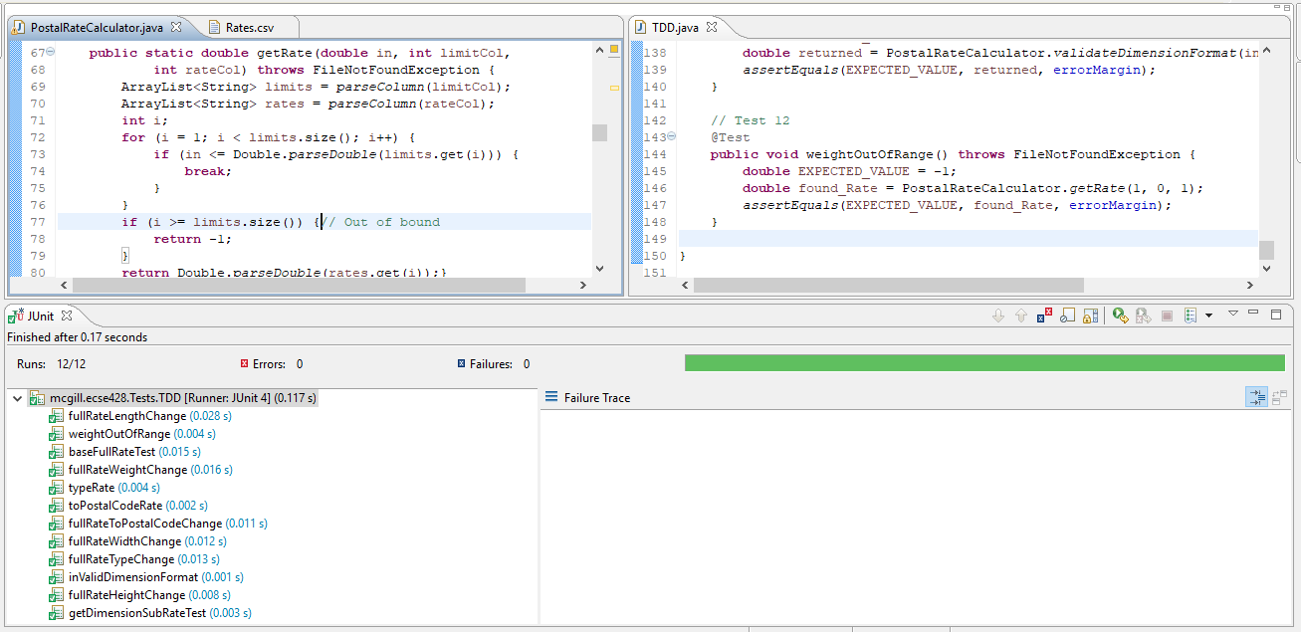

# Test 13: heightOutOfRange

## Purpose:

* Verify that the value entered for the ***height dimension*** is out of range. The ranges are found csv file.

## Inputs and Expected Output:

* An out of range double (300), and the columns of the height dimension ranges, and rates.
* The expected output is a double of value -1 indicating an out of range.

## Failing Screenshot:

This test passes as it relies on previously tested methods, with no need for any additional logic.

## C:\Users\karim\AppData\Local\Microsoft\Windows\INetCache\Content.Word\Test_13_Pass.pngPassing Screenshot:

# Test 14: lengthOutOfRange

## Purpose:

* Verify that the value entered for the ***length dimension*** is out of range. The ranges are found the csv file.

## Inputs and Expected Output:

* An out of range double (300), and the columns of the length dimension ranges, and rates.
* The expected output is a double of value -1 indicating an error.

## Failing Screenshot:

This test passes as it relies on previously tested methods, with no need for any additional logic.

## C:\Users\karim\AppData\Local\Microsoft\Windows\INetCache\Content.Word\Test_14_Pass.pngPassing Screenshot:

# Test 15: widthOutOfRange

## Purpose:

* Verify that the value entered for the ***width dimension*** is out of range. The ranges are found in the csv file.

## Inputs and Expected Output:

* An out of range double (300), and the expected output is a double of value -1.

## Failing Screenshot:

This test does not fail, since the previous logic gives the desired output.

## C:\Users\karim\AppData\Local\Microsoft\Windows\INetCache\Content.Word\Test_15_Pass.pngPassing Screenshot:

# Test 16: invalidType

## Purpose:

* Verify the user input for the type of postage. Ensuring that the user selects a type of postage from those that are accepted.

## Inputs and Expected Output:

* An invalid string, and the expected output is false.

## C:\Users\karim\AppData\Local\Microsoft\Windows\INetCache\Content.Word\Test_16_Fail.pngFailing Screenshot:

## C:\Users\karim\AppData\Local\Microsoft\Windows\INetCache\Content.Word\Test_16_Pass.pngPassing Screenshot:

# Test 17: invalidFromPostalCode

## Purpose:

* Verify that the origin postal code is of valid format (H1A 1A1), ***starting with H*** indicating that the package is sent from Montreal.

## Inputs and Expected Output:

* An invalid Origin postal code format.
* The expected output is a false Boolean.

## C:\Users\karim\AppData\Local\Microsoft\Windows\INetCache\Content.Word\Test_17_Fail.pngFailing Screenshot:

## Passing Screenshot:

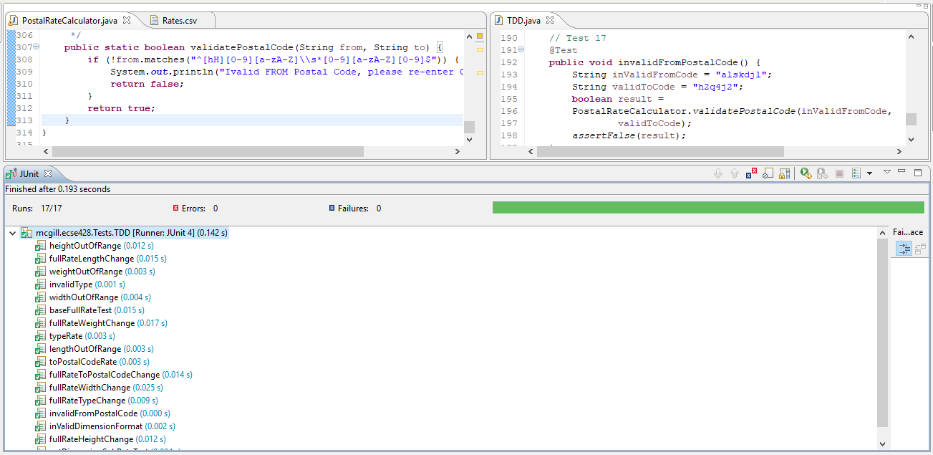

# Test 18: invalidToPostalCode

## Purpose:

* Verify that the destination postal code is of valid format (A1A 1A1).

## Inputs and Expected Output:

* An invalid destination postal code format.
* The expected output is a false Boolean.

## Failing Screenshot:

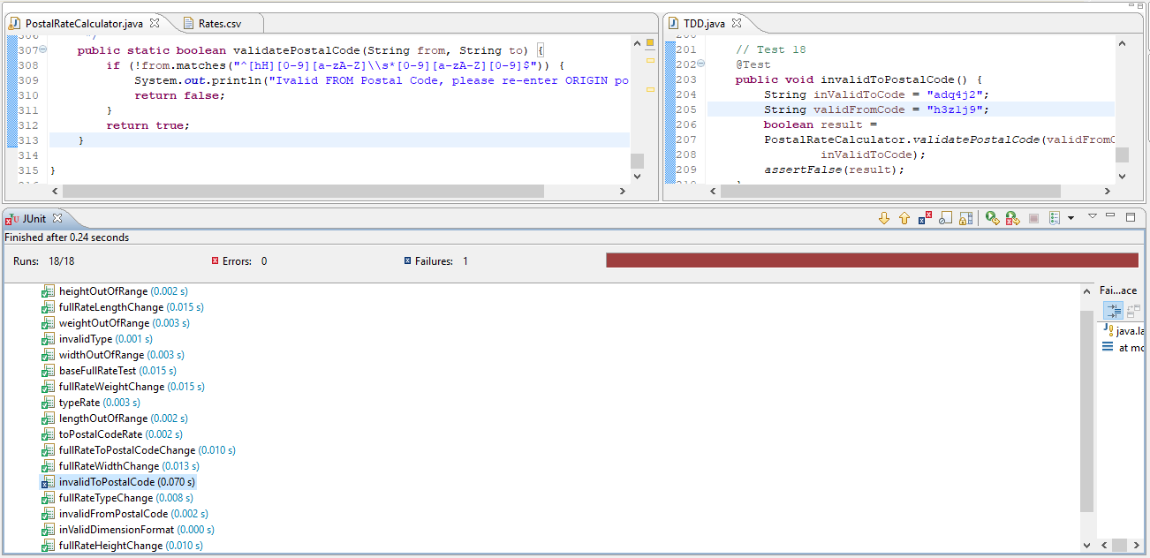

## C:\Users\karim\AppData\Local\Microsoft\Windows\INetCache\Content.Word\Test_18_Pass.pngPassing Screenshot:

# Test 19: negativeDimensions

## Purpose:

* Verify negative attributes (weight, height, length and width).

## Inputs and Expected Output:

* A negative value.
* The expected output is value of -1 indicating an error.

## C:\Users\karim\AppData\Local\Microsoft\Windows\INetCache\Content.Word\Test_19_Fail.pngFailing Screenshot:

## C:\Users\karim\AppData\Local\Microsoft\Windows\INetCache\Content.Word\Test_19_Pass.pngPassing Screenshot: