Responsible: El Abdulla K. D. Date: 2012-12-14 Doc. number: 12002 Version: 1.0

SRS – Software Requirements Specification:
WaterCalculatorSystem
SP

Table of Contents
1 Introduction 2
2 Reference documents 2
3 Background and goals 2
3.1 Main goals 2
3.2 Actors and their objectives 2
4 Terminology 3
5 Context diagram 3
6 Functional requirements 3
6.1 Calculation 3
6.2 Data 4
7 Quality requirements 4
7.1 Maintainability 4
7.2 Performance 4
8 Project requirements 4
8.1 Development environment 4

Document history
Ver. Date Resp. Description
1.0 02-10-2017 El Abdulla Karim First baseline version

1 Introduction
This document describes the requirements for the “WaterCalculatorSystem”, which is a frontend system for calculating daily amount of water. The system should provide the ability to calculate daily amount of water for each user, and should later be extended into a system with more useful functionality, such as a saving your previous calculations and building charts. The system is developed by the System Projecting faculty from Kiev Polytechnic Institute(SP).

2 Reference documents
No reference documents in this version.

3 Background and goals

3.1 Main goals
The main goal of the system is to provide functionality to calculate daily amount of water depending on the weight of user. That can be used as a basis when more advanced systems, like time-reporting systems, are developed on a server.

3.2 Actors and their objectives
The following main actors use the system
User A user can enter his data – weight, physical activity, gender. The main objectives of users are getting the daily amount of water.
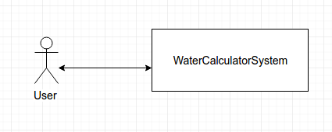

Figure 1: Context diagram

4 Terminology

functionality selection page a page with basic functionality of the system, available for every user of the website

5 Context diagram
A context diagram is displayed in Figure 1.

6 Functional requirements

6.1 Calculation
Requirement 6.1.1
The system should display daily amount of water in numeric format and in graphic format, using bottle image.
Scenario 6.1.1
Calculations
Precondition: The user is on calculation page

1. The user selects his values – weight, physical and gender
2. The system displays calculated data for the user
Requirement 6.1.2
Scenario 6.1.1 should be supported by the system
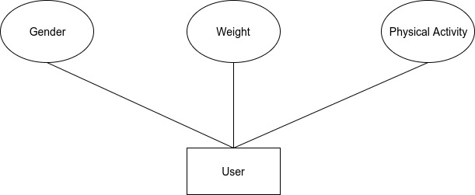
Figure 2: ER diagram

6.2 Data
Requirement 6.2.1
Weight should be between 20 and 140 kilograms.
Requirement 6.2.2
Physical activity should be between 0 and 6 hours.

7 Quality requirements

7.1 Maintainability
Requirement 7.1.1.
Knowledge corresponding to the knowledge goals of EDA016, and a basic knowledge of jQuery, CSS, HTML, should be sufficient in order to understand, maintain, and further develop the system.

7.2 Performance
Requirement 7.2.1.
The system should perform calculations faster than 5 seconds.

8 Project requirements

8.1 Development environment
Requirement 8.1.1
The system should perform calculations without server
Requirement 8.1.2
The system should be developed in jQuery.

