Lab 3

*Solve the following problems using Larp (Flowchart) and implement it in C language:*

1. Calculates the user’s body mass index (BMI) and categorizes it as underweight, normal, overweight, or obese, based on the following table from the United States Centers for Disease Control:

BMI Weight Status

* + - 1. Below 18.5 Underweight
      2. 18.5–24.9 Normal
      3. 25.0–29.9 Overweight
      4. 30.0 and above Obese

To calculate BMI based on weight in pounds (wt_lb) and height in inches

(ht_in), use this formula (rounded to tenths):

$$\frac{703 x wt_lb}{{ht_in}^{2}}$$

Prompt the user to enter weight in pounds and height in inches.

1. Reports the contents of a compressed-gas cylinder based on the first letter of the cylinder’s color. The program input is a character representing the observed color of the cylinder: “Y” or “y” for yellow, “O” or “o” for orange, and so on. Cylinder colors and associated contents are as follows:

orange ammonia

brown carbon monoxide

yellow hydrogen

green oxygen

Your program should respond to input of a letter other than the first letters of the given colors with the message, Contents unknown.

1. Accept the x–y coordinates of a point in the Cartesian plane and prints a message telling either an axis on which the point lies or the quadrant in which it is found.

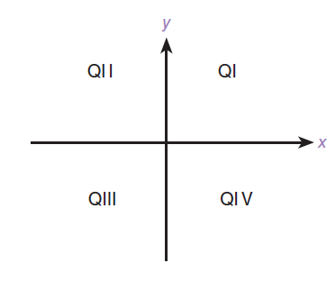

Samples lines of output:

(-1.0,-2.5) is in quadrant III

(0, 4.8) is on the y-axis

1. One large chemical company pays its salespeople on a commission basis. The salespeople receive $200 per week plus 9% of their gross sales for that week. For example, a salesperson who sells $5000 worth of chemicals in a week receives $200 plus 9% of $5000, or a total of $650. Draw a flowchart that will input each salesperson’s gross sales for last week and will calculate and display that salesperson's earnings. Process one salesperson's figures at a time.