Lab 9

*Write a C program to solve the following problems:*

1. Write a program that load students details from a data file containing the following data for each student: student ID, student name, student degree in subject 1, student degree in subject 2, student degree in subject 3. Each data are stored as a line. Your program should ask the user to choose to display the data of all students sorted according to student ID, student name, student total. (Use arrays and strings in implementing this program). Use the following data set.

|  |  |  |  |  |
| --- | --- | --- | --- | --- |
| Student ID | Student name | Degree 1 | Degree 2 | Degree 3 |
| 20001 | Ahmed Mohamed | 90 | 85 | 87 |
| 20002 | Mohamed Hassan | 95 | 92 | 90 |
| 20003 | Emad Mohsen | 75 | 88 | 91 |
| 20004 | Ali Nassar | 80 | 79 | 83 |
| 20005 | Yasser Maged | 97 | 98 | 99 |

1. A resistor is a circuit device designed to have a specific resistance value between its ends. Resistance values are expressed in ohms (Ω) or kilo-ohms (kΩ). Resistors are frequently marked with colored bands that encode their resistance values, as shown in the Figure. The first two bands are digits, and the third is a power-of-ten multiplier.

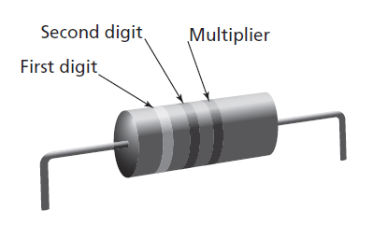

The Table below shows the meanings of each band color. For example, if the first band is green, the second is black, and the third is orange, the resistor has a value of 50 × 103 Ω or 50 k Ω. The information in the Table can be stored in a C program as an array of strings.

char COLOR_CODES[10][7] = {"black", "brown", "red", "orange", "yellow", "green", "blue", "violet", "gray", "white"};

Notice that “red” is COLOR_CODES[2] and has a digit value of 2 and a multiplier value of 102. In general, COLOR_CODES[n] has digit value n and multiplier value 10n.

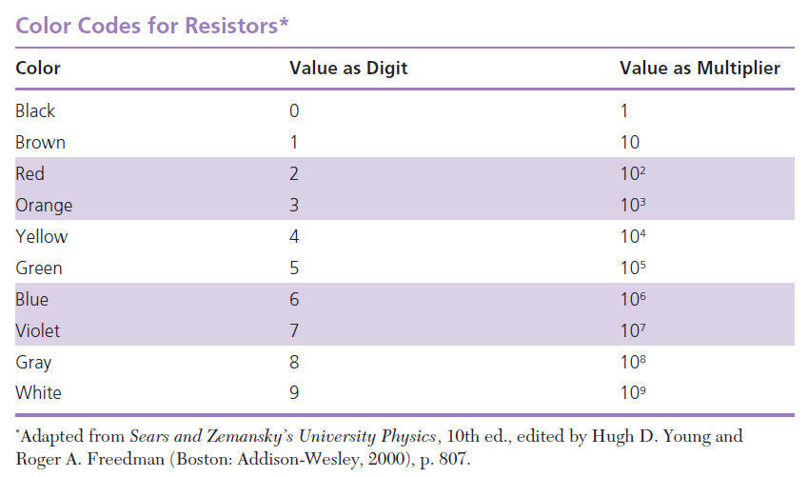

Write a program that prompts for the colors of Band1, Band2, and Band3, and then displays the resistance in kilo-ohms.

1. Write a program that reverses the input data, as shown below:

Input Output

32023 32023

teacher rehcaet

1. Write a program that takes verbs and forms their past tense on the basis of these rules:
   1. If verb ends in “e”, add “d”.
   2. If verb ends in “ss” or “gh”, add “ed”.
   3. In all other cases, inform the user that the verb may have an irregular past tense.

Print each verb and its past tense. Try the following data:

*smile discuss confess declare laugh run cough teach buy*