SHORTCUT ASIA INTERNSHIP CHALLENGE 2026
SlotWise MMU
Campus Resource Booking System

A responsive product prototype for discovering, booking, and managing shared university resources.
Candidate | Karim Hamzaoui
Submission | Shortcut Asia Internship Challenge 2026
Platform | Responsive web application
Technology | React, TypeScript, Vite, Tailwind CSS, Vercel
Date | 13 June 2026

LIVE APPLICATION
https://slotwise-mmu.vercel.app
SOURCE CODE
github.com/karimhamzaoui05/slotwise-mmu

Document guide
This report explains the product problem, implemented functionality, architecture, key workflows, engineering decisions, limitations, roadmap, and setup process.
- Executive summary and product context
- Target users, goals, and implemented features
- Booking and waitlist workflows
- Technical architecture and data model
- Engineering decisions, edge cases, and challenges
- Limitations, production roadmap, and setup instructions
- Suggested reviewer walkthrough
Review note The application is a functional front-end prototype. Authentication and shared persistence are simulated so reviewers can access the complete workflow without external credentials or infrastructure.

1. Executive summary
SlotWise MMU is a responsive campus resource booking application created for the Shortcut Asia Internship Challenge 2026. It gives students one place to discover and reserve rooms, equipment, laboratories, and project spaces, while giving administrators an operational view of utilization, maintenance, waitlists, and no-shows.
Core value Make campus availability visible, prevent invalid bookings, and recover cancelled capacity through a structured waitlist.

Problem | Fragmented or manual resource booking causes uncertainty, clashes, and wasted availability.
Solution | A unified interface for discovery, conflict-aware booking, check-in, cancellation, waitlists, and administration.
Primary users | MMU students and campus resource administrators.
Current scope | Functional front-end prototype with browser-based persistent demo data.
Deployment | Public Vercel application connected to the GitHub main branch.

2. Problem and target users

Problem statement
Campus resources are often coordinated through separate forms, spreadsheets, messages, or manual enquiries. Students may not know what is available, cancelled slots may remain unused, and administrators may lack a clear view of demand and operational status.
- Students cannot quickly compare availability, capacity, location, and amenities.
- Manual processes make double-booking and overlapping reservations harder to prevent.
- Cancelled reservations can leave useful rooms or equipment idle.
- Waitlist position, check-in status, and upcoming reservations are difficult to track.
- Administrators need one view of occupancy, maintenance, waitlists, and no-shows.

Target users
User | Primary need | Supported actions
Students | Find and reserve the right resource with minimal friction. | Search, filter, inspect, book, check in, edit, cancel, join and claim waitlists.
Administrators | Monitor operations and keep resources accurate and available. | Review metrics, utilization and activity; add, edit, block, maintain, or deactivate resources.

3. Product goals and feature scope
- Make availability immediately understandable.
- Prevent invalid, unavailable, maintenance, and overlapping bookings.
- Reduce wasted capacity through waitlist recovery.
- Support efficient repeated use on desktop and mobile.
- Demonstrate complete product states, not only a happy-path form.

Implemented feature set
Area | Implemented details
Demo access | Student and Admin shortcuts, university email validation UI, role-based navigation.
Dashboard | Search, quick availability controls, available-now resources, bookings, occupancy, and waitlist alerts.
Discovery | Search, filters, sorting, grid/list views, status, location, capacity, amenities, and next availability.
Booking | Weekly calendar, time-slot states, conflict feedback, live summary, booking reference, and confirmation.
My Bookings | Upcoming, past, and cancelled tabs with check-in, edit, cancellation, and direction actions.
Waitlist | Queue position, likelihood, expiration, countdown, claim, decline, and leave actions.
Administration | Operational metrics, charts, schedule, activity, resource table, edit drawer, and maintenance blocks.
Responsive UX | Desktop sidebar, mobile bottom navigation, accessible labels, focus states, and touch targets.

4. Key product workflows

Booking workflow
The booking experience goes deeper than basic create-and-save functionality. It communicates resource rules, prevents invalid selections, demonstrates conflict handling, and keeps the booking consistent across confirmation and management screens.
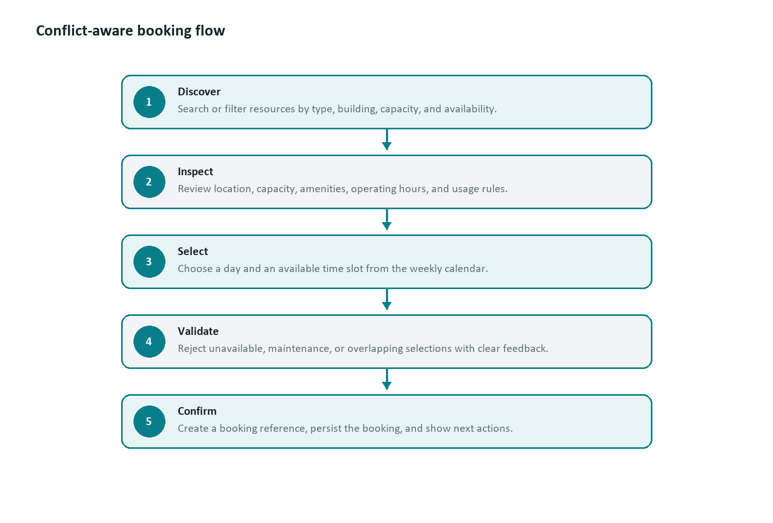
Figure 1. Conflict-aware student booking flow
Overlap rule A production conflict check uses: existingStart < requestedEnd AND requestedStart < existingEnd. This permits back-to-back bookings while rejecting intersecting ranges.

Waitlist workflow
The waitlist converts cancellations into usable capacity. Students see their position and a released slot countdown; a successful claim removes the queue entry and creates a confirmed booking.
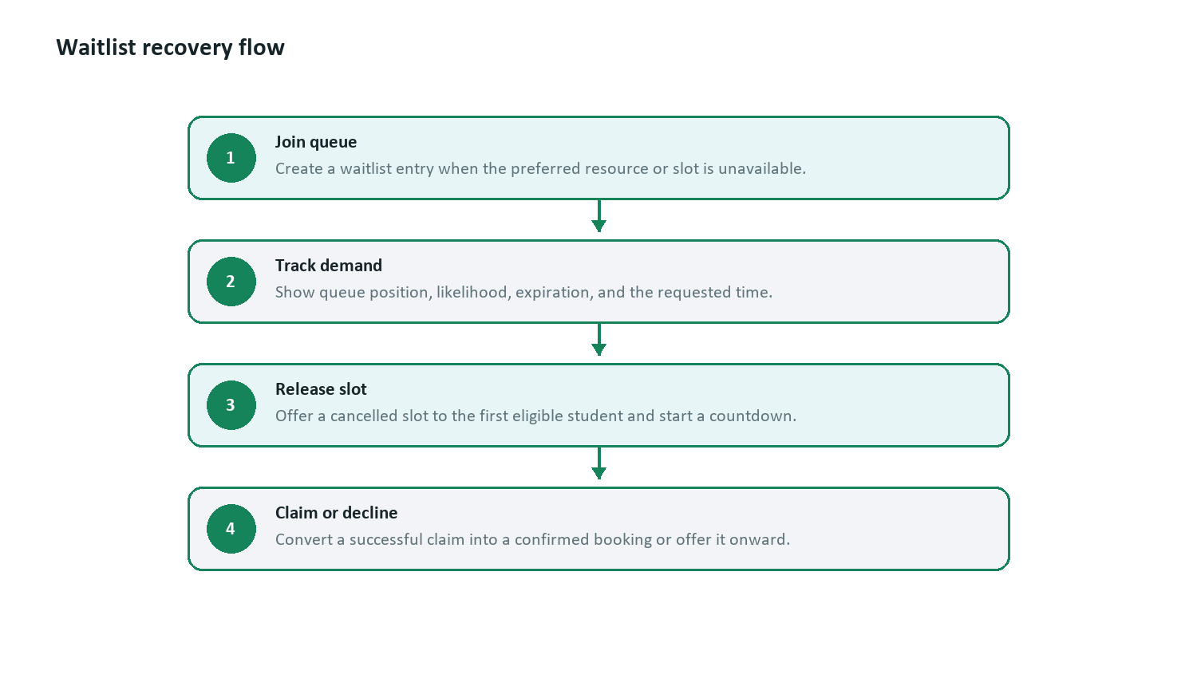
Figure 2. Waitlist release and claim flow

5. Technical architecture
SlotWise MMU is a client-side React application compiled by Vite and deployed as static assets on Vercel. Shared booking and waitlist state is managed at the application shell and persisted in the browser for a reliable reviewer demo.
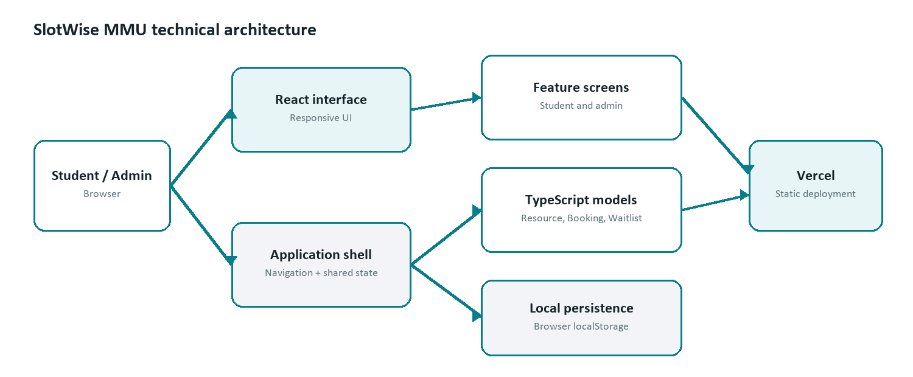
Figure 3. Current prototype architecture

Technology stack
Technology | Purpose
React 18 | Component-based interface and stateful product interactions.
TypeScript | Typed contracts for screens, resources, bookings, statuses, and waitlist entries.
Vite | Fast development server and optimized production build.
Tailwind CSS | Responsive utility styling supported by shared design tokens.
Lucide React | Consistent interface icons and accessible visual cues.
Recharts | Administrative utilization and booking trend visualizations.
Sonner | Clear success and status notifications.
Vercel | Public deployment and automatic redeployment from GitHub.

Application structure
Location | Responsibility
src/app/App.tsx | Navigation, user role, shared booking/waitlist state, events, and local persistence.
src/app/components/screens | Dashboard, Explore, Resource Details, Booking, Waitlist, Admin, and Profile screens.
src/app/components | Reusable navigation, resource cards, top bars, and status badges.
src/app/types.ts | Resource, Booking, WaitlistEntry, User, status, and screen contracts.
src/app/data/mockData.ts | Realistic MMU-style resources, bookings, waitlists, and admin metrics.
src/styles | Global presentation, design tokens, responsive behavior, and accessibility rules.

6. Technical decisions
React with TypeScript: The interface contains reusable, stateful workflows. TypeScript improves clarity and catches invalid values or incomplete transitions.
Vite for the prototype: The challenge prioritizes a dependable product within a short period. Vite keeps the build simple and fast without unnecessary server complexity.
Central shared state: Bookings and waitlists live at the application shell so actions on one screen immediately update confirmation, My Bookings, and Waitlist views.
Browser persistence: localStorage keeps the demo state after refresh and avoids database setup for reviewers. It is deliberately separated from the proposed production architecture.
Responsive web delivery: Students can book from phones while administrators can work from desktops, using one deployable codebase.
Reusable components: Navigation, resource cards, status badges, and design tokens improve consistency and reduce duplicated behavior.

7. Edge cases and quality considerations
- Unavailable and maintenance slots cannot be selected.
- A demonstrated overlap state provides immediate inline conflict feedback.
- Cancellation requires confirmation to reduce accidental destructive actions.
- Upcoming, past, cancelled, and waitlist screens include intentional empty states.
- Duplicate waitlist entries for the same resource are detected.
- Claimed waitlist slots become confirmed bookings in shared state.
- Malformed browser storage falls back to known mock data.
- Mobile layouts were verified at 390 px without horizontal overflow.
- Status is communicated through text and icons rather than color alone.

8. Challenges and solutions
Challenge | Resolution
Turning a design into maintainable code | Separated application state, typed models, reusable components, and screen-level responsibilities instead of isolated mock screens.
Keeping state consistent | Lifted bookings and waitlists into the application shell and used typed event handlers for create, update, leave, and claim operations.
Safely parsing time keys | Removed only the day prefix from values such as Fri:10:00, preserving the complete time rather than splitting on every colon.
Balancing scope and depth | Focused on two connected workflows: conflict-aware booking and waitlist recovery, supported by a useful admin experience.
Making review easy | Used realistic sample data, demo role shortcuts, public deployment, and browser persistence with no required environment variables.

9. Automated testing
Core booking rules are extracted into pure TypeScript functions and verified with Vitest independently from the React interface.
- Partial and contained booking overlaps.
- Valid back-to-back bookings.
- Conflict filtering by resource and date.
- Waitlist claim conversion and queue removal.
- Rejection of unreleased waitlist slots.
- Immutable booking cancellation.
Test command Run npm test to execute the complete unit suite.

10. Current limitations
Prototype boundary The application is intentionally optimized for evaluation and demonstration. The limitations below are explicit, not hidden production claims.

- Authentication is simulated and does not verify a real MMU identity.
- Data is stored per browser and is not synchronized across users or devices.
- Resource and administration data starts from realistic mock data.
- Email, push notifications, and calendar integration are not connected to external services.
- The final conflict check is demonstrated client-side rather than enforced by a transactional database.

11. Production roadmap
- Add Supabase or PostgreSQL for shared persistent data.
- Implement MMU email authentication and role-based authorization.
- Enforce booking overlap rules with database constraints or transactions.
- Expand the unit suite with React interaction and end-to-end browser tests.
- Add server-generated reminders and waitlist release notifications.
- Support QR-code check-in, calendar export, audit logs, and utilization reports.

12. Setup, build, and deployment

Requirements
- Node.js LTS
- npm
- A modern browser such as Chrome, Edge, Firefox, or Safari

Run locally
git clone https://github.com/karimhamzaoui05/slotwise-mmu.git
cd slotwise-mmu
npm install
npm run dev
Open the URL printed by Vite, normally http://localhost:5173. Select Student Demo or Admin Demo on the sign-in screen.

Quality commands
Automated tests | npm test
Type-check | npm run typecheck
Production build | npm run build
Preview build | npm run preview

Deployment
The GitHub repository is connected to Vercel. A successful push to the main branch triggers a new production deployment. The current prototype requires no environment variables.
Live application: https://slotwise-mmu.vercel.app
GitHub repository: github.com/karimhamzaoui05/slotwise-mmu

13. Suggested reviewer walkthrough
- Open the live application and choose Student Demo.
- Review the dashboard and available resources.
- Open Explore Resources and test search, filters, and view modes.
- Open a resource, test the conflict state, and reserve a valid slot.
- Confirm that the new reservation appears in My Bookings.
- Open Waitlist and claim the released Collaboration Room slot.
- Sign out and choose Admin Demo.
- Review metrics, charts, Resource Management, and maintenance actions.

14. Conclusion
SlotWise MMU demonstrates a complete product workflow rather than a collection of static screens. It addresses a realistic campus problem, includes meaningful booking and waitlist logic, handles important edge cases, and supports both student and administrative users. The architecture keeps the prototype easy to run and review while providing a clear path toward a secure, multi-user production system.
Submission position A working public application, transparent technical documentation, and a focused product story built around depth, usability, and explainable engineering decisions.

