Karim El Zaatari

Shopify Data Science Internship Challenge

Problem 1

The dataset provided consists of data for order amounts from 1000 shoe shops for the month of March 2017.
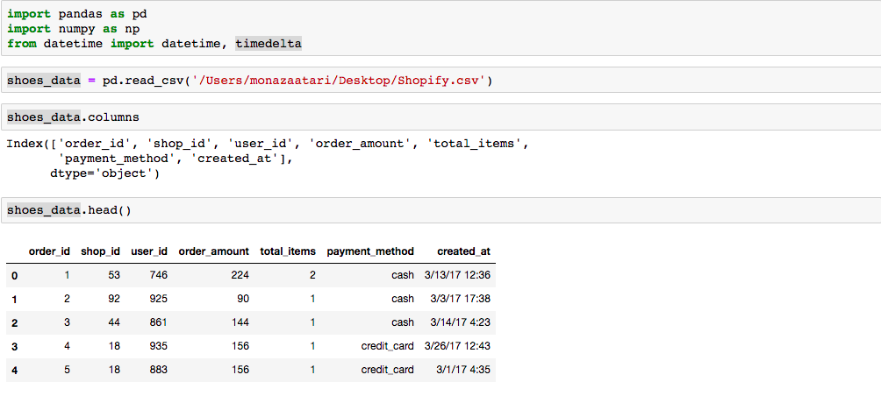

We first transform timestamps ‘created_at’ to date time objects in order to check for the range of dates.
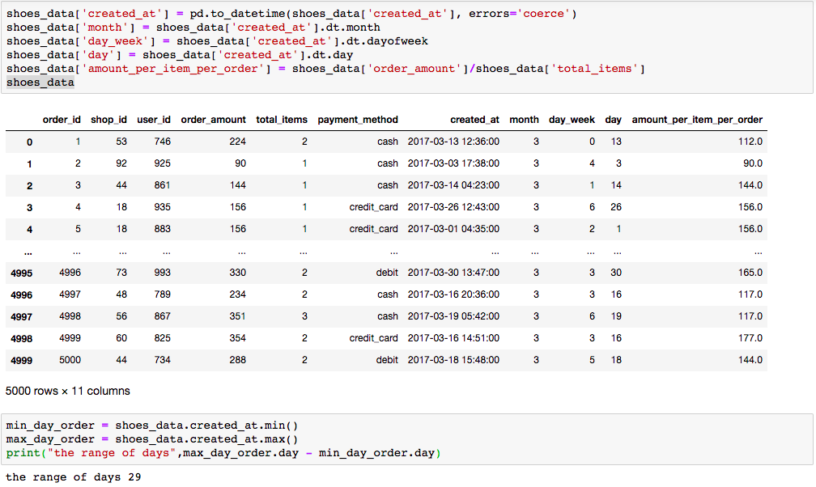

We have confirmed that the data used spans 1 months. We first calculate the average of the “order amount” column. The order amount includes the total price paid for all items purchased per order. This value is the average revenue per order.
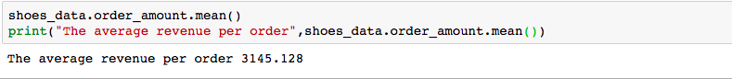
This value 3145 $ corresponds to the AOV naively calculated in problem 1. The value does not reflect average shoe price since an order can be composed of multiple shoes.

We introduce the variable “Amount_per item_per_order”. This variable reflecs the average price of an order per item (dividing total revenue per order by number of orders).

The average price of an order per item is 387.75$. this is a more reasonable estimation of the price of a shoe.

Problem 2

