Section 4 — Implementation
Smart Correspondence Tracking System — Lebanese Ministry of Interior and Municipalities

4.1 Implementation Overview
The Smart Correspondence Tracking System is a three-tier web application implemented in JavaScript across the entire stack. The frontend is a single-page React application built with Vite; the backend is a Node.js server using the Express framework; and the data layer is a MySQL 8 relational database accessed through the mysql2 promise-based driver. All three tiers run independently as separate processes during development, communicate over HTTPS-ready REST endpoints, and are designed to be containerized for deployment without code changes.
The implementation deliberately mirrors the workflow of the legacy Oracle Forms system the Ministry has used since 2002 — complaint intake, referral, decision, and resolution — while replacing the technology beneath it with a modern stack and addressing the twelve documented gaps from the legacy system analysis. Every functional requirement traced in Section 3 is realised by code in this section, and every architectural decision made here is justified against either a specific gap (Gap 1–12) or a non-functional requirement (NFR-1–NFR-7).

4.2 Repository Structure
The codebase is organised as a monorepo with two top-level packages, backend/ and frontend/, plus shared documentation at the repository root. The structure follows the conventions described in coding-conventions.md §2: each backend feature has parallel files in routes/, controllers/, validators/, and (where applicable) services/, so a new endpoint can be located by name in any of those directories.

4.2.1 Backend layout
backend/
├── src/
│ ├── app.js # Express app factory (no listener)
│ ├── server.js # Imports app and binds it to a port
│ ├── config/
│ │ ├── db.js # mysql2 connection pool
│ │ └── env.js # .env loader with required-key check
│ ├── controllers/ # Request handlers (one file per feature)
│ │ ├── authController.js
│ │ ├── complaintsController.js
│ │ ├── approvalsController.js
│ │ ├── attachmentsController.js
│ │ ├── adminController.js
│ │ ├── lookupsController.js
│ │ └── reportsController.js
│ ├── middleware/
│ │ ├── auth.js # JWT verification
│ │ ├── rbac.js # Role-based access control factory
│ │ ├── validate.js # Joi validator runner
│ │ ├── upload.js # Multer file upload config
│ │ └── errorHandler.js # Central error formatter
│ ├── routes/ # Thin route files: auth + rbac + validate → controller
│ ├── services/
│ │ └── trackingService.js # TRACKING-table audit-log helper
│ ├── utils/
│ │ ├── jwt.js # signToken / verifyToken
│ │ ├── password.js # bcrypt helpers
│ │ └── apiError.js # Typed error class
│ └── validators/ # Joi schemas (one file per feature)
├── tests/
│ ├── unit/ # 28 Jest unit tests
│ └── integration/ # 7 Supertest integration tests
├── scripts/
│ ├── seed.js # Demo data seed
│ └── create-admin.js # Initial admin bootstrap
└── package.json
Figure 4.1 — Backend folder structure

4.2.2 Frontend layout
The frontend follows a standard React + Vite layout. Reusable visual elements live in components/, route-level views in pages/, server interactions in api/, app-wide state in context/, and translation dictionaries in i18n/ — the latter is a deliberate Future Work seam for adding Arabic localization later (NFR-4) while shipping English-only in the MVP.
frontend/
├── src/
│ ├── App.jsx # Top-level router
│ ├── main.jsx # Vite entry point
│ ├── api/ # Axios wrappers per resource
│ ├── components/ # Sidebar, Topbar, AppToaster, ErrorBoundary, …
│ ├── context/ # AuthContext (JWT + user state)
│ ├── hooks/ # Reusable hooks
│ ├── i18n/ # react-i18next config + en.json
│ ├── pages/ # Route components (Dashboard, ComplaintDetail, …)
│ └── utils/ # apiError, formatters, date helpers
└── vite.config.js # Dev proxy → backend on :3001
Figure 4.2 — Frontend folder structure

4.3 Authentication Flow
Authentication follows the JSON Web Token (JWT) pattern recommended by the OWASP API Security Top 10. The flow is stateless on the server: no session table is maintained, and the token itself carries the staff_id, role_id, and role_name needed for authorization on every subsequent request. This design implements FR-1, FR-2, and FR-3 and directly addresses Gap 5 (legacy menu-only "security").

4.3.1 Login sequence
- A staff member submits email and password to POST /api/v1/auth/login.
- The auth controller looks up the staff row by email, joining ROLES so role_name is available without a second query.
- A bcrypt comparison is performed against the stored password_hash. If either the lookup or the comparison fails, an identical "Invalid email or password" response is returned, ensuring the API does not leak which of the two failed.
- Disabled accounts (STAFF.is_active = 0) are blocked at this step with a distinct 403 message — implementing FR-4 without compromising audit history.
- On success, a JWT signed with HS256 is returned to the client containing { staff_id, role_id, role_name } and an 8-hour expiry.
- The React AuthContext stores the token in memory and attaches it to every subsequent request as an Authorization: Bearer <token> header.

4.3.2 Per-request verification
The auth.js middleware shown in Listing 4.1 runs in front of every protected route. It extracts the token from the Authorization header, verifies the signature against the server-side JWT secret, and attaches the decoded payload to req.user so downstream middleware and controllers can read role and identity without re-querying the database. Verification failures (missing header, malformed token, expired token, wrong signature) are funnelled through the central errorHandler, which maps them to the stable error codes documented in api-spec.md §9.

Listing 4.1 — Authentication middleware (backend/src/middleware/auth.js)
const { verifyToken } = require('../utils/jwt');
const ApiError = require('../utils/apiError');

function auth(req, res, next) {
const header = req.headers.authorization || '';

if (!header.startsWith('Bearer ')) {
return next(new ApiError(401, 'NOT_AUTHENTICATED',
'Authentication required. Please log in.'));
}

const token = header.substring('Bearer '.length).trim();
if (!token) {
return next(new ApiError(401, 'NOT_AUTHENTICATED',
'Authentication required. Please log in.'));
}

try {
// verifyToken throws TokenExpiredError / JsonWebTokenError on failure;
// the central errorHandler maps those to our codes.
req.user = verifyToken(token);
next();
} catch (err) {
next(err);
}
}

module.exports = auth;
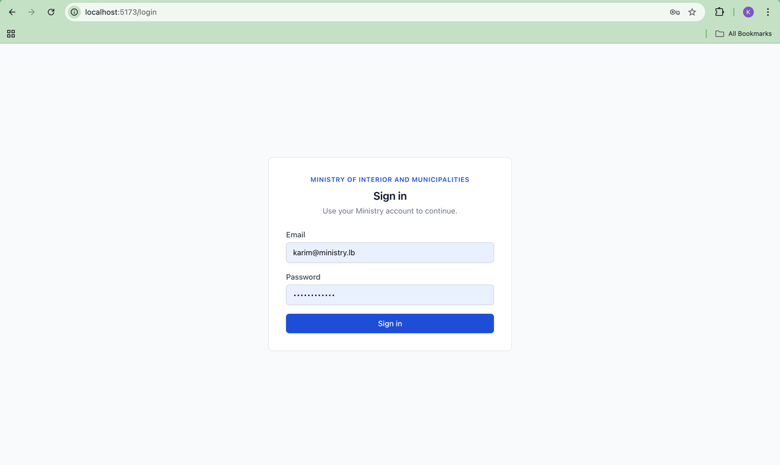Figure 4.3 — Login page (localhost:5173/login)

4.4 Role-Based Access Control (RBAC)
In the legacy Oracle Forms system, role enforcement was performed in the user interface only: menu options for restricted operations were hidden from non-manager accounts, but the underlying database queries remained accessible to anyone who could construct the right command. This is the central security defect identified as Gap 5 in the legacy analysis, and it is the most consequential modernization in this project.
The RBAC middleware is a factory function. Each protected route specifies its own allowed-roles array at registration time — for example, the staff creation route is registered with requireRole(["Admin"]), while the complaint creation route accepts ["Clerk", "Director", "Admin"]. The middleware compares req.user.role_name (set by the auth step) against the route's list and rejects the request with HTTP 403 if the role is not present. The check is case-insensitive but normalized once at setup, so per-request work is a single Array.includes call.

Listing 4.2 — RBAC middleware factory (backend/src/middleware/rbac.js)
const ApiError = require('../utils/apiError');

function requireRole(allowedRoles) {
// Normalize once at setup so we're not doing it per-request
const allowed = allowedRoles.map(r => r.toLowerCase());

return (req, res, next) => {
// auth must have run first and set req.user
if (!req.user || !req.user.role_name) {
return next(new ApiError(401, 'NOT_AUTHENTICATED',
'Authentication required.'));
}

if (!allowed.includes(req.user.role_name.toLowerCase())) {
return next(new ApiError(403, 'FORBIDDEN_ROLE',
'You do not have permission to perform this action.'));
}

next();
};
}

module.exports = requireRole;
In addition to the route-level check, controllers that return collections apply row-level filtering inside their SQL queries. For example, the GET /api/v1/complaints handler appends an ownership condition (c.submitted_by = ?) to its WHERE clause when the requester is a Clerk, so a Clerk does not even see the existence of complaints filed by colleagues. Directors, Ministers, and Admins skip the filter and see the full set. This two-layer model — route gate plus row filter — is the equivalent of the "menu hides, database doesn't" defect inverted: the database denies access first, and the UI only hides actions the user could not invoke anyway.
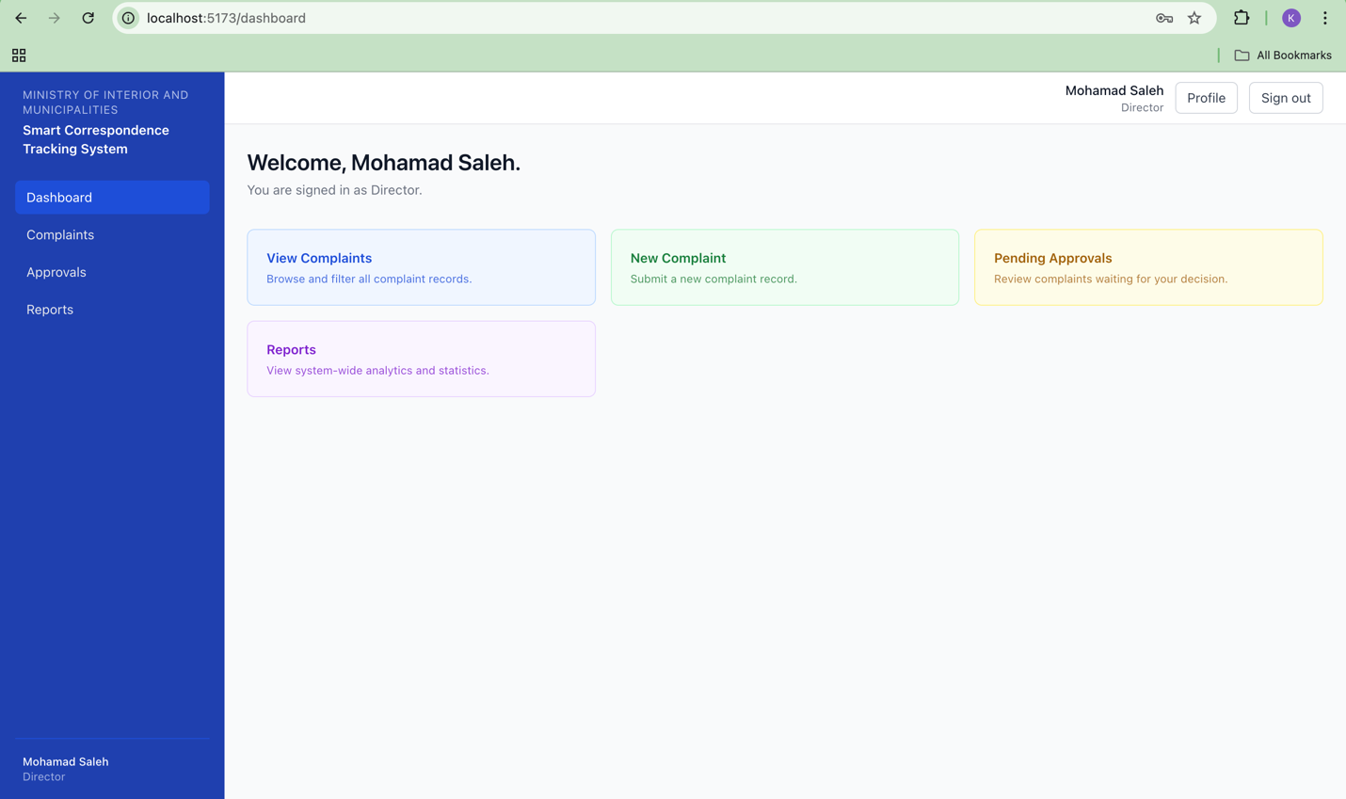
Figure 4.4 — Director dashboard (role-aware sidebar and quick-action cards)

4.5 The TRACKING Audit Pattern
The most operationally important feature of the new system is the audit trail. The legacy Transaction Card had no status field at all (Gap 1) and therefore no concept of a state-change history (Gap 2). Staff often resorted to handwritten notes to remember what had happened to a complaint. The proposed system replaces this with a dedicated TRACKING table that records every status change as an immutable row.

4.5.1 Table design
The TRACKING table has six application-level columns: complaint_id (foreign key), changed_by (foreign key to STAFF), from_status_id (nullable, NULL on the initial Submitted entry), to_status_id, notes, and changed_at. There are no UPDATE or DELETE operations exposed in the API for this table — it is append-only by convention and protected by the absence of any controller method that would modify or remove rows.

4.5.2 Transactional integrity
A status change is implemented as a three-statement transaction inside the complaints controller: an INSERT into APPROVALS, an INSERT into TRACKING, and an UPDATE on COMPLAINTS.status_id. All three statements run on the same mysql2 connection inside a beginTransaction()/commit() block, so a failure on any of the three rolls back the entire change. This satisfies NFR-3 (audit integrity).

4.5.3 Reusable helper
The actual TRACKING insert is wrapped in a small service helper, recordTransition, so any controller that performs a status change uses the same parameter shape and the same column ordering — eliminating a class of bugs where a developer might forget to log a transition or pass arguments in the wrong order.

Listing 4.3 — TRACKING insert helper (backend/src/services/trackingService.js)
/**
* Insert a tracking row inside an existing transaction connection.
* Implements FR-19 and addresses Gap 2.
*/
async function recordTransition(conn, {
complaintId, changedBy, fromStatusId, toStatusId, notes
}) {
await conn.execute(
`INSERT INTO TRACKING
(complaint_id, changed_by, from_status_id, to_status_id, notes)
VALUES (?, ?, ?, ?, ?)`,
[complaintId, changedBy, fromStatusId || null, toStatusId, notes || null]
);
}

module.exports = { recordTransition };
On the frontend, the same data is read back through GET /api/v1/complaints/:id/tracking and rendered as a reverse-chronological timeline on the complaint detail page. Each entry shows the previous and new status, the staff member who performed the change, the timestamp, and any comment they recorded — closing the loop on Gap 2 from the user's perspective.
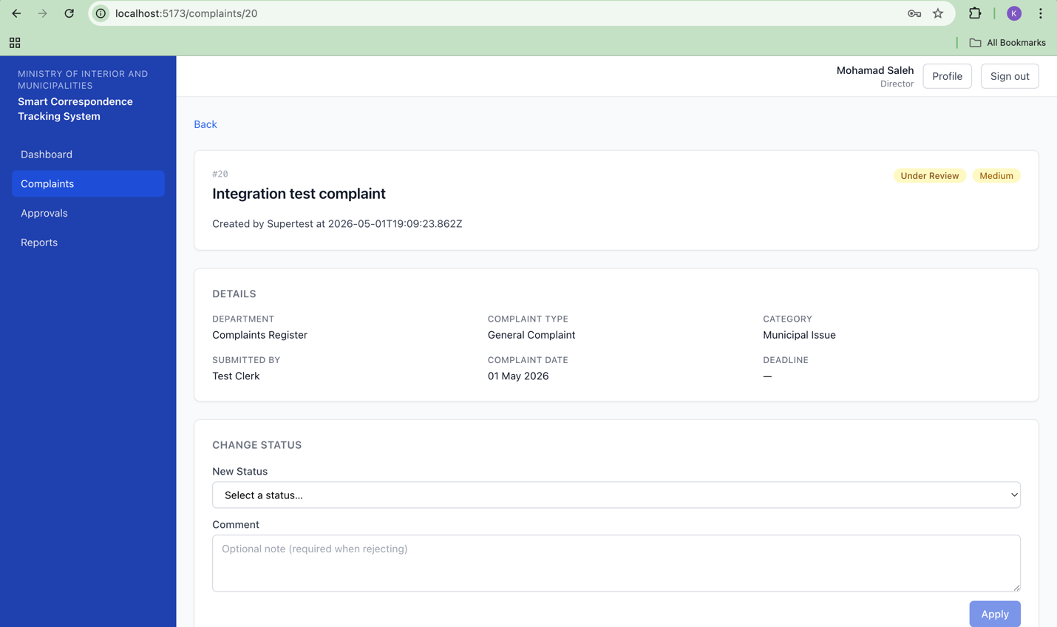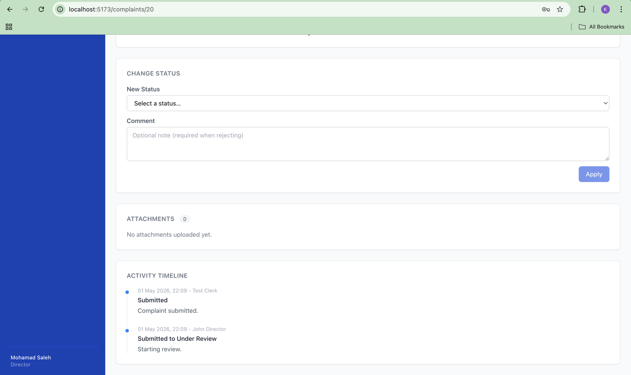Figure 4.5 — Complaint detail page showing audit timeline

4.6 File Upload (Attachments)
Gap 3 in the legacy analysis describes a paper-first workflow in which physical documents were scanned only after the fact, leading to the legacy "Transaction Not Scanned" warning that appeared on most records. The new system inverts this: attachments are first-class data uploaded at intake time, and the COMPLAINTS.is_scanned flag flips automatically as soon as one attachment exists.
The upload pipeline is built on Multer, configured at backend/src/middleware/upload.js. Each accepted file is renamed with a UUID v4 before being saved to disk under /uploads/, preventing collisions and making the on-disk filename non-guessable. The MIME-type filter restricts uploads to PDF, JPEG, PNG, and DOCX; the size limit is 10 MB per the api-spec.md §3 contract; and rejections are surfaced to the client through the same ApiError + errorHandler chain as every other validation failure, so a user-friendly English message ("Only PDF, JPEG, PNG, and DOCX files are allowed.") replaces the raw Multer error.
Once Multer has accepted the file, the attachments controller writes a row to the ATTACHMENTS table with the original filename, the on-disk filename, the MIME type, the size in kilobytes, and the uploading staff member's ID. The is_scanned flip is performed in the same controller using a single UPDATE … WHERE complaint_id = ? AND is_scanned = 0 statement, making the flip idempotent.
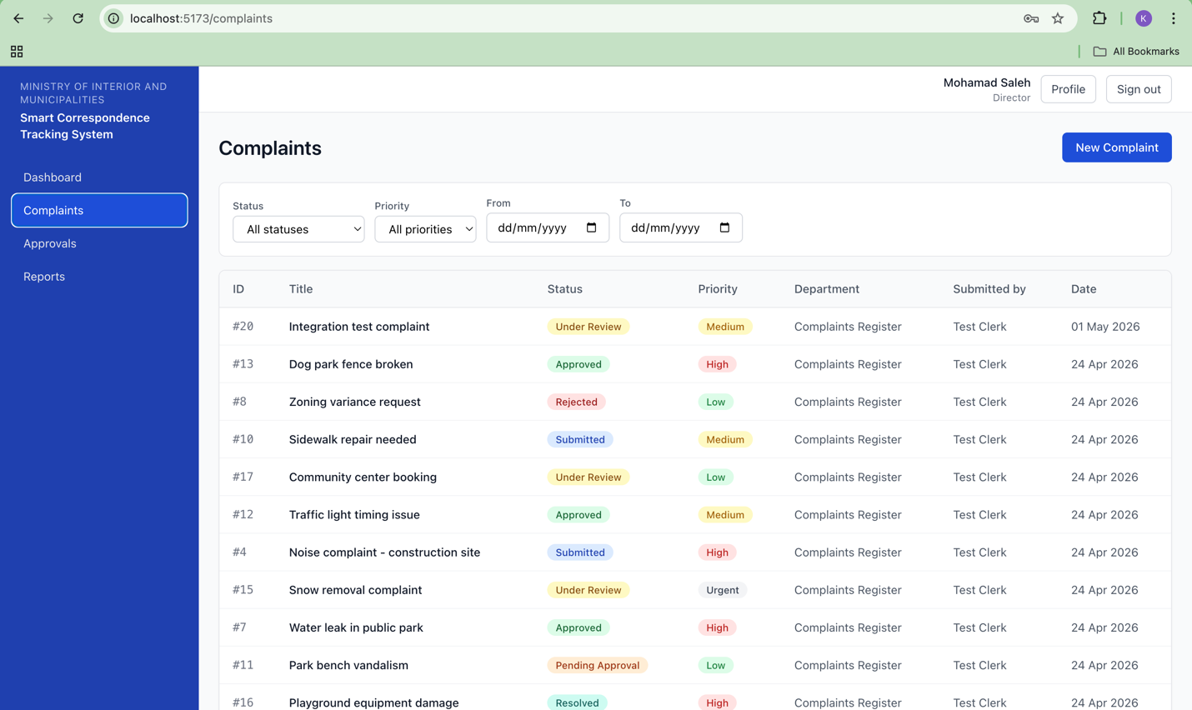Figure 4.6 — Complaints list with filters (Status, Priority, Date range)

4.7 Frontend Integration
The React frontend is intentionally thin. State management is done with a single AuthContext that wraps the application and exposes the JWT, the logged-in user object, and login/logout helpers. All server calls are routed through small per-resource modules in src/api/ (auth.js, complaints.js, reports.js, …) which use Axios and a shared interceptor that attaches the JWT and surfaces ApiError objects in a consistent shape.
The Sidebar component reads the role_name from AuthContext and only renders menu items the current role is permitted to use — Approvals is hidden from Clerks, the User Management entry is hidden from non-Admins, and so on. Crucially, this is purely a UX optimisation: every link the sidebar would hide is also defended by the route-level RBAC middleware on the backend, so navigating directly to a hidden URL still returns 403.
All user-facing strings are routed through react-i18next and read from src/i18n/en.json. No component in the codebase contains a hard-coded English string. This is enforced by code review per the coding-conventions.md pre-merge checklist and is the seam for future Arabic localization (NFR-4).
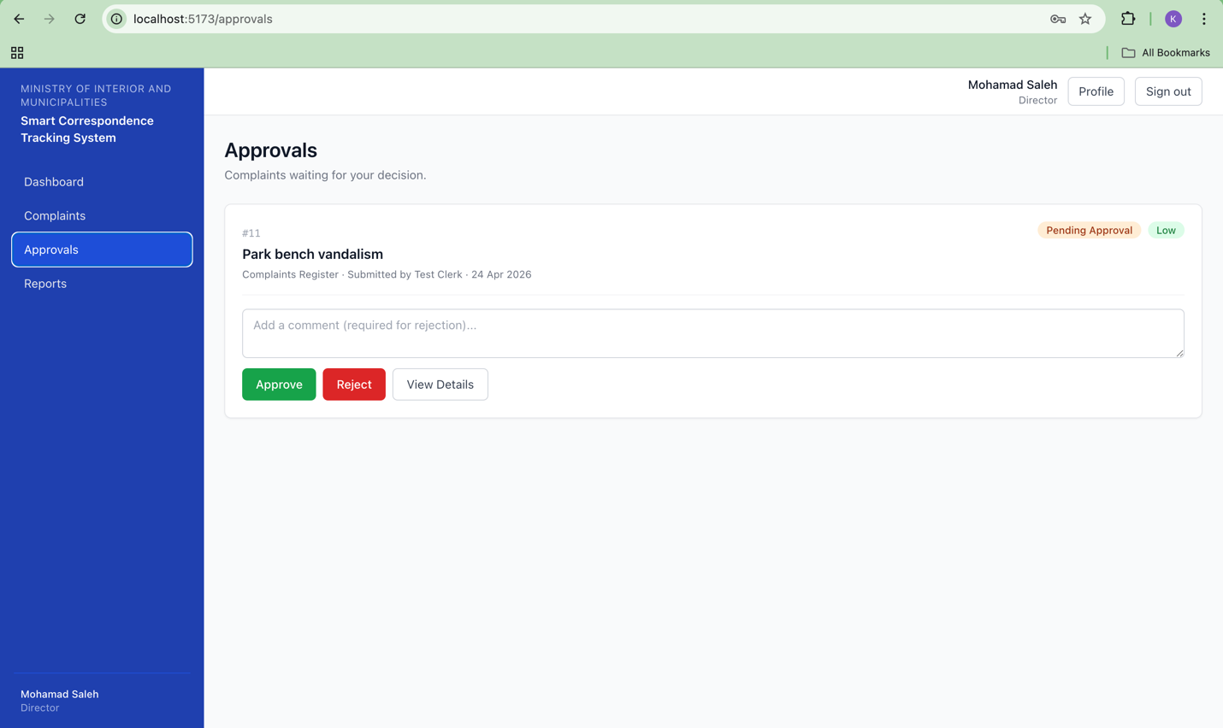
Figure 4.7 — Approvals page (Director queue at status_id = 3)

4.8 Input Validation, Error Handling, and Testing
Every request body is validated by a Joi schema before reaching the controller. The validate middleware runs the schema against req.body, and on failure constructs an ApiError with the code VALIDATION_FAILED and a message that concatenates the individual Joi messages — for example, '"category" is required; "priority" must be one of [Low, Medium, High, Urgent]'. This addresses Gap 7 (raw error codes leaking to users) and satisfies NFR-2.
The errorHandler middleware is registered last in app.js and is the only place in the codebase that calls res.status(...).json(...) for error responses. It distinguishes between three kinds of errors: ApiError instances are passed through with their own status and code; jsonwebtoken errors (TokenExpiredError, JsonWebTokenError) are mapped to TOKEN_EXPIRED or NOT_AUTHENTICATED; mysql2 ER_DUP_ENTRY errors are mapped to friendly DUPLICATE_EMAIL or DUPLICATE_NATIONAL_ID messages by inspecting the violated unique-key name; everything else becomes a generic INTERNAL_ERROR with no stack trace exposed to the client.
The implementation is covered by 35 automated tests: 28 Jest unit tests (auth controller, complaints controller, approvals controller, RBAC middleware, JWT/ApiError utilities) and 7 Supertest integration tests (login flow, complaint creation through transition, RBAC enforcement). Controller coverage exceeds 50%, and middleware/utility coverage is 100%. Test details are described in Section 5.
[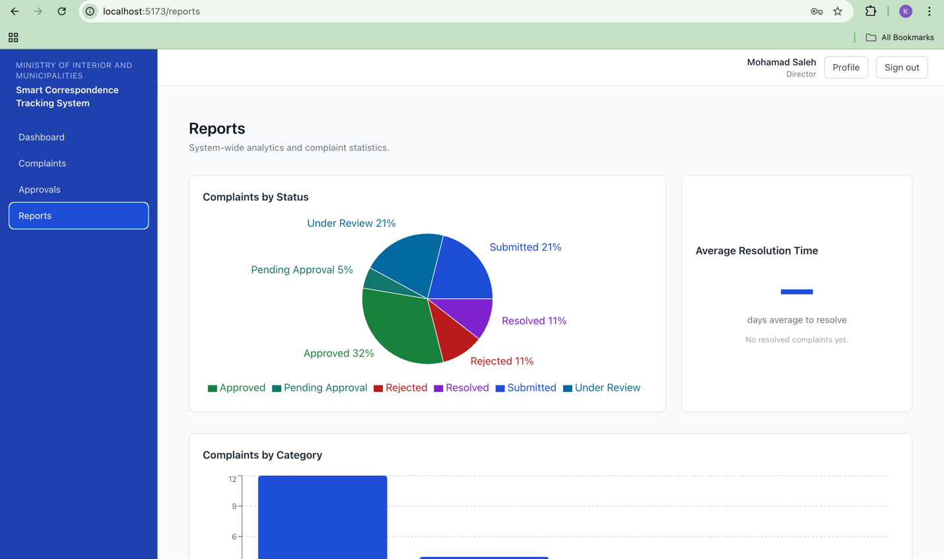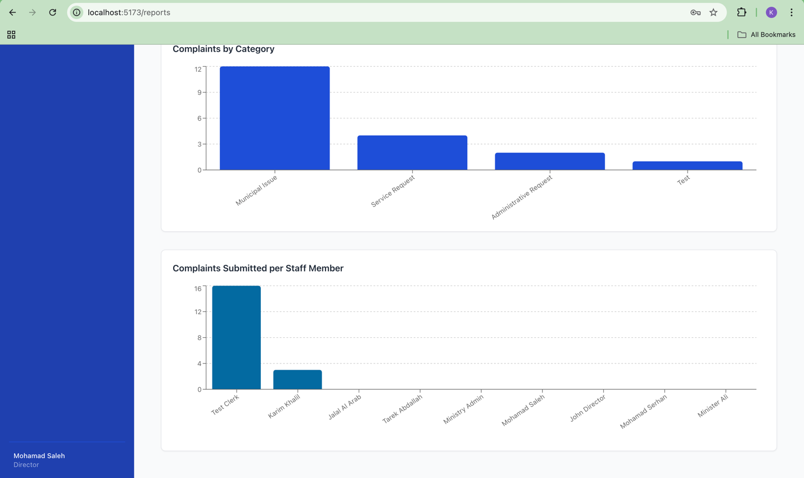
Figure 4.8 — Reports page with status, category, and resolution-time charts

4.9 Summary
The implementation delivers all 22 functional requirements traced in Section 3, addresses each of the 12 documented legacy gaps, and meets the seven non-functional requirements within the academic-demo scope defined in NFR-7. The codebase is organised so that any feature can be located through parallel files in routes/, controllers/, validators/, and services/; security is enforced server-side at two layers (route gate and row filter); and every state change in the system is recorded as an immutable row in TRACKING. The next section describes the testing strategy used to verify each of these claims.

5. Testing and Evaluation
This section describes how the Smart Correspondence Tracking System was tested before submission. Because this is an academic capstone rather than a production deployment, the testing strategy deliberately favors breadth over depth: every functional requirement in requirements.md is exercised by at least one test, but exhaustive load testing, security penetration testing, and User Acceptance Testing are explicitly out of scope per NFR-7. The goal of the testing phase was to demonstrate that every gap identified in legacy-system-analysis.md has been measurably closed by the new system, and that the corresponding code paths behave correctly for all four roles.

5.1 Test strategy
Testing was organized into three layers, each addressing a different class of risk. Unit tests verify that individual controller and middleware functions behave correctly in isolation, with the database and HTTP layer mocked. Integration tests verify that the Express application, the MySQL database, and the JWT pipeline cooperate correctly across multi-step workflows. Manual test cases verify the end-user experience against a running instance of the application — covering UI behavior, role-based navigation, and the final shape of error messages presented to staff.
Each test layer is traceable to a specific requirement. Authentication tests cover FR-1 through FR-4. Complaint workflow tests cover FR-5, FR-6, FR-11, FR-12, FR-13, and FR-14. Audit-trail tests cover FR-19 and FR-20 plus NFR-3 (transactional integrity of TRACKING inserts). The role-based access tests cover FR-3 and the four-role model defined in the ROLES table.

5.2 Tools used
- Jest 29 — JavaScript test runner used for backend unit tests, with built-in mocking and code-coverage reporting.
- Supertest — HTTP assertion library mounted on top of the Express app factory; used to drive integration tests without binding a real network port.
- Postman — used during development for ad-hoc API exploration and to confirm JWT and RBAC behavior on each new endpoint before the formal tests were written.
- phpMyAdmin — used to verify database state directly during manual test execution (TRACKING rows, is_scanned flag, status_id transitions).
- Microsoft Edge DevTools — used during manual testing to inspect network requests, confirm structured query parameters, and trigger negative test cases by sending forged requests from the console.

5.3 Unit tests
Twenty-eight Jest unit tests were written across five suites, exercising the highest-risk parts of the backend. The suites and their focus are summarized in Table 5.1. Database calls and Express request and response objects were mocked so that each test isolates the function under test from external dependencies. The test files live in backend/tests/unit/ and are run with npm test.
Table 5.1 — Unit test suites
Test suite | Cases | Focus
authController.test.js | 6 | Login success and failure, password hashing, JWT issuance, disabled-account rejection.
complaintsController.test.js | 8 | Complaint creation, role-conditional list filtering, transactional TRACKING insert, status transition guard.
approvalsController.test.js | 6 | Approve and reject paths, mandatory-comment check on rejection, valid-transition map.
rbac.test.js | 4 | Role membership check, 403 response shape, factory pattern for per-route role lists.
authUtils.test.js | 4 | JWT signing and verifying, ApiError class, password-hash compare wrapper.
Total | 28 | All five suites passing.
Coverage measured with Jest’s built-in --coverage flag is reported in Table 5.2. The aggregate controller coverage of 50.38 percent satisfies the NFR-6 quality target and the plan’s stated goal of greater than 50 percent without overinvesting in tests for trivial code paths.
Table 5.2 — Code coverage by area
Area | Coverage | Notes
Controllers (aggregate) | 50.38% | Meets NFR-6 target.
approvalsController.js | 76% | Highest-risk workflow path.
RBAC middleware | 100% | Small surface, fully covered.
JWT and ApiError utilities | 100% | Pure functions, easy to test.

5.4 Integration tests
Seven Supertest integration tests were written in backend/tests/integration/api.test.js and run with npm run test:integration. Unlike the unit tests, the integration tests use a real MySQL database with seeded credentials and exercise the full Express middleware stack (auth, RBAC, validation, controller, database, response). To make this possible without binding a real network port, the Express application was refactored into a separate factory file (src/app.js) that Supertest can import and wrap directly while src/server.js continues to handle the actual port binding for production runs.
- Login flow: valid credentials return a JWT; invalid credentials return 401.
- Role-gated endpoint: a Clerk JWT presented to GET /admin/staff returns 403 with code FORBIDDEN_ROLE.
- Complaint creation: POST /complaints inserts into both COMPLAINTS and TRACKING in a single transaction.
- Status transition: a Director can move a complaint from Submitted to Under Review and the timeline reflects the change.
- Tracking timeline: GET /complaints/:id/tracking returns rows in reverse chronological order with full join data.
- Invalid transition: POST /complaints/:id/transition with an illegal target status returns 400 with code INVALID_TRANSITION.
- Terminal status: a complaint in the Rejected status cannot be transitioned further by a Director.

5.5 Manual test cases
A document of 22 manual test cases (test-cases.md, included as an appendix) was written to exercise every functional requirement from FR-1 through FR-22 against the running application. Each case follows a consistent format: a unique ID, the FR number it addresses, the steps the tester performs, the expected result, the actual observed result, and a pass or fail verdict. The test cases were executed in a single session against a fresh seed of the database, with phpMyAdmin used to verify database state where the user interface alone would not suffice (for example, confirming the contents of the TRACKING table after each transition).
The summary of the manual test run is shown in Table 5.3. Sixteen cases passed, four failed, two were blocked by an unimplemented UI surface (the citizen-linking form), and one destructive case (forcing a transactional rollback by renaming the TRACKING table) was skipped to protect the demo database. The four genuine failures are tracked in bugs.md as B05, B06, B07, and B08, and are scheduled for triage in the polish phase before final submission.
Table 5.3 — Manual test pass and fail summary
Outcome | Count | Test cases
Pass | 16 | TC-01 to TC-08, TC-11 to TC-14, TC-16, TC-18, TC-19, TC-20
Fail | 4 | TC-15, TC-17, TC-21, TC-22
Blocked | 2 | TC-09, TC-10 (citizen UI not implemented)
Skipped (destructive) | 1 sub-step | TC-06 rollback step
Total cases | 22 | FR-1 through FR-22 each exercised at least once

5.6 Defects discovered and resolution status
Two defects (B01 and B02) were carried into the test phase from an earlier manual QA pass. Both stemmed from a single root cause in the GET /complaints/:id route, where the role-based access filter was too restrictive and prevented Directors and Admins from opening any complaint they had not personally submitted. The route was rewritten to be role-conditional, and the fix was verified during the manual test run under TC-11.
Six new defects (B03 through B08) were filed during the manual run. Four of them are missing-feature defects rather than incorrect behavior: B03 (no attachment upload UI on the complaint detail page after creation), B04 (no citizen search and link UI on the New Complaint form), B07 (no Admin lookup-table management page), and B08 (no grouped referral-destinations dropdown). Two are partial regressions in already-implemented features: B05 (the dashboard renders quick-action cards but is missing the role-specific numeric count cards FR-15 calls for) and B06 (the complaints list supports filtering and pagination but the column headers are not clickable for sorting). All six are open and prioritized for the polish phase in the order B05, B03, B06, B04, B07, B08.

5.7 Limitations of the testing approach
Several testing activities were deliberately deferred per NFR-7 because they belong to a production deployment rather than an academic capstone. No load testing was performed; the system has only been exercised at single-user scale on a developer laptop. No security penetration testing was performed beyond confirming that the documented authentication and authorization paths behave as specified — exposure of the API to a hostile network would require a separate hardening pass. No formal User Acceptance Testing with Ministry staff was performed because the system is a CSC 599 demonstration and the legacy 2002 Oracle Forms system remains in operational use.
Within those bounds, the testing performed is sufficient to demonstrate that the system meets the functional requirements that define the project’s scope. The combination of 28 unit tests, 7 integration tests, and 22 manual cases — together with the bug-tracking discipline shown in bugs.md — gives an honest picture of what is finished, what is not, and what is known to be broken at the time of submission.

6. Entrepreneurial Perspective and Innovation
This section examines the Smart Correspondence Tracking System through the lens of public-sector entrepreneurship rather than commercial product development. The system was not built to be sold; it was built to demonstrate that a small, well-scoped engineering effort can replace a 24-year-old administrative tool whose continued operation imposes a measurable cost on the Lebanese state. The discussion below considers market relevance, the path to extending the system to other ministries, and the ethical and societal considerations that arise when modernizing a system that touches citizen-government interactions.

6.1 Market relevance for the Lebanese public sector
The Lebanese public administration runs on a long tail of legacy systems built between the late 1990s and the early 2010s. The legacy correspondence-tracking application that this project replaces is a representative example: an Oracle Forms 9.0 build dated 14 May 2002, still in daily use in 2026, with no audit trail, no status field on the core record, and a security model that hides menu items but does not enforce them at the database layer. Systems of this kind are not unique to the Ministry of Interior. Similar Oracle Forms and FoxPro applications continue to operate inside ministries, municipalities, and public utilities across the country.
The market relevance of the project is therefore not a search for paying customers but a demonstration that a credible replacement can be built, shipped, and demonstrated within the constraints of an academic capstone — twenty production-style code modules, a normalized database, role-based access enforced server-side, and a documented audit trail. The same architecture, with different lookup tables and different role definitions, is applicable to municipal complaint registers, parliamentary correspondence units, and the document-flow offices of any directorate that currently relies on paper plus a desktop database.
The relevance is sharpened by the country’s broader context. Public trust in administrative processes is low, paper-trail loss is a real operational concern, and the cost of training new staff to operate Oracle Forms only becomes harder to justify each year as the developer market for that technology shrinks. A system that records every state change as an immutable row in a TRACKING table — visible to the staff who handled the case and auditable after the fact — is not an incremental upgrade. It is a different category of artifact.

6.2 Potential to extend to other ministries
Three architectural choices in the current system make extension to other ministries feasible without a rewrite. First, every domain-specific value lives in a lookup table rather than a hard-coded enumeration: COMPLAINT_TYPES, DEPARTMENTS, and REFERRAL_DESTINATIONS are all editable through admin routes (FR-21), so the same codebase can serve a Ministry of Interior workflow and, after a different seed, a Ministry of Finance correspondence-tracking workflow. Second, the role model is data-driven rather than coded: the four roles (Admin, Clerk, Director, Minister) are stored in the ROLES table and referenced by the RBAC middleware as strings, so adding or renaming roles requires a seed change rather than a code change. Third, the user-facing strings are routed through react-i18next (NFR-4), which means a future Arabic localization can be added by dropping in a translated JSON file without touching any component.
Extension is therefore primarily a configuration exercise: replace the seed data, adjust the role labels, swap the branding in the topbar, and translate the i18n bundle. The harder work — authentication, RBAC, audit trail, transactional integrity, file uploads, structured search — is shared across any ministry that handles incoming requests, routes them for decision, and needs to prove, after the fact, who did what and when.
A realistic deployment path would begin with a single municipal pilot — one mid-sized municipality willing to run the system in parallel with its existing process for a quarter — and use that pilot to validate the seed-and-localize extension model before approaching larger directorates. The pilot phase is also the moment at which the system would acquire the production-only concerns deferred by NFR-7: a hardened CORS policy, rate limiting, virus scanning on uploads, and a deployment topology that does not run on a developer laptop.

6.3 Ethical and societal considerations
Modernizing a government correspondence system is not an ethically neutral act. The legacy system’s opacity is a defect from the user’s perspective and a feature from the perspective of any individual who would prefer that their handling of a case not be reviewable. The proposed system removes that opacity by recording every status change with a staff identifier and a timestamp in an append-only TRACKING table that no controller method can modify or delete. This is the right design for accountability, and it is also a real change in the working conditions of the staff who will use the system. That tension deserves to be named honestly rather than waved away.
Three ethical considerations were carried throughout the design. First, citizen data is minimized: the CITIZENS table stores only the fields needed to identify and contact the complainant (national_id, full_name, phone, email, address) and deliberately does not store demographic or political attributes. Second, deletion is structurally constrained: STAFF rows can be deactivated via is_active = 0 but never deleted, preserving the integrity of historical TRACKING entries that reference the staff member (FR-4). Third, the system does not implement automated decision-making — every status change is performed by a human and signed by their staff_id. The system is a record-keeping and routing tool, not a judgment tool, and that scope was held deliberately throughout development.
The societal benefit, if the system were deployed at scale, is the gradual replacement of a paper-and-handwritten-note workflow with one in which a citizen can — in principle — be told why their complaint moved from one stage to the next, on what date, and by which department. That kind of traceability is a precondition for trust in public administration. It is also a precondition for any meaningful debate about service-level expectations: a Ministry that cannot measure its own response times cannot improve them, and one that can measure them is forced to reckon with what the numbers say.

7. Project Management and Teamwork
This section is a candid retrospective on how the work was organized, divided, and executed. The team consisted of two members, Karim Khalil and Jalal Al Arab, working together against a shared GitHub repository under the supervision of Dr. Mohammad Farhat. The project followed the five-milestone schedule laid out in the Design Report (Section 10): requirements and setup, system design, implementation, testing, and final submission, with a target submission at the end of Week 8 of the Spring 2026 capstone schedule.

7.1 Timeline retrospective
The project was structured around the five milestones defined in the Design Report. Milestone M1 (Requirements and Setup, target Week 2) covered requirements analysis, the legacy-system gap study, the database schema, the backend project scaffold, and JWT authentication tested with Postman. Milestone M2 (System Design Finalized, target Week 4) covered the UML diagrams, the page-level wireframes, and the Design Report draft. Milestone M3 (Implementation Complete, target Week 6) covered the full-stack development: the Express endpoint groups for complaints, approvals, attachments, users, and reports, the React frontend, and end-to-end integration. Milestone M4 (Testing Phase Completed, target Week 7) covered unit testing, integration testing, manual acceptance testing, and bug-fixing. Milestone M5 (Final Submission Ready, target Week 8) covered Final Report assembly, demo rehearsal, and submission. Table 7.1 summarizes the planned focus of each milestone against what was actually delivered.
Table 7.1 — Milestone focus, planned and actual
Milestone | Planned focus | Actual outcome
M1 — Requirements and Setup (Week 2) | Requirements analysis, legacy-system gap study, database schema in MySQL, backend scaffold, JWT authentication tested with Postman. | Met. schema.sql committed and deployed in MySQL, GET /health and login routes working, twelve legacy gaps documented in legacy-system-analysis.md.
M2 — System Design Finalized (Week 4) | UML diagrams, UI wireframes, schema design, Design Report drafted. | Met. Five UML diagrams rendered, seven page wireframes drafted, Design Report sections 1 to 13 completed and submitted to Dr. Farhat by email.
M3 — Implementation Complete (Week 6) | Backend and frontend development; all major features integrated; full end-to-end functionality working in browser. | Met. All seven endpoint groups implemented, frontend covers all four role flows, seed script loads four users and over thirty complaints, Reports page renders four Recharts visualizations.
M4 — Testing Phase Completed (Week 7) | Unit and integration testing, manual acceptance testing, bug fixing, system stabilization. | Exceeded. 28 Jest unit tests, 7 Supertest integration tests, 22 manual test cases. Two RBAC defects (B01, B02) discovered and resolved during this milestone; six further defects (B03–B08) filed and triaged for the finalization milestone.
M5 — Final Submission Ready (Week 8) | Final Report assembly, demo rehearsal, repository cleanup, submission. | In progress at the time of writing this section.

7.2 Role split between team members
The team adopted a deliberate working principle from the start of the project: at any given time, the two members would be working on different files, on different parts of the system. This rule kept the Git history readable, made merge conflicts almost nonexistent, and let each member operate in their stronger discipline without negotiating shared ownership of the same file. The split is summarized in Table 7.2.
Table 7.2 — Role split
Area | Karim Khalil | Jalal Al Arab
Database | schema.sql, seed script, manual MySQL verification. | ER diagram refinement, schema review against the legacy gaps.
Backend | All seven endpoint groups, auth and RBAC middleware, Multer config, transactional TRACKING helper. | changePassword route and controller, /api/v1/reports route registration during integration.
Frontend | Vite scaffold, AuthContext, complaints list, complaint detail, new-complaint form, approvals page, user management. | Register page, Profile page, role-aware Sidebar, ErrorBoundary, AppToaster, Reports page with Recharts.
Testing | 28 Jest unit tests, 7 Supertest integration tests, app factory split. | 22 manual test cases, end-to-end manual QA pass, bug log maintenance.
Documentation | Final Report Section 4 (Implementation), README, code listings, demo prep. | Design Report (sections 1 to 13), Final Report sections 1, 2, 3, 5, 6, 7, 8, 9, abstract.
The split was not strictly enforced. During the implementation milestone Jalal touched the backend to add a missing route registration and a changePassword controller method, and during the testing and documentation milestones Karim wrote both backend tests and Final Report Section 4. The principle was honored where it mattered (no two simultaneous edits to the same file) but relaxed where the work demanded it.

7.3 Advisor meetings and supervisory engagement
Supervisory engagement with Dr. Mohammad Farhat took place across the project lifecycle. The proposal itself was reviewed and approved at the start of the project. Subsequent communication was conducted by email after the Design Report was completed at milestone M2, and a pre-submission review is scheduled before the Final Report is submitted. The cadence was lighter than the rubric ideally calls for; the team has acknowledged this internally and intends to make the pre-submission review a substantive working session rather than a perfunctory check-in.
The mitigation for the relatively light meeting cadence was to hold the documentation artifacts to a high enough standard that they could stand on their own as a written record of the project’s state at any point: the Design Report at the close of M2, the bug log produced during M4, and the test-cases document produced alongside the manual QA pass. Each of these gives an external reader an honest view of where the project was without requiring synchronous explanation.

7.4 Challenges resolved during the project
The most consequential technical challenge of the project was a cluster of role-based access control defects that surfaced during the M4 integration testing pass. Two bugs were filed in bugs.md as B01 (Director cannot transition complaint status) and B02 (complaint detail page returns "Complaint not found" for all roles). Both turned out to share a single root cause: the GET /complaints/:id route applied a row-level RBAC filter that was correct for the Clerk role (only return complaints the requester submitted) but accidentally applied to every role. Directors and Admins, who should see every complaint in the system, were silently blocked from any complaint they had not personally created. The frontend read this as a 404 and rendered the detail page with empty fields, which in turn made the transition button invisible.
The fix was to make the row filter role-conditional inside the controller: Clerks continue to see only complaints with submitted_by equal to their own staff_id, while Directors, Ministers, and Admins skip the filter entirely. While auditing that route, two further latent issues were corrected: a JWT payload field-name mismatch (req.user.staff_id versus req.user.staffId) and a dead helper function (getStaffDepartment) that referenced a STAFF.department_id column the schema had never actually defined. The schema was left as is for the MVP because adding department-scoped filtering for Directors would have required a wider migration than the bug-fix budget allowed; the limitation is documented as a known gap and called out as Future Work in Section 9.
The non-technical challenge worth recording is the discipline of keeping the shared knowledge base synchronized between the two team members. The project relied heavily on Claude as a code-and-documentation force multiplier, and that only worked because every output — schema.sql, requirements.md, api-spec.md, the bug log, the test-cases document, this report itself — was committed back to the repository at the end of the session that produced it. The next session began by reading those files; without that ritual, the second session would not have known what the first had decided.

8. Results and Discussion
This section compares the system that was actually built to the system that was proposed in the Capstone Project Proposal of February 2026. The comparison is intended to be honest rather than promotional: where an objective was met, this is stated plainly; where the delivered system fell short of the proposal, the gap is named and explained; and where the proposal underspecified what was needed, the reasons are recorded so that the limitation does not look like an oversight when it was a deliberate scope decision.

8.1 Proposal objectives versus delivered outcomes
Section II of the proposal listed three numbered objectives: track complaints from intake to resolution, enable real-time updates for ministry staff, and generate detailed reports on complaint status. Section V then expanded these into five expected outcomes: a fully functional internal tracking system, increased accuracy in status tracking, increased transparency and accountability, scalability for increasing volumes, and an improved user experience for ministry staff. Table 8.1 maps each of those five outcomes to what was actually delivered.
Table 8.1 — Proposal expected outcomes versus delivered outcomes
Proposed outcome | What was delivered | Status
Fully functional internal tracking system covering the full complaint lifecycle. | The complaint lifecycle (Submitted to Under Review to Pending Approval to Approved or Rejected to Resolved to Closed) is implemented end to end. All four roles (Admin, Clerk, Director, Minister) can perform their actions through the React UI, and every transition writes to TRACKING and APPROVALS in a single transaction. | Met
Increased accuracy in complaint status tracking with full history. | The TRACKING table records every status change with the changing staff member, the from-status, the to-status, an optional comment, and a timestamp. The table has no UPDATE or DELETE route and is append-only by API design. The complaint detail page renders the full timeline in reverse chronological order (FR-19, FR-20). | Met
Increased transparency and accountability through real-time tracking and automatic assignment. | Tracking and accountability delivered: every action is signed by a staff_id and visible in the timeline. Automatic assignment was not delivered as proposed: complaints are assigned manually by Directors during the transition step rather than auto-routed by category or workload. | Partial
Scalability for increasing volumes. | The architecture supports scaling (stateless JWT auth, indexed foreign keys on TRACKING, paginated list endpoints), but no load testing was performed and the system has only been exercised at single-user scale on a developer laptop. Scalability is a property of the design rather than a measured outcome. | Designed, not measured
Improved user experience for Ministry staff. | The English-language web UI is a substantial improvement on the legacy Oracle Forms 9.0 interface: status badges, structured filters, role-aware sidebar, plain-English error messages, and a responsive layout. Improvement was not measured against actual Ministry staff because no User Acceptance Testing was performed (NFR-7). | Met (architecturally)
The third proposal objective — generating detailed reports on complaint status — is delivered through the Reports page, which renders four charts (status distribution, category distribution, average resolution time, complaints per staff) using the /api/v1/reports endpoint group. The reports satisfy the proposal’s wording but are simpler than the “detailed analytics” phrase in Section VIII of the proposal would suggest. Time-series trend reporting and scheduled report exports were deferred as Future Work.

8.2 Strengths of the delivered system
The four strengths of the delivered system that go beyond what the proposal explicitly asked for are worth recording, because they are the parts that distinguish this implementation from a literal reading of the proposal.
- Server-enforced RBAC. The proposal mentioned RBAC at the concept level. The delivered system enforces it at two layers: a route-level role gate (requireRole middleware) and row-level filtering inside list queries. This closes Gap 5 from the legacy analysis, which was not articulated in the proposal but turned out to be the central security defect of the legacy Oracle Forms system.
- Append-only audit trail. The proposal asked for “complete history of each complaint.” The TRACKING table delivers this in a stricter form: there is no API surface that can modify or delete a tracking row, and every status change writes to TRACKING and COMPLAINTS in a single mysql2 transaction so an audit row cannot be lost if a status update fails (NFR-3).
- Internationalization seam. The proposal did not mention multilingual support. The delivered frontend routes every user-facing string through react-i18next with an English JSON bundle, so an Arabic localization can be added later as a translation file rather than a code change. This is a genuine architectural improvement on what the proposal committed to.
- Documented test coverage. The proposal mentioned unit and integration testing in general terms. The delivered system has 28 Jest unit tests, 7 Supertest integration tests, and 22 manual test cases mapped one-to-one against functional requirements. Sixteen of the manual cases passed and four failed; the failures are recorded in bugs.md rather than hidden.

8.3 Limitations of the delivered system
Five limitations are worth recording explicitly because each represents a gap between what the proposal implied and what the system actually does.
- No automatic complaint assignment. The proposal listed automatic assignment among the transparency-and-accountability outcomes. The delivered system requires a Director to manually transition a complaint from Submitted to Under Review and to Pending Approval. Routing logic based on category, department workload, or priority would be a clear next step.
- No department-scoped Director access. The schema as built has no STAFF.department_id column, which means Directors currently see every complaint in the system rather than only their own department’s. The simplification was made consciously to keep the bug-fix budget intact, but it is a real divergence from the role-isolation the proposal implied.
- No citizen linking UI. The backend supports linking a complaint to an existing CITIZENS row (FR-9) and creating a citizen inline (FR-10), but the corresponding form on the New Complaint page was not built. Test cases TC-09 and TC-10 are blocked by this gap, recorded as bug B04.
- Dashboard count cards missing. The dashboard renders role-aware quick-action cards but not the role-specific numeric count cards FR-15 calls for (open complaints, overdue items, pending approvals). This is the single most visible gap during a live demo and is the top fix priority for the polish phase.
- No user acceptance testing. The proposal’s “improved user experience” outcome was meant to be validated with Ministry staff. Because the system is an academic demonstration and the legacy Oracle Forms application remains in operational use, no UAT was performed; usability claims rest on the design choices in Section 4 rather than on observed staff behavior.

8.4 Discussion
The honest summary is that the delivered system meets or exceeds the proposal on the parts that mattered most for demonstrating CS competency — data model, authentication, RBAC, audit trail, transactional integrity, structured search — and falls short on the parts that would only have been valuable in a real Ministry deployment, such as auto-routing, department-scoped visibility, citizen-linking forms, and user acceptance testing. The implementation window forced trade-offs, and the trade-offs were made in favor of correctness and traceability rather than feature breadth.
What the proposal could not have anticipated — because the legacy system analysis had not yet been performed when the proposal was written — was that the dominant defect of the existing Oracle Forms application was not the absence of automation but the absence of accountability: no status field on the core record, no audit trail, and a security model that hid menu items but did not enforce them at the database. The delivered system addresses these three defects directly. That is the most important result of the project, even though it is not phrased that way in the original proposal.

9. Conclusion and Future Work

9.1 Conclusion
The Smart Correspondence Tracking System replaces a 24-year-old Oracle Forms 9.0 application with a three-tier web application built on React, Node.js, Express, and MySQL. Within the implementation phase, the team delivered a working full-stack system covering the complete complaint lifecycle (intake, scanning, referral, approval, resolution), with role-based access control, an append-only audit trail, structured search, file uploads, four-role authentication, and a responsive English-language UI prepared for Arabic localization through an i18n layer. The system is exercised by 28 unit tests, 7 integration tests, and 22 manual test cases mapped one-to-one against the 22 functional requirements in requirements.md.
The project succeeded in its primary academic goal of demonstrating computer-science competency across the full stack — database normalization, REST API design, JWT and bcrypt authentication, server-enforced authorization, transactional integrity, frontend state management, and disciplined version control. It was less successful at the parts of the original proposal that would only matter in a production Ministry deployment, such as automatic complaint routing, department-scoped visibility for Directors, and user acceptance testing with real Ministry staff. Those gaps are recorded honestly in Section 8 and inform the future-work list below.
What the project demonstrates beyond the proposal is that the dominant defects of the legacy system — no status field, no audit trail, security enforced only in the menu — can be closed by a small, well-scoped engineering effort using a modern stack. The same architecture, with different lookup tables and a translated i18n bundle, could serve other directorates and ministries that currently rely on similar legacy applications. That extensibility is itself a deliverable, even though the proposal did not name it as such.

9.2 Future work
The future-work items below are listed in the order the team would prioritize them, with the highest-impact and lowest-cost items first. The ordering reflects what the build itself revealed: features that were deferred for time, features whose absence was felt during testing, and features that would mark the transition from an academic demonstration to a deployable Ministry system.

9.2.1 Arabic localization
The frontend was built i18n-ready from the start of the implementation, but only the English bundle (en.json) is populated. Adding ar.json with right-to-left layout support is the single highest-impact change for actual Ministry adoption: every Ministry staff member is more comfortable in Arabic than in English, and the legacy Oracle Forms application is Arabic-only. The architectural seam already exists; the remaining work is translation effort and the right-to-left CSS pass.

9.2.2 Dashboard count cards and column sorting
Two FR-15 and FR-17 gaps were filed during the manual testing phase as bugs B05 and B06. The dashboard currently shows quick-action cards but not the role-specific numeric counts (my open complaints, overdue items, pending approvals); the complaints list supports filtering and pagination but not column-header sorting. Both are small frontend tasks that would visibly raise demo quality and complete the FR-15 and FR-17 implementations.

9.2.3 Citizen linking UI and lookup-table management
The backend already supports citizen creation and linking (FR-9, FR-10) and the deprecation of complaint types and referral destinations (FR-21). The corresponding admin UI surfaces were not built (bugs B04, B07, B08). Implementing them is straightforward because the API contract already exists and the database schema already supports both flows; only the React forms and the admin Lookups page are missing.

9.2.4 Department-scoped visibility for Directors
Adding a STAFF.department_id column and updating the row-level filter inside the complaints controller would let a Director see only complaints in their own department, which is what a real Ministry deployment would require. The simplification was made deliberately to protect the bug-fix budget, but it is a clear next step and is well within the scope of a follow-up sprint.

9.2.5 AI-assisted complaint categorization
The legacy system’s 23-value transaction-type list contained obvious near-duplicates (recorded as Gap 9 in the legacy analysis), and Clerks today still pick a category by hand from a free-text input. A small classifier — either a lightweight model trained on historical complaint titles and descriptions, or a hosted LLM call — could suggest a complaint type at intake time and let the Clerk accept or override it. This would reduce categorization noise and produce cleaner reports without introducing automated decision-making about case outcomes, which the system deliberately avoids (Section 6.3).

9.2.6 Deeper reporting and analytics
The current Reports page renders four charts derived from straightforward COUNT and GROUP BY queries. A second iteration would add time-series resolution-time trends, per-department workload distribution, overdue-item heatmaps, and exportable PDF or Excel reports for periodic Ministry audits. The data is already in TRACKING and APPROVALS; the work is in the SQL queries and the frontend chart configurations.

9.2.7 Mobile companion app
The current Single-Page Application is mobile-responsive (NFR-5) but not a native mobile app. A React Native client that consumes the same REST API would let Directors approve or reject pending items from a phone and let Clerks log a complaint in the field. The backend would not change; the work is a separate frontend project.

9.2.8 Production hardening
Per NFR-7, several production-only concerns were deferred from the academic demonstration: load testing, rate-limit tuning, hardened CORS, virus scanning on uploads, a content-delivery network for assets, TLS deployment and certificate management, and a formal security audit. None of these are research problems; each is a known engineering task that would be tackled before any pilot deployment in a real Ministry directorate.

9.3 Closing remarks
The implementation window was tighter than the proposal’s original estimate, and the team chose to embrace the constraint rather than fight it. Every design decision in this report — the focus on the audit trail, the strict server-side RBAC, the i18n seam, the test discipline, the bug-tracking transparency — is a consequence of treating the time budget as a real constraint. The result is a system that does fewer things than the original proposal envisioned but does each of those things with traceable correctness, honest reporting of what works and what does not, and a documented path from where the project ends to where a real Ministry deployment would begin. That, more than any individual feature, is what the team would like the work to be remembered for.

Appendix A — Installation and Setup Guide
This guide enables a grader or evaluator to run the Smart Correspondence Tracking System from scratch on a local machine in under ten minutes. The only prerequisites are Node.js 18 or later, npm 9 or later, and a running MySQL 8 instance (XAMPP is suitable for local development).

A.1 Prerequisites
Tool | Minimum Version | How to Verify
Node.js | 18.x | node -v
npm | 9.x | npm -v
MySQL | 8.x | mysql --version
Git | Any | git --version

A.2 Step-by-Step Setup
Step 1: Clone the repository
git clone https://github.com/karimk223/Capstone-Project-Jalal-Karim.git
cd Capstone-Project-Jalal-Karim

Step 2: Create the database
mysql -u root -p ministry_complaints < schema.sql
(Or paste schema.sql into the phpMyAdmin SQL tab and click Go.)

Step 3: Configure the backend
cd backend
cp .env.example .env
# Edit .env: set DB_PASSWORD and JWT_SECRET

Step 4: Install backend dependencies and seed data
npm install
node scripts/seed.js
# Creates 4 staff accounts, 15 complaints, sample approvals

Step 5: Start the backend server
npm start
# Expected: [server] listening on http://localhost:3001

Step 6: Install frontend dependencies
cd ../frontend
npm install

Step 7: Start the frontend dev server
npm run dev
# Expected: VITE ready → Local: http://localhost:5173/

Step 8: Open the application
Navigate to http://localhost:5173 in any browser.
Log in with any demo account below.

A.3 Demo Accounts
All four accounts are created by the seed script. Passwords are case-sensitive.
Role | Email | Password | Permissions
Admin | admin@ministry.lb | Admin123! | Full access — staff management, lookup tables, all complaints
Clerk | clerk@ministry.lb | Clerk123! | Submit complaints, upload attachments, link citizens
Director | director@ministry.lb | Director123! | Review complaints, approve or reject, transition statuses
Minister | minister@ministry.lb | Minister123! | Read-only access across the whole system, final approvals

Tip: run node scripts/seed.js again at any time to reset all passwords and complaint data to this starting state.

A.4 Environment Variables
The backend reads configuration from backend/.env. Copy backend/.env.example to backend/.env and set the values shown below before starting the server.
PORT=3001
NODE_ENV=development
DB_HOST=localhost
DB_PORT=3306
DB_USER=root
DB_PASSWORD=your_mysql_password # ← change this
DB_NAME=ministry_complaints
JWT_SECRET=change_me_to_a_long_random_string # ← change this
JWT_EXPIRES_IN=8h
BCRYPT_COST=10
UPLOAD_DIR=./uploads
MAX_UPLOAD_SIZE_MB=10

Appendix B — User Manual
This appendix provides a short role-specific guide for each of the four staff roles in the system. Each section covers the most important tasks that role performs and the steps to complete them.

B.1 Clerk — Submitting and Managing Complaints
- Log in with your Clerk account at http://localhost:5173/login.
- Click New Complaint in the sidebar or on the dashboard.
- Fill in Title (required), Description (required), Category (required), Priority, Department, and Complaint Type.
- In the Link Citizen field, type a name or national ID and click Search. Select the matching citizen from the dropdown, or click Create new citizen to add a record inline.
- Optionally attach a PDF, JPEG, or PNG file (maximum 10 MB) using the Attachment picker.
- Click Submit Complaint. You are redirected to the complaint detail page with status Submitted.
- To upload additional files later, open the complaint detail page and use the Upload a file panel at the bottom of the Attachments section.

B.2 Director — Reviewing and Approving Complaints
- Log in with your Director account.
- Open the Approvals page from the sidebar to see all complaints in Pending Approval status.
- Click any complaint to open its detail page.
- In the Change Status panel, select a target status from the dropdown. Valid transitions are shown automatically.
- Add a comment (required if rejecting; optional otherwise).
- Click Apply. The Activity Timeline updates immediately to reflect the change.
- The Complaints list supports filtering by Status, Priority, and date range. Click column headers (Date, Deadline, Priority) to sort.

B.3 Admin — Managing Staff and Lookup Tables
- Log in with your Admin account.
- To create a staff account, click Register Staff under Administration in the sidebar.
- To disable an account without deleting it, go to Users, find the staff member, and click Disable.
- To manage complaint types and referral destinations, click Lookup Management under Administration.
- On the Lookup Management page, switch between the Complaint Types and Referral Destinations tabs.
- Click Deprecate next to any entry to hide it from new complaint forms. Click Restore to make it active again.
- Deprecated entries are retained in the database so historical complaints that used them remain accurate.

B.4 Minister — System-Wide Oversight
- Log in with your Minister account.
- The dashboard shows system-wide counts: total complaints, open complaints, pending approvals, overdue items, and resolved this month.
- Open any complaint to view its full audit timeline in the Activity Timeline section.
- Use the Complaints list filters to view complaints by status, priority, or date range.
- Open the Reports page for four analytics charts: status distribution, category distribution, average resolution time, and complaints per staff member.

Appendix C — Entity-Relationship Diagram
The diagram below shows the full normalized schema of the ministry_complaints database. Solid lines indicate foreign-key relationships. All column names and data types match schema.sql exactly — schema.sql is the single source of truth for the data model.
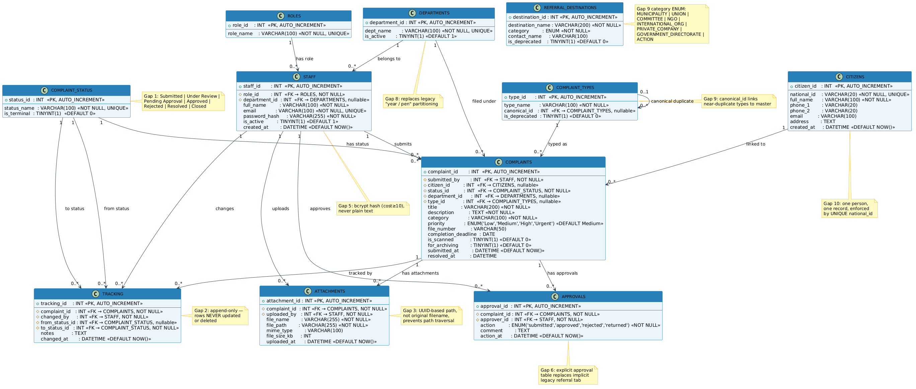
Figure C.1 — Entity-Relationship Diagram (generated from schema.sql)
Key design decisions visible in the diagram: COMPLAINT_STATUS is a controlled lookup table (Gap 1 — the legacy system had no status field); TRACKING is an append-only table recording every status change (Gap 2); CITIZENS carries a UNIQUE constraint on national_id to prevent duplicate applicant records (Gap 10); REFERRAL_DESTINATIONS includes a category column for grouped dropdowns (Gap 9).

Appendix D — Selected Code Listings
The four listings below represent the most important security and data-integrity patterns in the codebase. Each listing is the actual source file committed to the repository, not a simplified illustration.

D.1 Authentication Middleware (backend/src/middleware/auth.js)
Implements FR-3. Addresses Gap 5 (the legacy Oracle Forms system enforced roles only by hiding menu items; this middleware denies the HTTP request at the server before any controller code runs). Every protected route in the system passes through this function.
const { verifyToken } = require('../utils/jwt');
const ApiError = require('../utils/apiError');

// Implements FR-3. Addresses Gap 5 (menu-only security in legacy system).
function auth(req, res, next) {
const header = req.headers.authorization || '';
if (!header.startsWith('Bearer ')) {
return next(new ApiError(401, 'NOT_AUTHENTICATED',
'Authentication required. Please log in.'));
}
const token = header.substring('Bearer '.length).trim();
if (!token) {
return next(new ApiError(401, 'NOT_AUTHENTICATED',
'Authentication required. Please log in.'));
}
try {
req.user = verifyToken(token); // attaches { staff_id, role_id, role_name }
next();
} catch (err) { next(err); }
}
module.exports = auth;

D.2 RBAC Middleware Factory (backend/src/middleware/rbac.js)
Implements FR-3. A factory function: each route registration supplies its own allowed-roles list, so no route can accidentally inherit another route's permissions. The normalization step runs once per route registration, not on every request.
const ApiError = require('../utils/apiError');

// Factory — call requireRole([...]) when registering each route.
// Implements FR-3. Closes Gap 5 (UI-only role enforcement in legacy system).
function requireRole(allowedRoles) {
const allowed = allowedRoles.map(r => r.toLowerCase()); // normalize once

return (req, res, next) => {
if (!req.user || !req.user.role_name) {
return next(new ApiError(401, 'NOT_AUTHENTICATED',
'Authentication required.'));
}
if (!allowed.includes(req.user.role_name.toLowerCase())) {
return next(new ApiError(403, 'FORBIDDEN_ROLE',
'You do not have permission to perform this action.'));
}
next();
};
}
module.exports = requireRole;

D.3 TRACKING Insert Helper (backend/src/services/trackingService.js)
Implements FR-19. Addresses Gap 2 (no audit trail in the legacy system). The helper runs inside an existing mysql2 transaction connection, so an insert failure rolls back the status change that triggered it — satisfying NFR-3 (audit integrity).
// Implements FR-19. Addresses Gap 2 (no audit trail in legacy system).
// Every call runs inside an existing DB transaction — if any sibling
// INSERT or UPDATE fails, the whole transaction rolls back (NFR-3).

async function recordTransition(conn, {
complaintId, changedBy, fromStatusId, toStatusId, notes
}) {
await conn.execute(
`INSERT INTO TRACKING
(complaint_id, changed_by, from_status_id, to_status_id, notes)
VALUES (?, ?, ?, ?, ?)`,
[complaintId, changedBy, fromStatusId || null, toStatusId, notes || null]
);
}

module.exports = { recordTransition };

D.4 Status Transition Controller (backend/src/controllers/complaintsController.js — transition export)
Implements FR-11 through FR-14. Shows the complete state-machine guard logic: the ALLOWED_TRANSITIONS map enforces valid moves (FR-12), the is_terminal check blocks transitions out of final statuses (FR-14), the mandatory-comment check enforces rejection discipline (FR-13), and the three-statement transaction keeps APPROVALS, TRACKING, and COMPLAINTS.status_id in sync (NFR-3).
// POST /complaints/:id/transition — status state machine (FR-11-14)
const ALLOWED_TRANSITIONS = {
1: [2, 5], // Submitted → Under Review | Rejected
2: [3, 5], // Under Review → Pending Approval | Rejected
3: [4, 5], // Pend. Appr. → Approved | Rejected
4: [6], // Approved → Resolved
6: [7], // Resolved → Closed
};

exports.transition = async (req, res) => {
const conn = await db.getConnection();
try {
await conn.beginTransaction();
const { to_status_id, comment } = req.body;
const [rows] = await conn.execute(
`SELECT c.status_id, cs.is_terminal, cs.status_name
FROM COMPLAINTS c
JOIN COMPLAINT_STATUS cs ON c.status_id = cs.status_id
WHERE c.complaint_id = ?`, [complaintId]
);
// Guard: reject if already terminal (FR-14)
if (rows[0].is_terminal && roleId !== ROLE.ADMIN)
throw new ApiError(400, 'TERMINAL_STATUS', '...');
// Guard: validate allowed next state (FR-12)
const allowed = ALLOWED_TRANSITIONS[rows[0].status_id] || [];
if (!allowed.includes(parseInt(to_status_id)))
throw new ApiError(400, 'INVALID_TRANSITION', '...');
// Guard: rejection requires a comment (FR-13)
if (parseInt(to_status_id) === 5 && !comment?.trim())
throw new ApiError(400, 'VALIDATION_FAILED', 'Comment required.');
// Atomic: APPROVALS + TRACKING + COMPLAINTS in one transaction (NFR-3)
await conn.execute('INSERT INTO APPROVALS ...', [...]);
await conn.execute('INSERT INTO TRACKING ...', [...]);
await conn.execute('UPDATE COMPLAINTS SET status_id = ? ...', [...]);
await conn.commit();
return res.json({ complaint_id, from_status, to_status, changed_at });
} catch (err) { await conn.rollback(); next(err); }
finally { conn.release(); }
};

