Proposal Authoring Platform — Functional & Technical Specification
Sep 29, 2026 · @Karim
CTO Consulting needs one web platform that takes a bid from the client's request to a submitted Word proposal and client presentation. It should cover shared authoring, approval gates, a governed content library and AI-assisted drafting. This specification defines version 1 of that platform.

1. Document control
Item | Detail
Document | Functional and technical specification
Version | 0.1, draft for review
Audience | CTO Consulting partners, bid managers, delivery leads, content owners and the build team
Related system | CTO Consulting Regulatory & Standards Assessment Tool (this repository). The new platform reuses its brand tokens, React and Node.js stack, and Claude integration
Requirement IDs | A prefix per area, e.g. WF-03 for workflow, CL-05 for content library
Priority scale | Must = required for v1 · Should = v1 if capacity allows · Could = later release · Won't = excluded from v1

2. Executive summary
The platform should turn proposal writing from assembling old documents by hand into a governed, repeatable process. It should produce a reviewed first draft within one business day and keep partners in control of everything submitted.
Problems it addresses (to confirm with the bid team):
- Proposals are rebuilt from previous submissions, which carries forward stale content and other clients' names.
- Case studies, CVs, rate cards and certificates sit in folders and inboxes, with no owner or expiry date.
- Reviews and approvals run over email, so version control is weak and sign-off is hard to evidence.
- There is no single view of bids in flight, deadlines or win rates.
Outcomes v1 must deliver:
- One workspace per bid. It holds the client request, extracted requirements, team, sections, pricing, approvals and outputs.
- A governed content library. Approved templates, case studies, consultant profiles, rate cards and standard answers are tagged, versioned and set to expire.
- AI-assisted first drafts. Claude drafts each section from the library and the client's documents and cites every source it used.
- Controlled approval. Nothing is marked final or submitted until the required gates are signed off.
- One-click outputs. The platform generates an on-brand Word proposal and PowerPoint presentation from CTO Consulting templates.
- Insight. Dashboards show the pipeline, cycle time, content reuse and win/loss by client, sector and offering.
Proposed success measures:
Measure | Target
Time from RFP upload to confirmed compliance matrix | Under 1 hour for a 100-page request
Time to a complete first draft of a standard proposal | 1 business day
Submissions with a complete, recorded approval trail | 100%
Proposal sections drafted from approved library content | 80% or more
Formatting rework after generation | None beyond final proofreading

3. Scope
Version 1 covers the whole internal bid process, from intake to outcome. It stops at the point of submission to the client and does not replace CRM, contract or resourcing systems.
In scope for v1 | Out of scope for v1
Bid workspaces and the end-to-end lifecycle (section 5) | A client-facing portal. Clients never log in
Single sign-on and role-based access | Automatic upload to tender portals. The bid manager submits and records it
Upload and parsing of client requests, requirement extraction, compliance matrix | Contract management and e-signature after award
Content library: templates, case studies, consultant profiles, rate cards, standard answers, corporate evidence | A full CRM. The platform integrates with one instead
Shared section authoring with comments, suggestions and version history | Timesheets and resource scheduling
Configurable review and approval workflow with gates | Accounting and invoicing
AI drafting grounded in library content, with citations
Word proposal and PowerPoint presentation generation, plus PDF
Team, pricing and commercial approval
Email and Microsoft Teams notifications, dashboards and reporting
Assumptions (each is also listed in section 18 to confirm):
- CTO Consulting uses Microsoft 365, with Entra ID as its identity provider.
- All data is hosted in Australia, because many clients are Australian government agencies.
- Client material handled is at most OFFICIAL: Sensitive. PROTECTED material would require IRAP-assessed hosting.
- The platform is a new module in this repository and shares its stack and brand.

4. Users, roles and permissions
Access combines a platform role with bid membership. A user sees a bid only if they are on its team, unless their role grants portfolio access (Administrator, Partner or Viewer). One person can hold several roles.
Role | Responsibilities
Administrator | Manages users, roles, workflow templates, integrations and AI settings
Partner (bid owner) | Accountable for the bid. Makes the bid/no-bid decision and gives final approval
Bid manager | Creates the workspace, plans the response, assigns sections, runs the timetable, generates outputs and records submission
Author (consultant or subject-matter expert) | Writes assigned sections using the library and AI, and resolves comments
Reviewer | Comments on and scores sections against the evaluation criteria. Requests changes
Commercial approver | Approves pricing, rates, margin, terms and commercial risk
Content librarian | Curates the library: approves, tags, versions and retires content
Consultant | Maintains their own profile and CV. Confirms availability when proposed for a team
Viewer | Read-only access to dashboards and bids, for leadership
External collaborator (Could) | A partner firm or subcontractor, limited to the sections assigned in one bid
Permissions matrix (Yes = allowed; Team = only on bids where the user is a team member; Own = only their own items):
Capability | Admin | Partner | Bid manager | Author | Reviewer | Commercial | Librarian | Viewer
Create a bid | Yes | Yes | Yes | — | — | — | — | —
Decide bid/no-bid | — | Yes | — | — | — | — | — | —
Plan and assign sections | Yes | Team | Team | — | — | — | — | —
Edit section content | — | Team | Team | Own | — | — | — | —
Comment and suggest | — | Team | Team | Team | Team | Team | — | —
Approve a gate | — | Team | — | — | Team | Team | — | —
See cost rates and margin | Yes | Team | — | — | — | Team | — | —
Generate outputs | — | Team | Team | Team | — | — | — | —
Record submission and outcome | — | Team | Team | — | — | — | — | —
Add content to the library | Yes | Yes | Yes | Yes | — | — | Yes | —
Approve library content | — | — | — | — | — | — | Yes | —
Configure workflows and templates | Yes | — | — | — | — | — | Yes | —
View dashboards | Yes | Yes | Yes | Own | — | Yes | Yes | Yes
Confidential bids can be restricted further with an ethical wall. Named users are then excluded even if their role would normally grant access, for example where a conflict of interest exists.

5. End-to-end proposal lifecycle
Every bid moves through nine stages and three approval gates: bid/no-bid, commercial approval and partner sign-off. Stages and gates are configurable per workflow template (WF-06). The default flow is below.
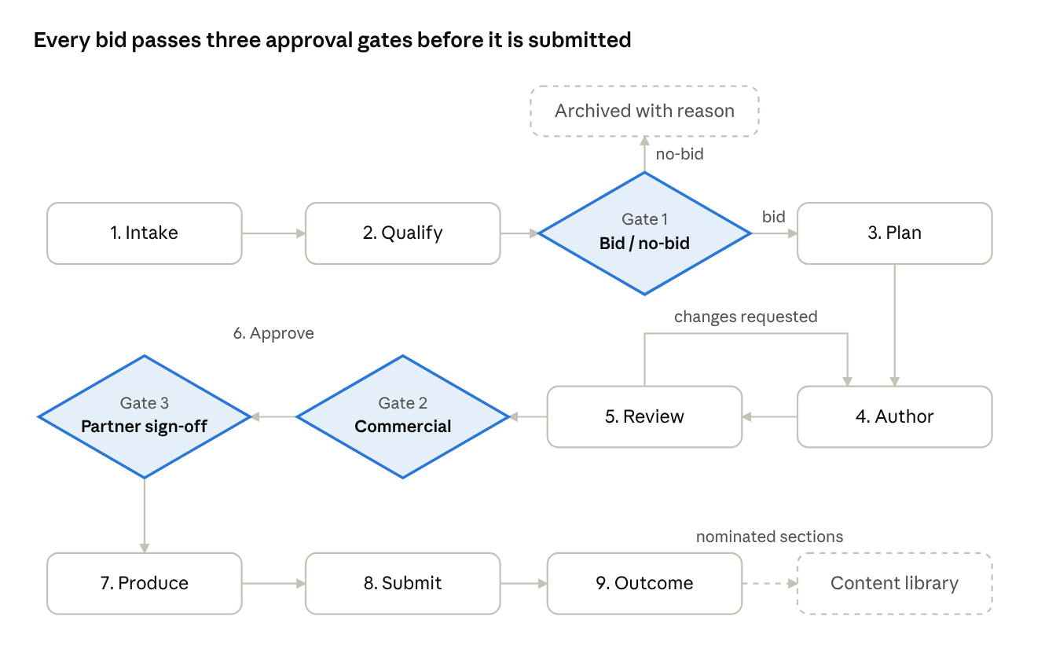
proposal lifecycle · 9 stages, 3 gates
A reviewer's change request sends a section back to Author. A rejection at gate 2 or 3 does the same for the sections it names. Dashed boxes sit outside the live bid.
Stage | What happens | Exit condition | Owner
1. Intake | Opportunity registered manually, from CRM or from a forwarded email. Client documents uploaded | Request documents attached | Bid manager
2. Qualify | AI summarises the request and extracts requirements. Bid/no-bid scorecard is pre-filled | Gate 1: bid/no-bid. A no-bid is archived with its reason | Partner
3. Plan | Win themes, response outline, section owners, deadlines, proposed team | Plan published to the team | Bid manager
4. Author | Sections drafted with AI and the library. Pricing and team built | All sections marked ready for review | Authors
5. Review | Structured reviews, such as a solution review and a red team, scored against evaluation criteria | All sections approved; changes loop back to Author | Reviewers
6. Approve | Commercial review of price, margin, terms and risk, then final partner review of the whole response | Gate 2: commercial approval and Gate 3: partner sign-off | Commercial approver, Partner
7. Produce | Word proposal, PowerPoint deck and PDFs generated. Automated compliance and quality checks run | Checks pass and outputs are marked final | Bid manager
8. Submit | Submitted through the client's channel. Time, files and receipt recorded. A read-only snapshot is kept | Submission recorded | Bid manager
9. Outcome | Clarifications, presentation or orals, award decision, debrief. Strong sections nominated for the library | Win or loss recorded with reasons | Partner, Bid manager

6. Shared authoring and approval workflow
Each bid is split into sections, and each section has one owner, a due date and a status. Approvals are gates: they snapshot the content and lock it until the named approvers sign off. Any later edit reopens the approval.
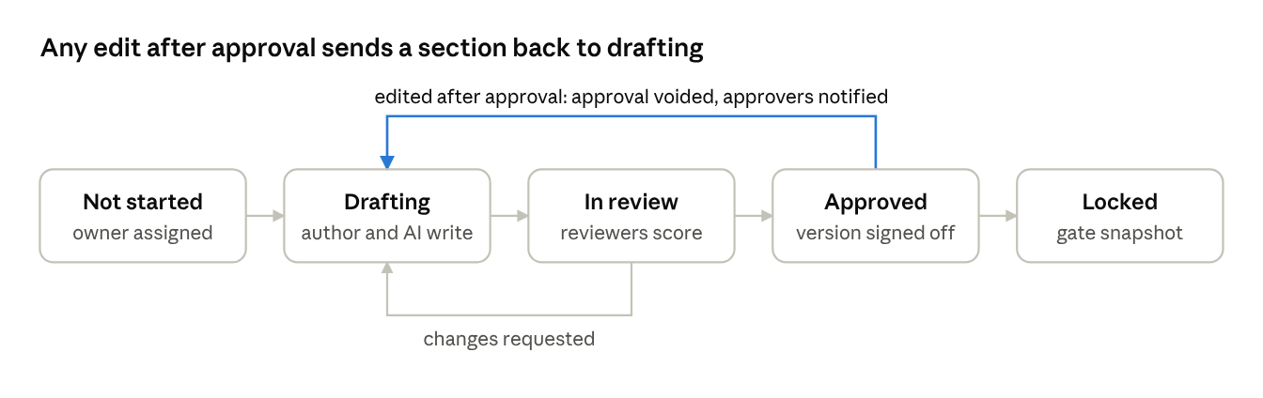
section statuses · 5 states, 2 loops back to drafting
Approvers sign off a specific version of a section. A gate passes only when every section it covers is approved, and it then locks a snapshot of them.
ID | Requirement | Priority
WF-01 | Build the response outline from a CTO Consulting template or the client's mandated structure. The platform proposes the outline from the extracted request | Must
WF-02 | Give each section an owner, contributors, reviewers, a due date, a word or page limit, and its linked client requirements | Must
WF-03 | Let several users edit the same section at once, with live presence indicators and no overwritten changes | Must
WF-04 | Support inline comments, @mentions and suggestion mode with accept or reject | Must
WF-05 | Keep full version history per section, with side-by-side comparison, restore, and a named snapshot at each gate | Must
WF-06 | Let administrators configure workflow templates: stages, gates, required approver roles and conditions. For example, bids above a set value need a second partner | Must
WF-07 | Record every approval decision (approve, approve with conditions, reject) with approver, time, comment and the exact version approved | Must
WF-08 | Block final outputs and submission until all required approvals exist. An edit after approval voids that approval and notifies the approvers | Must
WF-09 | Let reviewers score sections against the client's evaluation criteria and show the scores as a heatmap | Should
WF-10 | Give each user a "My work" inbox of assigned sections, reviews, approvals and overdue items | Must
WF-11 | Send email notifications and a daily digest. Escalate tasks overdue by a configurable period to the bid manager | Must
WF-12 | Send notifications to Microsoft Teams and allow approval from a Teams card | Should
WF-13 | Back-schedule milestones from the submission deadline and export them to calendars (.ics) | Should
WF-14 | Let approvers delegate to someone with equal or higher authority while away | Should
WF-15 | Keep an immutable audit trail of every action on a bid | Must
WF-16 | Keep a register of clarification questions to the client, their answers, and the sections they affect | Should

7. Client request intake
The bid manager uploads the client's request once. The platform then extracts the requirements, dates and evaluation criteria into a compliance matrix that drives planning, drafting, review and the final check.
Extracted from each request pack:
- Client, opportunity title, reference number and procurement channel (for example AusTender, BuyICT or a state portal)
- Key dates with time zones: closing date and time, clarification deadline, briefing sessions, presentation dates
- Submission instructions: format, page and word limits, fonts, file naming, lodgement method
- Mandatory and desirable requirements, each with its source reference
- Evaluation criteria and weightings
- Pricing schedule format and commercial conditions, including departures from standard terms
- Response forms the client requires respondents to use
ID | Requirement | Priority
CR-01 | Upload request documents (PDF, DOCX, XLSX, PPTX, ZIP, and .msg or .eml emails) up to 200 MB per bid, with a virus scan on upload | Must
CR-02 | Extract text from every file, including OCR for scanned PDFs, keeping table structure | Must
CR-03 | Use AI to extract the items listed above into structured fields | Must
CR-04 | Link every extracted item to its source document, page and paragraph. Users confirm or correct items before they are used | Must
CR-05 | Maintain a compliance matrix: requirement ID, text, mandatory or desirable, response section, owner, status (comply, partial, not comply) and evidence. Export it to Excel, in the client's format where one is given | Must
CR-06 | Produce a one-page opportunity brief: client, need, scope, timing, risks and suggested win themes | Must
CR-07 | Pre-fill a bid/no-bid scorecard (strategic fit, relationship, capability match against the library, competition, capacity, risk, value) with evidence, for the partner to decide | Must
CR-08 | Import client-mandated response forms as bid templates, so answers are written straight into the client's own format | Should
CR-09 | On upload of an addendum, compare it with earlier versions, flag changed requirements and dates, and notify owners of affected sections | Should
CR-10 | Create bids from tender alerts and from emails forwarded to a bid mailbox | Could

8. Content library
The library is the single approved source of reusable content. The AI drafts only from approved library items and the bid's own documents, so the library's quality sets the quality of every proposal.
Content type | Examples | Key metadata | Formats
Proposal templates | Full proposal, short-form response, expression of interest, capability statement | Template type, section map, placeholders, brand version | .docx, .dotx
Presentation templates | Orals deck, capability deck, proposal summary | Slide layouts, placeholder map, brand version | .pptx, .potx
Case studies | Project credentials | Client (or anonymised name), sector, services, technologies, value, dates, measurable outcomes, referee, client consent to be named | Structured form plus .docx or .pdf
Consultant profiles | Bios and CVs | Role, level, skills, certifications, security clearance (for example Baseline or NV1), sectors, availability, rate band, photo | Structured form, generated .docx
Rate cards | Standard rates by level, panel or contract rates | Valid from and to, client or panel, currency, GST treatment | Structured table, .xlsx import
Standard answers | Company overview, methodology, quality, security, WHS, insurance, ESG, modern slavery | Topic, question variants, owner, last reviewed | Rich text
Methods and offerings | Service catalogue, delivery frameworks, method diagrams | Offering, phases, deliverables | Rich text, images
Corporate evidence | ABN, insurance certificates, ISO certificates, financial statements, panel memberships | Issuer, expiry date | PDF
Past proposals | Won and lost submissions | Outcome, client, value, evaluator feedback | .docx, .pdf
Media | Logos, photos, diagrams, icons | Usage rights, alt text | PNG, JPG, SVG

ID | Requirement | Priority
CL-01 | Upload single items or in bulk (drag and drop, ZIP) and import existing SharePoint folders | Must
CL-02 | Suggest metadata on upload with AI (for example a case study's sector, technologies and outcomes) for the librarian to confirm | Must
CL-03 | Maintain an administrator-managed taxonomy: sectors, offerings, technologies, clients, capabilities, regions | Must
CL-04 | Apply a content lifecycle: draft, in review, approved, expiring, retired. Only approved content can be used in bids or by the AI | Must
CL-05 | Give every item an owner and review date, and remind owners before expiry (for example insurance certificates, or CVs not updated in 12 months) | Must
CL-06 | Version every item. Each bid records the exact version it used and prompts authors when a newer approved version exists | Must
CL-07 | Provide keyword and semantic search with filters, "find similar" and inline preview | Must
CL-08 | Mark client-confidential content (named clients, pricing). Keep an anonymised variant for reuse, and track client consent to be named | Must
CL-09 | Let consultants maintain their own profile, and generate CVs in the format each client requires from the structured profile | Must
CL-10 | Validate template placeholders on upload against the tag syntax and field list (section 9.2) and report errors to the uploader | Must
CL-11 | After an outcome, let the bid manager nominate sections for the library, subject to librarian review | Should
CL-12 | Show where each item was used and the win rate of bids that used it | Should

9. Automated authoring: Word proposals
The platform drafts each section with AI from approved content. It then merges the approved sections into a CTO Consulting Word template to produce a submission-ready .docx that needs no manual reformatting.

9.1 AI section drafting
Inputs to each draft:
- The section brief, word limit and win themes
- The client requirements and evaluation criteria linked to the section
- The most relevant approved library items, found by semantic search. Content confidential to another client is excluded
- The CTO Consulting style guide: tone, Australian English, preferred terms and banned phrases
Behaviour: each draft cites the library items and request clauses it used. Sentences with no source are flagged "needs evidence". AI text stays labelled until a person accepts or edits it.
Other AI actions: shorten to the limit, strengthen against the evaluation criteria, tailor a case study to this client, draft the executive summary from approved sections, check a section against its linked requirements, and bulk-answer questionnaire returnables from standard answers with a confidence score per answer.

9.2 Word templates
Templates are ordinary Word files that use named styles and the placeholder tags below. Designers keep full control of the cover, styles, headers and footers.
Tag type | Example | Filled with
Field | {{client.name}}, {{bid.reference}}, {{submission.due}} | A single value
Section | {{section:executive_summary}} | The approved content of that response section
Repeating block | {{#case_studies}} … {{/case_studies}} | One block per selected item
Table | {{table:compliance_matrix}}, {{table:pricing}}, {{table:team}} | A table in the template's table style
Image | {{image:client_logo}} | An image with alt text
Condition | {{#if lot_2}} … {{/if}} | Content shown only when the condition is true

9.3 Generation pipeline
- Assemble bid fields, approved section content, selected case studies and CVs, and the pricing and team tables.
- Convert rich text (headings, lists, tables, images, footnotes, cross-references) to the template's named styles, never inline formatting.
- Merge into the template. Build the table of contents, captions, cross-references, page numbers, and headers and footers with the client's name and reference.
- Check the rendered document:
  - every mandatory requirement maps to answered content
  - page and word limits are met, with pages counted on the rendered PDF
  - no empty placeholders, broken references, comments or tracked changes remain
  - no other client's name or confidential content appears
  - Australian English spelling and the style guide are followed
  - headings are in order, images have alt text and tables have header rows
  - document properties and hidden text are cleaned
- Publish the .docx and PDF as a versioned output linked to the approved snapshot.
ID | Requirement | Priority
WD-01 | Draft any section with AI from the inputs above, citing library items and request clauses | Must
WD-02 | Flag unsupported sentences as "needs evidence" | Must
WD-03 | Label AI-generated text until a person accepts or edits it. Block gate approval while unreviewed AI text remains | Must
WD-04 | Offer the other AI actions listed in 9.1 | Should
WD-05 | Upload Word templates using the tag syntax in 9.2. Validate them and preview them with sample data | Must
WD-06 | Generate the .docx using only template styles, with contents page, captions, cross-references, headers and footers | Must
WD-07 | Run the checks in 9.3 before an output can be marked final. Link each failure to the section that needs fixing | Must
WD-08 | Export PDF, and PDF/A where the client requires it, from the same render | Must
WD-09 | Allow a final Word edit outside the platform: download, edit and re-upload. The upload is recorded as a manual output against the snapshot | Must
WD-10 | Fill the client's own Word or Excel returnable schedules from mapped answers | Should
WD-11 | Record for each output the template version, content versions and AI model used | Must

10. Automated authoring: client presentations
The platform generates an editable PowerPoint deck in the CTO Consulting master template from the same approved bid data. The deck and the proposal therefore never disagree on team, price or approach.
Deck recipes. A recipe is an ordered list of slides, each mapped to a layout in the master template. Administrators maintain the recipes. Defaults:
Recipe | Typical use | Default slides
Orals or shortlist presentation | Presenting to the evaluation panel | Title, agenda, our understanding of your needs, approach, timeline, team, relevant case studies, why CTO Consulting, next steps, questions
Proposal summary | Leave-behind or cover deck for a written submission | Title, executive summary, approach, team, commercial summary, next steps
Capability statement | Early engagement, panel onboarding | Who we are, services, sectors, selected case studies, credentials, contacts
Kick-off (Could) | First meeting after award | Objectives, scope, governance, team, plan, first 30 days
How a deck is built:
- The bid manager picks a recipe and includes or excludes slides.
- The AI writes a storyboard from approved content. Each slide gets an action title that states its message, 3 to 5 points and speaker notes.
- The bid manager edits the storyboard in an outline view and previews the slides in the browser.
- The platform renders the deck with native, editable PowerPoint objects: text, tables, charts from pricing and timeline data, a timeline built from shapes, team photos and bios from consultant profiles, and case studies at one per slide.
- Text that would overflow a placeholder is flagged before rendering rather than shrunk.
ID | Requirement | Priority
PP-01 | Upload PowerPoint master templates. Map each layout's placeholders to data fields and validate the mapping | Must
PP-02 | Let administrators maintain deck recipes | Must
PP-03 | Generate an AI storyboard with action titles, points and speaker notes, citing its sources | Must
PP-04 | Provide an outline editor and slide preview before rendering | Should
PP-05 | Render .pptx using the master's layouts and native, editable objects, plus a PDF copy | Must
PP-06 | Flag placeholder overflow before rendering | Must
PP-07 | Allow re-upload of a deck finalised in PowerPoint, recorded as the final output | Must
PP-08 | Produce a rehearsal pack: likely panel questions from the evaluation criteria and risks, with suggested answers and a named presenter | Should

11. Pricing, staffing and commercials
The bid team builds the team and the price inside the platform. The proposal's team section, CVs, pricing tables, client pricing schedule and slides all draw on the same approved figures.
ID | Requirement | Priority
PR-01 | Search consultants by skill, certification, clearance, sector and availability. Propose named people or unnamed roles for the team | Must
PR-02 | Attach each proposed consultant's CV automatically, in the format the client requires | Must
PR-03 | Support time and materials, fixed price with milestones, capped time and materials, and retainer pricing models | Must
PR-04 | Take rates from the applicable rate card, with panel or contract rates overriding standard rates. Support discounts and expenses. Show prices in AUD with GST shown separately | Must
PR-05 | Show an internal-only margin view (cost against sell rates). A margin below the configured threshold adds a required commercial approval | Should
PR-06 | Keep a register of pricing assumptions, commercial risks and departures from the client's terms, carried into the proposal | Should
PR-07 | Generate the client's pricing schedule in Excel, in the client's format where one is given | Should
PR-08 | Restrict cost rates and margin to the Partner, Commercial approver and Administrator roles | Must

12. Search, dashboards and reporting
Every user starts on a dashboard suited to their role. Leadership gets portfolio analytics that show which offerings, clients and content win work. All search and reporting respect bid-level permissions.
View | Audience | What it shows
My work | Everyone | Sections, reviews and approvals assigned to me, sorted by due date, with overdue items first
Pipeline | Partners, bid managers, leadership | Bids by stage, value, closing date and owner. At-risk bids: overdue sections, or approvals pending within 48 hours of the deadline
Bid health | Bid team | Sections by status, compliance coverage, review scores, open comments, days to deadline
Win/loss analytics | Leadership | Win rate and value by sector, client, offering, partner and quarter. Loss reasons. Cycle time per stage
Content insight | Librarian | Most-used items, items due for review or expired, library gaps where requests found no matching content, reuse win rate
AI usage | Administrator | Drafts generated, share of AI text accepted without major edits, extraction corrections, cost per bid
Global search covers bids, sections, requirements and library items, using keyword and semantic matching. Every view exports to Excel or PDF. Scheduled email reports are a Should.

13. Integrations
V1 needs four integrations: Entra ID for sign-in, the Claude API and an embedding model for AI, and email for notifications. The rest are added as the platform proves itself. All integrations use documented APIs with credentials held in a key vault.
System | Purpose | Direction | Priority
Microsoft Entra ID | Single sign-on (OIDC), MFA, group-to-role mapping, SCIM user provisioning | Inbound | Must
Anthropic Claude API | Extraction, summarisation, drafting and checking. The existing assessment tool already uses it | Outbound | Must
Embedding model (for example Voyage AI) | Vectors for semantic search over the library and client documents | Outbound | Must
Email via Microsoft Graph | Notifications and digests. A bid mailbox that turns forwarded requests into bids | Both | Must
Microsoft Teams | Notifications, approval cards, a link to a channel per bid | Outbound | Should
SharePoint and OneDrive | Import the existing content library. Archive final submissions to the records site | Both | Should
CRM (product to confirm) | Create bids from opportunities. Sync stage, value and outcome | Both | Should
Calendar (.ics) | Bid milestones in personal calendars | Outbound | Should
Tender portals (AusTender, BuyICT, state portals) | Opportunity alerts matched to CTO Consulting offerings | Inbound | Could
Word and PowerPoint add-in | Search and insert library content from inside Office. Edit a section in Word and sync it back | Both | Could
HR or resourcing system | Consultant availability and skills | Inbound | Could

14. Data model
The bid (opportunity) is the central record. Everything produced for a bid hangs off it, while library content is shared across bids by reference to a specific version. Core entities:
Entity | Key attributes | Relationships
Client | Name, ABN, sector, jurisdiction, confidentiality level | Has bids, case studies
Bid | Reference, title, stage, estimated value, closing date and time zone, partner, bid manager, confidentiality, outcome, loss reason | Belongs to a client. Has documents, requirements, sections, team, pricing, approvals, outputs
Client document | File, type (request, addendum, Q&A, form), version, extracted text, content hash | Belongs to a bid. Source of requirements
Requirement | Reference, text, mandatory or desirable, evaluation criterion, weighting, source location, compliance status | Belongs to a bid. Mapped to sections
Response section | Title, order, parent, brief, limits, owner, status, content (rich-text JSON), AI provenance | Belongs to a bid. Has versions, comments, citations
Section version | Content snapshot, author, time, gate label | Belongs to a section
Comment | Anchor, text, author, suggestion flag, resolved | Belongs to a section
Citation | Source type (library item version or client document), location | Links section text to its sources
Workflow template | Stages, gates, approval rules and their conditions | Assigned to bids
Approval | Gate, approver, decision, conditions, snapshot approved, time | Belongs to a bid
Library item | Type, title, body or file, tags, status, owner, review date, version, confidentiality | Has versions. Cited by sections
Consultant profile | Role, level, skills, certifications, clearance, sectors, rate band, availability | Linked to a user. Proposed in bid teams
Rate card | Role or level, rate, valid dates, client or panel | Used by pricing
Pricing | Model, lines (role, days, rate), discounts, expenses, cost and margin | Belongs to a bid
Template | Kind (Word or PowerPoint), file, placeholder map, version, status | Used by outputs
Output | Kind, file, template version, source snapshot, check results, final flag, AI model | Belongs to a bid
Audit event | Actor, action, object, before and after hash, time | Append-only, any object
User, role, membership | Identity, roles, bid team membership, ethical-wall exclusions | Govern all access

15. Solution architecture and technology
Build the platform on the stack the assessment tool already uses: a React 19 and Vite front end, a Node.js server and the Anthropic SDK. Add the database, file storage, background workers and real-time collaboration that a multi-user workflow needs.
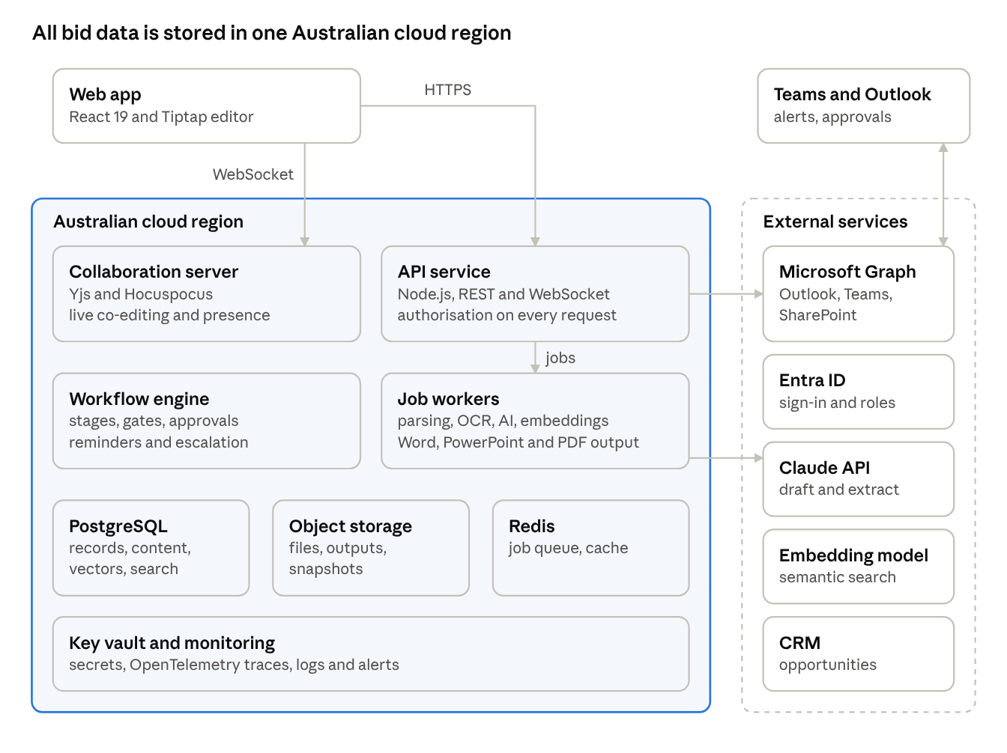
solution architecture · app services, data stores, external services
Only the API service and the job workers call external services: sign-in, Microsoft 365, the Claude API, embeddings and the CRM. Every other component, and all stored data, stays inside the Australian region.
Component | Recommended technology | Notes
Web client | React 19 single-page app built with Vite. Tiptap (ProseMirror) rich-text editor | Reuses the brand tokens in src/styles/app.css
Real-time collaboration | Yjs with a Hocuspocus server | Conflict-free co-editing and presence. Document state is saved to PostgreSQL
API service | Node.js 20+ in TypeScript. REST plus WebSocket | One authorisation module enforces roles, bid membership and ethical walls
Workflow engine | Configuration-driven state machines, for example XState | Lifecycle, section statuses, gates, and timers for reminders and escalation
Job queue and workers | BullMQ on Redis | Parsing, OCR, AI calls, embeddings, document generation and virus scans, with retries and progress shown in the app
Document parsing | Apache Tika for text. Azure AI Document Intelligence or Tesseract for OCR and tables | Keeps page and paragraph positions for source links
Word and PowerPoint generation | docxtemplater with its PowerPoint module, or a Python worker using docxtpl and python-pptx. LibreOffice (headless) for PDF and page counts | Engine to be chosen in Phase 0 (section 18)
AI service | Claude through the Anthropic API. The model is configurable, as in server/index.mjs | Retrieval over library chunks, structured JSON output for extraction, versioned prompts, every call logged with its sources
Database | PostgreSQL 16 with pgvector and full-text search | Records, rich-text JSON and vectors in one store
File storage | Azure Blob Storage or Amazon S3, encrypted | Originals, outputs and snapshots. Immutable once submitted
Hosting | Azure Australia East or AWS Sydney, in containers, defined as infrastructure as code (Bicep or Terraform) | Private networking between services
Delivery | GitHub Actions: lint, unit tests, template golden-file tests, deploy | A staging environment mirrors production
Observability | OpenTelemetry traces and metrics, central logs, alerts | AI latency and cost tracked per bid

16. Non-functional requirements
The platform will hold client-confidential request documents, pricing and personal information in CVs. Security, privacy and AI governance are therefore Must requirements, not later hardening. The targets below are proposed and are to be confirmed in Phase 0.
Area | Requirement
Authentication | Entra ID single sign-on with MFA enforced. Sessions time out after 12 hours, or 30 minutes idle
Authorisation | Roles plus bid membership plus ethical walls, enforced on the server for every request, search result and file download
Encryption | TLS 1.2 or later in transit. AES-256 at rest for the database, files and backups. Keys held in a managed key vault
Security assurance | OWASP ASVS Level 2. Controls aligned to the Essential Eight (Maturity Level 2) and relevant ISM controls. Independent penetration test before go-live, then yearly
Data sovereignty | All data, backups and logs stored in Australia
Privacy | Meets the Privacy Act 1988 and the Australian Privacy Principles. Consultants can see and correct their own profile. Retention periods configurable by content type
AI data handling | Client data sent only to AI endpoints under terms that exclude training and limit retention, ideally zero data retention. Use a Claude endpoint hosted in an Australian region if clients require in-country processing
AI governance | A person reviews all AI text before approval. Sources are cited, and AI text is labelled until accepted. Model, prompt version, inputs and outputs are logged. AI can be switched off per bid where a client prohibits it, and AI use can be reported for bids that require disclosure. Changes to prompts or models are tested against a benchmark set of past bids first
Performance | Page load under 2 s and search under 1 s at the 95th percentile. Co-editing updates appear within 300 ms. AI section draft within 60 s. A 100-page proposal generated within 2 minutes
Capacity | Designed for 200 users, 50 concurrent bids and 50,000 library items without re-architecture
Availability and recovery | 99.5% availability during Australian business hours. Recovery point 1 hour, recovery time 8 hours. Point-in-time restore for 14 days
Audit | Append-only audit log kept for 7 years and exportable for client audits
Accessibility | The app meets WCAG 2.2 AA. Generated documents have tagged headings, alt text and table headers
Browsers and devices | Current Edge, Chrome, Safari and Firefox. Review and approval work on tablets and phones
Localisation | Australian English, AUD with GST, and time zones shown on all deadlines (AEST, AEDT and the client's zone)

17. Delivery roadmap
Deliver in four phases over about 32 weeks. A pilot on two live bids gates the MVP. Every Must requirement ships by the end of Phase 2, the v1 general release. Phase 3 adds the remaining Should and Could items. Durations are indicative until Phase 0 confirms scope and team size.
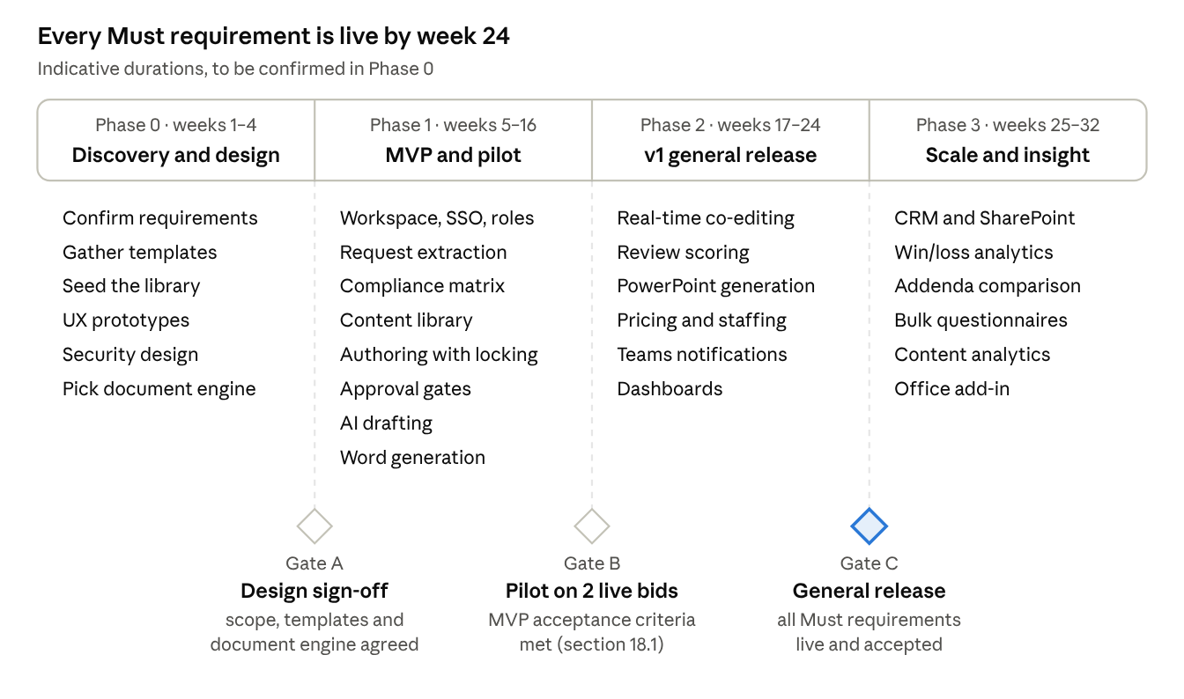
delivery roadmap · 4 phases, 3 gates, 32 weeks
The MVP uses section-level locking so two people cannot overwrite each other. Real-time co-editing (WF-03) replaces it in Phase 2.

18. Acceptance criteria, risks and open questions

18.1 MVP acceptance criteria
The MVP is accepted when the pilot bids show all of the following:
- ☐ A bid manager uploads a 100-page request and confirms its compliance matrix within 1 hour.
- ☐ Every extracted requirement links to its source page. Extraction corrections are recorded.
- ☐ Every AI draft shows its sources. Unsupported sentences are flagged.
- ☐ The final gate cannot pass while a mandatory requirement is unmapped or AI text is unreviewed.
- ☐ An edit after approval voids that approval and notifies the approvers.
- ☐ The generated .docx opens in Word without repair, uses only template styles and passes every automated check.
- ☐ A user outside the bid team cannot see, search or download anything from the bid (tested).
- ☐ Both pilot bids are produced end to end in the platform. The bid team records the time saved against their previous process.

18.2 Risks
Risk | Impact | Mitigation
An inaccurate AI claim reaches a submission | Reputational and contractual exposure | Drafts grounded in approved content, citations, "needs evidence" flags, mandatory human review and approval
Library content is thin or out of date | Generic drafts and low adoption | Seed the library in Phase 0. Name a librarian. Expiry reminders. Harvest content from each outcome
Confidential content leaks between clients | Breach of confidence, loss of trust | Confidentiality flags, anonymised variants, a check for other clients' names, bid-level access control
Complex Word or PowerPoint templates render badly | Manual rework erodes the time saved | Template tagging standard, validation on upload, golden-file tests for each template
Consultants keep working in Word and email | Split versions and no audit trail | Word round-trip, Teams approvals, pilot champions, a simple "My work" inbox
A client prohibits AI or requires disclosure of its use | Non-compliant bid | Per-bid AI switch and an AI usage report for disclosure statements

18.3 Open questions
- ☐ Does CTO Consulting use a CRM, and which one?
- ☐ Is Microsoft 365 with Entra ID the identity platform?
- ☐ What is the highest classification of client material handled: OFFICIAL, OFFICIAL: Sensitive or PROTECTED?
- ☐ Should the platform be hosted on Azure or AWS?
- ☐ How many users, bids a year and pages per typical request are expected?
- ☐ How many Word and PowerPoint templates exist today, and who owns the brand guidelines?
- ☐ What is the approval authority matrix: who approves at which contract value and risk level?
- ☐ How are rate cards structured, and which panel or contract rates apply (for example BuyICT)?
- ☐ Should the platform extend this repository's app or be a separate application sharing its components?
- ☐ Which document engine: Node.js (docxtemplater with its commercial PowerPoint module) or a Python worker (docxtpl and python-pptx)?

