APPLICATION OF SDR

Seminar Report

Submitted in partial fulfillment of the requirements

For the Degree of

Master of Technology in Information Communication Technology (ICT)

Prepared By
PATHAN MO KARIMKHAN Y.
12MICT32

Guide:
Prof. Sapan H. Mankad



DEPARTMENT OF COMPUTER ENGINEERING
INSTITUTE OF TECHNOLOGY
NIRMA UNIVERSITY
AHMEDABAD-382481

CERTIFICATE

This is to certify that the Project entitled “Application of SDR” submitted by Mr. Pathan Mo Karimkhan Y. (12MICT32), towards the partial fulfillment of the requirements for the degree of Master of Technology in The Computer Engineering of Nirma University of Science and Technology, Ahmedabad is the record of work carried out by him under my supervision and guidance. In my opinion, the submitted work has reached a level required for being accepted for examination. The results embodied in this Dissertation project, to the best of my knowledge, haven’t been submitted to any other university or institution for award of any degree.

Guide, Professor and Head,
Prof. Sapan H. Mankad Dr. Snjay Garg
Professor of CSE Dept. CSE Department,
Institute of Technology, Institute of Technology,
Nirma University. Nirma University.

Index

1 . Introduction 4
  - Introduction 4
  - What is SDR? 4
  - What is GNU Radio? 4
  - What is GRC? 5
2. Hack RF 6
2.1 Initial Goal 6
2.2 What is Hack RF? 6
3. AM Signal processing 7
3.1 How to process the AM signal using GNU Radio 7
4. Processing Pre Recorded USRP signal. 9
4.1 Steps to implement the SDR using grc 9
5. Future work 17
6 . Conclusion 26

CHAPTER - 1
INTRODUCTION
1.1 Introduction
This seminar is intended to introduce the Application of Software Defined Radio (SDR) and to show that how SDR technology can be used as an alternative to costly hardware device for various signal processing project. Here we have experimented SDR using on pre recorded USRP FM signal source file. While going through the report one can understand that how GNU radio toolkit can be used to implement SDR. The promise of a digital computer has been that of a universal machine, one that can be a word processor one minute and a robot brain the next. So why are radios, a technology even older than computers, still designed stubbornly to do one thing–like 3G, Wifi, FM, or GPS–for their entire lives? We can see from this project that how SDR can be used to transmit and receive any range of signal starting from 100 megahertz to 6 gigahertz, including frequencies as low as the range used by FM radio up to the gigahertz frequencies used by Wifi.
1.2 What is SDR?
Software Defined Radio (SDR) is a technology capable of configuring a wireless device to work with any communications system, be it a cellular phone, a pager, a WI-FI transceiver, an FM or AM radio, a satellite communications terminal and even a garage door opener. Software defined radio is a radio communication systems wherein which the hardware like filters, amplifiers, modulators etc are implemented in the personal computers or some embedding devices [1]. By doing so, hardware complexity can be widely reduced. In addition to software part there is a RF front end preceding this software section. By using such a design one can transmit and receive variety of signals based on the applications .
In SDR, signal is captured by an antenna which is further converted into digital samples with regular intervals. These digital values are then processed in software, where the required application is written. The resulting output can be then converted ba ck into audio, video or required form. It offers both cost and time savings for consumers, who would only need to buy one radio to meet multiple communications needs.

1.3 What is GNU Radio?
GNU Radio is a free & open-source software development toolkit that provides signal processing blocks to implement software radios. It can be used with readily-available low-cost external RF hardware to create software-defined radios, or without hardware in a simulation-like environment. It is widely used in hobbyist, academic and commercial environments to support both wireless communications research and real-world radio systems [2].
GNU Radio performs all the signal processing. You can use it to write applications to receive data out of digital streams or to push data into digital streams, which is then transmitted using hardware. GNU Radio has filters, channel codes, synchronisation elements, equalizers, demodulators, vocoders, decoders, and many other elements (in the GNU Radio jargon, we call these elements blocks) which are typically found in radio systems. More importantly, it includes a method of connecting these blocks and then manages how data is passed from one block to another. Extending GNU Radio is also quite easy; if you find a specific block that is missing, you can quickly create and add it.
Since GNU Radio is software, it can only handle digital data. Usually, complex baseband samples are the input data type for receivers and the output data type for transmitters. Analog hardware is then used to shift the signal to the desired centre frequency. That requirement aside, any data type can be passed from one block to another - be it bits, bytes, vectors, bursts or more complex data types.
GNU Radio applications are primarily written using the Python programming language, while the supplied, performance-critical signal processing path is implemented in C++ using processor floating point extensions, where available. Thus, the developer is able to implement real-time, high-throughput radio systems in a simple-to-use, rapid-application-development environment [2].
1.4 What is GNU Radio Companion (GRC)?
GNU Radio Companion (GRC) is a graphical tool for creating signal flow graphs and generating flow-graph source code. The GUI termed GRC allows user to implement GNU radio signal processing blocks in a manner similar to Simulink and Labview. GRC provides a graphical user interface to the user so that any hardware functions like mixers, oscillators, etc., can be implemented as a block and can be executed. These blocks use Python code to de_ne its functioning (at the background) and xml code for creating GUI (in the foreground).
CHAPTER - 2
HACK RF

Initial goal of the project was to develop the Hack RF device which can coverts frequency range that is been used by all wireless device. The purpose was like Just observing [a signal] over the air, we can reverse engineer it completely to figure out the information transmitted over the network, and potentially inject our own transmissions onto that network. All of that can be done with one HackRF device and a laptop.
For that we need to build a single wideband transceiver peripheral that can be attached to a general purpose computer for software radio functions. This device has following characteristics.
  - half-duplex transceiver
  - operating freq: 100 MHz to 6 GHz
  - maximum sample rate: 20 Msps
  - resolution: 8 bits
  - interface: High Speed USB
  - power supply: USB bus power
  - portable
But as this implementation required USRP, a hardware device to transmit and receive the signal in order to perform the practical. And it was not feasible to purchase such a costly device so we shifted to FM Radio signal processing and frequency listening project which is also kind of Software Defined Radio.

CHAPTER - 3
PROCESSING AM SIGNAL
Using GRC with USRP we can process and live air signal just same like what we can do using hardware components. We can transmit and receive any range of signals using grc attached with USRP. Here as we don’t have grc we will perform our experiments using prerecorded USRP file. It uses a data file that contains several seconds of recorded signals from the AM broadcast band. This data file was obtained from the USRP. If you have a USRP available you could also use that as our input and receive live signals. The data file can be downloaded from the SDR Web page.

After having the signal from USRP in grc, we have different processing blocks like sink, filters, operators, stream convertors etc. Using all this block we can process the signal and can achieve expected out put signal. Basic grc screen looks like.

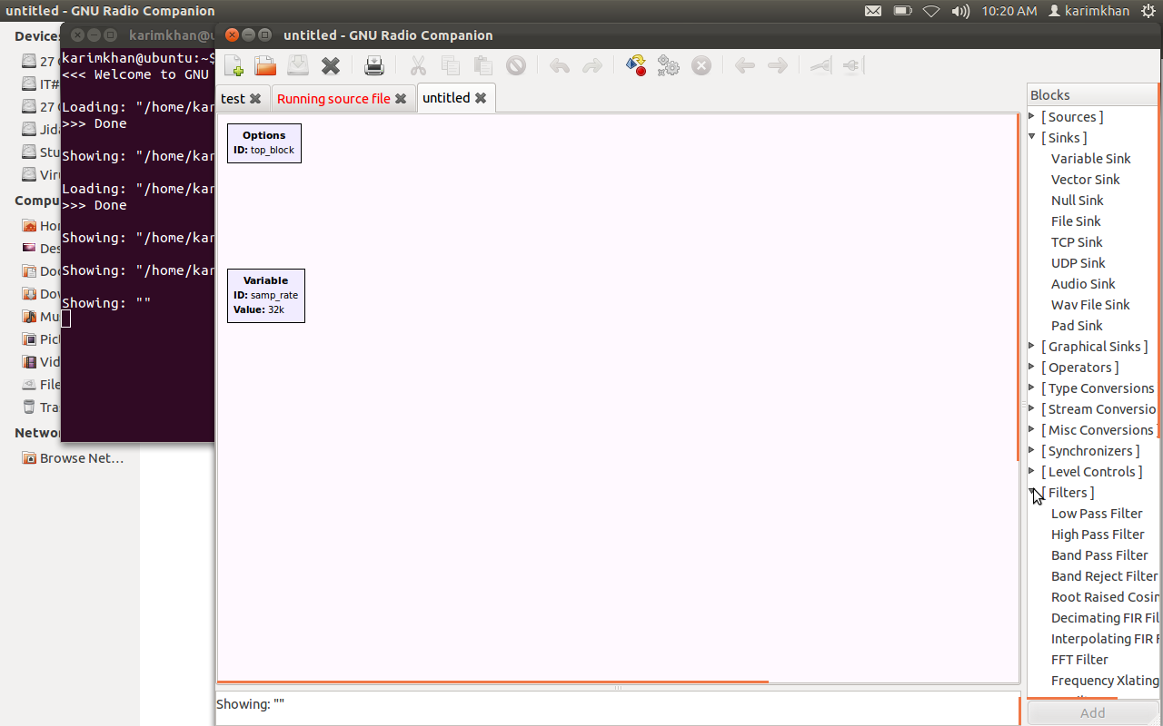
From the panel available on right side we can select any component. After connecting appropriate components we can run the file which creates python file for grc flow graph. When we execute this file then we can see out put of our grc file.

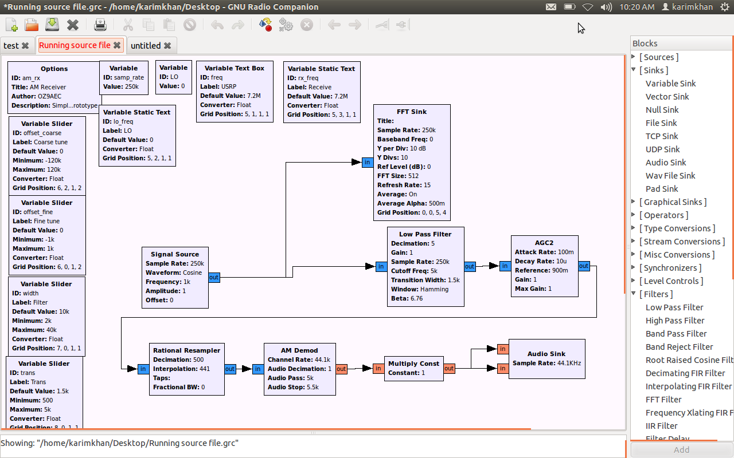
CHAPTER - 4
PROCESSING PRE RECORDED USRP FILE
Lets see one by one all steps to know how SDR implementatopm for pre recorded USRP file is done:
- Download the file: am_usrp710.dat from the SDR Web page. Save it in a location that you can access later. If you download it as a zip file, unzip it.
- Open a terminal window using: Applications > Accessories > Terminal. At the prompt type:
grc
- Construct the flow graph shown below consisting of a File Sink, Throttle, and FFT Sink. Set the Sample Rate in the variable block to 256000. This is the rate at which the saved data was sampled.

- Double click on the File Source block. Click on the ellipsis (…) next to the File parameter. Locate the am_usrp710.dat file that you saved in step 1 (unzipped). The path to our file will appear as shown in the figure below. Set the Output Type to Complex. The use of complex data to describe and process waveforms in SDR will be discussed next week. Set Repeat to Yes. This will cause the data to repeat so that you have a continuously playing signal.

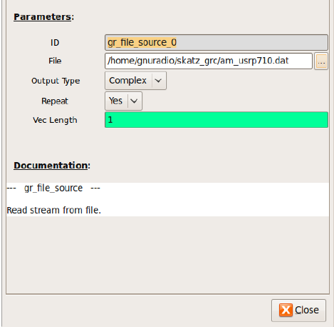
- Save and execute the flow graph. You should observe an FFT display similar to the one shown below. You may need to click on Autoscale button to scale the data as shown. Note the following:
- This data was recorded with a USRP set to 710KHz. Thus, the signal you see at the center (indicated as 0 KHz) is actually at 710 KHz. Similarly, the signal at 80 KHz is actually at 710KHz + 80KHz = 790KHz.

- The display spans a frequency range from just below -120KHz to just above 120KHz. This exact span is 256KHz, which corresponds to the Sample Rate that the data was recorded at.

- The peaks that you observe on this display correspond to the carriers for AM broadcast signals. You should also be able to observe the sidebands for the stronger waveforms.

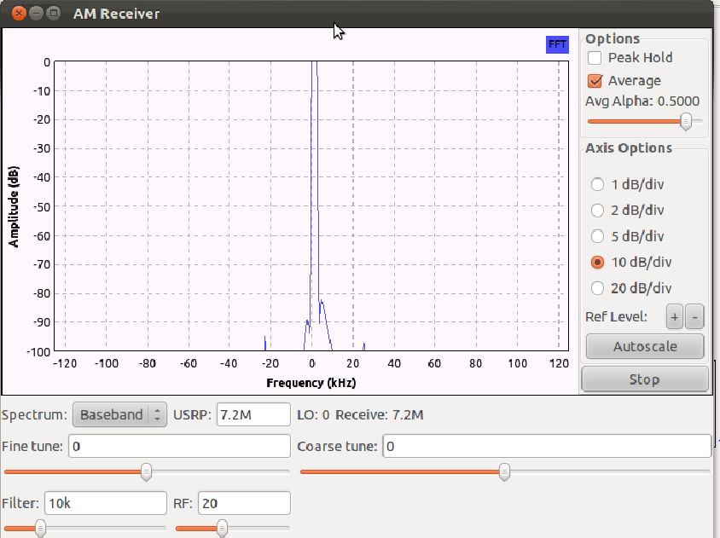

- In this step we will expand the frequency scale on the FFT display so that you can view the signals with greater resolution. Recall from step 5 above that the span of the frequency axis is determined by the sample rate (256K for this file). While we cannot change the original data, we can resample it to either increase or decrease the sample rate. We will decrease the sample rate by using decimation. Modify the flow graph as follows:
- Add a Variable block (under Variables menu). Set the ID to resamp_factor and the Value to 4 as shown below.
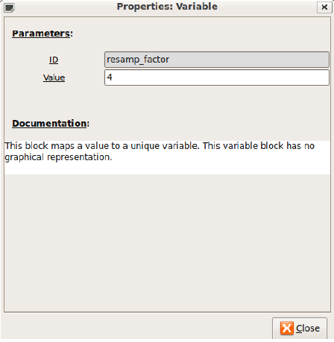

Add the Rational Resampler (NOT Rational Resampler Base) from the Filters menu as shown below. Set its decimation factor to resamp_factor. Thus, it will use the value of the variable set in the previous step (4) to decimate the incoming data. That means that it will divide the incoming data rate by the decimation factor. In this example, the incoming 256K samp/sec data will be converted down to 256K/4 = 64K samp/sec.

Note that the Throttle and FFT Sink now need their Sample Rates changed to correspond to this new rate. Change the Sample Rate in both of these blocks to:
samp_rate/resamp_factor . Now we can change the decimation factor in the Variable block and it will be reflected in each of the other blocks automatically.
Our flow graph should now appear as shown below.

- Execute the new flow graph. You should now observe a frequency span of only 64KHz (-32KHz to +32KHz).

- The bandwidth of an AM broadcast signal is 10KHz (+/- 5KHz from the carrier frequency). You may find it useful to click the “Stop” button on the FFT plot to see this more clearly. Also, note that many stations also include additional information outside of the 10KHz bandwidth.

- In order to select the station at 710 KHz (or 0KHz) we need to insert a filter to eliminate all but the one station that we want to receive. This is often referred to as a channel filter. Since the station at 710 KHz has been moved to 0 KHz (in the USRP) we will use a low pass filter.

The station bandwidth is 10 KHz, so we will use a low pass filter that cuts off at 5 KHz.Insert the Low Pass Filter (from the Filters menu) between the Rational Resampler and the Throttle. Set the parameters as shown below.

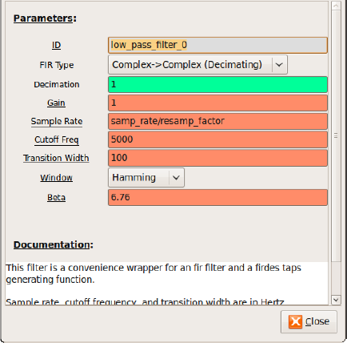

- Execute the flow graph. You should see that only the station between +/- 5KHz remains

- The next step is to demodulate the signal. In the case of AM, the baseband signal is the envelope or the magnitude of the modulated waveform. GNU Radio contains a Complex to Mag block (in the Type Conversions menu) that can be used for this purpose. Again, the use of complex signal representation will be dealt with in depth in the future. Insert this block between the Low Pass Filter and the Throttle.
- Note that the titles of some of the blocks are now red and the Execute Flow Graph icon is dimmed. This indicates an error. Prior to adding this block, all of the block inputs and outputs were complex values. However, the output of the Complex to Mag block is Float (a real number). Thus, any blocks following this block should be Type: Float. Modify the Throttle and FFT Sink accordingly.

- Execute the flow graph. You should now observe the spectrum of the baseband signal in the FFT Sink. Note that since the input data type to the FFT Sink is Float, only the positive frequency spectrum is displayed.

- The next step is to listen to this demodulated waveform to confirm that it is in fact receiving the baseband signal. Remove the Throttle and the FFT Blocks. Add an Audio Sink block to the output of the Complex to Mag block. Note that the default sample rate for the Audio Sink is 32KHz. Most current audio cards require a sample rate of at least 44.1KHz. Change the sample rate to 48 KHz.

- Note that the sample rate out of the Complex to Mag block is 64K and the input to the Audio Sink is 48K. In order to convert 64K to 48K we need to divide (decimate) by 4 and multiply (interpolate) by 3. Insert a Rational Resampler between the Complex to Mag and Audio Sink blocks and set the decimation and interpolation as noted above. Also set its Type to Floa ->Float.

- Place a Scope Sink at the output of the Rational Resampler (in addition to the Audio Sink). Change its Type to Float. The flow graph should be similar to the one shown below.

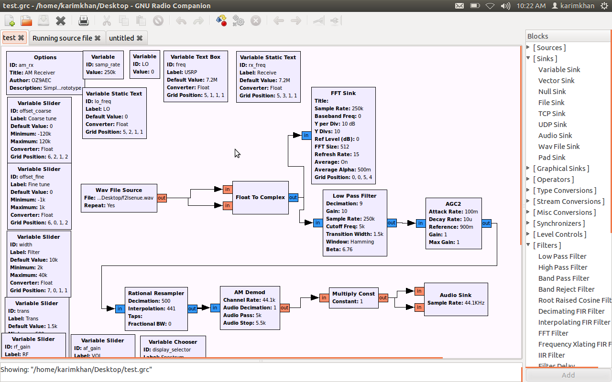

When we run and execute the grc file we see out put as below:

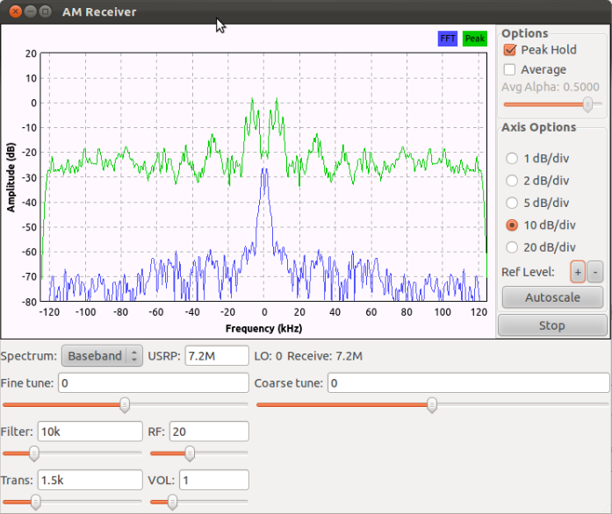
CHAPTER – 5
IMPLEMENTING BLUETOOTH NODE TRACKING DEVICE

For each bluetooth device we need di_erent channel so that we can identify uniqely. [1] I have use bandpass _lter(BPS) here to do channelization. There may be more e_cient block to do the same but in absent of USRPI prefer to work with BPS.

If USRP is available to use then we can apply similar kind of channelization and transmit the signal to targeted device. Similarly using USRP source block we can receive the signal coming from device and store and manipulate them.
CHAPTER – 6
CONCLUSION
- So we can conclude that using SDR we can transmit and receive any range of signal in surrounding area using USRP.

- If we record the receipt of signal for each channel, we can apply superwised learning techniques and predict the location of any particular device. We have to place transceiver on that device.
M.Tech.(ICT) -
References:

[1] http://www.wirelessinnovation.org/what_is_sdr
[2] http://gnuradio.org/redmine/projects/gnuradio/wiki/WhatIsGR
[3] http://gnuradio.org/redmine/projects/gnuradio/wiki/GNURadioCompanion
[4] W. M. Brown, J. E. Clark, A GNU Radio Based Cognitive Signal Identi_cation and Classi_cation Platform III, Metric Systems Corporation 2320 Cousteau Court, Vista, CA 92081 USA
[5] Tatsunori Kimpara and Susumu Ishihara,Using GNU Radio for Experiments on Data Distribution in Wireless Ad-hoc Networks Graduate School of Engineering, Shizuoka University, para@ishilab.net, Graduate School of Science and Technology, Shizuoka University, ishihara@ishilab.net 3-5-1, Johoku, Hamamatsu-Shi, Shizuoka, 432-8011, Japan

