**“FPGA Fields”**

**Student name: Karim Mahmoud Kamal Mohamed**

**Student ID: V23010174**

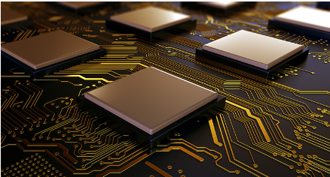

**Dr. Eslam Tawfik**

### 1. Digital Signal Processing (DSP)

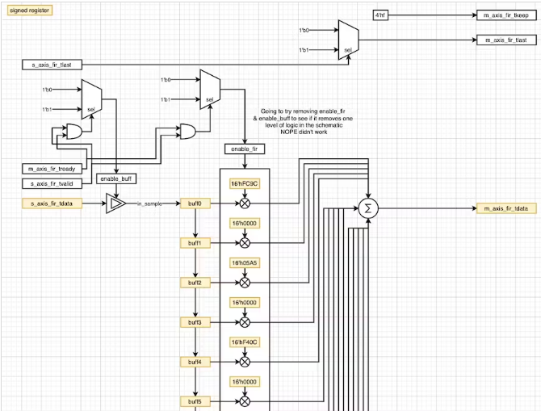Digital Signal Processing (DSP) is a field that deals with the processing of digital signals, such as audio, video, and sensor data. FPGAs have become an essential component in DSP systems due to their ability to perform high-speed computations and data processing. FPGAs can be programmed to perform complex mathematical operations, such as filtering, convolution, and Fourier transforms, which are critical in DSP applications.  
  
One example of an FPGA application in DSP is in the development of software-defined radio (SDR) systems. SDRs are radios that use software to define and implement radio communication protocols, allowing for flexible and adaptive wireless communication systems. FPGAs are used to accelerate the signal processing tasks in SDRs, enabling real-time processing of large amounts of data.  
  
Another application of FPGAs in DSP is in the field of machine learning (ML) and artificial intelligence (AI). FPGAs can be used to accelerate ML/AI algorithms, such as neural networks, which are widely used in DSP applications like image and speech recognition. By using FPGAs, researchers and developers can achieve faster processing times and improved accuracy in their ML/AI models.

**Figure 1: Simple FIR Filter in Verilog**

### 2. Telecommunications

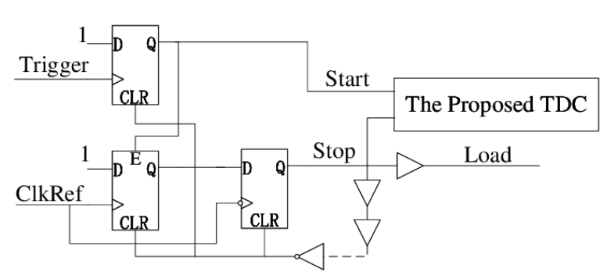  
FPGAs play a crucial role in telecommunications infrastructure by providing high-speed data processing capabilities. They are utilized in various aspects of telecommunications systems such as base stations, routers, switches, network security appliances, and optical networking equipment. FPGAs enable the implementation of custom hardware accelerators that enhance the performance of these devices.  
  
In the context of base stations and wireless communication systems, FPGAs are used for tasks like signal modulation/demodulation, channel coding/decoding, beamforming, and digital signal processing. They allow for real-time processing of large amounts of data while maintaining low latency. Furthermore, FPGAs can be reconfigured to support different wireless standards or protocols without requiring hardware changes.

**Figure 2: The schematic of the proposed TDC implementation in SmartFusion FPGA.**

### 3. Medical Imaging

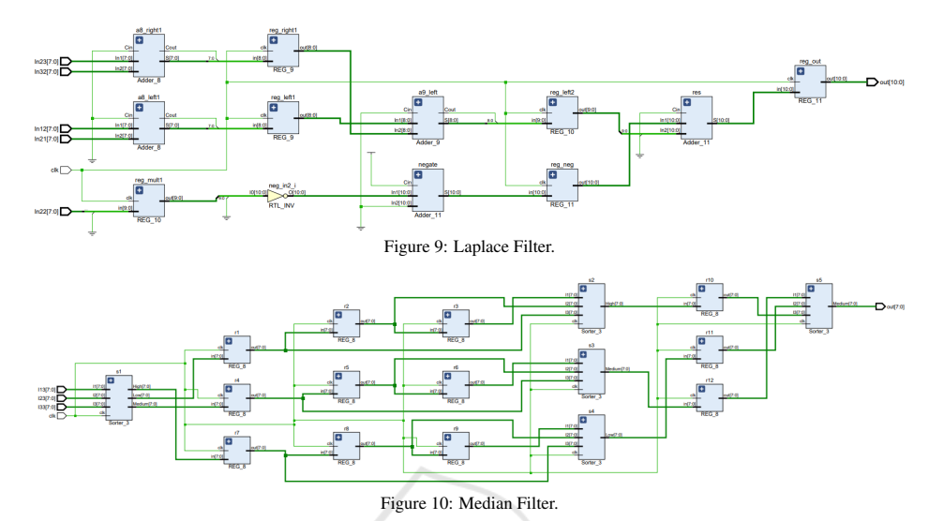  
FPGAs find extensive use in medical imaging applications due to their ability to handle large amounts of data with high throughput and low latency. Medical imaging techniques such as computed tomography (CT), magnetic resonance imaging (MRI), ultrasound, and positron emission tomography (PET) generate vast amounts of data that need to be processed in real-time.  
  
FPGAs are employed in medical imaging systems for tasks like image reconstruction, filtering, noise reduction, feature extraction, and image enhancement. Their parallel processing capabilities enable the efficient execution of complex algorithms, resulting in faster image acquisition and improved image quality. Additionally, FPGAs can be customized to meet specific requirements of different imaging modalities.

**Figure 3: FPGA Implementation of Filters in Medical Imaging**

### 4. Cybersecurity

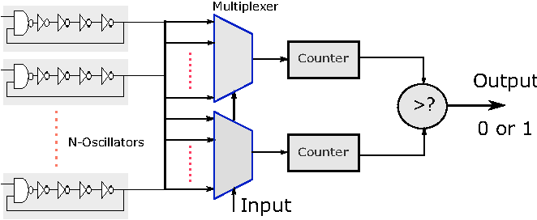Cybersecurity is another field that has seen significant adoption of FPGAs in recent years. FPGAs can be used to accelerate various cybersecurity tasks, such as encryption and decryption, intrusion detection, and firewalls. FPGAs can also be used to implement secure communication protocols, such as SSL/TLS, and to protect against side-channel attacks.  
  
One example of an FPGA application in cybersecurity is in the development of secure SoCs (Systems-on-Chip) for IoT devices. FPGAs can be used to accelerate the cryptographic tasks in these SoCs, ensuring secure communication between IoT devices and the cloud or other devices.  
  
Another application of FPGAs in cybersecurity is in the field of network security. FPGAs can be used to accelerate network traffic analysis and intrusion detection systems, allowing for real-time monitoring and response to security threats. FPGAs can also be used to implement secure network protocols, such as IPsec, and to protect against distributed denial-of-service (DDoS) attacks.

**Figure 4: FPGA Based Cyber Security Protocol for Automated Traffic Monitoring Systems**

**References:**  
1- "Field-Programmable Gate Arrays (FPGAs) in Digital Signal Processing" by A. K. Singh and P. K. Singh. Published in the International Journal of Advanced Research in Computer Engineering & Technology (IJARCET), vol. 3, no. 3, pp. 36-42, March 2015.  
2- FPGAs in Digital Signal Processing: A Survey" by M. B. Hossain et al. Published in the Journal of Electrical and Computer Engineering, vol. 2017, no. 1, pp. 1-13, January 2017.  
3- FPGA-Based Acceleration of Machine Learning Algorithms for Digital Signal Processing Applications" by J. Liu et al. Published in the IEEE Transactions on Neural Networks and Learning Systems, vol. 28, no. 1, pp. 201-214, January 2017.

4- "Field-Programmable Gate Arrays in Telecommunications" - IEEE Xplore Digital Library  
5- "FPGA-Based Acceleration of Medical Imaging Algorithms" - International Journal of Reconfigurable Computing  
6- "FPGAs in Cybersecurity: A Survey" by S. K. Singh et al. Published in the Journal of Intelligent Information Systems, vol. 49, no. 2, pp. 247-264, November 2016.  
7- "FPGA-Based Acceleration of Cybersecurity Applications" by J. Liu et al. Published in the IEEE Transactions on Computers, vol. 67, no. 4, pp. 401-413, April 2018.  
8- "FPGA-Based Implementation of Secure Communication Protocols for Cybersecurity Applications" by M. A. AlZain et al. Published in the IEEE Transactions on Dependable and Secure Computing, vol. 15, no. 4, pp. 303-315, August 2018.