
UDPULSE V1
CSE 361 Computer Networking


Mini-RFC (Phase 1)
Team 28
Karim Marwan Wahid | 23P0009
Yousef Waleed Anwar | 23P0254
Adam Heshmat Makram | 23p0222
Mohamed Sameh Sayed | 23p0161
Aly Ahmed Aly Ahmed | 23p0078

Mini‑RFC: UDPulse v1 (Phase 1)

1. Introduction
Purpose: UDPulse v1 is a lightweight, loss‑tolerant application‑layer protocol for IoT sensors that periodically send small readings to a central collector over UDP.
Use case: Battery‑powered devices reporting metrics such as temperature, humidity, or voltage at fixed intervals. The collector ingests packets, suppresses duplicates, detects sequence gaps, and logs to CSV for analysis.
Why a new protocol: MQTT/HTTP incur higher control and header overhead and often rely on connection state or retransmission. UDPulse v1 targets constrained nodes and lossy links with minimal bytes and computation.
Assumptions and constraints:
- Transport: UDP only. No retransmissions.
- Header: fixed 10 bytes, big‑endian network byte order.
- Message types: INIT, DATA and HEARTBEAT.
- Reporting intervals: configurable (e.g., 1s, 5s, 30s).
- Payload limit: ≤ 200 bytes application data per UDP datagram.
- Loss tolerance: operates correctly with ≈5% random loss; server detects, does not recover.

2. Protocol Architecture
Entities.
- Sensor Client: creates UDP datagrams carrying telemetry or heartbeat.
- Collector Server: receives from client.
Sequence flow (session-less telemetry over UDP):
-Client -> Server : INIT(device_id, seq, ts, battery health, msg_type, payload)
-Client -> Server : DATA(device_id, seq, ts, battery health, msg_type, payload)
-Client -> Server : HEARTBEAT(device_id, seq, ts, battery health, msg_type, payload)

Server behavior:
- Currently just receive packets from client.

3. Message Formats
Header layout (fixed 10 bytes, big‑endian).
Field | Offset (bytes) | Size (bytes) | Type | Description | Reason
Version | 0 | 1 | B | Protocol version (currently 1) | Only small integer values (1–255) are needed to represent protocol versions, so one byte is enough.
DeviceID | 1 | 1 | B | Unique sensor identifier | A single byte supports up to 255 devices, sufficient for small IoT testbeds and keeps header compact.
SeqNum | 2 | 2 | H | Monotonic per‑device sequence number | Needs to count many packets; 2 bytes (0–65,535) provides a good balance between range and size.
Timestamp | 4 | 4 | I | Unix epoch seconds (client send time) | 4 bytes can hold timestamps up to the year 2106, fits standard UNIX time format.
MsgType | 8 | 1 | B | 0=INIT,  1=DATA, 2=HEARTBEAT | Only a few message types exist, so one byte is enough for easy parsing.
Battery Health | 9 | 1 | B | Battery Health out of 100% | Battery level fits naturally in one byte and simplifies numeric comparison at the server.

- Total header size: 10 bytes.
- Network byte order packing (Python struct ‘!’):
- struct.pack('!B B H I B B', protocol_version, device_ID, sequence_number, timestamp, message_type, battery_health)
Message types:
MsgType | Value | Semantics | Payload
INIT | 0 | Initial message after establishing a connection | Initial message when establishing connections
DATA | 1 | One or more sensor readings in payload | Sensor readings
HEARTBEAT | 2 | No new data; indicates liveness | Periodic liveness cheks

4. Communication Procedures
This section describes the complete operational behavior of UDPulse v1, including session establishment, normal telemetry exchange, packet ordering, error handling, and shutdown.

4.1 Session Establishment (INIT Handshake)
UDPulse v1 operates over UDP and does not establish transport-level sessions. Instead, a soft session is created at the application layer using an INIT handshake.
- Client Startup
When a client boots, it initializes its protocol state with:
  - DeviceID = 0 (temporary, unassigned)
  - SeqNum = 0
  - Battery = 100
- INIT Transmission
The client sends an INIT message to the server:
  - MsgType = INIT (0)
  - DeviceID = 0
  - SeqNum = 1
  - Payload: ASCII string "client booting"
- Server ID Assignment
Upon receiving an INIT message with DeviceID = 0, the server:
  - Allocates a new unique DeviceID
  - Initializes per-device state (sequence tracking, buffers, counters)
- ASSIGNED_ID Response
The server replies with an INIT message containing:
  - The assigned DeviceID
  - Payload: ASCII string "ASSIGNED_ID"
- Client Activation
The client stores the assigned DeviceID and transitions to the ACTIVE state. All subsequent messages include this identifier.

4.2 Normal Data Exchange
Once active, the client periodically transmits telemetry and heartbeat messages.

DATA Messages
- Generated every DATA_INTERVAL seconds.
- Each DATA message includes:
  - Incremented sequence number
  - Sensor timestamp
  - Current battery level
- Payload:
  - Single integer value, or
  - Comma-separated integers if batching is enabled.

HEARTBEAT Messages
- Sent every HEARTBEAT_INTERVAL seconds.
- Used to indicate liveness even when no sensor data is sent.
- Payload: ASCII string "alive".
The client may send DATA and HEARTBEAT messages independently based on their respective timers.

4.3 Packet Reception and Buffering (Server Side)
Because UDP does not guarantee packet order, the server implements a reordering buffer.
- Upon receiving a packet, the server:
  - Extracts the header and payload.
  - Identifies the device using DeviceID.
  - Inserts the packet into a per-device priority queue ordered by timestamp.
- Each device maintains:
  - Last processed sequence number
  - Reorder buffer
  - Duplicate and gap counters

4.4 Packet Reordering
To tolerate network jitter, the server applies a fixed reorder window of 50 ms.
- Packets are buffered until their arrival time exceeds the reorder window.
- Packets older than the window are processed in timestamp order.
- This allows limited reordering without unbounded buffering.
Packets still in the reorder window remain buffered.

4.5 Duplicate Detection
Duplicate packets may occur due to network duplication or delayed delivery.
- For each device, the server tracks the last processed sequence number.
- If an incoming packet satisfies:
- SeqNum ≤ last_processed_seq
then:
  - The packet is classified as a duplicate.
  - It is ignored and not processed further.
  - The duplicate counter is incremented.
  - The event is logged with duplicate_flag = 1.

4.5 Gap Detection (Packet Loss)
Packet loss is detected using sequence numbers.
- If a packet arrives with:
- SeqNum > last_processed_seq + 1
then:
  - One or more packets are considered lost.
  - The number of missing packets is calculated.
  - The gap counter is incremented accordingly.
  - The packet is still accepted and processed.
  - The event is logged with gap_flag = 1.
UDPulse v1 does not request retransmission of missing packets.

4.7 Logging and State Update
For each processed packet (DATA or HEARTBEAT), the server:
- Prints packet details to the terminal
- Logs the following fields to CSV:
  - Device ID
  - Sequence number
  - Sensor timestamp
  - Arrival timestamp
  - Duplicate flag
  - Gap flag
- Updates per-device state:
  - Last sequence number
  - Receive counters

4.8 Client Shutdown
The client continuously monitors its battery level.
- Battery level decreases periodically based on sequence count.
- When battery reaches zero:
  - The client stops sending packets.
  - The UDP socket is closed.
  - No explicit shutdown message is sent.

4.9 Server Shutdown
When the server receives a termination signal (SIGINT) (Ctrl+C in terminal):
- All per-device statistics are aggregated.
- Final performance metrics are computed, including:
  - Total packets received
  - Duplicate rate
  - Sequence gap count
  - CPU milliseconds per report
- Metrics are printed to the console.
- The server exits cleanly.

5. Communication Procedures
UDPulse v1 provides reliability and performance support at the application layer while intentionally avoiding transport-level mechanisms such as retransmission and acknowledgements. This design reduces protocol complexity and energy consumption, making it suitable for resource-constrained IoT devices.

5.1 Reliability Model
UDPulse v1 does not guarantee reliable delivery of packets. Instead, it detects and records reliability events without attempting recovery. Lost packets are not retransmitted, and the protocol does not use acknowledgements or timers for resend operations. This design choice prioritizes low overhead and continuous data flow over strict delivery guarantees.

5.2 Sequence Numbering
Each message transmitted by a client carries a monotonically increasing sequence number. Sequence numbers enable the server to:
- Detect duplicated packets
- Identify missing packets
- Maintain per-device message ordering state
Sequence numbers are global per device and apply to all message types, including INIT, DATA, and HEARTBEAT messages.

5.3 Duplicate Detection
The server detects duplicate packets by comparing the sequence number of each incoming message with the last successfully processed sequence number for the same device. Packets with sequence numbers less than or equal to the last processed value are classified as duplicates. Such packets are discarded, recorded for statistical purposes, and not processed further.

5.4 Packet Loss Detection (Gap Detection)
Packet loss is inferred using sequence number gaps. If the server receives a packet with a sequence number greater than the expected next value, one or more packets are considered missing. The server records the number of missing packets but continues processing subsequent messages without requesting retransmission.

5.5 Packet Reordering Support
UDPulse v1 tolerates limited packet reordering caused by network jitter. The server temporarily buffers incoming packets and processes them only after a fixed reordering window has elapsed. Packets are then released in timestamp order. This mechanism allows the server to handle moderate reordering while preventing unbounded buffering or delays.

5.6 Performance Metrics
UDPulse v1 evaluates protocol behavior using quantitative performance metrics computed at the server. All metrics are derived from counters maintained during packet reception and are calculated at server shutdown.
Let:
- $N_{r}$= total number of packets received
- $N_{p}$= total number of packets successfully processed (non-duplicate)
- $N_{d}$= total number of duplicate packets detected
- $N_{g}$= total number of missing packets inferred from sequence gaps
- $B_{t}$= total number of bytes received by the server
- $T_{cpu}$= total CPU processing time consumed by the server (milliseconds)

5.6.1 Bytes per Report
The average number of bytes received per processed packet is defined as:
$$\text{Bytes per Report}=\frac{B_{t}}{N_{p}}$$
This metric reflects protocol overhead and payload efficiency.

5.6.2 Duplicate Rate
The duplicate rate quantifies the fraction of received packets that were classified as duplicates:
$$\text{Duplicate Rate}=\frac{N_{d}}{N_{r}}$$
A low duplicate rate indicates effective duplicate suppression and stable network behavior.

5.6.3 Sequence Gap Count
Packet loss is inferred through sequence number gaps. The total number of missing packets is computed as:
$$\text{Sequence Gap Count}=N_{g}$$
where $N_{g}$is the cumulative count of packets missing between consecutive sequence numbers.

5.6.4 CPU Time per Report
The average server CPU processing cost per processed packet is defined as:
$$\text{CPU Time per Report}=\frac{T_{cpu}}{N_{p}}$$
This metric reflects server-side processing efficiency and scalability.

5.6.5 Metric Interpretation
- Lower Bytes per Report indicate lower protocol overhead.
- Lower Duplicate Rate indicates fewer redundant transmissions.
- Higher Sequence Gap Count reflects increased packet loss.
- Lower CPU Time per Report indicates better server efficiency.
These metrics together provide a comprehensive evaluation of UDPulse v1 performance under varying network conditions.

6.Experimental Evaluation Plan

This section describes the methodology used to evaluate the reliability and performance of UDPulse v1.
The evaluation is designed to observe protocol behavior under both normal and impaired network conditions using controlled, repeatable experiments.

6.1 Baseline Configuration
The baseline experiment establishes reference performance values under ideal network conditions.
Baseline Conditions:
- No packet loss
- No artificial delay, jitter, duplication, or reordering
- Single client transmitting DATA and HEARTBEAT messages
- Fixed client configuration parameters
- Fixed experiment duration
Purpose:
The baseline serves as a reference point for comparison with impaired scenarios and verifies correct protocol operation in the absence of network disturbances.
Expected Behavior:
- Zero or near-zero sequence gap count
- Duplicate rate approaching zero
- Stable bytes per report
- Minimal CPU time per report

6.2 Performance Metrics
All experiments collect the following metrics, defined in Section 5:
- Bytes per report
- Duplicate rate
- Sequence gap count
- CPU time per report
Metrics are computed at the server using aggregated counters collected during packet reception.

6.3 Measurement Methodology
Each experiment follows a consistent measurement procedure to ensure comparability:
- The server is started and begins listening for incoming UDPulse v1 packets.
- Network conditions are configured according to the selected scenario.
- One or more clients are launched with fixed traffic parameters.
- Clients transmit DATA and HEARTBEAT messages for a predefined duration.
- The server logs all received packets and updates reliability counters.
- At the end of the experiment, the server is terminated gracefully.
- Final performance metrics are computed and recorded.
All experiments are executed for equal durations to ensure fair comparison across scenarios.

6.4 Network Impairment Simulation (Linux)
On Linux systems, network impairments are introduced using the tc utility with the netem queuing discipline applied to the loopback interface.

6.4.1 Packet Loss (5%)
- Simulates unreliable network conditions by randomly dropping packets.
- >sudo tc qdisc add dev lo root netem loss 5%
Expected Effect:
Increased sequence gap count with stable protocol operation and no retransmissions.

6.4.2 Delay and Jitter (100 ms ± 10 ms)
- Simulates propagation delay and variable network latency.
- >sudo tc qdisc add dev lo root netem delay 100ms 10ms
Expected Effect:
Out-of-order packet arrivals corrected by the server’s reordering mechanism.

6.4.3 Packet Duplication (10%)
- Simulates packet duplication caused by network anomalies.
- >sudo tc qdisc add dev lo root netem duplicate 10%
Expected Effect:
Increased duplicate rate with correct duplicate suppression at the server.

6.4.4 Packet Reordering (25%)
- Simulates packet reordering with delayed delivery.
- >sudo tc qdisc add dev lo root netem reorder 25% delay 30ms 10ms
Expected Effect:
Correct ordered processing after the reorder window expires without buffer overflow.

6.4.5 Verification and Reset
- Active impairment rules are verified using:
>sudo tc qdisc show dev lo
- All impairments are removed after each experiment:
>sudo tc qdisc del dev lo root
- This ensures clean and isolated experimental runs.

6.5 Network Impairment Alternatives (Non-Linux Systems)
For systems where Linux netem is unavailable, equivalent tools may be used:
- Windows:
Clumsy (supports loss, delay, duplication, and reordering)
- macOS:
Network Link Conditioner or packet filtering tools
- Virtualized Environments:
Linux virtual machines or containers running netem
These alternatives provide functional equivalents for controlled network impairment.

6.6 Client Traffic Configuration Parameters
Client behavior during experiments is controlled using configurable parameters:
- Batch size (-b, --batch)
Number of sensor readings aggregated into a single DATA packet.
Default: 1
- Data interval (-d, --data_interval)
Time interval between successive sensor readings, in seconds.
Default: 4 seconds
- Heartbeat interval (-H, --heartbeat_interval)
Time interval between HEARTBEAT messages, in seconds.
Default: 1 second
These parameters allow controlled variation of traffic rate and payload size during experiments.

6.7 Automation and Repeatability
Experiments are automated using scripts that:
- Configure network impairments
- Launch the server
- Start clients with fixed parameters
- Run experiments for a predefined duration
- Terminate the server to trigger metric computation
- Collect output logs and CSV files
Each scenario is executed multiple times using identical configurations to ensure repeatability and reduce measurement variance.

6.8 Experimental Automation Scripts
To ensure reproducibility, consistency, and ease of evaluation, all UDPulse v1 experiments are automated using a combination of Bash and Python scripts included in the project repository.

6.8.1 Network Impairment Script (netem.sh)
Network impairments are configured using a Bash script named netem.sh, located in the tests/ directory. This script applies and removes Linux netem queuing disciplines on a specified network interface.
The script supports the following modes:
- Baseline (no impairment)
- Packet loss (5%)
- Delay and jitter (100 ms ± 10 ms)
The script ensures that any previously applied netem rules are removed before applying new ones, preventing interference between experimental runs.
Usage:
./tests/netem.sh <interface> <mode>
Where:
- <interface> is the network interface (e.g., lo for loopback)
- <mode> is one of:
  - none — remove all impairments
  - loss — apply 5% packet loss
  - delay — apply 100 ms delay with 10 ms jitter
Example:
sudo ./tests/netem.sh lo loss
After each experiment, the script is invoked with the none mode to reset the network state and ensure isolation between runs.

6.8.2 Experiment Orchestration Script (run_experiment.py)
A Python-based experiment runner, run_experiment.py, is used to orchestrate the full experimental workflow. This script coordinates the application of network impairments, execution of the server and client programs, and collection of experimental outputs.
The script performs the following steps automatically:
- Applies the selected network impairment by invoking netem.sh.
- Launches the UDPulse v1 server (server.py) and allows it to initialize.
- Starts one or more UDPulse v1 clients (client.py) with fixed configuration parameters.
- Executes the experiment for a predefined duration.
- Gracefully terminates the server process, triggering final metric computation.
- Resets all network impairments.
- Saves server logs, client logs, and CSV measurement files with timestamped filenames.
This approach guarantees identical execution order and timing across all experimental scenarios.
Usage:
python3 run_experiment.py <mode>
Where <mode> corresponds to the same impairment modes supported by netem.sh:
- none
- loss
- delay
Example:
python3 run_experiment.py loss

6.8.3 Output Artifacts
Each experiment execution generates the following artifacts:
- Server log file
Contains ordered packet traces, duplicate and gap detection messages, and final performance metrics.
- Client log file
Records transmitted DATA and HEARTBEAT messages.
- CSV file (telemetry_log.csv)
Logs per-packet metadata including device ID, sequence number, timestamps, duplicate flags, and gap flags.
Log files are automatically timestamped to prevent overwriting previous results and to facilitate post-experiment analysis.

6.8.4 Repeatability and Experimental Control
By combining deterministic client configuration, fixed experiment durations, and automated impairment control, the scripting framework ensures that all experimental scenarios are repeatable and directly comparable. Each scenario can be executed multiple times using identical parameters to reduce measurement variance and support statistical analysis.
The use of explicit automation scripts satisfies the project requirement for reproducible experimentation and enables third-party evaluators to replicate all reported results with minimal setup effort.

7. Example Use Case Walkthrough
This section presents an end-to-end walkthrough of a single UDPulse v1 session between one client and the server. The walkthrough traces protocol behavior from device initialization through normal telemetry transmission and demonstrates how messages are sent, received, and processed. The description is supported by an actual packet capture obtained during the experiment, which is referenced in this section and included in Appendix A.

7.1 Session Start and Device Registration
At the start of execution, the client initializes with a temporary device identifier and prepares to establish communication with the server. Since UDPulse v1 operates over UDP, no transport-level session is created. Instead, a soft session is established at the application layer.
The client sends an INIT message to the server containing its protocol version, a temporary device identifier, an initial sequence number, a sensor timestamp, and its current battery level. Upon receiving this INIT message, the server recognizes that the device identifier is unassigned and allocates a new unique identifier for the client.
The server replies with an INIT response containing the assigned device identifier. After receiving this response, the client stores the assigned identifier and transitions into the active operational state. All subsequent messages from the client include this assigned identifier.

7.2 Normal Data Transmission
Once the client enters the active state, it begins generating telemetry data at fixed intervals. For each sensor reading, the client sends a DATA message to the server. Each DATA message includes the assigned device identifier, an incremented sequence number, a sensor-generated timestamp, the current battery level, and a payload containing the sensor reading.
When the server receives a DATA message, it records the packet arrival time and inserts the packet into a per-device reordering buffer. After the reordering window expires, the packet is processed in order. The server then prints the packet details, updates per-device state, and logs the event for later analysis.
Figure A.1 in Appendix A shows a captured UDPulse v1 DATA packet from this session. The packet capture confirms correct encoding of the protocol header fields, including the protocol version, device identifier, sequence number, timestamp, message type, battery level, and telemetry payload.

7.3 Heartbeat Transmission
In addition to telemetry data, the client periodically transmits HEARTBEAT messages to indicate liveness. HEARTBEAT messages are sent at a fixed interval independent of DATA messages and contain no sensor readings.
Upon receiving a HEARTBEAT message, the server processes it in the same manner as other messages, updating per-device state and logging the event. HEARTBEAT messages allow the server to observe continued device activity even during periods when no sensor data is generated.

7.4 Packet Loss and Gap Detection
During extended operation or under impaired network conditions, packet loss may occur. UDPulse v1 detects packet loss indirectly using sequence numbers.
If the server receives a packet with a sequence number greater than the expected next value, it infers that one or more packets were lost in transit. The server records the number of missing packets as a sequence gap event. Despite the detected loss, the received packet is still accepted and processed, and no retransmission is requested.
This behavior demonstrates that UDPulse v1 treats reliability as an observable property rather than a recoverable one.

7.5 Duplicate Packet Handling
Packet duplication may occur due to network behavior such as retransmission at lower layers or delayed delivery. When the server receives a packet whose sequence number is less than or equal to the last successfully processed sequence number for the same device, the packet is classified as a duplicate.
Duplicate packets are discarded and not processed further. The server records the duplicate event for statistical analysis. This mechanism ensures idempotent processing and prevents duplicated telemetry data from affecting results.

7.6 Timestamp Comparison
Each UDPulse v1 message carries a sensor-generated timestamp, and the server records a separate arrival timestamp when the packet is received. Comparing these timestamps enables estimation of network delay and validation of packet reordering behavior.
Timestamp comparison is also used during offline analysis to correlate packet timing with observed network impairments.

7.7 Walkthrough Summary
This example walkthrough demonstrates that UDPulse v1:
- Establishes a soft session using an INIT handshake
- Transmits telemetry and heartbeat messages correctly
- Detects packet loss using sequence gaps
- Suppresses duplicate packets using sequence numbers
- Logs timing and reliability information for analysis
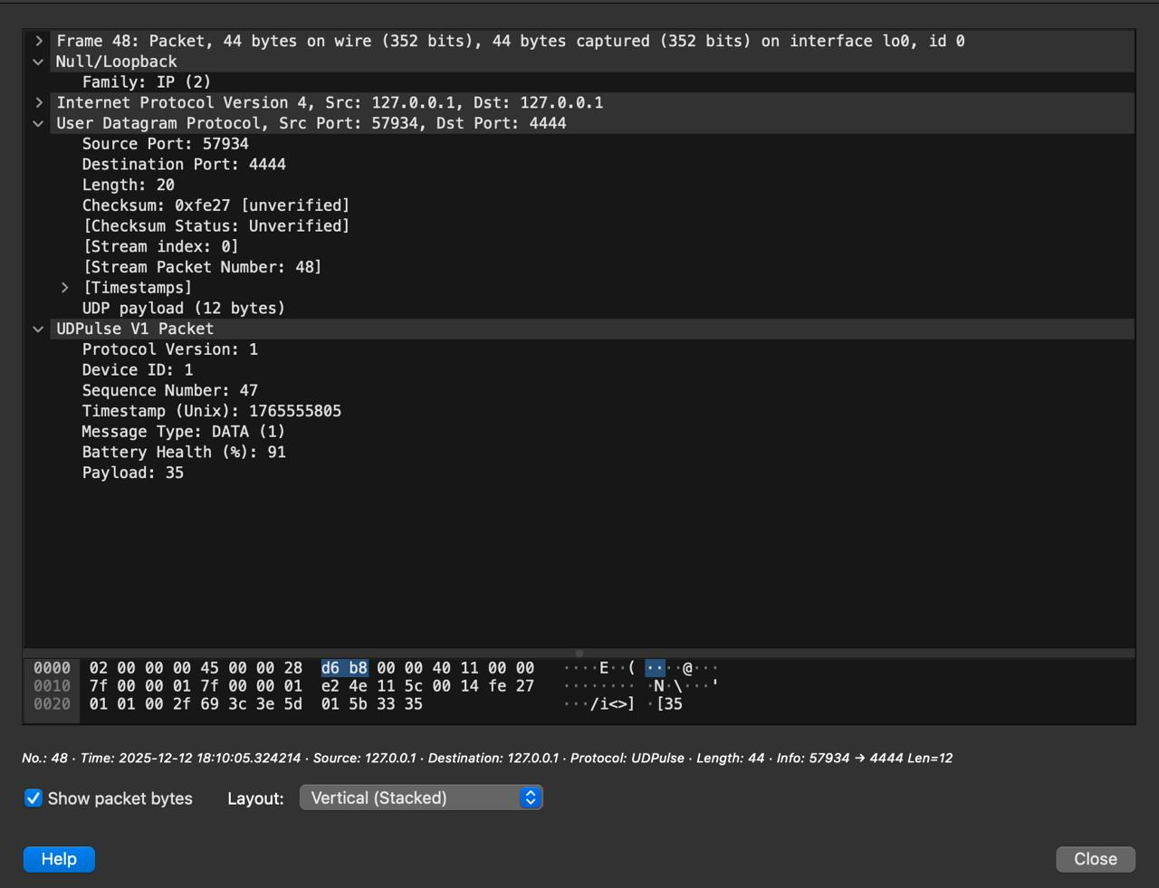
The packet capture included in Appendix A provides experimental evidence that the observed protocol behavior matches the UDPulse v1 specification described in earlier sections.

Figure 1.A UDPulse v1 Data packet captured on Wireshark

