This is the original image before applying any quantization to it.



This is the image, after applying quantization with range 10, meaning that the colors in the original image that the difference between them regarding the RGB values is between 10 and -10 are combined and represented by only one color. This had a negative effect on the transition between similar colors and shades resulting in harsher fade between them, another effect of this quantization is decreasing the size of the color map.

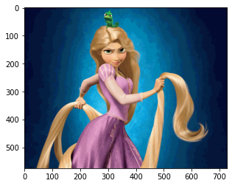

This is the image, after applying quantization with range 20, meaning that the colors in the original image that the difference between them regarding the RGB values is between 20 and -20 are combined and represented by only one color. This had a negative effect on the transition between similar colors and shades resulting in an even harsher fade between them compared to quantization with range 10 as more colors are combined, another effect of this quantization is decreasing the size of the color map even smaller than the one with range 10, as more colors are combined.

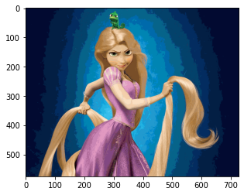

This is the image, after applying quantization with range 30, meaning that the colors in the original image that the difference between them regarding the RGB values is between 30 and -30 are combined and represented by only one color. This had a negative effect on the transition between similar colors and shades resulting in an even harsher fade between them compared to quantization with range 20, however the difference between quantization by 20 and by 30 is not as significant (as between 10 and 20) due to the fact that there are less colors to group for the 30 range as the 20 has already covered most of them, another effect of this quantization is decreasing the size of the color map even smaller than the one with range 20, as more colors are combined, however not a significant different as the 20 range was already covering most of the colors that can be merged.

