DevOps Tutorial

What is GIT in Hindi/Urdu | What is github | Distributed Version Control System | Github tutorial

Source Code Management

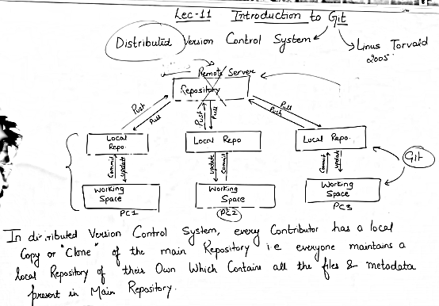

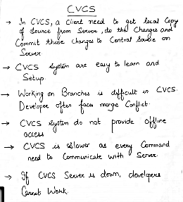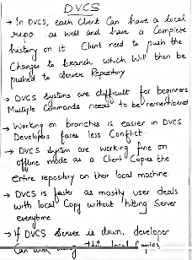

# Git-Three Stages -Working Directory,Staging area and Local Repository | What is Branch in git

# 

# 

# 

# 

# 

# 

# How to install git on aws linux machine-Hindi/Urdu | How to Create github account | What is git?

# 

# How to add,commit in git-Hindi/Urdu | How to push from git to github | How to pull code from github

# 

# 

# How to create Branch in git-Hindi | What is git reset,git stash and git Merge | What is git conflict

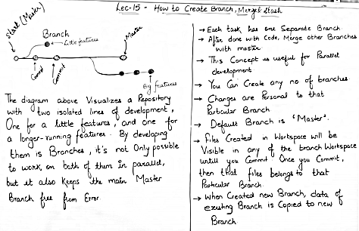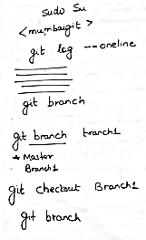

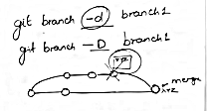

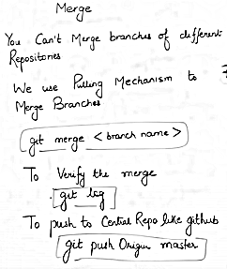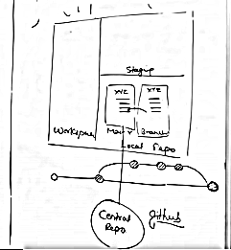

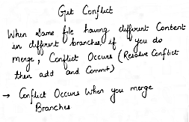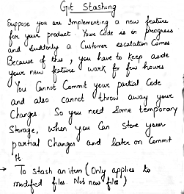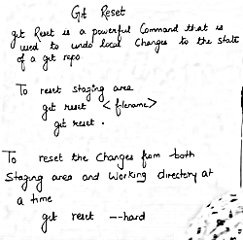

# What is git revert-Hindi/Urdu |What is tag in git | Github clone | git reset vs git revert | gitlab

# 

# 