DAILY PROGRESS REPORT TEMPLATE
Training VLSI – Final Project: CNN on Basys3 FPGA
Identification | Details
Day / Date | Thursday/29-10-2026
Group / Team Name | Group 3
Members and Roles | Michael Reynaldi Tamara  Handy Jonarta  Karunia Muda Kurniawan  Nabil Karim Abdurrahman  Bramantio Ananda
Project Title / Design Revision | CNN Implementation for eye drowsiness driver in ADAS Vehicle
A. Objectives and Work Plan
- Today's Target / Milestone:
Discussing about topic and task division
- Priorities and Task Allocation:
Confirming the topic and collecting for data set
- Start-of-Day Activities (select applicable):
☐ Independent planning ☐ Progress review ☑ Reference study ☑ Team discussion ☐ Mentor consultation ☑ Instructor briefing
- Key Technical Decisions / Guidance:
Confirmed topic
B. Progress and Technical Evidence
- Modules / Subsystems Worked On:
Reyn - Python model + dataset + weight generation
Handy - architecture design
Tio - Architecture design + topic
Karan - Dataset + setting environment for github
- Verified Working Results: __________________________________________________
- Verification Evidence (testbench log, waveform snippet, synthesis report, demo photo, commit hash):
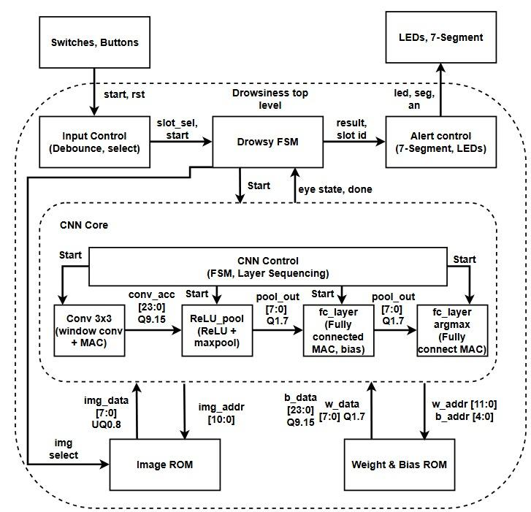
- Major Design / File Changes: _______________________________________________
C. Progress Review (14:00–15:00)
- Summary of Demonstration / Presentation: __________________________________________
- Mentor / Peer Feedback: _____________________________________
- Decisions and Corrective Actions: _________________________________________________
D. Additional Work (Optional)
- Post-Review Activities and Outcomes: _________________________________________
E. Milestone Status and Issues
Milestone Item | Status (Complete / Partial / Not Started) | Evidence / Notes
__________________ | __________________ | __________________
__________________ | __________________ | __________________
- Technical / Non-Technical Blockers: ________________________________________________
- Attempted Solutions / Assistance Required: ___________________________________
- Estimated Cumulative Progress: ______ %
F. Next-Day Plan
- Priority 1: __________________________ Priority 2: __________________________
- Priority 3: __________________________ Task Owners: ________________
Prepared by: __________________________ Team: __________________________

DAILY REPORT – SHORT VERSION
Day: Thursday Date: 29/10/2026 Team: 3

1. Today's target
Discussion for topic chosen and
2. Main progress and evidence (file/commit/waveform/demo)
________________________________________________________________________
3. Feedback / decisions from progress review (if any)
________________________________________________________________________
4. Milestone status: ☐ Complete ☐ Partial ☐ Not started
________________________________________________________________________
5. Issues, attempted solutions, and assistance needed
________________________________________________________________________
6. Tomorrow's priorities and owners
________________________________________________________________________

