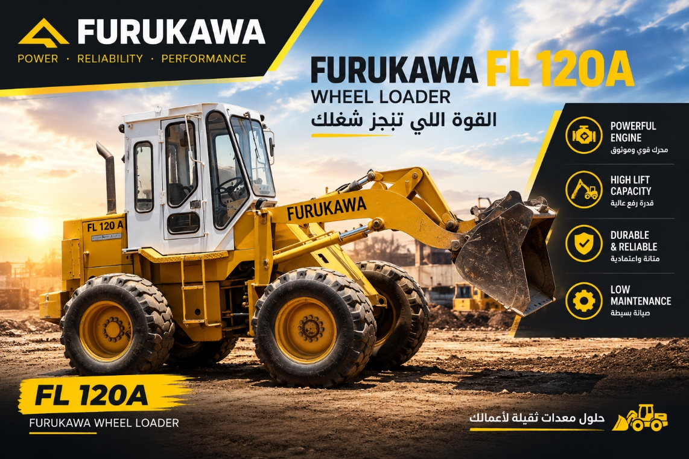

Furukawa FL120A Wheel Loader – Specifications
- Manufacturer: Furukawa
- Model: FL120A
- Machine Type: Wheel Loader
- Bucket Capacity: Approx. 1.2–1.3 m³
- Rated Engine Power: Isuzu 6 cylinder diesel
- Operating Weight: Approx. 7,660 kg
- Drive: 4-Wheel Drive
- Transmission: Torque Converter Transmission
- Steering: Articulated Steering
- Cab: Enclosed Operator Cabin
- Attachment: Front Loader Bucket
- Application: Material handling, loading, construction, quarrying and general earthmoving
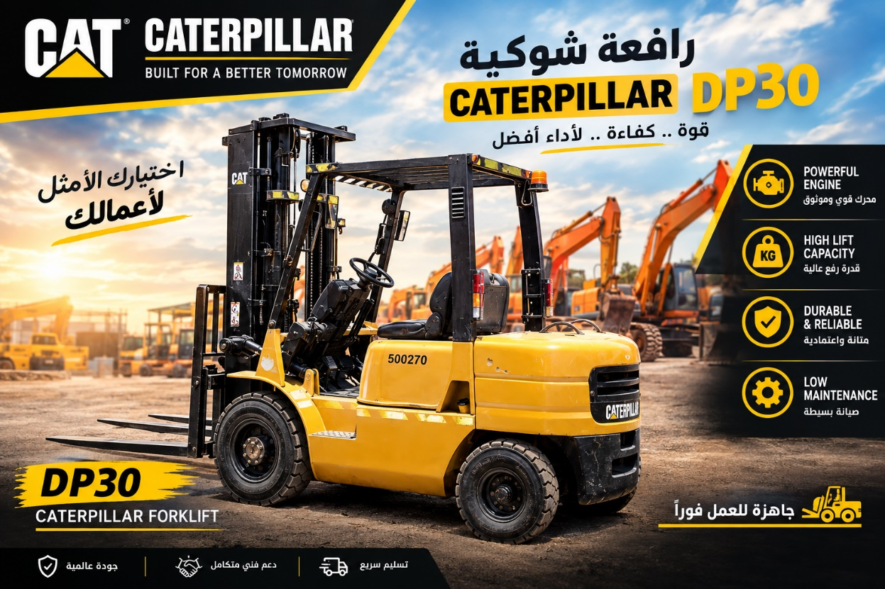

CATERPILLAR FORKLIFT – SPECIFICATIONS
- Brand: Caterpillar (CAT)
- Equipment Type: Forklift
- Fuel Type: Benzene ,Mitsubishi 4 cylinder
- Transmission: Automatic / Power Shift
- Drive: 2WD
- Mast Type: Standard Mast
- Fork Type: Standard Forks
- Tires: Solid / Industrial Tires
- Operating Condition: Used
- Color: Caterpillar Yellow
- Application: Industrial, Warehouse & Construction Use
- Operator Position: Seated
- Steering: Hydraulic Power Steering
- Safety: Overhead Guard & Safety Beacon
- Machine Condition: Used – Good Working Condition
- Serial / Asset No.: 500270

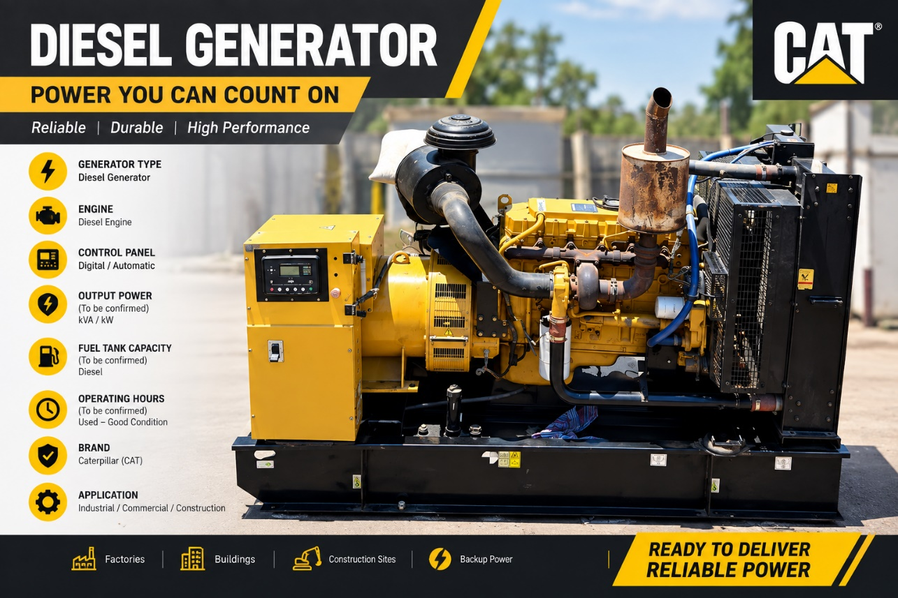

Olympian Caterpillar DIESEL GENERATOR SET
- Brand: Olympian Caterpillar
- Equipment Type: Diesel Generator Set 250 KVA
- Engine Type: Perkins 1306 (English made).
- Fuel Type: Diesel
- Generator: Industrial Alternator
- Cooling System: Radiator-Cooled
- Starting System: Electric Start
- Control Panel: Digital Control Panel
- Exhaust System: Heavy-Duty Industrial Exhaust
- Engine: Caterpillar Diesel Engine
- Configuration: Open Skid-Mounted Type
- Application: Industrial, Commercial & Construction Use
- Operating Mode: Standby / Prime Power
- Color: Caterpillar Yellow

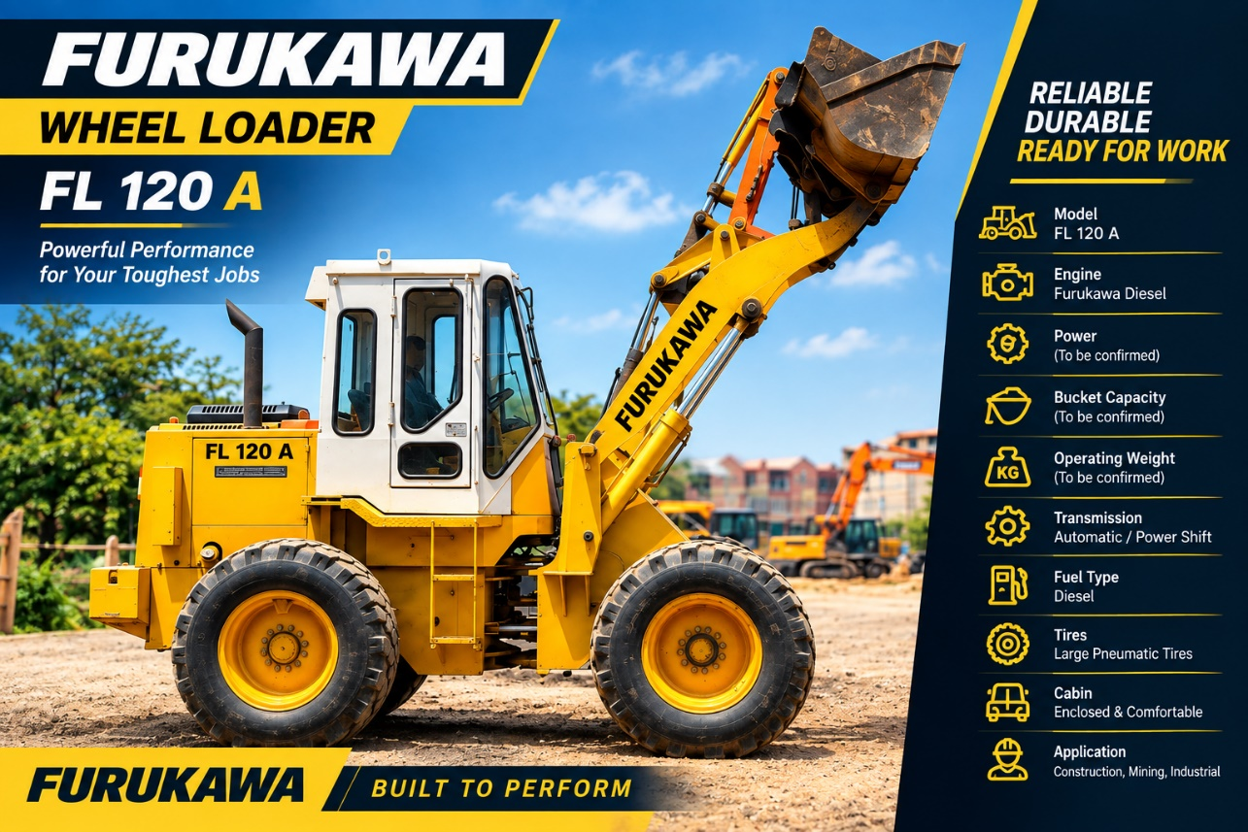

FURUKAWA FL120A WHEEL LOADER
- Brand: Furukawa
- Model: FL120A
- Machine Type: Wheel Loader
- Bucket Capacity: Approx. 1.2–1.3 m³
- Engine :Isuzu 6 cylinder diesel
- Rated Power: Approx. 85 PS
- Operating Weight: Approx. 7,660 kg
- Transmission: Powershift / Automatic Transmission
- Steering: Hydraulic Articulated Steering
- Drive: 4-Wheel Drive
- Bucket: Standard General-Purpose Bucket
- Cabin: Enclosed Operator Cabin
- Hydraulic System: Hydraulic Boom & Bucket System
- Braking System: Hydraulic Service Brakes
- Tires: Heavy-Duty Loader Tires
- Application: Construction, Quarrying, Earthmoving & Material Handling
- Color: Furukawa Yellow
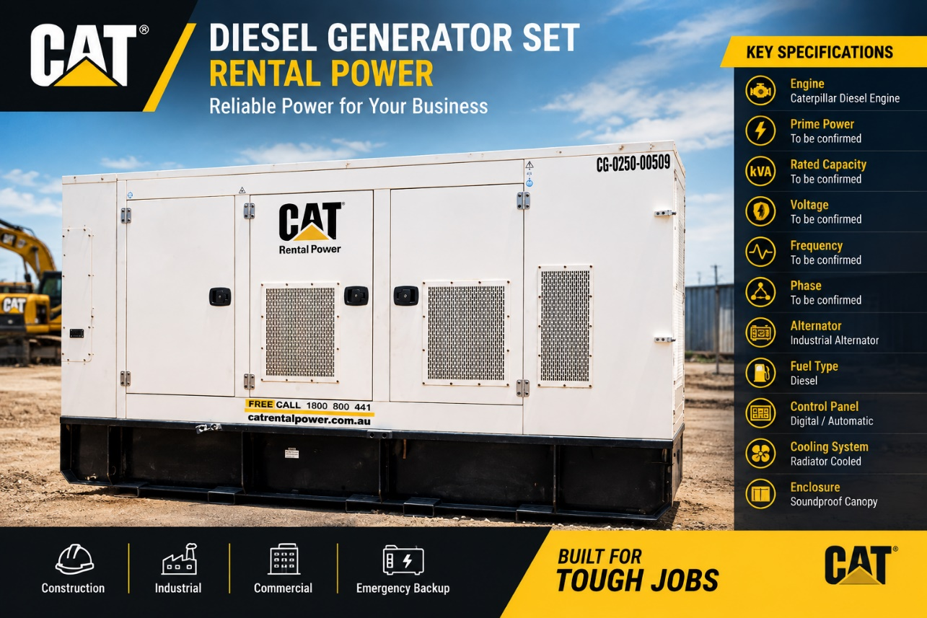

Olympian Caterpillar – DIESEL GENERATOR SET
- Brand: Olympian Caterpillar
- Type: Perkins 1306 (English made).
- Series: CAT Rental Power
- Configuration: Enclosed / Sound-Attenuated Canopy
- Fuel: Diesel
- Cooling System: Radiator-Cooled
- Generator Type: Industrial Alternator
- Control System: Digital Generator Control Panel
- Starting System: Electric Start
- Mounting: Skid-Mounted
- Enclosure: Weatherproof & Sound-Attenuated
- Application: Industrial, Commercial, Construction & Rental Power
- Operating Mode: Prime / Standby Power
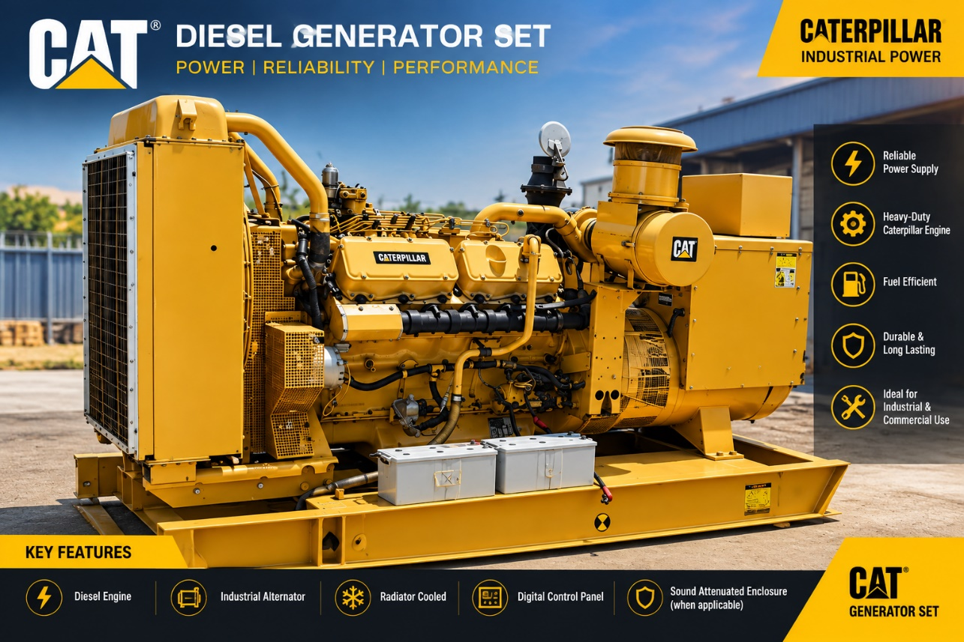

CAT Diesel Generator Set – Specifications
- Brand: Caterpillar (CAT)
- Type: 3412 Diesel Generator Set 455KVA
- Engine: Caterpillar Heavy-Duty Diesel Engine
- Generator: Industrial Alternator
- Cooling System: Radiator-Cooled
- Fuel Type: Diesel
- Control System: Digital Control Panel
- Starting System: Electric Start
- Performance: Reliable Prime & Standby Power
- Construction: Heavy-Duty Industrial Design
- Noise Control: Sound-Attenuated Enclosure (when applicable)
- Fuel Efficiency: Designed for Efficient Fuel Consumption
- Operation: Automatic / Manual Control
- Application: Industrial, Commercial, Construction & Emergency Power
- Installation: Suitable for Stationary Power Applications
- Reliability: Designed for Continuous and Backup Power Requirements

- 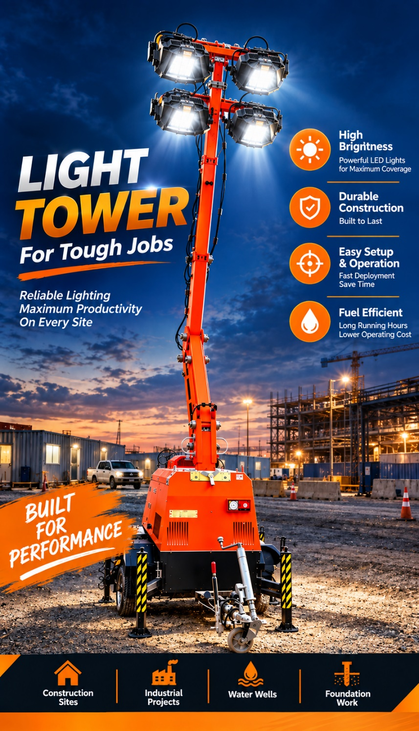

LIGHT TOWER – Specifications

Type: Portable LED Light Tower

Lighting System: High-Intensity LED Floodlights

Light Heads: 4 Adjustable LED Light Heads

Mast: Telescopic Vertical Mast

Mast Operation: Hydraulic / Mechanical Extension System

Power Source: Integrated Generator

Lighting Coverage: Wide-Area Illumination

Mobility: Trailer-Mounted Design with Wheels

Stability: Heavy-Duty Adjustable Outriggers

Deployment: Quick and Easy Setup

Construction: Heavy-Duty Steel Structure

Operation: Suitable for Continuous Jobsite Lighting

Applications: Construction Sites, Industrial Projects, Road Works, Foundation Work, and Remote Sites

Key Benefits: High Brightness, Durable Construction, Easy Operation, Excellent Mobility, and Reliable Performance

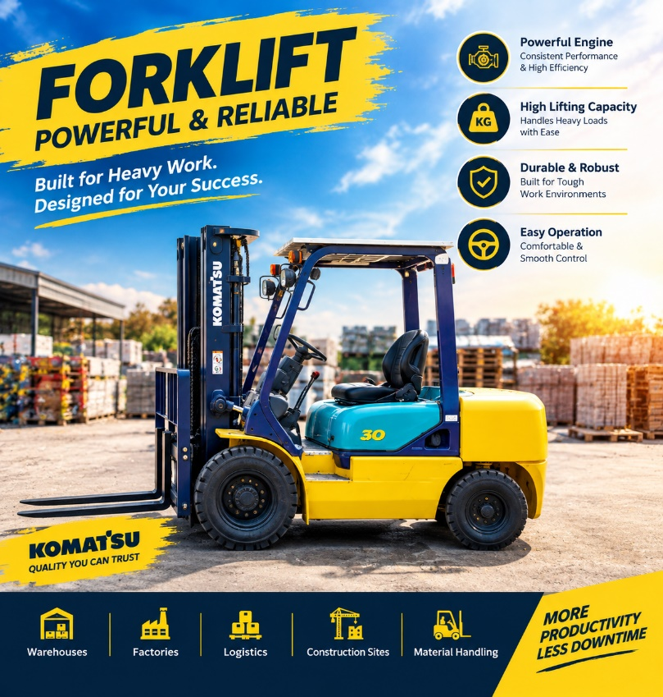

KOMATSU FORKLIFT – Specifications
- Brand: Komatsu
- Type: Diesel Forklift
- Lifting Capacity: 3,000 kg
- Mast Type: Hydraulic Lifting Mast
- Forks: Heavy-Duty Forks
- Engine: Powerful & Reliable Diesel Engine
- Transmission: Industrial Heavy-Duty Transmission
- Steering: Hydraulic Steering System
- Operator Seat: Adjustable Operator Seat
- Safety: Overhead Guard & Heavy-Duty Safety Structure
- Tires: Heavy-Duty Industrial Tires
- Load Handling: Designed for Heavy Material Handling
- Operation: Smooth & Easy Operation
- Construction: Robust Heavy-Duty Construction
- Application: Warehouses, Factories, Logistics, Construction Sites & Material Handling

