Assigement-5

Big number in given two numbers

Program:

//Main Method

class GreaterTwo

{

public static void main(String args[])

{

int a=20;

int b=40;

if(a>b)

{

System.out.println(a+" is greater");

}

else

{

System.out.println(b+" is greater");

}

}

}

Output:

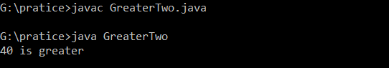

Big number in given three numbers

Program:

//Main Method

class GreaterThree

{

public static void main(String args[])

{

int a=20;

int b=40;

int c=80;

if(a>b)

{

if(a>c)

{

System.out.println(a+" is greater");

}

else

{

System.out.println(c+" is greater");

}

}

else if(b>c)

{

System.out.println(b+" is greater");

}

else

{

System.out.println(c+" is greater");

}

}

}

Output:

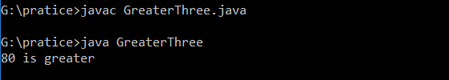

Sum of the numbers of an integer

Program:

//Inside main

class Integer

{

public static void main(String args[])

{

int lucky[]={10,20,30,40,80};

int sum=0;

for(int i=0;i<lucky.length;i++)

{

sum+=lucky[i];

}

System.out.println("The sum Of integer is:"+sum);

}

}

Output:

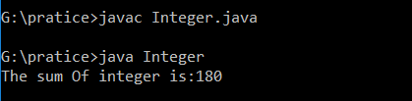

First and Last

Program:

//Inside Main

class FirstLast

{

public static void main(String args[])

{

int array[]={10,40,30,50,22,63};

System.out.println("First Number is:"+array[0]);

System.out.println("Last Number is:"+(array[array.length-1]));

}

}

Output:

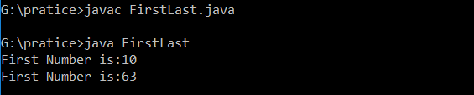

Big number in the given array

Program:

//Design Class

class ArrBig

{

void getArray()

{

int a[]={50,30,80,90,54};

int k=a[0];

for(int i=0;i<a.length;i++)

{

if(k<a[i])

{

k=a[i];

}

}

System.out.println(k+" Big Number in the array");

}

}

//Inside main

class TestArrBig

{

public static void main(String args[])

{

ArrBig obj=new ArrBig();

obj.getArray();

}

}

Output:

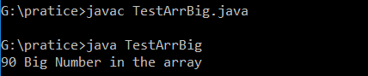

Five athematic operations

Program:

//Design class

class Arthematic

{

int a=20;

int b=54;

int choice=6;

void getData()

{

switch(choice)

{

case 1:

System.out.println("sum is:"+(a+b));

break;

case 2:

System.out.println("sub is:"+(a-b));

break;

case 3:

System.out.println("sum is:"+(a\*b));

break;

case 4:

System.out.println("Div is:"+(a/b));

break;

case 5:

System.out.println("ModDiv is:"+(a%b));

break;

default:

System.out.println("choose should be 1 to 5");

}

}

}

//Inside Main

class TestArthematicOpt

{

public static void main(String args[])

{

Arthematic obj=new Arthematic();

obj.getData();

}

}

Output:

