**Assignment-7 (16-11-2018)**

**//write a program in java finding frequence**

**Program:**

**public** **class** Frequency {

**public** **static** **void** main(String[] args) {

String s="aaaaabbaaabcccccc";

**int** choice1=0;

**int** choice2=0;

**int** choice3=0;

**char** ch[]=s.toCharArray();

**for**(**int** i=0;i<ch.length;i++)

{

**if**(ch[i]=='a')

{

choice1++;

}

**else** **if**(ch[i]=='b')

{

choice2++;

}

**else**

{

choice3++;

}

}

System.***out***.println("char Frequency");

System.***out***.println("-----------------------------------------");

System.***out***.println(" a "+choice1);

System.***out***.println(" b "+choice2);

System.***out***.println(" c "+choice3);

}

}

Output:

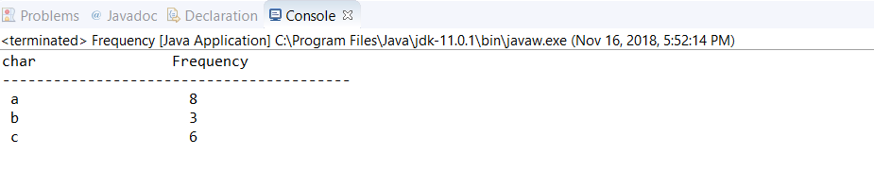

//Write a java program find the vowels in a string

Program:

**public** **class** Vowels {

**public** **static** **void** main(String[] args) {

String s2="Karimulla";

**char** ch[]=s2.toCharArray();

**for** (**int** index = 0; index < ch.length; index++) {

**if**(ch[index]=='a' || ch[index]=='e' || ch[index]=='i' || ch[index]=='o' || ch[index]=='u')

{

**int** z=s2.indexOf(ch[index]);

System.***out***.println(z +" is Position of Vowel " +ch[index]);

}

}

}

}

Output:

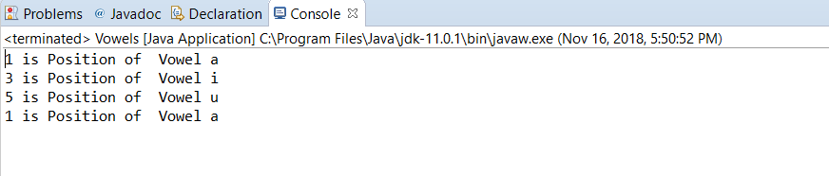

//write a java program find reverse string

**public** **class** ReverseString {

**public** **static** **void** main(String[] args) {

String s="karimulla";

**char** ch[]=s.toCharArray();

**char** b[]=**new** **char**[ch.length];

**int** j=0;

**for** (**int** i=ch.length-1; i >=0; i--)

{

b[j]=ch[i];

j++;

}

String s2=**new** String(b);

System.***out***.println("Reverse of a String is:"+ s2);

}

}

Output:

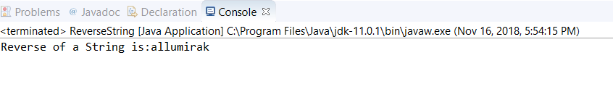

//write a java program reverse char

**public** **class** Char {

**public** **static** **void** main(String[] args) {

**char** ch[]= {'b','f','g','j'};

**char** b[]=**new** **char**[ch.length];

**int** j=0;

**for** (**int** i = ch.length-1; i >=0; i--) {

b[j]=ch[i];

j++;

}

**for** ( j = 0; j < b.length; j++) {

System.***out***.println(b[j]+" is a reverse number");

}

}

}

Output:

