Java Assignment 2

Increment & Decrement Programs

Program:

class Increment

{

public static void main(String args[])

{

int a=21;

int b=--a;

System.out.println("a is :"+a);

System.out.println("b is :"+b);

}

}

Output:

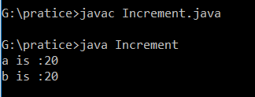

Program:

class PostDecrement

{

public static void main(String args[])

{

int a=47;

int b=a--;

System.out.println("a is :"+a);

System.out.println("b is :"+b);

}

}

Output:

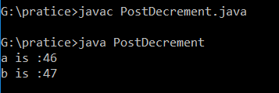

Program:

class PreIncrementAddition

{

public static void main(String args[])

{

int a=20;

int b=++a + ++a;

System.out.println("a is :"+a);

System.out.println("b is :"+b);

}

}

Output:

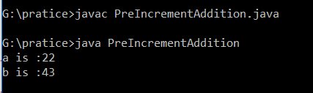

Program:

class PreIncrementAdd

{

public static void main(String args[])

{

int a=21;

int b=a++ + a++;

System.out.println("a is :"+a);

System.out.println("b is :"+b);

}

}

Output:

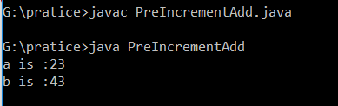

Program:

class PreIncrementAddi

{

public static void main(String args[])

{

int a=11;

int b=a++ + ++a;

System.out.println("a is :"+a);

System.out.println("b is :"+b);

}

}

Output:

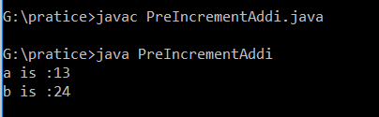

Program:

class Employee

{

//instance variables

int empno;

int basic;

int hra;

int da;

String ename;

//constructors

Employee(int empno,String ename,int basic,int hra,int da)

{

this.empno=empno;

this.basic=basic;

this.hra=hra;

this.da=da;

this.ename=ename;

}

void getEmpData(int n)

{

System.out.println("employee :"+(++n));

System.out.println("------------------------------------");

System.out.println("employee no:" +(++empno));

System.out.println("employee name:" +ename);

System.out.println("employee salary:"+(basic+hra+da));

}

}

//Inside Main

class TestEmp

{

public static void main(String args[])

{

Employee obj=new Employee(534,"kareem",10000,1500,1000);

obj.getEmpData(0);

Employee obj1=new Employee(535,"Anil",20000,1500,1000);

obj1.getEmpData(1);

Employee obj2=new Employee(536,"Sai",30000,1500,1000);

obj2.getEmpData(2);

Employee obj3=new Employee(536,"Sai",30000,1500,1000);

obj3.getEmpData(3);

}

}

Output:

