Arthematic operation

Program:

//Design the class

class Arthematic

{

//Static Method

static int operationSum(int a,int b)

{

int c=a+b;

return c;

}

static int operationSub(int a,int b)

{

int d=a+b;

return d;

}

static int operationMul(int a,int b)

{

int e=a\*b;

return e;

}

static float operationDiv(float a,float b)

{

float q= a/b;

return q;

}

static float operationModDiv(float a,float b)

{

float j= a%b;

return j;

}

}

//Inside Main

class TestArthematic

{

public static void main(String args[])

{

int sum= Arthematic.operationSum(20,30);

System.out.println("Sum is:"+sum);

int sub= Arthematic.operationSub(40,30);

System.out.println("Sub is:"+sub);

int mul= Arthematic.operationMul(20,30);

System.out.println("Mul is:"+mul);

float div= Arthematic.operationDiv(20,30);

System.out.println("Div is:"+div);

float mod= Arthematic.operationModDiv(5,7);

System.out.println("Module Division is:"+mod);

}

}

Output:

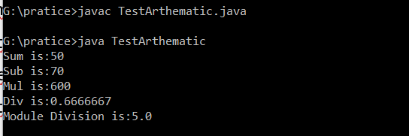

Employee Details

Program:

//Design class

class Details

{

int empid;

String ename;

float salary;

//Static Method

static String company="Wellsforgo";

//constructor

Details(int empid,String ename,float salary)

{

this.empid=empid;

this.ename=ename;

this.salary=salary;

}

//Method

void getData()

{

System.out.println("----------------------------------");

System.out.println("Employee id:" +empid);

System.out.println("Employee Name:" +ename);

System.out.println("Employee Salary:" +salary);

System.out.println("Employee Company:" +company);

}

}

//Inside Main

class TestDetails

{

public static void main(String args[])

{

//create an object

Details obj=new Details(104,"Nag",10000);

obj.getData();

Details obj1=new Details(105,"Ibhrahim",20000);

obj1.getData();

Details obj2=new Details(106,"kalyan",40000);

obj2.getData();

Details obj3=new Details(107,"Anil",50000);

obj3.getData();

Details obj4=new Details(108,"Narendra",60000);

obj4.getData();

}

}

Output:

