**SCHOOL MANAGEMENT SYSTEM**

**Date:** 7th June 2024

**Submitted By:** Shaik Karimunnisa (23kq5a0705)

**Details of project:** I’m implementing this project by using python programming language.

**Code:**

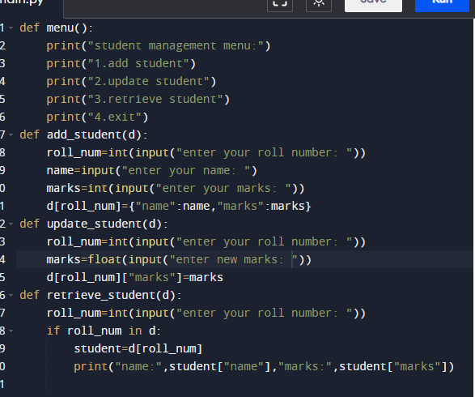

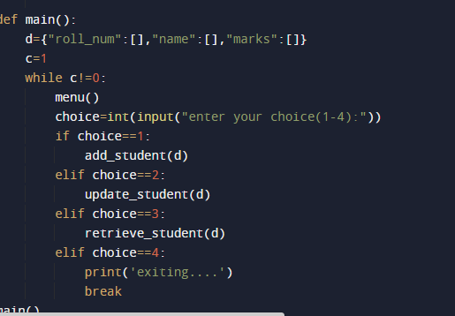

**Input and output:**

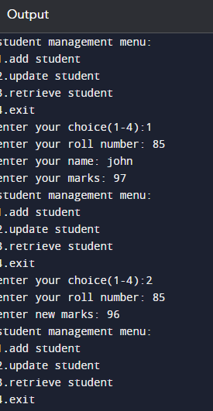

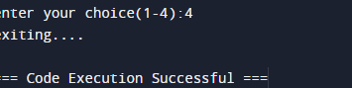

**Explanation:**

In this program I have implemented school management system which is nothing but taking inputs from the users based on unique roll number and name to add student, update marks ,retrieve and exit. For that I’m using while loop to be iterate infinity times until I met the desired output, later I’m using break statement to come out of from the loop and it checks the main() function which runs directly and finally output will be displayed as per the given input.

**Conclusion:**

The implemented school management system effectively handles the student information. It allows easy addition of new students, updating existing student records and retrieval of student details based on their roll number and very efficient in managing student data.