**CDAC Mumbai PG-DAC AUGUST 24**

**Assignment No- 2**

**1)Write a program that checks if a given year is a leap year or not using both if-else and switch-case.**

**Using if else loop:**

**package leap;**

**import java.util.Scanner;**

**public class Leapyear {**

**public static void main(String[] args)**

**{**

**int year;**

**Scanner scn = new Scanner(System.*in*);**

**year = scn.nextInt();**

**if ((year % 400 == 0)**

**|| ((year % 4 == 0) && (year % 100 != 0))) {**

**System.*out*.println(year + " : Leap Year");**

**}**

**else {**

**System.*out*.println(year + " : Non - Leap Year");**

**}**

**}**

**}**

**Output:** **2024**

**2024 : Leap Year**

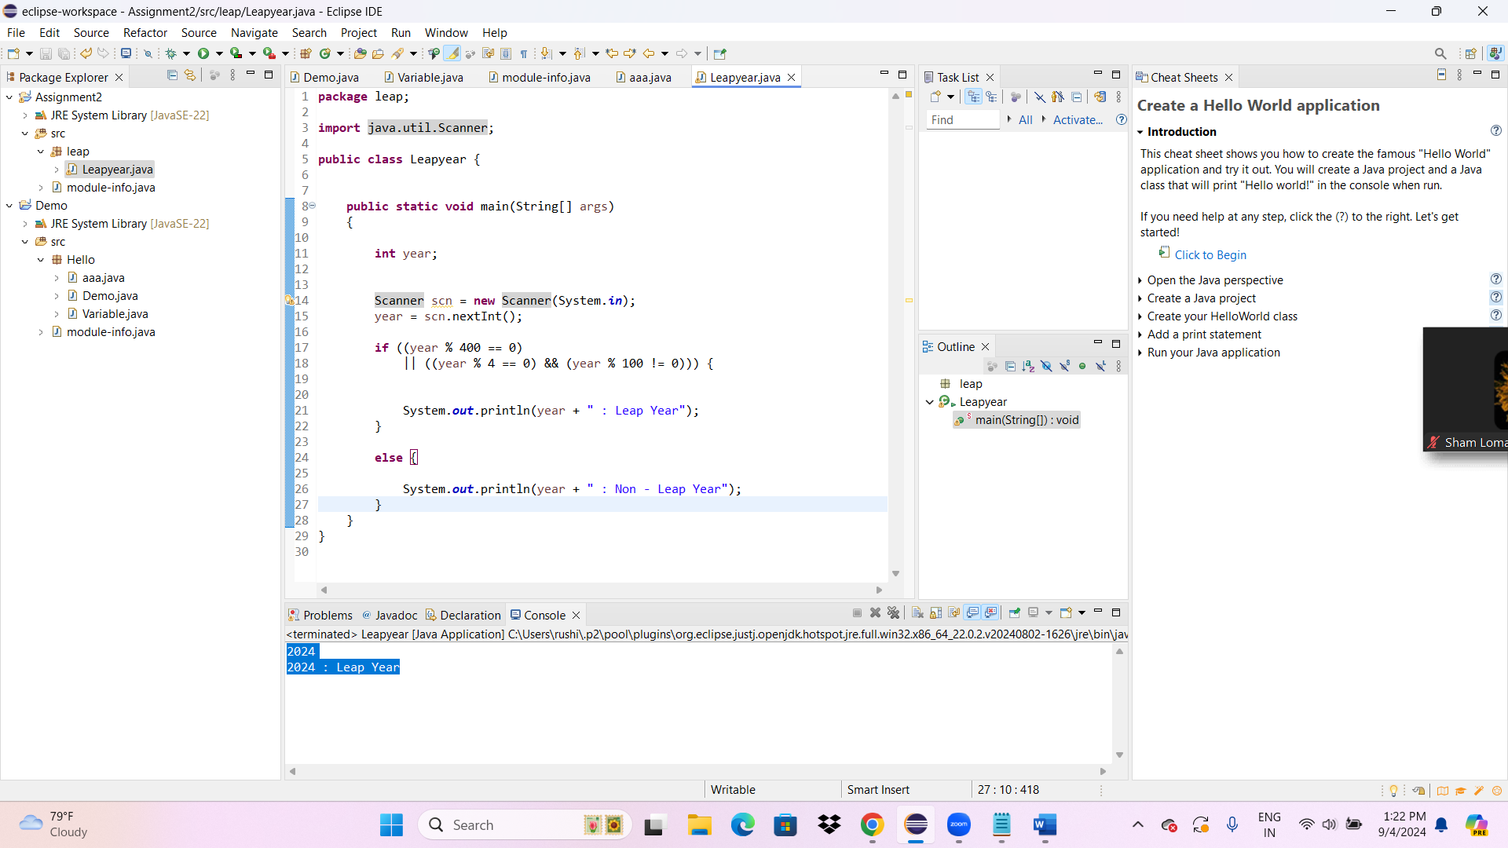

**1)Write a program that checks if a given year is a leap year or not using switch-case.**

**package leap;**

**import java.util.Scanner;**

**public class Switchleap {**

**public static void main(String[] args)**

**{**

**int year;**

**Scanner scn = new Scanner(System.*in*);**

**year = scn.nextInt();**

**if ((year % 400 == 0)**

**|| ((year % 4 == 0) && (year % 100 != 0)))**

**{**

**System.*out*.println(year + " : Leap Year");**

**}**

**else {**

**System.*out*.println(year + " : Non - Leap Year");**

**}**

**switch (year) {**

**case 1:**

**System.*out*.println(year + " : Leap Year");**

**break;**

**case 2:**

**System.*out*.println(year + " : Non - Leap Year");**

**break;**

**}**

**}**

**}**

**Output:** **2023**

**2023 : Non - Leap Year**

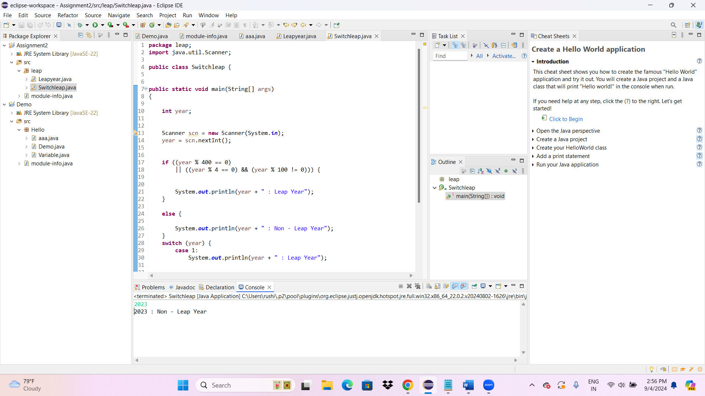

**2)Implement a program that calculates the Body Mass Index (BMI) based on height and weight input**

**using if-else to classify the BMI int categories (underweight, normal weight, overweight,etc).**

**package leap;**

**import java.util.Scanner;**

**public class BMI {**

**public static void main(String[] args) {**

**double weightInKg = 0.0f;**

**double heightInMeters = 0.0f;**

**Scanner scan = new Scanner(System.*in*);**

**System.*out*.print("Enter weight in Kg: ");**

**double weight = scan.nextDouble();**

**System.*out*.print("Enter height in meters: ");**

**double height = scan.nextDouble();**

**double bmi = weight / ( height * height) ;**

**// check range**

**if(bmi < 18.5)**

**System.*out*.println("thinness");**

**else if(bmi < 25)**

**System.*out*.println("normal");**

**else if(bmi < 30)**

**System.*out*.println("overwaight");**

**else**

**System.*out*.println("obese");**

**}**

**}**

**Output:**

**Enter weight in Kg: 80**

**Enter height in meters: 1.7**

**overwaight**

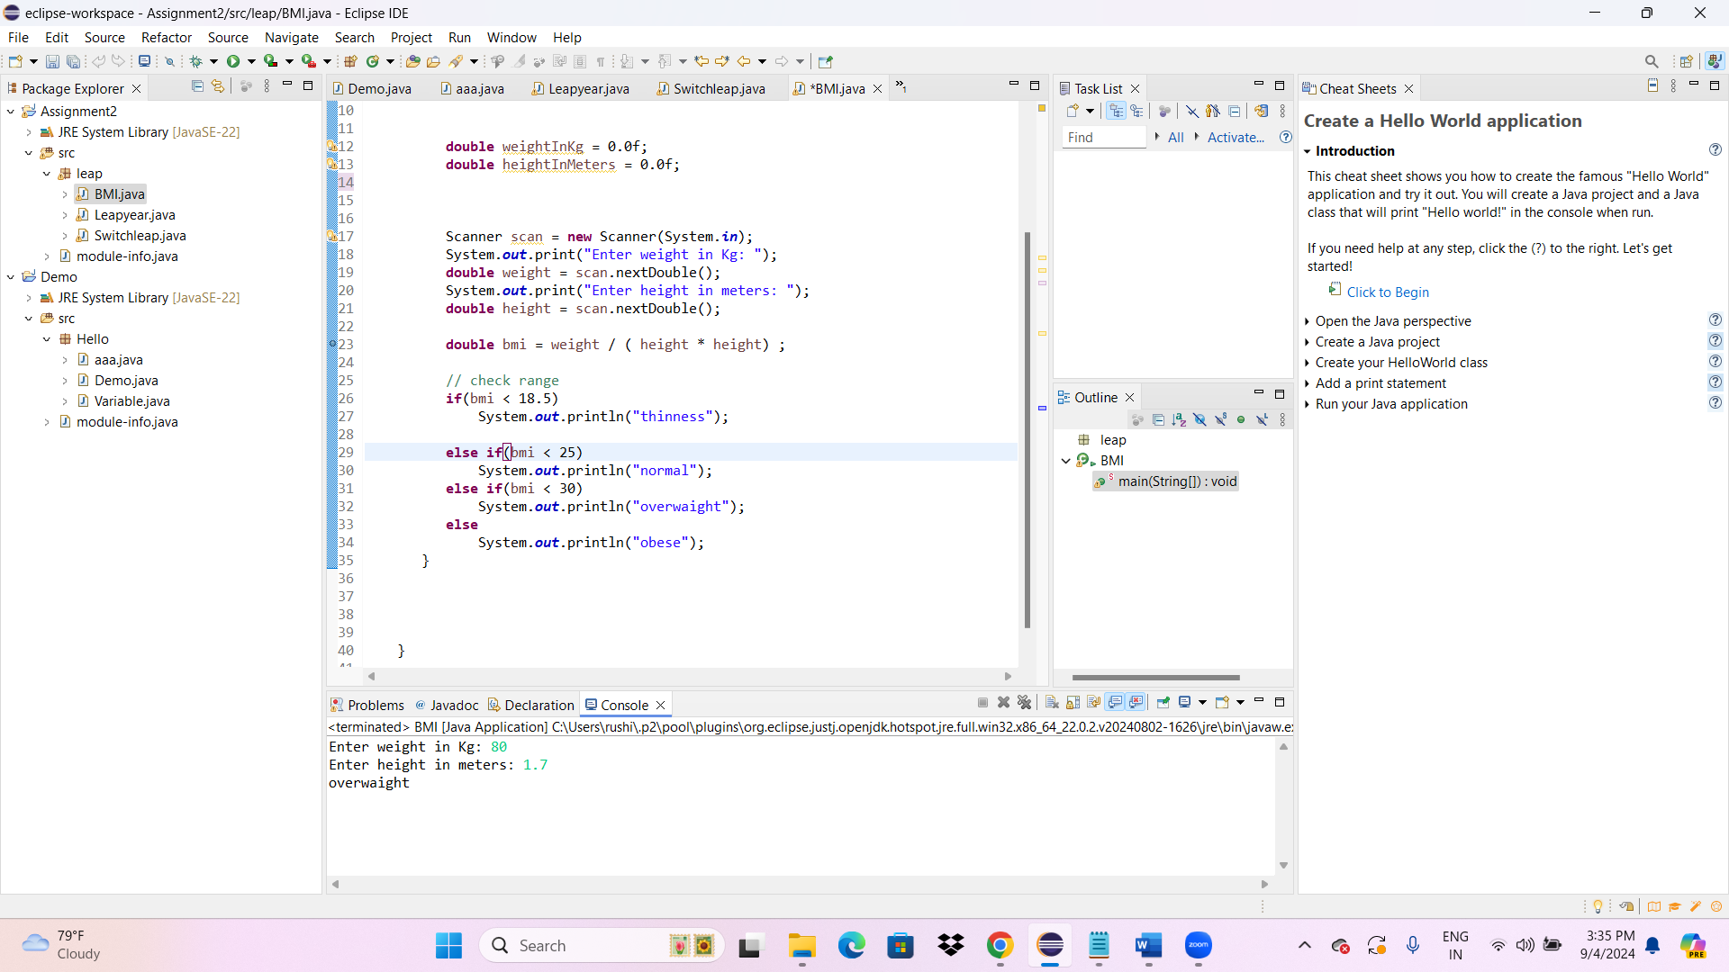

**3)Write a program that checks if a person is eligible to vote based on their age.**

**package leap;**

**import java.util.Scanner;**

**public class Vote {**

**public static void main(String[] args) {**

**Scanner scanner = new Scanner(System.*in*);**

**System.*out*.println("Enter your age:")**

**int age = scanner.nextInt();**

**if (age >= 18) {**

**System.*out*.println("Person is allowed to vote");**

**} else {**

**System.*out*.println("Person is not allowed to vote");**

**}**

**}**

**}**

**Output:**

Enter your age:

12

Person is not allowed to vote

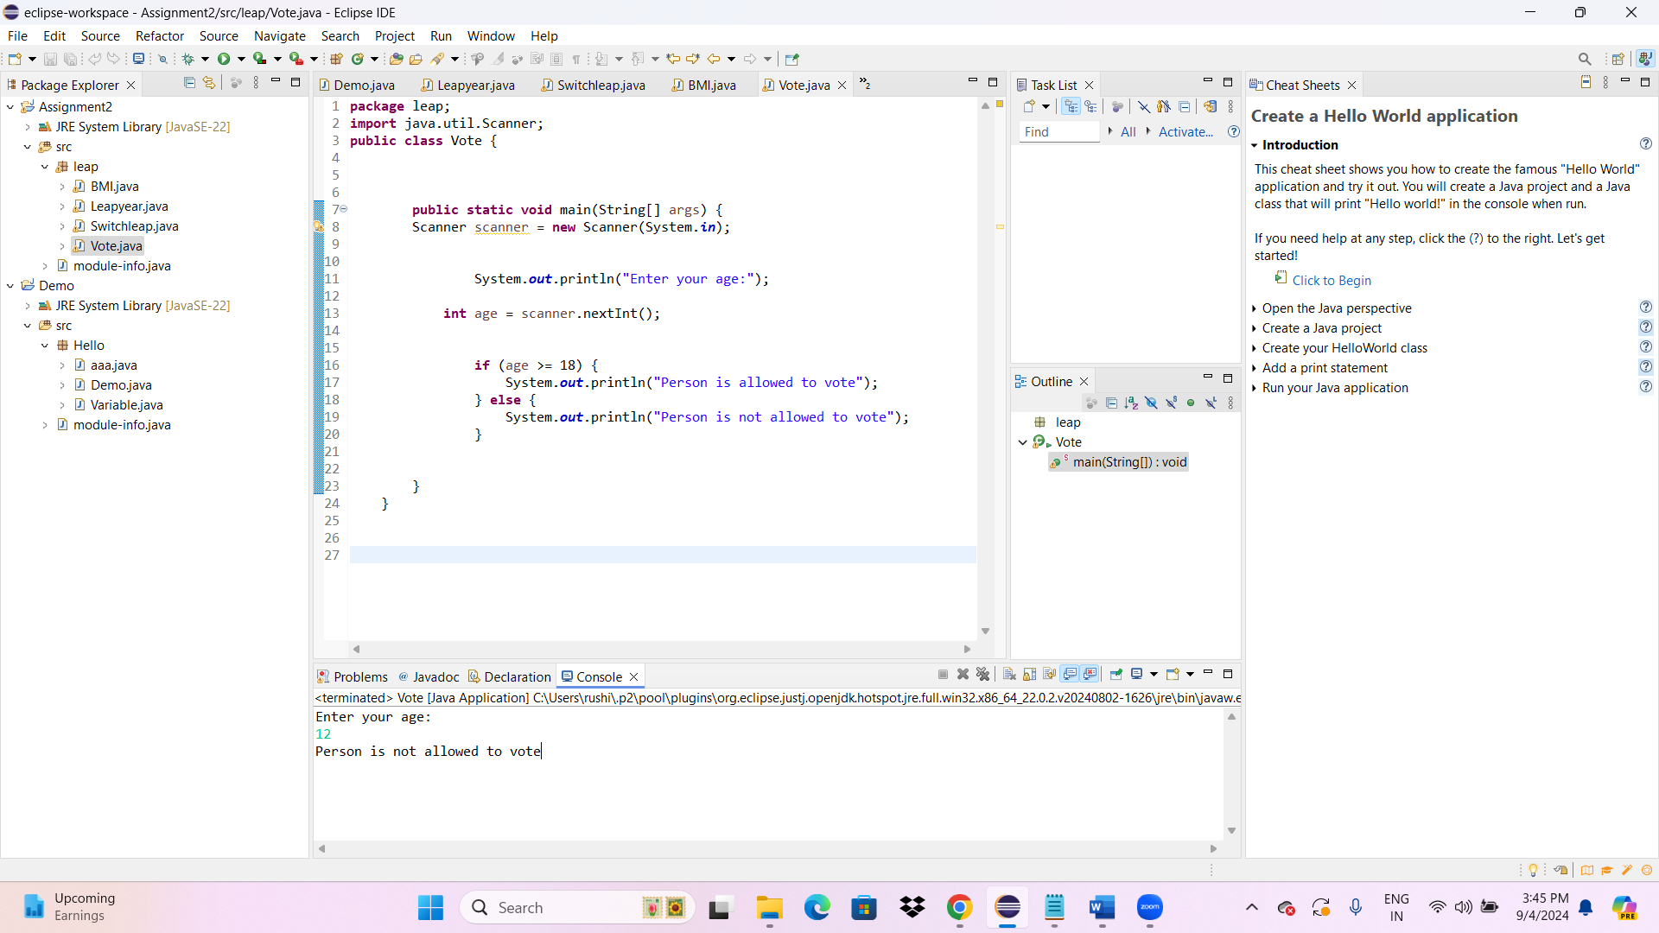

**4)Write a program that takes a month (1-12) and prints the corresponding season (Winter, Spring,**

**Summer, Autumn) using a switch case**

**package leap;**

**import java.util.*;**

**public class Month {**

**public static void main(String abc[])**

**{**

**Scanner scanner = new Scanner(System.*in*);**

**System.*out*.println("Enter the month:");**

**int month = scanner.nextInt();**

**switch (month) {**

**case 12:**

**case 1:**

**case 2:**

**System.*out*.println("WINTER");**

**break;**

**case 3:**

**case 4:**

**case 5:**

**System.*out*.println("SPRING");**

**break;**

**case 6:**

**case 7:**

**case 8:**

**System.*out*.println("SUMMER");**

**break;**

**case 9:**

**case 10:**

**case 11:**

**System.*out*.println("AUTUMN");**

**break;**

**default:**

**System.*out*.println("Invalid Month number");**

**break;**

**}**

**}**

**}**

**Output:**

Enter the month:

12

WINTER

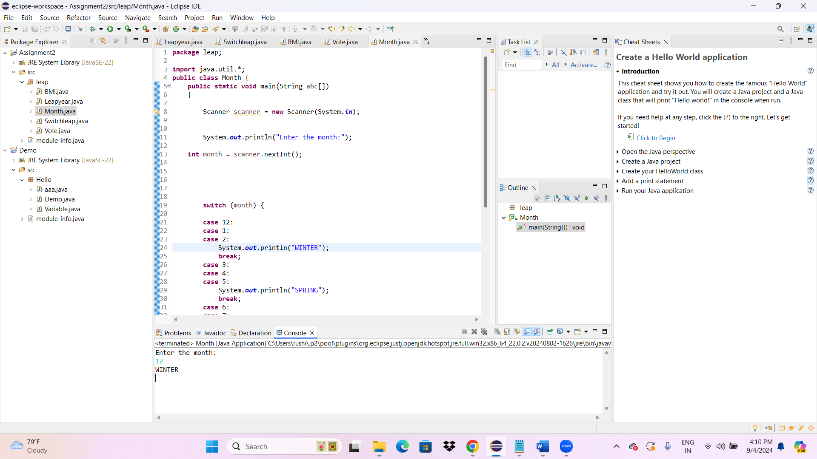

**5)Write a program that allows the user to select a shape (Circle, Square, Rectangle, Triangle) and then**

**calculates the area based on user-provided dimensions using a switch case.**

**package leap;**

**import java.util.*;**

**public class Shape {**

**public static void main(String[] args) {**

**int choice;**

**int counter=0;**

**Scanner scan;**

**do{**

**System.*out*.println("1) Triangle\n" +**

**"2) Square\n" +**

**"3) Rectangle\n" +**

**"4) Circle\n" +**

**"5) Quit\n" );**

**scan=new Scanner(System.*in*);**

**do{**

**System.*out*.println("Enter your choice from the menu:");**

**choice= scan.nextInt();**

**} while(choice<1||choice>5);**

**switch(choice)**

**{**

**case 1:System.*out*.println("u chose Triangle");**

**System.*out*.println("Enter base");**

**double base=*getUserInput*();**

**System.*out*.println("Enter height");**

**double height=*getUserInput*();**

**double area= *triangleArea*(base,height);**

**System.*out*.print("Area is "+area);**

**continue;**

**case 2:System.*out*.println("u chose Square.Enter Side of square");**

**double side=*getUserInput*();**

**double SquareArea=*squareArea*(side);**

**System.*out*.println("Area of square is"+SquareArea);**

**continue;**

**case 3:System.*out*.println("u chose Rectange.Enter Length of rect");**

**double length=*getUserInput*();**

**System.*out*.println("Enter width of rect");**

**double width=*getUserInput*();**

**double rectArea= *rectangleArea*(length,width);**

**System.*out*.println("Area of rectangle is"+rectArea);**

**continue;**

**case 4:System.*out*.println("u chose Circle.Enter circle radius");**

**double radius=*getUserInput*();**

**double circleArea= *circleArea*(radius);**

**System.*out*.println("Area of Circle is "+circleArea);**

**continue;**

**case 5:System.*out*.print("u chose exit"); scan.close();System.*exit*(0);**

**default:System.*out*.print("Invalid");**

**}**

**counter++;**

**}while(counter<1);**

**scan.close();**

**}**

**public static double triangleArea(double base, double height){**

**double area=0.5 * base *height;**

**return area;**

**}**

**public static double squareArea(double side){**

**double area=side*side;**

**return area;**

**}**

**public static double rectangleArea(double length, double breadth){**

**double area=length*breadth;**

**return area;**

**}**

**public static double circleArea(double radius){**

**double area=Math.*PI*\*radius;**

**return area;**

**}**

**public static double getUserInput( ) {**

**int inp;**

**do {**

**System.*out*.println("Enter input");**

**Scanner scan = new Scanner(System.*in*);**

**inp=scan.nextInt();**

**}while(inp<=0);**

**return inp;**

**}**

**}**

**Output:**

**1) Triangle**

**2) Square**

**3) Rectangle**

**4) Circle**

**5) Quit**

**Enter your choice from the menu:**

**1**

**u chose Triangle**

**Enter base**

**Enter input**

**2**

**Enter height**

**Enter input**

**3**

**Area is 3.01) Triangle**

**2) Square**

**3) Rectangle**

**4) Circle**

**5) Quit**

**Enter your choice from the menu:**

**2**

**u chose Square.Enter Side of square**

**Enter input**

**4**

**Area of square is16.0**

**1) Triangle**

**2) Square**

**3) Rectangle**

**4) Circle**

**5) Quit**

