**Assignment No 3**

**Exercise 1:**

**Create a function processData that takes two parameters: a string and a callback function. Your task is to write a callback that converts the string to uppercase and then call it within processData. Requirements: ● Define a function toUpperCase that will serve as a callback. ● Pass a string and toUpperCase to processData and log the output.**

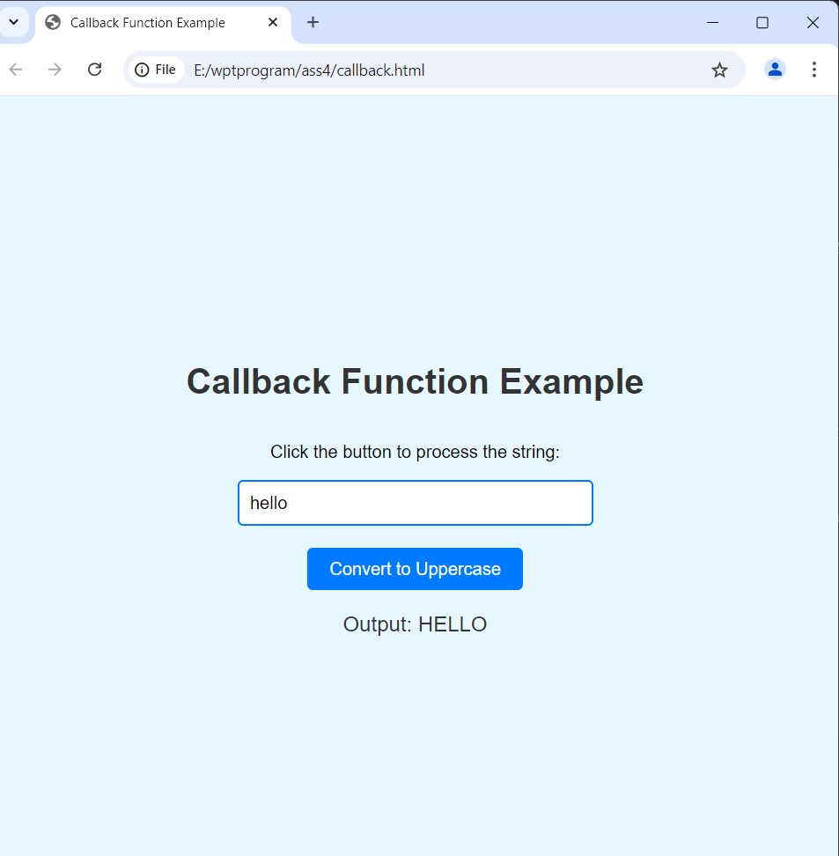

**Exercise 2:**

**Write a function forEachElement that accepts an array and a callback. This function should apply the callback to each element of the array. Requirements: ● Pass an anonymous function as the callback that multiplies each element by 2 and logs the result with the index.**

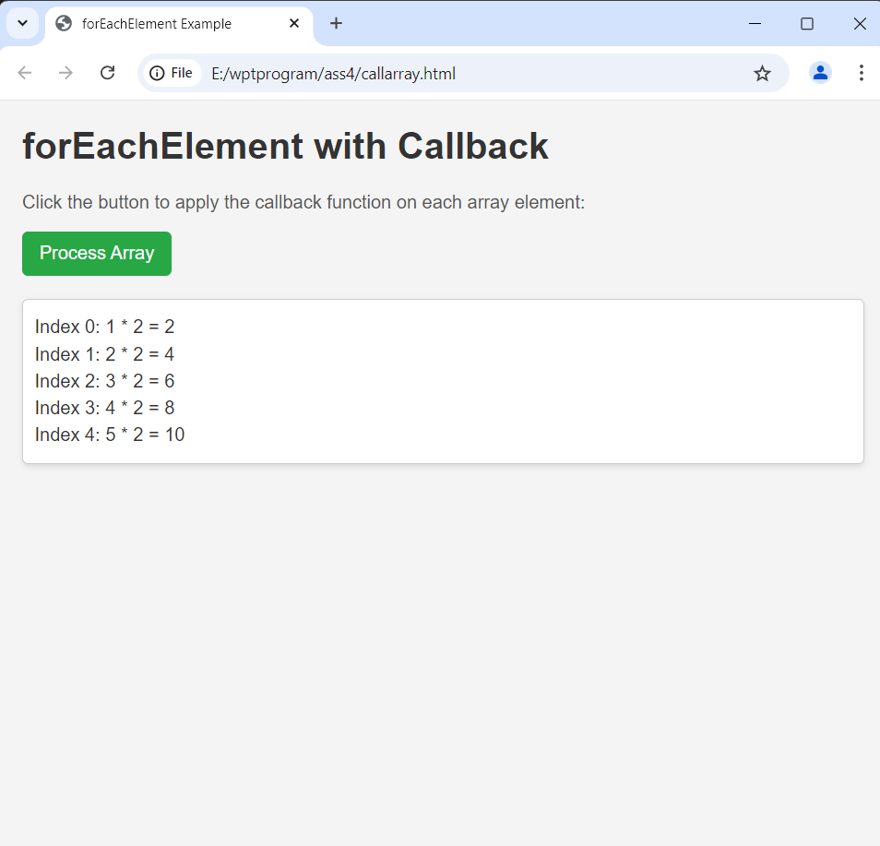

**Exercise 3:**

**Simulate a network request by creating a function fetchData that takes a URL and a callback as parameters. Use setTimeout to simulate a delay and then call the callback with a string representing a response. Requirements: ● After a delay, log the “response” to the console**

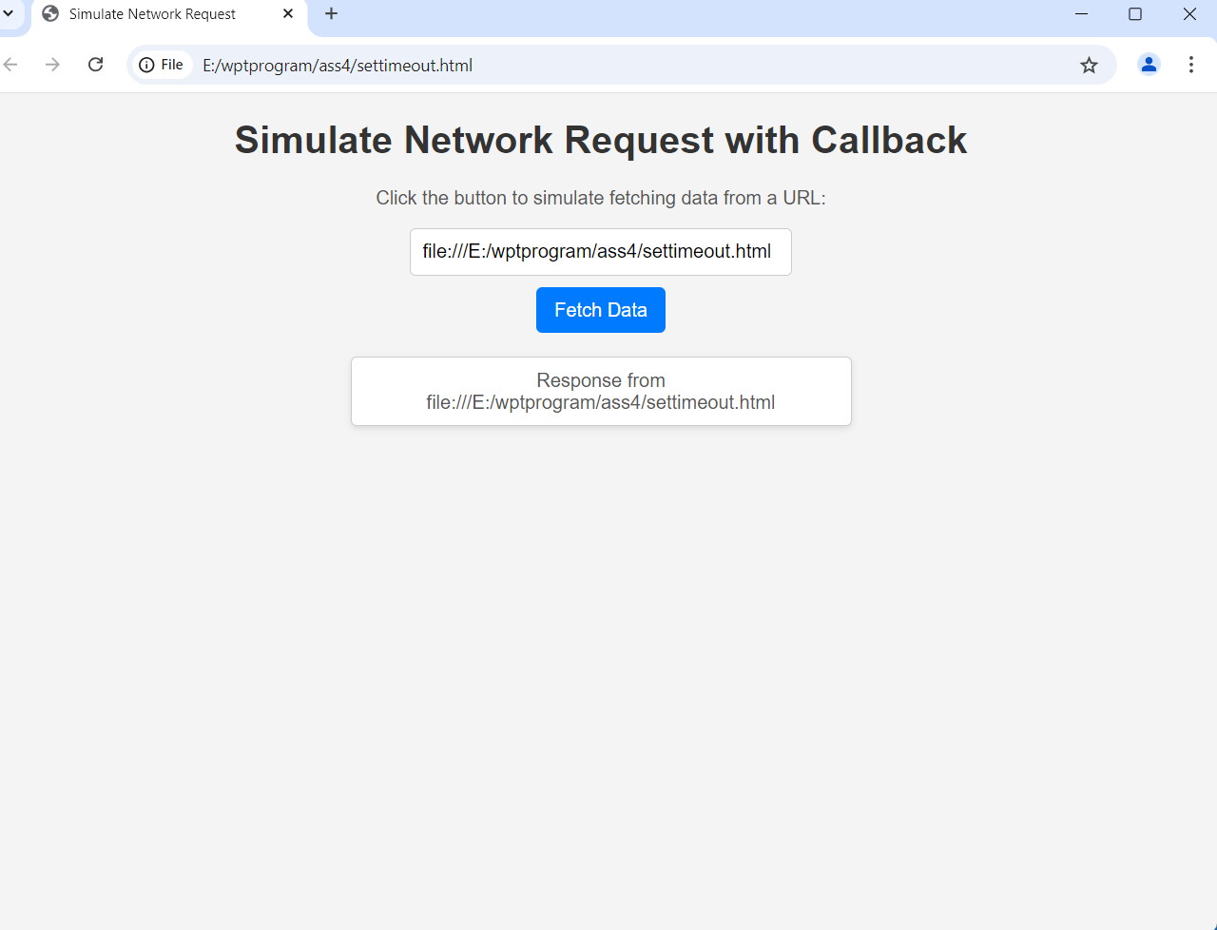

**Exercise 4:**

**Modify fetchData from Exercise 3 to include error handling. Requirements: ● Call the callback with an error message if an error occurs; otherwise, pass the “response.” ● Handle the error gracefully by logging it if it occurs**

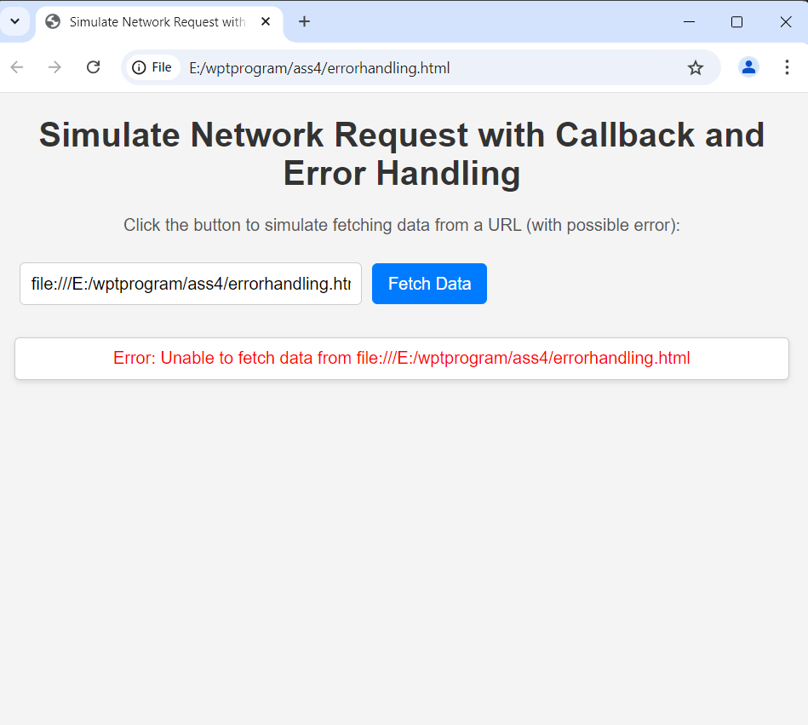

**Exercise 5:**

**Using fetchData from Exercise 4, create another function processData that simulates processing the fetched data. Chain these functions together using nested callbacks. Requirements: ● First, call fetchData. Once the response is received, pass it to processData. ● processData should modify the data and log the processed result**

